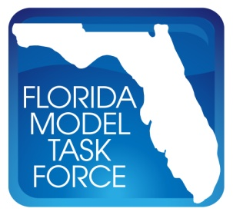

Advanced Traffic Assignment (ATA) Sub-Committee Meeting

Agenda

Web Conference

July 26, 2012

10:00 AM - 12:00 PM

- Introduction by Neelam Fatima, ATA Sub-Committee Chair.

- Presentation on the Use of Dynamic Traffic Assignment (DTA) in FSUTMS by
Dr. Hadi, Florida International University (FIU), and Fred Ducca, University of Maryland.

- Discussion on the DTA Final Report

- Next Meeting

- Adjourn

