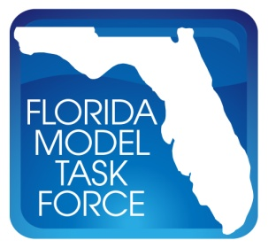
Use of Dynamic Traffic Assignment in FSUTMS
Florida Department of Transportation-Research Center

Technical Committee Meeting – Agenda

Web Conference

November 7, 2011 – 10:30 AM to 12:00 PM

- Introduction

- Project Update

- ISSTA Development

- Use of ITS in DTA

- Next Meeting

