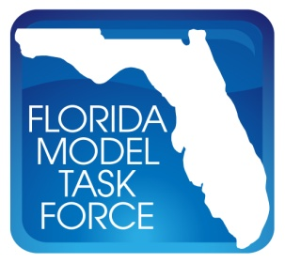
Use of Dynamic Traffic Assignment in FSUTMS
Florida Department of Transportation-Research Center

Technical Committee Meeting – Agenda

Web Conference

July 28, 2011 – 10:00 AM to 11:30 AM

- Introduction

- Project Update

- Requirements for Assignment Environment Discussion

- Next Meeting

