report

draft final

prepared for

prepared by

Cambridge Systematics, Inc.

report

prepared for

prepared by

Cambridge Systematics, Inc.

date

Table of Contents

1.0 Implementation of Constant Time of Day Factors 1-1

1.1 Approaches to Modeling Time of Day 1-2

Where to Incorporate Time of Day in the Modeling Process 1-3

1.2 Dataset for Estimating Temporal Distribution of Trips 1-4

1.3 Geographic Segmentation 1-5

Sampling Region Segmentation 1-6

Urban Size Segmentation 1-7

Income Segmentation 1-9

1.4 Time Period Definition 1-11

1.5 Time of Day Factors 1-14

1.6 CONFAC Development 1-20

1.7 Guidance For Using Time Of Day Factors 1-21

2.0 Incorporating Time of Day into Transit Modeling 2-1

2.1 Domination of Data Sets by Auto Travel 2-1

2.2 Defining time periods for analysis 2-3

2.3 Transit network and path building considerations 2-4

3.0 Validating Time of Day Models 3-1

3.1 Validating the Time of Day Modeling Component 3-1

3.2 Validating Highway Assignment 3-2

3.3 Validating Other Model Components 3-5

4.0 Econometric-based Approaches to Time of Day Modeling 4-6

4.1 Data Description 4-6

4.2 Methodological Techniques 4-10

4.3 Findings and Recommendations 4-11

HBW Trips 4-11

HBO Trips 4-17

NHB Trips 4-25

4.4 Summary and Recommendations 4-28

5.0 Empirical Methods to Relate Reported and Network Travel Times 5-1

5.1 Data Validation and Statistics 5-1

Screening Method 1 5-3

Screening Method 2 5-4

Screening Method 3 5-5

Trip Distribution by Time of Day 5-6

Speed Distribution by Time of Day after Screening 5-7

5.2 Regression Analysis 5-8

5.3 Statewide Transportation Engineering Warehouse for Archived Regional Data (STEWARD) Database 5-11

Viability of STEWARD as Data Source 5-12

A. Appendix: Hourly Time of Day Factors A-1

B. Appendix: CONFAC DEVELOPMENT B-1

List of Tables

Table 1.1 Sampling Region Segment – Sample Size 1-6

Table 1.2 Sampling Region Segmentation – ANOVA Results 1-7

Table 1.3 Urban Size Segment – Sample Size 1-8

Table 1.4 Urban Size Segmentation – ANOVA Results 1-9

Table 1.5 Urban Size Segmentation - Tests for Variability within Each Level 1-9

Table 1.6 Income Segment – Sample Size 1-10

Table 1.7 Income Segmentation – ANOVA Results 1-11

Table 1.8 Income Segmentation - Tests for Variability within Each Level 1-11

Table 1.9 Morning and Afternoon Peak Periods 1-12

Table 1.10 Time of Day Factors – Income Segmentation 1-15

Table 1.11 Time of Day Factors – Urban Size Segmentation 1-17

Table 1.12 CONFAC by Household Income Segment 1-20

Table 1.13 CONFAC by Urban Size Segment 1-20

Table 2.1 Transit and Auto Percentages of Travel by Time of Day for Four U.S. Urban Areas 2-2

Table 3.1 Percentages of Travel by Time of Day for Eight U.S. Urban Areas 3-4

Table 4.1 Model Fit Statistics for HBW Models 4-12

Table 4.2 Home-to-Work TOD Model Coefficient Estimates 4-13

Table 4.3 Work-to-Home TOD Model Coefficient Estimates 4-14

Table 4.4 Model Fit Statistics for HBO Models 4-17

Table 4.5 Home-to-Other TOD Model Coefficient Estimates 4-20

Table 4.6 Other-to-Home TOD Model Coefficient Estimates 4-21

Table 4.7 Model Fit Statistics for NHB Model 4-26

Table 4.8 Non-Home Based TOD Model Coefficient Estimates 4-26

Table 5.1 Regression Results 5-10

Table 5.2 STEWARD Data Availability 5-11

Table B.1 CONFAC Development – Income Based B-1

Table B.2 CONFAC Development – Urban Size Based B-2

List of Figures

Figure 1.1 Weekday Trip Purpose Distribution – 2009 NHTS 1-5

Figure 1.2 Sampling Region Segments 1-7

Figure 1.3 Urban Size Segment 1-8

Figure 1.4 Income Distribution by County 1-10

Figure 1.5 Diurnal Distribution of Weighted Trips 1-13

Figure 4.1 Reported Trip Start Times at 5-, 15-, 30-, and 60-min Intervals for NE Florida HH Survey 4-7

Figure 4.2 Reported Trip Start Times at 5-, 15-, 30-, and 60-min Intervals for SE Florida HH Survey 4-8

Figure 4.3 Reported Trip Start Times at 5-, 15-, 30-, and 60-min Intervals for 2009 NHTS 4-9

Figure 4.4 Age and Job Type Effects on Model-Predicted TOD Distributions for Home-to-Work Trips 4-15

Figure 4.5 Mode and Distance Effects on Model-Predicted TOD Distributions for Home-to-Work Trips 4-16

Figure 4.6 Age and Job Type Effects on Model-Predicted TOD Distributions for Work-to-Home Trips 4-18

Figure 4.7 Mode and Distance Effects on Model-Predicted TOD Distributions for Work-to-Home Trips 4-19

Figure 4.8 Presence of Children and Age Effects on Model-Predicted TOD Distributions for Home-to-Other Trips 4-22

Figure 4.9 Mode and Distance Effects on Model-Predicted TOD Distributions for Home-to-Other Trips 4-23

Figure 4.10 Presence of Children and Household Size Effects on Model-Predicted TOD Distributions for Other-to-Home Trips 4-24

Figure 4.11 Mode and Age Effects on Model-Predicted TOD Distributions for Other-to-Home Trips 4-25

Figure 4.12 Household Size and Presence Children Effects on Model-Predicted TOD Distributions for NHB Trips 4-27

Figure 4.13 Age and Mode Effects on on Model-Predicted TOD Distributions for NHB Trips 4-28

Figure 5.1 Mean ratio of reported to network speed versus time of day using screening method 1 5-3

Figure 5.2 Mean ratio of reported to free flow speed versus time of day using screening method 2 5-4

Figure 5.3 Mean ratio of reported to free flow speed versus time of day using screening method 3 5-5

Figure 5.4 Mean ratio of reported to free flow speed versus time of day using screening method 3 and 1-hr time periods 5-6

Figure 5.5 Distribution of Trips by Time of Day before and after Screening 5-7

Figure 5.6 Mean speed distribution by time of day after screening method 3 is applied 5-8

Figure A.1 Household Income Less than $25,000 A-2

Figure A.2 Household Income between $25,000 and $75,000 A-3

Figure A.3 Household Income More than $75,000 A-4

Figure A.4 Urban Population between 50,000 and 199,999 A-5

Figure A.5 Urban Population between 200,000 and 499,999 A-6

Figure A.6 Urban Population between 500,000 and 999,999 A-7

Figure A.7 Urban Population - $100,000 or more without heavy rail A-8

Figure A.8 Urban Population - $100,000 or more with heavy rail A-9

Figure A.9 Not in an Urban Area A-10

# Implementation of Constant Time of Day Factors

Capturing the variations in travel by time of day is essential to predicting transportation system performance and air quality impacts of the transportation sector. A vast amount of transportation research has been conducted to study travel demand by time of day. Much of this research has been limited to observing trends in service usage, such as vehicular volumes and the number of person trips. While important to understanding past and present usage patterns, these types of studies are less valuable for predicting future travel by time of day given changes in transportation service availability, quality, and policy.

Possibly the behavior least accounted for in travel forecasting is “peak spreading,” e.g., persons rescheduling their travel from daily periods of high demand to the portions of the day where travel takes less time and is more reliable. Travel surveys and other monitoring activities have documented the correlation between decreasing service quality (congestion) and longer peak periods. Also, many planning agencies need to test the effectiveness of policy initiatives specifically targeted at shifting travel demand to off-peak periods.

The Model Task Force (MTF) priorities survey done in 2009 determined that incorporating time of day (TOD) into the Florida Standard Urban Transportation Model Structure (FSUTMS) framework was one of the highest priorities of the Florida modeling community. Currently, with the exception of the Southeast Florida Regional Planning Model, FSUTMS estimates only daily travel demand. Estimates of peak hour volumes are made through manual post-processing calculations using K and D-factors published by FDOT. However, there are pressing needs to address planning issues and answer questions that are TOD-related such as understanding peak spreading and how time of day impacts transit and toll modeling. For example, many travel demand management strategies intend to smooth the temporal distribution of travel over the entire day. The daily 24-hour modeling framework is not able to evaluate the impacts of such strategies. The research report “Development of Time of Day Modeling Procedures using FSUTMS powered CUBE-VOYAGER” (hereafter referred as Florida DOT TOD research report) will form the basis for implementation of this project.

The major objectives of this project are to:

* develop procedures to implement TOD into the FSUTMS framework;
* develop econometric models that account for passive and active peak spreading; and
* Implement TOD into the FSUTMS framework.

The project is split into two phases. In phase one, factors from traffic count and National Household Travel Survey (NHTS) data were developed and implemented into the FSUTMS framework. This phase laid the preliminary groundwork for estimating econometric models. In phase two, the vision is to have the econometric models estimated and implemented into the FSUTMS framework.

One of the main objectives of this project is to use the recent NHTS data (where Florida was an add-on) and develop factors for regions in the state where such data are unavailable. The analysis results presented here include data from the entire state because the sample size of the NHTS data from any single region would be insufficient to develop factors for use throughout the state.

## Approaches to Modeling Time of Day

Trips occur at different rates at different times of the day. Typically, there are one or more peaks in daily travel. The dominant weekday peak periods are in the morning (a.m. peak period) and in the late afternoon (p.m. peak period). A peak period can be characterized by its maximum trip rate (in trips per unit of time). The peak hour is the hour during which maximum traffic volume occurs. The portions of the peak before and after the peak hour are called the ”shoulders of the peak.”

The time at which travel occurs and, more specifically travel peaking intensity and duration are critical to the estimation of a number of important travel performance measures, including speeds, congestion, and emissions. Yet peaking and time of travel are included in the traditional travel model in highly approximate ways, typically by developing peaking or time of day factors from observed data and assuming the same patterns will persist in the future.

A time of day factor (TODF) is the ratio of vehicle trips made in a peak period (or peak hour) to vehicle trips in some given base period, usually a 24-hour day. Time of day factors are most commonly specified as exogenous values that are fixed and independent of congestion levels. If applied prior to trip assignment these time of day factors are usually determined from household activity/travel survey data and from on-board transit and intercept auto surveys, with a separate TODF for each trip purpose and time period. If applied after assignment, the peaks' timing and duration are generally estimated from traffic data (e.g., 24-hour machine counts on streets and highways, transit counts, or truck counts), perhaps interpreted and adjusted based on data from special studies (e.g., travel surveys of workplaces and customer-serving businesses in a particular area or driveway counts at major activity centers). Occasionally, time of day factors are borrowed from other areas and adjusted during the model calibration process.

There are several commonly employed methods for accounting for time of day of travel in the four-step travel modeling process. To proceed from the initial daily trip generation estimates to the volume estimates by time period, average daily travel estimates must be converted to trips by time period. This time of day assignment can happen at four places in the modeling process:

* Between trip generation and trip distribution;
* Between trip distribution and mode choice;
* Between mode choice and trip assignment; and
* After trip assignment.

Post-generation modeling estimates trip productions and attractions for different time periods by factoring the initial daily estimates. This method allows for different travel characteristics by time of day to be considered during trip distribution and mode choice processes. However, this method is computationally intensive given the large number of time of day and purpose combinations that should be modeled for trip distribution and mode choice[1].

Post distribution modeling divides the daily trip Tables by purpose into trip purposes by time of day. Only one distribution model is required in this process but the differences in level of service among different time periods are ignored in the distribution process.

Post mode choice modeling allows different TOD factors for different modes. However, since mode choice must be modeled based on the daily trip distribution, there is an inconsistency in the path building between mode choice and transit assignment. Post assignment modeling of TOD uses factors calculated from the observed traffic data and does not take into account different trip purposes and modes[2].

During scope review the possibility of doing time of day after trip generation was raised. The main issue with this approach is dealing with trip ends (productions and attractions) as opposed to trips with both an origin and a destination.

However, it is possible to do the time of day factoring after trip generation but we will have to do some sort of iterative feedback from assignment to distribution to ensure that travel times are consistent. In order to ensure time of day variability among transit users is captured adequately, it was decided to incorporate time of day after trip generation.

## Dataset for Estimating Temporal Distribution of Trips

The data set from the 2009 NHTS Florida Add-On (including the Florida portion of the national sample) was used to define the time periods for time of day analysis and to develop the factors to convert daily trips to peak and off-peak period trips. Each record in the trip data set includes information on trip start and end times. The information needed for time of day model development includes:

* Weighting factor for the record;
* Trip purpose; and
* Trip Start and End Times.

There are three ways to define the time period for a trip, including the departure time, the arrival time, and the midpoint. It was decided to use the midpoint of the trip since the period in which it falls is the period in which most of the trip takes place. The midpoint was computed by taking the middle of the trip start and end times. The 2009 NHTS data set used for the analysis has 15,844 households with 30,922 persons making 114,910 trips. Figure 1.1 shows the distribution of trips by purpose in the 2009 NHTS. Of the 114,910 trips, 1.3 percent trips were made via transit. The transit modes considered included the following:

* Local public transit;
* Commuter bus;
* Commuter train;
* Elevated/Subway train; and
* Streetcar/Trolley.

Trips in motion is another way to define the time periods for trips. It requires splitting trips that extend from one time period into the next into components for each time period. This requires a significant amount of additional data processing, even more if the time periods are not predefined, and the trips need to be split into hour, half hour, or 15 minute periods. However, it is unclear if doing this additional data processing would lead to significant improvements from the midpoint definition used in this study and due to these two reasons it was decided to proceed with the midpoint of the trip as the analysis unit. Further, the suggestion to consider trips in motion was proposed towards the end of the project and the lack of resources prevented the project team from doing a comparative analysis of the two analysis units – midpoint Vs. trips in motion.

Figure . Weekday Trip Purpose Distribution – 2009 NHTS

## Geographic Segmentation

This project was initiated because many regions do not have local data from which to develop factors. Therefore, one of the tasks in the project is to recommend geographic strata that identify areas around the state that do not have survey data readily available with which to determine peak periods. It was necessary to come up with information that the regions could use to determine the appropriate factors that come from the NHTS data. This required segmenting the statewide NHTS data into strata that regions can use to transfer time of day factors for their day to day use.

The following geographic strata were considered for the purposes of analysis:

* Sampling Region;
* Urban Size;
* Income;
* University Presence; and
* Tourist/Resort Area.

This report focuses on the first three since it was determined through analysis of the data that sufficient samples are not available in the NHTS dataset to be able to arrive at statistically valid conclusions for the remaining two. It was the objective of the project team to prove that there are variances in the time of day distribution by purpose when considering sampling region, or urban size or household income For most of these segmentations Analysis of Variance (ANOVA) was used to determine the statistical validity of the segmentation across different levels within each segment. ANOVA was used because it allows testing the differences in the means of the dependent variable (midpoint of travel time) broken down by the levels of the independent variable (the geographic strata). A discussion of the ANOVA results for each segmentation considered is given below.

### Sampling Region Segmentation

Figure 1.2 shows the sampling region across the state and Table 1.1 shows the sample size available by trip purpose for each sampling region. The sampling regions were determined as part of the NHTS sampling plan and are detailed in the FSUTMS Florida Transportation Modeling newsletter, Vol. 37[3]. To test the validity of this segmentation, ANOVA tests were performed to determine if there were any statistically significant differences across the different sampling regions by trip purpose. Based on the results of the analysis, except for the Home-based Work (HBW) trip purpose, there is a statistically significant difference across different geographic segments. Table 1.2 shows the results of the ANOVA analysis where the hypothesis is that there is no variability among the different sampling regions in terms of the time of day distribution by purpose.

Table . Sampling Region Segment – Sample Size

|  |  |  |  |  |  |
| --- | --- | --- | --- | --- | --- |
| Sampling Region | HBW | HBSHOP | HBSOCREC | HBO | NHB |
| 1 | 701 | 2,775 | 1,886 | 1,902 | 2,919 |
| 2 | 971 | 2,516 | 1,601 | 2,274 | 3,244 |
| 3 | 964 | 2,251 | 1,437 | 1,921 | 3,322 |
| 4 | 2,930 | 8,155 | 5,463 | 7,189 | 9,629 |
| 5 | 1,532 | 4,740 | 2,695 | 3,575 | 5,439 |
| 7 | 1,453 | 4,684 | 2,927 | 3,736 | 5,205 |
| 8 | 1,202 | 3,839 | 2,186 | 2,717 | 4,675 |

Figure . Sampling Region Segments

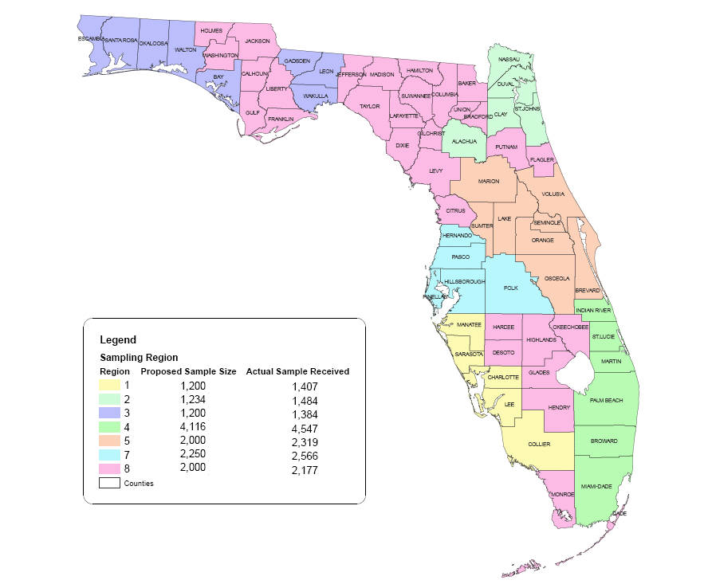

Table . Sampling Region Segmentation – ANOVA Results

|  |  |  |  |
| --- | --- | --- | --- |
| LEVEL | SAMPLING REGION | | |
| Purpose | Degrees of Freedom | F-Value | Hypothesis Result |
| HBW | 6 | 1.4 | Do Not Reject |
| HBSHOP | 6 | 6.4 | Reject |
| HBSOCREC | 6 | 6.7 | Reject |
| HBO | 6 | 4.4 | Reject |
| NHB | 6 | 4.3 | Reject |

### Urban Size Segmentation

The urban area segmentation is based on the distribution of population in the urban area. The urban size categories are derived from the NHTS to maintain a consistent definition between the data and analysis. Figure 1.3 shows the urban size distribution and Table 1.3 shows the sample size distribution by urban size. Based on the results of the analysis, except for the HBW trip purpose, there is a statistically significant difference across different urban size categories. Table 1.4 shows the results of the ANOVA analysis where the hypothesis is that there is no variability among areas of different urban sizes in terms of time of day distribution by purpose.

Table . Urban Size Segment – Sample Size

|  |  |  |  |  |  |
| --- | --- | --- | --- | --- | --- |
| Urban Size | HBW | HBSHOP | HBSOCREC | HBO | NHB |
| 50,000 to 199,999 | 1,040 | 3,402 | 1,913 | 2,532 | 4,063 |
| 200,000 to 499,999 | 1,307 | 3,993 | 2,445 | 2,995 | 4,538 |
| 500,000 to 999,999 | 709 | 2,271 | 1,462 | 1,812 | 2,467 |
| 1,000,000 or more (excluding Southeast Florida) | 1,603 | 4,469 | 2,813 | 3,785 | 4,958 |
| Southeast Florida | 2,496 | 6,898 | 4,527 | 6,217 | 8,043 |
| Not in an Urban Area | 2,598 | 7,927 | 5,035 | 5,973 | 10,364 |

Figure . Urban Size Segment

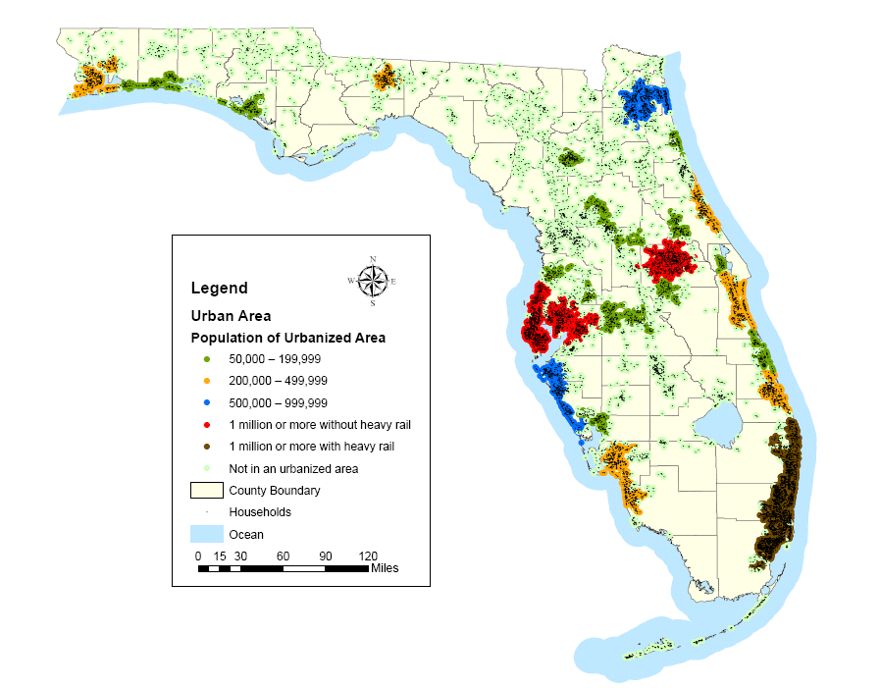

Table . Urban Size Segmentation – ANOVA Results

|  |  |  |  |
| --- | --- | --- | --- |
| LEVEL | URBAN SIZE | | |
| Purpose | Degrees of Freedom | F-Value | Hypothesis Result |
| HBW | 5 | 1.8 | Do Not Reject |
| HBSHOP | 5 | 12.2 | Reject |
| HBSOCREC | 5 | 4.3 | Reject |
| HBO | 5 | 4.0 | Reject* |
| NHB | 5 | 5.79 | Reject |
| HBW | 5 | 26.5 | Reject§ |

* 10% significance level

§ Kruskal-Wallis χ2 statistic

An additional ANOVA test was done to ensure that there are differences among all counties within each urban size category. The hypothesis tested here is that there is no variability between different counties within each urban size category. Table 1.5 shows the results of the ANOVA tests, confirming variability among counties by urban size except where the population is between 500,000 to 999,999.

Table . Urban Size Segmentation - Tests for Variability within Each Level

|  |  |  |  |
| --- | --- | --- | --- |
| Urban Size | Degrees of Freedom | F-Value | Hypothesis Result |
| 50,000 to 199,999 | 6 | 5.1 | Reject |
| 200,000 to 499,999 | 8 | 10.7 | Reject |
| 500,000 to 999,999 | 3 | 2.7 | Reject* |
| 1,000,000 or more without heavy rail | 4 | 5.8 | Reject* |
| 1,000,000 or more with heavy rail (Southeast Florida)  Not in an Urban Area | 2  38 | 26.5  5.6 | Reject  Reject§ |

* 10% Confidence Level

### Income Segmentation

The third segmentation tested was income segmentation. In this segmentation, the NHTS data were disaggregated into four reported household income categories – Annual Household Income less than $25,000, between $25,000 and $50,000, between $50,000 and $75,000, and more than $75,000. The annual household income is in 2007/2008 Dollars. The distribution of households was determined for each county in the state and the category with the highest distribution of households was allocated as the average household income for that county. After doing this analysis, only one county was assigned to the $50,000 to $75,000 bin, and so it was decided to combine the $25,000 to $50,000 and $50,000 to $75,000 category into one $25,000 to $75,000 category and all further testing was done at these three levels of income segmentation. Figure 1.4 shows the counties by their respective income categories. Table 1.6 shows the sample distribution by purpose for these three income categories.

Table . Income Segment – Sample Size

|  |  |  |  |  |  |
| --- | --- | --- | --- | --- | --- |
| Income | HBW | HBSHOP | HBSOCREC | HBO | NHB |
| Less than $25,000 | 1,541 | 3,312 | 1,262 | 2,446 | 3,843 |
| $25,000 to $75,000 | 2,291 | 6,119 | 2,249 | 3,732 | 6,678 |
| More than $75,000 | 5,107 | 10,902 | 4,386 | 7,460 | 12,290 |

Figure . Income Distribution by County

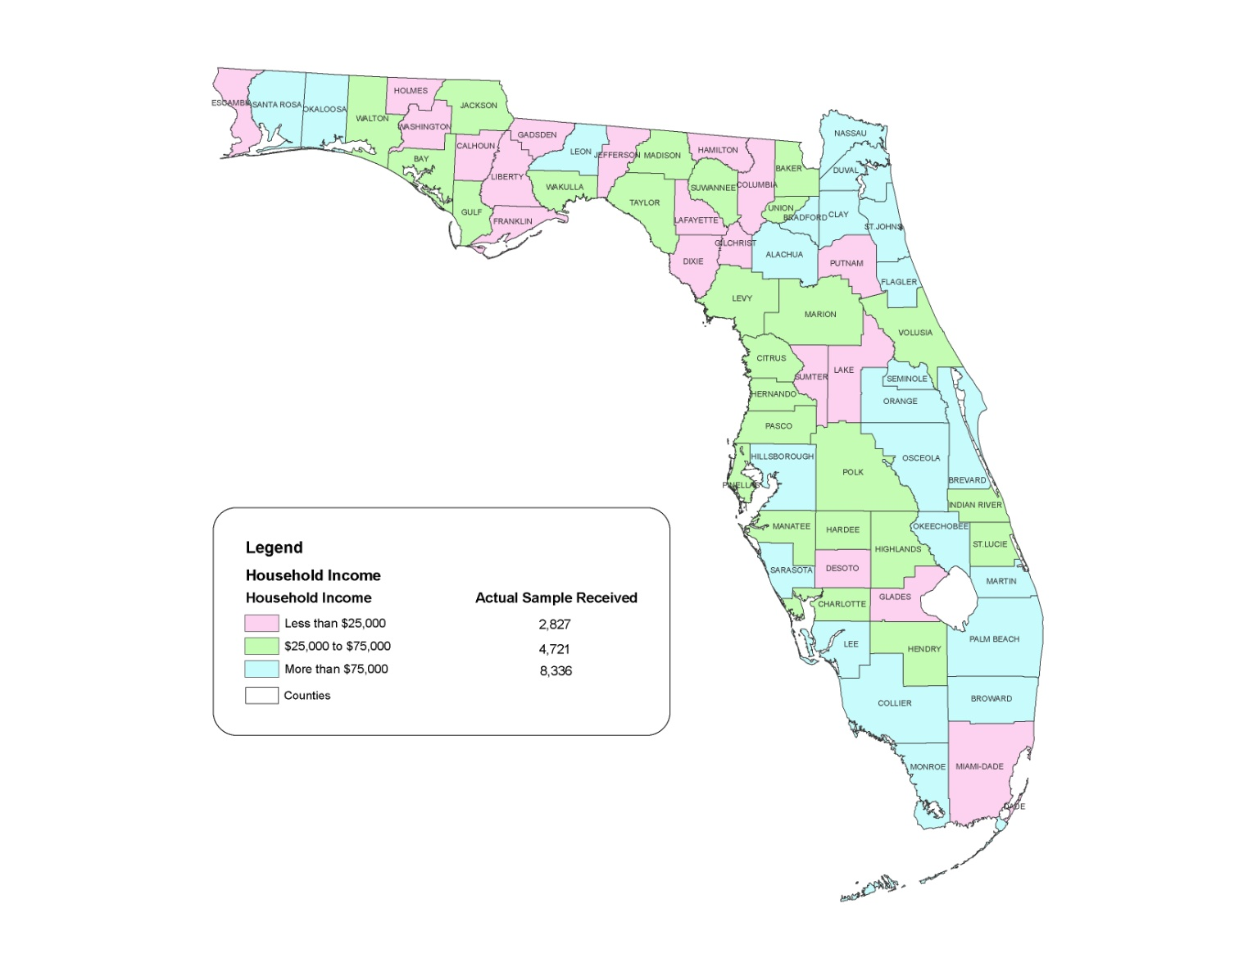

The ANOVA tests indicated, once again, that except for the HBW purpose, there is considerable variability among the different income segments. However, since the F-value from the ANOVA was not as severely degraded as for the other two segmentations it was decided to test it further using the non-parametric Kruskal-Wallis test for the HBW purpose. The results of this test indicated that the HBW also had variability among the income levels once the assumption that the midpoint of the travel time was normally distributed was relaxed. Table 1.7 shows the results of the ANOVA and Kruskal-Wallis test (HBW only) results.

Table . Income Segmentation – ANOVA Results

|  |  |  |  |
| --- | --- | --- | --- |
| LEVEL | INCOME | | |
| Purpose | Degrees of Freedom | F-Value | Hypothesis Result |
| HBW | 2 | 2.1 | Do Not Reject |
| HBSHOP | 2 | 20.3 | Reject |
| HBSOCREC | 2 | 25.8 | Reject |
| HBO | 2 | 10.6 | Reject |
| NHB | 2 | 6.2 | Reject |
| HBW* | 2 | 7.9 (Chi-square stats) | Reject |

An additional ANOVA test was done to ensure that there are differences among all counties within each income category. The hypothesis tested here is that there is no variability between different counties within each income level. Table 1.8 shows the results of the ANOVA tests, confirming variability among all counties by income category.

Table . Income Segmentation - Tests for Variability within Each Level

|  |  |  |  |
| --- | --- | --- | --- |
| Income | Degrees of Freedom | F-Value | Hypothesis Result |
| Less than $25,000 | 18 | 3.9 | Reject |
| $25,000 to $75,000 | 24 | 4.6 | Reject |
| More than $75,000 | 22 | 7.8 | Reject |

Based on this analysis, it is the recommendation of the project team that MPOs determine which income category they fall under and use the corresponding factors for time of day analysis. MPOs also have the option of using urban size segmentation to determine the time of day for their regions.

## Time Period Definition

The weighted trip records were sorted by time of day and aggregated into one hour increments within the morning (6:00 to 10:00) and afternoon (2:00 to 7:00) periods. This enabled calculation of the peak one, two, and three hour periods in the morning and afternoon. These are shown in Table 1.9.

In the morning, the 7 a.m. to 8 a.m. and the 8 a.m. to 9 a.m. periods have more travel than shoulders of 6 a.m. to 7 a.m. and 9 a.m. to 10 a.m. A two-hour peak period therefore makes sense. Thus the a.m. peak period is defined from 7:00 to 9:00. In the afternoon, the 3 p.m. to 5 p.m. period has less travel than the 5 p.m. to 6 p.m. hour but more than the hours of 2 p.m. to 3 p.m. and 6 p.m. to 7 p.m.. A three-hour peak period therefore makes sense. Thus the p.m. peak period is defined from 3:00 to 6:00 p.m. Figure 1.5 shows a diurnal distribution of weighted trips.

In addition, another consideration was to be consistent with the peak periods defined in the Florida DOT TOD Research Report. As a result of these, TOD factors were developed for the following time periods:

* Midnight to 7 a.m.;
* A.M. Peak – 7 a.m. to 9 a.m.;
* Mid-day – 9 a.m. to 3 p.m.;
* P.M. Peak – 3 p.m. to 6 p.m.; and
* 6 p.m. to Midnight.

Table . Morning and Afternoon Peak Periods

|  |  |  |
| --- | --- | --- |
|  | **AM PEAK** | |
| **Time Period** | **Daily Percent** | **Percent in Peak** |
| 6 AM - 7 AM | 3.8% | 16% |
| 7 AM - 8 AM | 7.7% | 33% |
| 8 AM - 9 AM | 6.9% | 29% |
| 9 AM - 10 AM | 5.0% | 22% |
|  | **PM PEAK** | |
| **Time Period** | **Daily Percent** | **Percent in Peak** |
| 2 PM - 3 PM | 7.1% | 18% |
| 3 PM - 4 PM | 7.9% | 20% |
| 4 PM - 5 PM | 7.8% | 20% |
| 5 PM - 6 PM | 8.7% | 22% |
| 6 PM - 7 PM | 7.0% | 18% |

Figure . Diurnal Distribution of Weighted Trips

MPOs looking to develop and define peak periods should take the planning context into consideration rather than just use the periods defined above. Some of the considerations include:

* Is there a need for more out of peak periods if congestion is not an issue beyond the peak periods, i.e. will only one or two off-peak periods suffice? Given the impact this selection of time periods will have on model run times it is necessary to consider the implications of more off-peak periods.
* Is transit available? If transit is available for certain time periods at night, then the night time period should be divided into periods when transit is available and when it is not.
* What do the data say? Data from traffic counts and other sources can be quite useful in determining the appropriate time periods for the area under analysis.
* Peak periods should be defined as the time period during which there is sufficient congestion to influence path choice. To the extent possible, transit operations should be considered as well (peak and off-peak headways).

## Time of Day Factors

The time of day factors were developed directly from the weighted NHTS survey data. Factors were developed for each of the five person trip purposes in the NHTS. For the four home based purposes, factors were developed for both directions: from home (production to attraction) and to home (attraction to production). These factors by income category and urban size are shown in Tables 1.10 and 1.11 respectively. Appendix A provides time of day factors for each hour by income category and direction as well as urban size and direction. The data from Appendix A can be used to aggregate to the required period and obtain time of day factors by specific period.

In order to apply these factors after trip generation, it is necessary to determine the total time of day factor by purpose (summing the directional factors). This process factors the daily trip productions and attractions by purpose to produce trip end estimates by purpose for each time period. These estimates are then used as inputs to time period specific trip distribution and mode choice models. Calibration and validation of these model components should be done for each time period and are discussed in detail further in Chapter 3.0.

Many FSUTMS models use peak period level-of-service characteristics (travel times and costs) for trip distribution and mode choice analysis of home-based work trips and off-peak characteristics for non-work trips. However, there are trips of all purposes during each of these periods. In some models, a pre-trip distribution time of day model was developed. In this technique, the trip ends are split by time period for each trip purpose.

The time of day approach used in these applications is a two-step process. The initial step is the pre-trip distribution model, in which a set of factors is used to calculate trips by time of day, usually for multi-hour peak and off-peak periods, and by trip purpose. These factors are applied to the trip ends from the trip generation model and produce trip ends by peak and off-peak periods for each of the trip purposes.

The peak and off-peak trip ends are then used in the trip distribution model, with the resulting trip tables used in the mode choice models. The resulting trip tables, by mode and time of day, are then factored in the second, or final, time of day model. The user can specify the time period desired and factors based on trip purposes and mode are applied to produce the desired trip tables, usually representing peak and off-peak hours rather than multi-hour periods.

In some applications of this approach, peak network characteristics (e.g., travel times) are used for work mode choice, and off-peak characteristics are used for non-work mode choice. The advantage of this approach is that the time of day factoring is done (by purpose) for trips on all modes together, reflecting only the influence of activity patterns throughout the day. As result, the time of day factors are likely to be reasonably stable over time and across alternatives.

Table . Time of Day Factors – Income Segmentation

|  |  |  |  |  |  |  |  |
| --- | --- | --- | --- | --- | --- | --- | --- |
| **Segment - Household Income Less than $25,000** | | | | | | | |
| **Purpose** | **Number of Trips** | **Direction** | **Midnight to 7 AM** | **7 AM to 9 AM** | **9 AM to 3 PM** | **3 PM to 6 PM** | **6 PM to Midnight** |
| HBW | 1,575 | From Home | 12.3% | 27.5% | 10.8% | 2.7% | 1.3% |
| To Home | 1.3% | 0.6% | 5.1% | 22.7% | 15.8% |
| HBSHOP | 3,140 | From Home | 1.3% | 5.0% | 20.2% | 6.9% | 10.8% |
| To Home | 0.6% | 1.9% | 21.5% | 12.3% | 19.6% |
| HBSOCREC | 1,943 | From Home | 2.2% | 4.8% | 10.2% | 14.8% | 19.5% |
| To Home | 2.3% | 1.7% | 7.6% | 10.4% | 26.6% |
| HBO | 3,425 | From Home | 4.8% | 20.2% | 15.2% | 5.5% | 6.4% |
| To Home | 1.0% | 2.9% | 15.3% | 16.7% | 12.1% |
| NHB | 4,358 |  | 2.6% | 11.4% | 46.0% | 24.4% | 15.7% |
| **Segment - Household Income between $25,000 and $75,000** | | | | | | | |
| **Purpose** | **Number of Trips** | **Direction** | **Midnight to 7 AM** | **7 AM to 9 AM** | **9 AM to 3 PM** | **3 PM to 6 PM** | **6 PM to Midnight** |
| HBW | 2,268 | From Home | 16.4% | 23.6% | 9.8% | 3.2% | 0.6% |
| To Home | 0.4% | 0.5% | 7.4% | 26.8% | 11.2% |
| HBSHOP | 6,001 | From Home | 1.1% | 4.8% | 22.7% | 9.3% | 6.6% |
| To Home | 0.4% | 1.6% | 23.3% | 15.5% | 14.9% |
| HBSOCREC | 3,619 | From Home | 1.9% | 5.6% | 16.1% | 12.6% | 14.7% |
| To Home | 1.4% | 2.1% | 11.1% | 10.6% | 23.9% |
| HBO | 4,785 | From Home | 6.0% | 18.2% | 16.0% | 8.0% | 5.2% |
| To Home | 0.5% | 3.4% | 16.4% | 17.3% | 9.1% |
| NHB | 7,556 |  | 2.40% | 9.0% | 52.7% | 23.2% | 12.7% |

**Table 1.10 Time of Day Factors – Income Segmentation (Continued)**

|  |  |  |  |  |  |  |  |
| --- | --- | --- | --- | --- | --- | --- | --- |
| **Segment - Household Income More than $75,000** | | | | | | | |
| **Purpose** | **Number of Trips** | **Direction** | **Midnight to 7 AM** | **7 AM to 9 AM** | **9 AM to 3 PM** | **3 PM to 6 PM** | **6 PM to Midnight** |
| HBW | 4,981 | From Home | 15.1% | 24.5% | 11.4% | 2.9% | 1.1% |
| To Home | 0.6% | 0.3% | 7.4% | 24.2% | 12.6% |
| HBSHOP | 10,043 | From Home | 1.5% | 3.8% | 20.8% | 8.9% | 8.2% |
| To Home | 0.2% | 1.3% | 21.7% | 15.7% | 18.0% |
| HBSOCREC | 6,550 | From Home | 3.7% | 5.5% | 15.9% | 11.5% | 12.9% |
| To Home | 2.3% | 2.8% | 11.5% | 12.0% | 22.0% |
| HBO | 10,088 | From Home | 5.7% | 21.3% | 14.1% | 7.2% | 5.2% |
| To Home | 1.0% | 4.2% | 14.0% | 17.7% | 9.7% |
| NHB | 13,742 |  | 2.8% | 9.8% | 49.3% | 23.9% | 14.3% |

Table . Time of Day Factors – Urban Size Segmentation

|  |  |  |  |  |  |  |  |
| --- | --- | --- | --- | --- | --- | --- | --- |
| **Segment – Urban Population 50,000 to 199,999** | | | | | | | |
| **Purpose** | **Number of Trips** | **Direction** | **Midnight to 7 AM** | **7 AM to 9 AM** | **9 AM to 3 PM** | **3 PM to 6 PM** | **6 PM to Midnight** |
| HBW | 876 | From Home | 16.4% | 20.9% | 12.5% | 2.8% | 0.8% |
| To Home | 0.2% | 0.2% | 7.6% | 27.2% | 11.5% |
| HBSHOP | 1,720 | From Home | 1.6% | 4.6% | 22.8% | 10.4% | 4.0% |
| To Home | 0.3% | 1.7% | 24.0% | 15.7% | 14.9% |
| HBSOCREC | 1,123 | From Home | 3.2% | 6.5% | 15.3% | 14.2% | 12.6% |
| To Home | 1.2% | 3.4% | 11.2% | 10.0% | 22.4% |
| HBO | 1,605 | From Home | 6.1% | 21.3% | 11.4% | 9.3% | 5.8% |
| To Home | 0.6% | 3.6% | 15.9% | 17.1% | 8.9% |
| NHB | 2,543 |  | 3.2% | 9.4% | 52.2% | 21.0% | 14.3% |
| **Segment - Urban Population 200,000 to 499,999** | | | | | | | |
| **Purpose** | **Number of Trips** | **Direction** | **Midnight to 7 AM** | **7 AM to 9 AM** | **9 AM to 3 PM** | **3 PM to 6 PM** | **6 PM to Midnight** |
| HBW | 1,530 | From Home | 16.5% | 26.5% | 9.2% | 2.3% | 0.6% |
| To Home | 0.9% | 0.4% | 7.2% | 25.0% | 11.5% |
| HBSHOP | 3,710 | From Home | 1.4% | 3.9% | 21.9% | 9.6% | 8.4% |
| To Home | 0.5% | 1.2% | 21.3% | 14.6% | 17.3% |
| HBSOCREC | 2,178 | From Home | 2.6% | 6.6% | 14.5% | 14.0% | 12.0% |
| To Home | 1.9% | 2.6% | 11.1% | 13.1% | 21.6% |
| HBO | 3,223 | From Home | 5.9% | 20.8% | 14.5% | 7.2% | 3.9% |
| To Home | 0.6% | 3.9% | 15.6% | 17.9% | 9.7% |
| NHB | 4,872 |  | 3.0% | 9.1% | 50.6% | 26.1% | 11.3% |

**Table 1.11 Time of Day Factors – Urban Size Segmentation (Continued)**

|  |  |  |  |  |  |  |  |
| --- | --- | --- | --- | --- | --- | --- | --- |
| **Segment – Urban Population 500,000 to 999,999** | | | | | | | |
| **Purpose** | **Number of Trips** | **Direction** | **Midnight to 7 AM** | **7 AM to 9 AM** | **9 AM to 3 PM** | **3 PM to 6 PM** | **6 PM to Midnight** |
| HBW | 762 | From Home | 18.3% | 23.0% | 8.1% | 2.6% | 1.8% |
| To Home | 0.1% | 0.3% | 5.2% | 28.1% | 12.5% |
| HBSHOP | 1,757 | From Home | 1.6% | 3.0% | 22.0% | 8.0% | 9.8% |
| To Home | 0.1% | 1.3% | 23.8% | 12.2% | 18.3% |
| HBSOCREC | 1,176 | From Home | 3.2% | 5.4% | 19.0% | 11.1% | 12.4% |
| To Home | 1.2% | 1.9% | 11.7% | 13.9% | 20.2% |
| HBO | 1,527 | From Home | 7.7% | 18.6% | 16.6% | 6.0% | 4.7% |
| To Home | 0.9% | 4.7% | 14.4% | 17.9% | 8.7% |
| NHB | 2,185 |  | 3.2% | 8.7% | 50.2% | 24.3% | 13.6% |
| **Segment - Urban Population More than 1,000,000 without Heavy Rail** | | | | | | | |
| **Purpose** | **Number of Trips** | **Direction** | **Midnight to 7 AM** | **7 AM to 9 AM** | **9 AM to 3 PM** | **3 PM to 6 PM** | **6 PM to Midnight** |
| HBW | 1,693 | From Home | 13.7% | 24.6% | 12.3% | 3.1% | 1.4% |
| To Home | 0.8% | 0.3% | 8.5% | 23.3% | 12.0% |
| HBSHOP | 3,338 | From Home | 1.0% | 4.5% | 19.8% | 9.3% | 8.2% |
| To Home | 0.3% | 1.3% | 20.8% | 16.9% | 18.0% |
| HBSOCREC | 2,241 | From Home | 4.1% | 4.6% | 14.7% | 11.6% | 13.5% |
| To Home | 2.6% | 2.1% | 12.0% | 10.1% | 24.8% |
| HBO | 3,423 | From Home | 5.9% | 20.4% | 13.7% | 7.8% | 6.2% |
| To Home | 1.1% | 3.8% | 13.3% | 17.7% | 10.1% |
| NHB | 4,327 |  | 2.2% | 9.7% | 48.4% | 22.9% | 16.9% |

**Table 1.11 Time of Day Factors – Urban Size Segmentation (Continued)**

|  |  |  |  |  |  |  |  |
| --- | --- | --- | --- | --- | --- | --- | --- |
| **Segment – Urban Population More than 1,000,000 with Heavy Rail (Southeast Florida)** | | | | | | | |
| **Purpose** | **Number of Trips** | **Direction** | **Midnight to 7 AM** | **7 AM to 9 AM** | **9 AM to 3 PM** | **3 PM to 6 PM** | **6 PM to Midnight** |
| HBW | 2,327 | From Home | 11.8% | 27.3% | 11.5% | 2.9% | 0.9% |
| To Home | 1.0% | 0.5% | 5.7% | 23.3% | 15.1% |
| HBSHOP | 4,561 | From Home | 1.3% | 4.8% | 20.0% | 7.2% | 10.3% |
| To Home | 0.3% | 1.8% | 21.6% | 14.2% | 18.5% |
| HBSOCREC | 3,048 | From Home | 2.7% | 4.9% | 12.2% | 12.3% | 18.4% |
| To Home | 2.7% | 2.4% | 8.5% | 11.0% | 25.0% |
| HBO | 5,178 | From Home | 4.4% | 21.1% | 14.8% | 5.9% | 6.2% |
| To Home | 1.1% | 3.5% | 14.6% | 16.7% | 11.6% |
| NHB | 6,095 |  | 2.5% | 11.3% | 46.8% | 23.9% | 15.4% |
| **Segment – Not in an Urban Area** | | | | | | | |
| **Purpose** | **Number of Trips** | **Direction** | **Midnight to 7 AM** | **7 AM to 9 AM** | **9 AM to 3 PM** | **3 PM to 6 PM** | **6 PM to Midnight** |
| HBW | 1,636 | From Home | 18.8% | 21.3% | 10.0% | 3.9% | 0.9% |
| To Home | 0.4% | 0.6% | 7.0% | 24.4% | 12.6% |
| HBSHOP | 4,098 | From Home | 1.8% | 4.5% | 23.1% | 8.2% | 5.5% |
| To Home | 0.4% | 1.8% | 23.2% | 15.5% | 16.0% |
| HBSOCREC | 2,346 | From Home | 1.4% | 5.8% | 17.9% | 11.7% | 15.2% |
| To Home | 1.5% | 2.1% | 11.1% | 10.5% | 22.7% |
| HBO | 3,342 | From Home | 5.6% | 18.4% | 18.2% | 7.0% | 4.4% |
| To Home | 0.6% | 3.5% | 16.5% | 17.4% | 8.4% |
| NHB | 5,634 |  | 2.5% | 9.5% | 52.7% | 23.8% | 11.5% |

## CONFAC Development

Because network capacities are expressed in vehicles per hour (per lane) and travel demand levels vary within the peak periods, it is necessary to develop period conversion factors, or CONFACs. These factors represent the ratio of the demand during the peak hour of travel to the entire period of travel for each peak and off-peak period and are used in the highway assignment process. For each period, the hourly capacity is divided by this factor to develop an effective capacity for the period.

The period conversion factors for the five time periods are shown in Tables 1.12 and 1.13 for income and urban size respectively. These factors were derived by dividing the number of (weighted) trips from the household survey occurring in the peak hour within the period by the number of trips in the period. The factor of 0.51 for the a.m. peak period means that about 51% of the travel demand during the two-hour a.m. peak period occurs during the peak hour. Similarly, the factor of 0.379 for the p.m. peak period means that about 38% of the travel demand during the three-hour p.m. peak period occurs during the peak hour. Appendix B shows the hourly distribution of travel by income and urban size and can potentially be used to develop CONFACs for specific regions with time periods and peaking characteristics that are defined differently.

Table . CONFAC by Household Income Segment

|  |  |  |  |
| --- | --- | --- | --- |
|  | **Income Segmentation** | | |
| **Time Period** | **Less than $25,000** | **$25,000 to $75,000** | **More than $75,000** |
| Midnight to 7 AM | 0.666 | 0.765 | 0.673 |
| 7 AM to 9 AM | 0.526 | 0.514 | 0.537 |
| 9 AM to 3 PM | 0.192 | 0.188 | 0.203 |
| 3 PM to 6 PM | 0.372 | 0.352 | 0.356 |
| 6 PM to Midnight | 0.320 | 0.343 | 0.373 |

Table . CONFAC by Urban Size Segment

|  |  |  |  |  |  |  |
| --- | --- | --- | --- | --- | --- | --- |
|  | **Urban Size Segmentation** | | | | | |
| **Time Period** | **50,000 to 199,999** | **200,000 to 499,999** | **500,000 to 999,999** | **1,000,000 or more without heavy rail** | **1,000,000 or more with heavy rail (Southeast Florida)** | **Not in an Urban Area** |
| Midnight to 7 AM | 0.734 | 0.680 | 0.675 | 0.680 | 0.683 | 0.733 |
| 7 AM to 9 AM | 0.581 | 0.536 | 0.506 | 0.519 | 0.531 | 0.518 |
| 9 AM to 3 PM | 0.194 | 0.194 | 0.220 | 0.196 | 0.202 | 0.184 |
| 3 PM to 6 PM | 0.401 | 0.341 | 0.360 | 0.366 | 0.369 | 0.349 |
| 6 PM to Midnight | 0.342 | 0.402 | 0.386 | 0.358 | 0.321 | 0.355 |

## Guidance For Using Time Of Day Factors

The following procedure for using the time of day factors developed in this report assumes that the region does not have a recent household survey and is therefore relying on the NHTS data to develop time of day factors. The steps to use these time of day factors are as follows:

* Step 1 – Determine the hourly distribution of traffic in the model region.
* Step 2 – Determine the peak (a.m. and/or p.m.) periods which show a distinctive peaking in the traffic distribution. For example, in Figure 1.5 the a.m. peak period is between 6 to 9 a.m. and the p.m. peak period is between 3 to 6 p.m.
* Step 3 – Determine the characteristics of the model area (either using the income or urban size segmentations).
* Step 4 – Once the peak period and the characteristics of the model region are known, refer to Appendix A to develop the time of day factors for the specific peak period and Appendix B to develop the relevant CONFACs.

# Incorporating Time of Day into Transit Modeling

Transit modeling includes the components of transit network and path building, mode choice, and route choice (transit assignment). Each of these components depends on the process of building transit paths from origins to destinations. Other model components such as trip distribution may indirectly reflect transit level of service (for example, through the use of mode choice logsum variables).

This chapter discusses how transit considerations affect time of day models and how such models can be structured to account for these considerations. The following topics are discussed: the domination of data sets by auto travel, defining time periods for analysis, and transit network and path building considerations.

## Domination of Data Sets by Auto Travel

Time of day modeling is often dominated by auto travel considerations. Time of day model parameters are generally estimated from household travel survey data sets, in which a large majority of trip records represent auto trips. This means that the parameters of time of day models applied to trips of all modes are nearly the same as the parameters that would be estimated for a model dealing only with auto trips. Traffic count data are a key source for developing and validating time of day models and of course include only vehicle travel.

The effects of using parameters that are effectively for auto travel in time of day models applied to transit trips can be understood by examining differences in peaking for auto and transit demand in the same region. Table 2.1 shows a comparison of separate auto and transit trip percentages of trips by purpose and direction for four U.S. urban areas, including two areas in Florida, using data from the 1990s. While overall peaking patterns for auto and transit show some similarity, there are a few significant differences. Morning peak transit travel is a higher percentage of daily home based work travel than for auto trips, at least in the peak direction. The percentage of home based non-work travel occurring in the both peak periods is higher for auto than for transit, more so for the a.m. peak period. The same is true for non-home based travel in the a.m. peak period.

The simplest way of addressing these discrepancies would be to apply the time of day model after mode choice, using different sets of parameters for auto and transit travel (and perhaps for submodes of auto and transit, if sufficient data were available for estimation). However, this may lead to inconsistencies between the transit path building for mode choice and transit assignment. For example, say there is a corridor whose only available transit service is express bus that operates only during peak periods. The mode choice model, applied to daily trips, would estimate some transit trips for the corridor based on the presence of the express bus service. If, say, a fixed set of factors converting daily trips to trips by time period is used, the application of the factors will result in some off-peak trips in the corridor, which the transit assignment process will be unable to assign since there is no off-peak transit service. This problem would occur even if there were separate time of day factors for auto and transit trips.

Table . Transit and Auto Percentages of Travel by Time of Day for Four U.S. Urban Areas

|  |  |  |  |  |  |  |  |  |
| --- | --- | --- | --- | --- | --- | --- | --- | --- |
|  | **Transit Factors** | | | | **Auto Factors** | | | |
| **A.M. Peak** | **Jacksonville** | **Portland** | **Sacramento** | **Tampa** | **Jacksonville** | **Portland** | **Sacramento** | **Tampa** |
|  |  |  |  |  |  |  |  |  |
| **HBW H-W** | 21.60% | 31.80% | 40.60% | 22.10% | 28.70% | 25.10% | 27.00% | 22.50% |
| **HBW W-H** | 0.00% | 0.30% | 0.00% | 0.80% | 1.00% | 0.60% | 1.00% | 1.20% |
|  |  |  |  |  |  |  |  |  |
| **HBNW H-O** | 3.10% | 1.40% | 10.80% | 3.80% | 8.70% | 5.10% | 8.20% | 8.90% |
| **HBNW O-H** | 0.00% | 0.00% | 0.00% | 0.80% | 1.80% | 1.80% | 1.60% | 1.60% |
|  |  |  |  |  |  |  |  |  |
| **NHB** | 3.10% | 0.00% | 33.50% | 4.50% | 8.30% | 4.20% | 6.40% | 7.70% |
|  |  |  |  |  |  |  |  |  |
| **P.M. Peak** | **Jacksonville** | **Portland** | **Sacramento** | **Tampa** | **Jacksonville** | **Portland** | **Sacramento** | **Tampa** |
|  |  |  |  |  |  |  |  |  |
| **HBW H-W** | 0.70% | 1.20% | 0.00% | 1.00% | 1.50% | 3.20% | 3.20% | 2.50% |
| **HBW W-H** | 27.50% | 35.00% | 46.50% | 29.50% | 27.30% | 33.00% | 26.30% | 28.10% |
|  |  |  |  |  |  |  |  |  |
| **HBNW H-O** | 6.90% | 6.50% | 15.40% | 7.60% | 8.40% | 9.30% | 8.90% | 9.10% |
| **HBNW O-H** | 9.60% | 10.80% | 17.60% | 11.10% | 12.60% | 14.90% | 13.00% | 14.80% |
|  |  |  |  |  |  |  |  |  |
| **NHB** | 13.80% | 26.50% | 14.60% | 15.70% | 22.60% | 11.50% | 23.70% | 12.90% |

Source: Cambridge Systematics, Inc. Time of Day Modeling Process for Jacksonville. Prepared for the Jacksonville Transportation Authority, March 2000.

This issue is why several time of day modeling studies for FDOT have recommended applying time of day models prior to mode choice, either between trip generation and trip distribution or between trip distribution and mode choice.

It should also be noted that percentages such as those shown in Table 2.1 that are derived from household survey data may be based on limited data for transit trips, especially for non-work travel. It is likely that at least some of the differences between the transit and auto percentages are not statistically different.

This leads to the question of whether to use transit rider survey data for developing time of day model parameters. Sample size is not an issue for transit rider surveys, which may feature thousands of records, all of which represent transit trips. However, trips in transit rider surveys are not sampled randomly with respect to time of day. Due to logistical and budgetary concerns in conducting the survey, sampled trips are clustered by route and time of day (for example, surveys may be conducted only between 7:00 a.m. and 7:00 p.m.). Transit rider survey data may, of course, be weighted using transit ridership data segmented by time of day, but caution should be exercised to address survey biases related to responses and sampling. (The use of transit ridership data by time of day is discussed below.)

## Defining time periods for analysis

Typically, peak periods are defined based on total travel demand by all modes. While this practice is probably adequate for the auto trips that constitute the vast majority of travel demand, it may prove problematic for planning analyses involving transit. It may also result in inaccuracies in transit demand estimation. The transit level of service may vary significantly within a defined time period, especially a longer off-peak period (where service may cease entirely for the overnight period). Transit demand may also peak differently than auto travel demand.

In areas where transit planning by time of day is important, two considerations should help guide the definition of the time periods into which the travel day is divided:

* *How transit level of service varies during the day*. When does service become more or less frequent? During what hours do certain services, such as express services, operate? Does transit service stop altogether overnight? If so, for which hours? Do fares vary by time of day?
* *How demand varies across the day*.

It is relatively easy to answer the questions posed above regarding level of service using schedule information from transit providers. Many providers specifically define peak periods during which more frequent service is provided. In some cases, fares for peak service may be higher than for off-peak service. If possible, it makes sense to define peak periods for the time of day model to coincide as closely as possible with those used by the transit providers. It may also make sense to define as a separate period the overnight time when no service is provided. While there is a cost in model run time to have an additional period, the cost to include an overnight period is much lower than the incremental cost of adding another time period during the day, since:

* There would be no need to perform transit network skims for the overnight period;
* The mode choice application itself would be greatly simplified with transit modes being unavailable (mode choice might be able to be skipped entirely for this period); and
* Overnight demand is relatively low, meaning highway assignments would rapidly converge.

Regarding demand, it would be expected to vary by time of day in a similar manner to the level of service since transit operators design their service plans to meet demand. Ridership data can be used to determine whether peak transit demand occurs at times similar to peak auto demand and peak transit supply (level of service).

## Transit network and path building considerations

Since network skims are required for each defined time period, a particular transit network must be associated with each period. The question is whether a single transit network could be used for multiple periods. For example, consider a case where the time of day model divides daily demand into five periods: a.m. peak, mid-day, p.m. peak, evening, and overnight. If levels of service are similar between the two periods, it might be possible to use the same transit network and skims for the mid-day and evening periods, and perhaps also for the overnight period if transit service exists in that period (if not, then no transit network or skims are needed for the overnight).

It might save significant resources if the same peak transit network could be used for the a.m. and p.m. peak periods. This would presume a symmetric transit operating plan with similar levels of service for both peak periods. If the transit service has substantial asymmetry, then separate a.m. and p.m. peak networks will be needed.

However, another issue arises with assumptions of symmetry if transit with auto access (park-and-ride, kiss-and ride) is included in the model. For such trips, the auto access or egress is assumed to be at the home end of each trip, which might be either the origin or the destination end. If someone is leaving home on such a trip, he or she is assumed to drive/ride *to* the transit stop; if he or she is returning home, he or she is assumed to be driving/riding home *from* the transit stop or station. Generally, there are more trips leaving home in the morning and more trips returning home in the afternoon and evening, and so there can be substantial asymmetry during peak periods and even off-peak periods. In the five period example presented above, it might be the case that essentially all auto access transit trips in the a.m. peak period are coming from home, and all trips in the evening period are returning home, but there are likely trips in both directions in the mid-day and p.m. peak periods. In this case, using the same network and skims for the a.m. and p.m. peak periods might produce significant inaccuracy in model results for auto access transit trips.

The question then arises is whether this problem of auto access goes away if the transit trips are assigned in a P->A format. However, it does not make sense to assign trips in P->A format for peak periods. To illustrate the problem, consider a trip from work in zone A to home in zone B in the p.m. peak period using express bus with park-and-ride. The trip would travel from zone A to the park-and-ride lot via express bus and from the lot to home in zone B by car. If the skim for this trip is used in P->A format, the in-vehicle time would be from B to A, which in a peak period could be significantly different from the time from A to B, the actual direction of the trip. Unlike daily trips, travel in periods where travel times by direction can be significantly different cannot be modeled in the opposite direction.

The issue of producing transit auto egress skims for trips returning home may be problematic depending on the capabilities of the modeling software. Some software can perform skims only for auto access trips, not auto egress. Even if the software can perform auto egress skims, the potential to require both auto access and auto egress skims for some time periods could add a substantial amount of run time to the model. In cases where there is little demand for transit with auto access/egress, the cost of performing these additional skims might not be worth the benefit in terms of model accuracy. In some cases, the oversimplification of assuming all auto access in the morning and all auto egress in the afternoon/evening has been made.

# Validating Time of Day Models

Three important considerations in validating models with time of day components are:

* Validating the time of day modeling component itself;
* Validation of highway assignment results would not be limited to daily volumes, but also will include volumes for each time period; and
* Validation of other model components, such as trip distribution and mode choice, whose outputs are segmented by time period. For example, highway assignment results would not be limited to daily volumes, but also will include volumes for each time period.

## Validating the Time of Day Modeling Component

The validation of the time of day model component itself includes reasonableness checks of the model parameters and of the results of the application. For the method used in Phase 1 of this project, which uses fixed factors representing applied to daily trips, the parameters are the factors themselves, which represent the percentages of daily trips by purpose occurring in each time period, and by direction for home based trips. These factors generally are estimated from household survey data, either the NHTS data set or local survey data. Perhaps the best reasonableness check is to compare the factors by trip purpose to factors used in a variety of other urban areas. Table 3.1 shows example factors from a variety of U.S. urban areas circa 2001. Keeping in mind that temporal patterns of travel can vary greatly from place to place, consideration of a wide range of areas to which the local factors can be compared is a good idea. The modeler should consider unique characteristics of the modeled area in determining what is reasonable compared to other regions.

Sensitivity tests are generally not relevant for fixed factor models. Since the factors are fixed (i.e., they are the same for any base or forecast year scenario), the model is by definition insensitive to the changes that might occur in travel demand or transportation supply.

While it is ideal to have sources of data to use for model validation that are independent of the model estimation data, such data are often unavailable for the validation of the factors themselves. Checks using independent data sources may have to wait until other model components are validated. For example, traffic count data by time of day constitute an independent data source, but these data can be used only for validation after highway assignment has been run. This process is described in the next section.

The models that are planned for Phase 2 of this project (and are presented in Task 2 of Phase 1) are time of day choice models. The parameters of these models will be different, and therefore the reasonableness checks will be different. Since there are relatively few time of day choice models that have been implemented in the context of four-step travel demand models such as the FSUTMS family of models, there is relatively little information from other models to use for comparison to the estimated model parameters. However, the resultant percentages of trips by purpose and direction for each time period could be compared to percentages derived from survey data.

Key validation checks for time of day choice models will also include sensitivity checks. The model can be run for a variety of base and forecast year scenarios, and the differences in results between scenarios checked for reasonableness. For example, the model could be run for a base year and a forecast year scenario, and the resulting percentages of trips by purpose and time period compared between the two scenarios. If the forecast year scenario includes significant growth from the base year, then one might expect some peak spreading and the peak percentages to be lower than in the base year scenario.

The time of day model would typically be applied between trip generation and trip distribution, or between trip distribution and mode choice. Model components applied subsequent to time of day would therefore be run for each time period. This implies that validation of these components should include consideration of time of day. Further, in addition to demand, peak period and peak hour speeds are highly influenced by volume-delay assumptions and capacity.

## Validating Highway Assignment

Perhaps the largest validation effort involves the highway assignment step. Highway assignment validation generally consists of vehicle miles traveled (VMT) checks, such as comparisons of modeled to observed VMT by facility type, geographic subregion, etc.; volume checks, such as screenline comparisons and percentage root mean square error (RMSE) calculations between modeled volumes and traffic counts for groups of links; and speed checks (where observed speed data are available). These are fairly straightforward checks for daily volumes although the issues that may be revealed through these checks often require calibration of other model steps such as trip generation or trip distribution.

When time of day modeling is used, the outputs of highway assignment are link volumes and speeds/travel times for each time period. The sum of the modeled volumes on each link for the time periods represents the modeled daily volume. There are no average daily speeds estimated by such a model, but daily speeds do not represent anything that can easily be compared to observed data. If observed speed data are available, they may more readily be used to compare to modeled speeds by time period.

The modeled daily volumes are important outputs even in a model that considers time of day. They provide a measure of whether the model as a whole has the “right” amount of travel demand, and they may be used to provide measures of overall travel such as daily VMT that may be compared among project or policy alternatives (for example, computing the reduction in VMT resulting from an alternative land use pattern or a congestion pricing scheme). Volumes throughout the day are also needed for air quality analysis. It therefore makes sense to validate the modeled daily volumes as well as those by time period.

Hence, it is recommended that the first checks involving VMT and volumes be performed at the daily level, i.e. for the sums of the modeled time period volumes. The desired validation checks—such as VMT checks, screenlines, percentage RMSE, etc.—would be performed using the modeled daily (summed time period) volumes and daily traffic counts. Speed related checks would not be performed at the daily level.

Once the model has been adequately validated and calibrated (including calibration changes to other model components) at the daily level, validation for the individual time periods may be performed. Essentially, the same volume and VMT checks done at the daily level can be performed for the a.m. and p.m. peak periods using traffic count data separated into the same time periods as defined by the model. (It should be noted that in some locations traffic counts by time of day may not be available.) Either total volumes/VMT or percentages of daily volumes/VMT may be compared. Calibration actions to address any issues identified during the time period validation may include adjustments to the time of day model parameters.

It should be noted that statistics such as percentage differences between modeled and observed volumes/VMT and percentage RMSE may track higher than daily differences due to the lower values for the numbers from which percentage differences are computed. Most published validation thresholds and guidelines, such as those published by FDOT[4], apply to daily model results.

As discussed above, speed checks should be performed at the time period level. Modeled speeds for each time period may be compared to observed speeds for the corresponding periods at the link, corridor, and regional levels.

Table . Percentages of Travel by Time of Day for Eight U.S. Urban Areas

|  |  |  |  |  |  |  |  |  |  |
| --- | --- | --- | --- | --- | --- | --- | --- | --- | --- |
| **A.M. Peak (7 to 9 AM)** | **Denver** | **Jacksonville** | **Miami** | **Philadelphia** | **Portland** | **Sacramento** | **Salt Lake** | **Tampa** | **Avg.** |
| HBW |  |  |  |  |  |  |  |  |  |
| H-W | 33.80% | 28.90% | 23.30% | 33.00% | 25.10% | 27.00% | 24.50% | 26.60% | 27.80% |
| W-H | 0.30% | 1.00% | 1.10% | 0.90% | 0.60% | 1.00% | 0.70% | 1.10% | 0.80% |
| HBO |  |  |  |  |  |  |  |  |  |
| H-O | 7.70% | 8.60% | 8.50% | 14.80% | 5.10% | 8.20% | 10.20% | 11.90% | 9.40% |
| O-H | 0.70% | 1.80% | 1.40% | 1.00% | 1.80% | 1.60% | 1.50% | 1.70% | 1.40% |
|  |  |  |  |  |  |  |  |  |  |
| NHB | 2.70% | 8.20% | 5.60% | 8.50% | 4.20% | 6.40% | 5.10% | 9.10% | 6.20% |
|  |  |  |  |  |  |  |  |  |  |
| **P.M. Peak (3:00-6:00)** | **Denver** | **Jacksonville** | **Miami** | **Philadelphia** | **Portland** | **Sacramento** | **Salt Lake** | **Tampa** | **Avg.** |
| HBW |  |  |  |  |  |  |  |  |  |
| H-W | 3.00% | 1.40% | 1.60% | 2.40% | 3.10% | 3.20% | 2.00% | 2.80% | 2.40% |
| W-H | 27.30% | 27.00% | 24.90% | 30.20% | 32.30% | 26.30% | 28.00% | 25.40% | 27.70% |
| HBO |  |  |  |  |  |  |  |  |  |
| H-O | 10.60% | 8.50% | 10.80% | 8.80% | 9.10% | 8.90% | 9.70% | 9.00% | 9.40% |
| O-H | 12.90% | 12.80% | 10.80% | 15.40% | 14.50% | 13.00% | 15.80% | 13.60% | 13.60% |
|  |  |  |  |  |  |  |  |  |  |
| NHB | 24.20% | 22.60% | 16.00% | 20.00% | 22.50% | 23.70% | 26.00% | 24.90% | 22.50% |

Source: Rossi, Thomas F. Recent Experience with Time of Day Modeling. Proceedings of the Eight National Conference on the Application of Transportation Planning Methods, Corpus Christi, Texas, 2001.

Time period validation should be performed for the a.m. and p.m. peak periods in all cases. In some cases, validation of the two peak periods may be all that is necessary. For example, if the model has only three time periods, two peak and one off-peak period, the validation of the daily model results and those of the two peak periods is sufficient. It may also be unnecessary to validate model results for multiple off-peak periods if the results for these periods are not used separately.

## Validating Other Model Components

In models where transit related results are important, the transit assignment and mode choice models must be validated at both the daily and time period levels. Both of these components are applied for each time period defined in the model.

As with highway assignment validation, transit assignment checks should be performed first at the daily level, to ensure that the modeled number of transit riders is accurate for the model as a whole. Similar to the process described above for highway assignment, the daily transit ridership checks normally performed as part of model validation (boardings by route, route group, station, etc.) are performed using the summed ridership over all time periods, compared to daily transit ridership counts. Following the daily validation, the modeled ridership for the a.m. and p.m. peak periods can be validated.

A similar approach is taken for other model components that produce outputs by time period. As discussed earlier, it is recommended that the time of day model be applied prior to mode choice and trip distribution, and so the mode choice model will produce outputs (trip tables by mode and purpose) for each time period. In some models, time of day is applied prior to trip distribution, and so in these cases the trip table outputs from trip distribution should also be validated by time of day. For any model components with outputs by time period, the initial validation checks should be performed at the daily level, i.e. for the sums of the modeled time period trips. Once the overall daily travel is validated for each model component, then the travel by time period can be validated.

It should be pointed out that while some validation data sources (for example, household survey data) can be segmented to produce information by time period, other data sources (for example, Census journey-to-work data) may not be able to be segmented. This means that some validation checks can be performed only at the daily level.

# Econometric-Based Approaches to Time of Day Modeling

This chapter provides some recommendations for econometric-based approaches to modeling time of day in FSUTMS. The chapter discusses the data available and the data used to develop preliminary models of time of day. It also summarizes the basic methodological techniques employed for these preliminary models, findings of the models, and recommendations for future implementation of time of day models in FSUTMS.

The investigation summarized in this chapter was intended to produce recommendations on incorporating TOD in FSUTMS. The key components of this investigation include the following:

* Examine the available data to understand the resolution of TOD modeling that can be achieved;
* Develop an econometric-based modeling framework for modeling TOD, consistent with current state-of-the-practice techniques; and
* Using the available data, estimate models under this framework to understand key determinants of travelers’ TOD choices in Florida and make recommendations for implementing TOD in FSUTMS.

## Data Description

Three data sources were identified for this work: the NHTS and the Northeast and Southeast Florida Household Surveys. The NHTS data contained approximately 115,000 trip records for households in the state of Florida, while Northeast and Southeast Florida Household Surveys contained only 22,000 and 20,000 trip records, respectively.

In determining the appropriate time resolution to use in modeling, the data were grouped by 5-, 15-, 30-, and 60-minute intervals (based on reported trip start times). Figures 4.1, 4.2, and 4.3 show the results of the analysis for each of the three datasets. For NHTS data, only those trips occurring on weekdays were used.

Figure . Reported Trip Start Times at 5-, 15-, 30-, and 60-min Intervals for NE Florida Household Survey

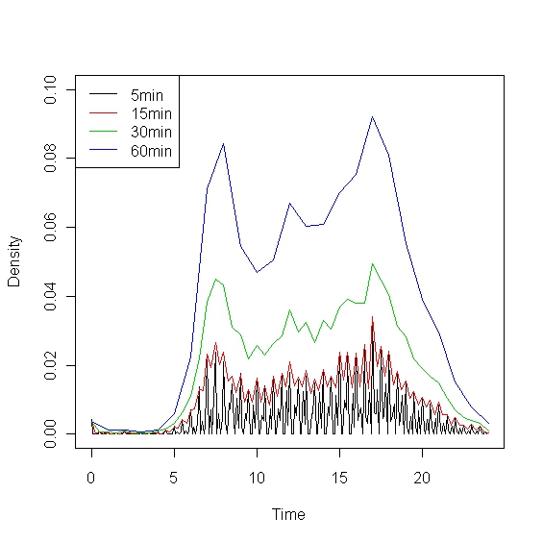

Figure . Reported Trip Start Times at 5-, 15-, 30-, and 60-min Intervals for SE Florida Household Survey

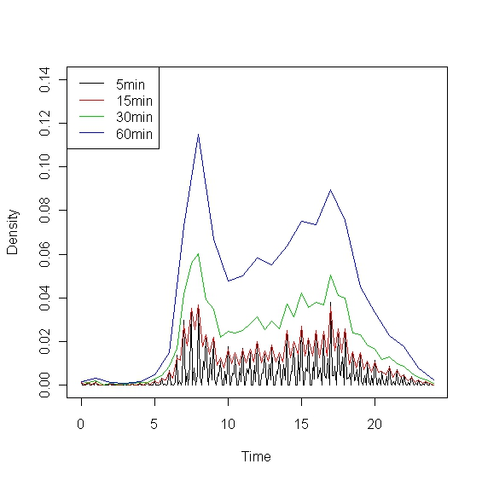

Figure . Reported Trip Start Times at 5-, 15-, 30-, and 60-min Intervals for 2009 NHTS

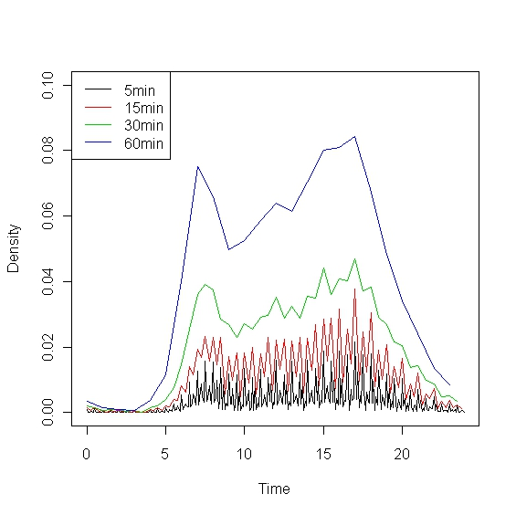

The results clearly suggest that 5-minute resolution is simply too short for each of the datasets, and 15-minute resolution displays a fair amount of oscillation in each dataset as well. Thus, 30-minute intervals appear to be smallest time resolution the data can support and are used in development of the models discussed later.

In model development, it was desired to use a single dataset. Since the NHTS data are applicable for the entire state of Florida (rather than a specific region of the state for the other datasets), the NHTS data were chosen for model development. In addition, the NHTS contain a much larger number of trip records, which can aid in identifying the most important determinants of the models, once estimated. While the dataset contains trips occurring on each day of the week, only those taking place on weekdays were used in the analysis presented later.

A key attribute that was desired of the TOD models was sensitivity to congestion. Since the NHTS data offer information on origin or destination locations of trips, it is possible to relate travel time information (in the form of skim data, for instance) to trip records.

## Methodological Techniques

Since the 30-minute time intervals explored here represent discrete alternatives, the multinomial logit (MNL) model structure was selected. The MNL allows offers the following choice probabilities for an alternative.

$$p_{ik}=\frac{e^{V_{ik}}}{\sum_{j∈C}{e^{V_{ij}}}}$$

Here, *i* indexes an individual, *j* and *k* index alternatives, *C* represents the choice set of all alternatives, $V_{ij}$ is the systematic utility defined as follows:

$$V_{ij}=X_{ij}β$$

$X_{ij}$ are variables in the model related to alternative *j* for individual *i*, and $β$ is the parameter vector to be estimated.

Each 30-minute interval represents a choice alternative in the model, and is measured as the midpoint between reported trip start and end time. Five TOD periods were generated to aid in model specification. These include the a.m. peak (5 to 9 am), midday (9 am to 3 pm), p.m. peak (3 to 7 pm), evening (7 to 10 pm), and night (10 pm to 5 am). Since few individuals travel during the night hours, and there is little or no congestion on roadway networks during these hours, they are less important to model at such a detailed level. Moreover, the data contain fewer instances of such trips, which can create statistical identification issues in model estimation. Thus, the night intervals (10pm to 5am) were combined in model estimation. Evening intervals (7pm to 10pm) were also combined. While the evening period likely exhibits less of the qualities discussed above for the night period, a bigger focus here was put on the a.m. and p.m. peak periods and middle of the day. After combining 30-minute intervals in these two broad TOD periods, a total of 30 choice alternatives remain.

To allow for shifts within the a.m. peak, midday, and p.m. peak periods, a set of shift variables were defined; a “shift early” and a “shift late” variable for each period. The shift early variable is defined as the difference between the midpoint of the broad TOD period and the midpoint of a particular 30-minute alternative (e.g., for the 5-5:30 am alternative, the shift early variable takes a value of 7 – 5.25 = 1.75). The shift late variable is defined as the difference between the midpoint of a particular 30-minute interval and the midpoint of the broad TOD period. Each shift variable is specific to a broad TOD period (i.e., the a.m. shift early variable takes values of zero for each midday and p.m. alternative). Furthermore, each shift variable is specific to either side of the midpoint of its broad TOD period (i.e., the a.m. shift early variable takes values of zero for each a.m. alternative occurring after 7 am). A second set of shift variables is computed as the square of the first set, for a total of 12 variables (four for each broad TOD). Finally, additional shift variables are introduced by interacting with trip-specific variables (e.g., job type, mode, or household size).

In addition to the shift variables, TOD-specific variables were specified. These include a constant along with a variety of variables related to the traveler, the traveler’s household, and the trip itself. These include household size, household vehicle ownership, presence and number of children, an indicator for whether household vehicles are at least as many as household workers, household income (low is less than $30,000, middle is $30,000 to $60,000, and high is $60,000 or more [measured in 2008 dollars]), gender of the traveler, age of the traveler, job type of the traveler (the first type includes sales and service, the second includes clerical and administrative support, the third includes manufacturing, construction, maintenance, and farming job types, and the last includes professional, managerial, and technical jobs), mode used (single-occupancy vehicle [SOV], high-occupancy vehicle [HOV], transit, walk or bike, and other), distance traveled, and indicators for the size of the region in which the trip took place (less than 500,000 population, 500,000 to 1 million population, and 1 million population or more). Each of these variables were interacted with broad time period indicators for a.m. peak, midday, p.m. peak, and evening periods (with the night period as the base).

In this analysis, home-based work (HBW), home-based other (HBO, excluding shopping, social, and recreational trips), and non-home-based (NHB) trips are analyzed.

## Findings and Recommendations

Because this analysis is more focused on exploring the determinants of TOD choice, model refinement was not pursued. In other words, regardless of whether a variable was found to be statistically and/or practically significant, it was retained in the models presented here. And, since estimated parameter values can be difficult to interpret on their own (particularly in models such as the ones presented here with a large number of explanatory effects), TOD distributions were generated, which detail how model-predicted TOD distributions vary for different trip segments (as predicted by the estimated models).

### HBW Trips

Since these trips relate to a traveler’s job, job type variables were hypothesized to have important implications for HBW trip timing. Thus, in addition to the variables discussed above, job type indicators were interacted with each of the shift variables in the HBW models. Two models were estimated: one for home-to-work trips and a second for work-to-home trips, since these trip types would obviously have very different TOD distributions. Table 4.1 details the model fit statistics for the two models, and Tables 4.2 and 4.3 show the estimated coefficient values.

Table . Model Fit Statistics for HBW Models

|  |  |  |
| --- | --- | --- |
| **Measure** | **Home-to-Work Model** | **Work-to-Home Model** |
| Observations | 4,500 | 3,761 |
| Log Likelihood | -12,320 | -10,313 |
| Log Likelihood at Zero | -15,999 | -13,372 |
| Pseudo Rho-Squared | 0.230 | 0.229 |

Figures 4.4 and 4.5 detail the effects of several variables on model-predicted TOD distributions for home-to-work trips. All variables in these figures (other than the one being analyzed) are identical. That is, the TOD distributions are evaluated using mean variable values. Several variables were found to have meaningful effects on TOD distributions for home-to-work trips, as shown in Figures 4.4 and 4.5. However, most other explanatory variables were found to have only mild effects on TOD distributions of home-to-work trips, and thus, are not presented.

Figure 4.4a shows that very young workers are less likely to travel to work during the a.m. peak period, and more likely to travel during the p.m. peak. This makes sense, since many younger workers may be in school during typical working hours and only work in the evenings. Job type was also found to be a key determinant of home-to-work trip timing (Figure 4.4b). In particular, those employed in industrial type jobs (like manufacturing, construction, and farming) appear more likely to travel to work toward the beginning of the a.m. peak period than those employed in clerical or professional type jobs. In addition, those employed in sales or service jobs are more likely to travel to work during midday hours than other those employed in other job categories.

Travel mode also appears to have important effects on home-to-work timing (Figure 4.5a). For instance, those traveling by walk or bike modes more often travel to work during midday hours. Of course, the a.m. peak hours remain most likely, even for those traveling by walk and bike modes. Finally, distance of travel has some implications for home-to-work TOD choice as well (Figure 4.5b). In particular, those traveling longer distances are more likely to travel during a.m. peak hours. Such long distance commuters would be expected to make fewer HBW trips and stay at work longer, on average. For instance, someone that lives one mile from work may go home for lunch each day, and thus, make one home-to-work trip in the morning and one midday. Longer distance commuters would not typically have this luxury.

Table . Home-to-Work TOD Model Coefficient Estimates

|  |  |  |  |  |  |  |  |  |  |
| --- | --- | --- | --- | --- | --- | --- | --- | --- | --- |
|  | | **AM Peak** | | **Midday** | | **PM Peak** | | **Evening** | |
| **Variables** | | **Coeff.** | **t-stat** | **Coeff.** | **t-stat** | **Coeff.** | **t-stat** | **Coeff.** | **t-stat** |
|  | **ASC** | 5.048 | 4.28 | 2.137 | 1.72 | 1.735 | 0.94 | 0.124 | 0.07 |
| **Household Level Variables** | **HH Size** | -0.066 | -0.32 | 0.003 | 0.02 | -0.104 | -0.45 | -0.15 | -0.35 |
| **Vehicles** | -0.182 | -1.24 | -0.029 | -0.19 | -0.184 | -1.07 | -0.771 | -2.08 |
| **Presence Children** | 0.385 | 0.85 | 0.352 | 0.76 | 0.862 | 1.7 | 0.537 | 0.36 |
| **No. Children** | -0.182 | -0.94 | -0.186 | -0.92 | -0.582 | -2.49 | -1.253 | -1.14 |
| **Vehicle Sufficiency** | 1.19 | 2.92 | 1.484 | 3.45 | 1.336 | 2.87 | 2.302 | 2.16 |
| **Middle Income** | -0.447 | -1.35 | -0.343 | -1 | -0.515 | -1.4 | 0.561 | 0.98 |
| **High Income** | -0.204 | -0.58 | -0.518 | -1.43 | -0.61 | -1.57 | -2.37 | -2.07 |
| **Individual Level Variables** | **Male** | 0.259 | 1.06 | 0.361 | 1.43 | 0.288 | 1.04 | 1.003 | 2.05 |
| **Age** | -0.016 | -1.71 | -0.026 | -2.68 | -0.074 | -6.89 | -0.001 | -0.05 |
| **Sales/Service Job** | -2.896 | -3.21 | -2.463 | -2.55 | 0.717 | 0.43 | -3.661 | -3.53 |
| **Manuf., Constr., Maint. Job** | -3.194 | -3.48 | -3.618 | -3.48 | 1.643 | 0.92 | -3.211 | -3.01 |
| **Prof., Manager, Tech. Job** | -2.021 | -2.23 | -1.862 | -1.91 | -0.004 | 0 | -2.983 | -2.84 |
| **Trip Level Variables** | **Shared Ride Mode** | 0.729 | 1.83 | 0.507 | 1.22 | 1.252 | 2.89 | -0.938 | -0.78 |
| **Non-Motorized Mode** | 1.482 | 1.15 | 2.277 | 1.76 | -0.068 | -0.04 | 2.195 | 1.32 |
| **Transit Mode** | 7.676 | 0.31 | 7.452 | 0.3 | 8.411 | 0.34 | -1.479 | -0.02 |
| **Distance (miles)** | -0.011 | -1.42 | -0.034 | -4.04 | -0.012 | -1.3 | -0.054 | -1.81 |
| **Region-Specific Variables** | **Population 500K-1M** | -0.551 | -1.42 | -0.714 | -1.74 | -0.247 | -0.54 | -7.807 | -0.26 |
| **Population 1M+** | -0.246 | -1.04 | 0.032 | 0.13 | -0.176 | -0.65 | 0.49 | 1.03 |
| **Shifts** | **Shift Early 1** | -1.164 | -2.44 | -0.99 | -1.83 | 2.297 | 0.85 |  |  |
| **Shift Early 2** | -0.146 | -0.49 | 0.548 | 3.15 | -0.495 | -0.41 |  |  |
| **Shift Late 1** | 0.198 | 0.55 | 0.338 | 0.57 | 9.21 | 1.42 |  |  |
| **Shift Late 2** | -0.382 | -1.96 | -0.186 | -0.88 | -8.587 | -1.33 |  |  |
| **Sales, Service Shifts** | **Shift Early 1** | -0.938 | -1.5 | 1.068 | 1.73 | -2.766 | -1 |  |  |
| **Shift Early 2** | 0.782 | 2.07 | -0.429 | -2.15 | 0.934 | 0.74 |  |  |
| **Shift Late 1** | -1.24 | -2.58 | 0.642 | 0.96 | -9.156 | -1.4 |  |  |
| **Shift Late 2** | 0.904 | 3.57 | -0.144 | -0.61 | 8.085 | 1.25 |  |  |
| **Manuf., Constr., Maint. Shifts** | **Shift Early 1** | 1.169 | 1.95 | 0.576 | 0.66 | -20.27 | -3.52 |  |  |
| **Shift Early 2** | -0.265 | -0.73 | -0.354 | -1.22 | 9.761 | 3.21 |  |  |
| **Shift Late 1** | -1.17 | -2.18 | -0.154 | -0.18 | -17.46 | -2.53 |  |  |
| **Shift Late 2** | 0.462 | 1.55 | 0.216 | 0.74 | 12.99 | 1.98 |  |  |
| **Prof., Manager, Tech. Shifts** | **Shift Early 1** | 0.45 | 0.81 | 0.094 | 0.15 | -2.497 | -0.83 |  |  |
| **Shift Early 2** | -0.304 | -0.86 | -0.028 | -0.14 | 0.756 | 0.55 |  |  |
| **Shift Late 1** | 0.269 | 0.64 | 0.124 | 0.18 | -9.536 | -1.43 |  |  |
| **Shift Late 2** | -0.076 | -0.34 | -0.033 | -0.13 | 8.813 | 1.36 |  |  |

Table . Work-to-Home TOD Model Coefficient Estimates

|  |  |  |  |  |  |  |  |  |  |
| --- | --- | --- | --- | --- | --- | --- | --- | --- | --- |
|  | | **AM Peak** | | **Midday** | | **PM Peak** | | **Evening** | |
| **Variables** | | **Coeff.** | **t-stat** | **Coeff.** | **t-stat** | **Coeff.** | **t-stat** | **Coeff.** | **t-stat** |
|  | **ASC** | -20.89 | -0.61 | -1.685 | -2.51 | -1.022 | -1.94 | -2.624 | -4.35 |
| **Household Level Variables** | **HH Size** | 0.377 | 1.09 | -0.413 | -3 | -0.225 | -1.96 | -0.013 | -0.09 |
| **Vehicles** | 0.362 | 1.41 | 0.392 | 3.52 | 0.188 | 1.93 | 0.062 | 0.53 |
| **Presence Children** | 1.452 | 1.97 | -0.474 | -1.64 | -0.39 | -1.61 | -0.646 | -2.2 |
| **No. Children** | -0.445 | -0.98 | 0.774 | 5.12 | 0.548 | 4.05 | 0.521 | 3.35 |
| **Vehicle Sufficiency** | 0.398 | 0.38 | -0.512 | -1.74 | 0.228 | 0.92 | -0.107 | -0.36 |
| **Middle Income** | 0.964 | 1.8 | 0.376 | 1.82 | 0.472 | 2.74 | 0.393 | 1.79 |
| **High Income** | 0.029 | 0.05 | 0.831 | 3.78 | 1.181 | 6.4 | 1.021 | 4.49 |
| **Individual Level Variables** | **Male** | -0.447 | -1.13 | 0.087 | 0.55 | 0.08 | 0.6 | -0.005 | -0.03 |
| **Age** | 0.093 | 5.63 | 0.056 | 9.14 | 0.055 | 10.48 | 0.038 | 5.96 |
| **Sales/Service Job** | -11.99 | -0.32 | -2.273 | -4.47 | -2.698 | -7.69 | -1.615 | -4.92 |
| **Manuf., Constr., Maint. Job** | 7.89 | 0.23 | -1.362 | -2.23 | -2.244 | -5.62 | -2.412 | -5.6 |
| **Prof., Manager, Tech. Job** | 3.82 | 0.11 | -0.037 | -0.07 | -1.085 | -3.01 | -0.609 | -1.72 |
| **Trip Level Variables** | **Shared Ride Mode** | -1.152 | -0.98 | 0.171 | 0.68 | 0.767 | 3.73 | 0.331 | 1.29 |
| **Non-Motorized Mode** | -6.282 | -0.05 | 2.717 | 2.65 | 3.34 | 3.35 | 2.592 | 2.46 |
| **Transit Mode** | -8.625 | -0.08 | 0.498 | 0.82 | 0.942 | 1.82 | 1.872 | 3.48 |
| **Distance (miles)** | -0.049 | -1.89 | -0.058 | -6.79 | 0.002 | 0.32 | 0.016 | 2.52 |
| **Region-Specific Variables** | **Population 500K-1M** | -1.274 | -1.07 | -0.669 | -2.19 | -0.362 | -1.51 | -0.317 | -1.09 |
| **Population 1M+** | 0.074 | 0.19 | -0.148 | -0.91 | -0.203 | -1.45 | -0.078 | -0.46 |
| **Shifts** | **Shift Early 1** | 6.359 | 0.01 | -2.781 | -1.68 | -0.322 | -0.65 |  |  |
| **Shift Early 2** | -5.323 | -0.01 | 0.037 | 0.03 | -0.55 | -1.82 |  |  |
| **Shift Late 1** | 12.65 | 0.26 | -0.157 | -0.27 | -0.519 | -1.09 |  |  |
| **Shift Late 2** | -3.242 | -0.19 | -0.003 | -0.01 | -0.314 | -1.12 |  |  |
| **Sales, Service Shifts** | **Shift Early 1** | 17.98 | 0.03 | 1.018 | 0.58 | -0.733 | -1.17 |  |  |
| **Shift Early 2** | -2.01 | 0 | 0.385 | 0.33 | 0.913 | 2.48 |  |  |
| **Shift Late 1** | 20.98 | 0.4 | -0.387 | -0.56 | 0.636 | 1.05 |  |  |
| **Shift Late 2** | -8.565 | -0.48 | 0.241 | 1.03 | -0.058 | -0.17 |  |  |
| **Manuf., Constr., Maint. Shifts** | **Shift Early 1** | -20.5 | -0.01 | 0.947 | 0.49 | 2.056 | 3.2 |  |  |
| **Shift Early 2** | 2.254 | 0 | 0.275 | 0.22 | -0.361 | -0.97 |  |  |
| **Shift Late 1** | -6.578 | -0.13 | -0.751 | -0.89 | 2.921 | 4.42 |  |  |
| **Shift Late 2** | 0.782 | 0.05 | 0.425 | 1.54 | -1.358 | -3.49 |  |  |
| **Prof., Manager, Tech. Shifts** | **Shift Early 1** | 9.208 | 0.02 | -1.416 | -0.8 | -0.822 | -1.45 |  |  |
| **Shift Early 2** | -5.652 | -0.01 | 1.146 | 0.97 | 0.87 | 2.56 |  |  |
| **Shift Late 1** | 0.979 | 0.02 | -1.797 | -2.67 | 0.941 | 1.74 |  |  |
| **Shift Late 2** | -2.331 | -0.14 | 0.647 | 2.85 | -0.236 | -0.75 |  |  |

Figure . Age and Job Type Effects on Model-Predicted TOD Distributions for Home-to-Work Trips

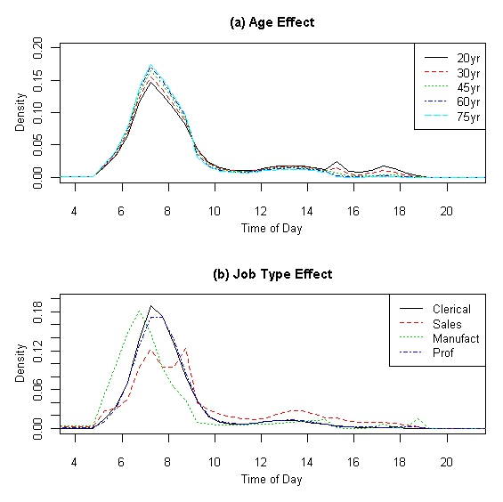

Figure . Mode and Distance Effects on Model-Predicted TOD Distributions for Home-to-Work Trips

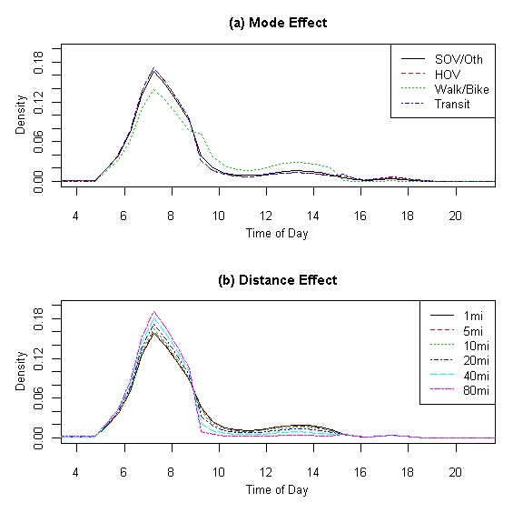

Not surprisingly, the variables having most significant effects for work-to-home trip timing are the same as those for home-to-work trip timing. Figures 4.6 and 4.7 show the TOD distributions for the return commute, segmented by these variables. Three other variables not depicted in Figures 4.6 and 4.7 also had meaningful effects on TOD distribution. First, those from high income households were found to be more likely to travel during the p.m. peak than those from middle and low income households, and those from middle income households were found to be more likely to travel during the p.m. peak than those from low income households. In addition, those from 0-vehicle households and those from households with more workers than vehicles (obviously these two variables are correlated) were found to be less likely to travel during the p.m. peak period and more likely to travel during evening hours (7 to 10 pm).

As depicted in Figure 4.6a, younger workers more often return home during evening and night hours, which is not surprising since they are also more likely to commute to work during later hours than other workers. Job type has very important implications for work-to-home trip timing (Figure 4.6b). Like home-to-work trips, return commute TOD distributions for those employed in sales and service jobs are more spread across TODs, suggesting there is simply more uncertainty associated with the work hours for such job types. Those working in industrial type jobs appear more likely to return home earlier in the day than others, which is reasonable considering they are also more likely to travel to work earlier. Finally, it was found that those traveling by a transit mode are more likely to return home during evening hours than those traveling by other modes (Figure 4.7a) and those traveling longer distances more often return home later in the day than those traveling shorter distances (Figure 4.7b). In fact, we see for those traveling very short distances (less than 5 miles, for instance), there appears to be a rather high probability of returning home midday. Of course, in many cases these trips are probably workers eating lunch at home.

### HBO Trips

Since any person can engage in HBO trips, the job type variables were not used in these models. Also unlike the HBW models, shift variables were interacted with the household size variable, number of children variable, and HOV travel mode variable. Two models were again estimated: one for home-to-other trips and a second for other-to-home trips. Table 4.4 shows the model fit statistics for the two models, and Tables 4.5 and 4.6 show estimated model coefficients.

Table . Model Fit Statistics for HBO Models

|  |  |  |
| --- | --- | --- |
| **Measure** | **Home-to-Other Model** | **Other-to-Home Model** |
| Observations | 9,103 | 7,710 |
| Log Likelihood | -27,799 | -24,757 |
| Log Likelihood at Zero | -32,364 | -27,412 |
| Pseudo Rho-Squared | 0.141 | 0.097 |

Figure . Age and Job Type Effects on Model-Predicted TOD Distributions for Work-to-Home Trips

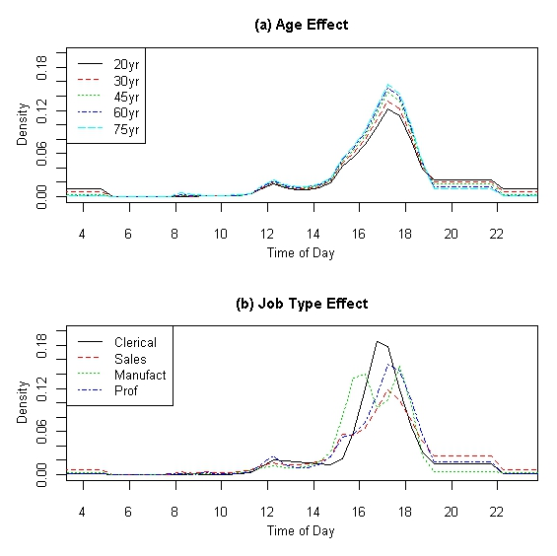

Figure . Mode and Distance Effects on Model-Predicted TOD Distributions for Work-to-Home Trips

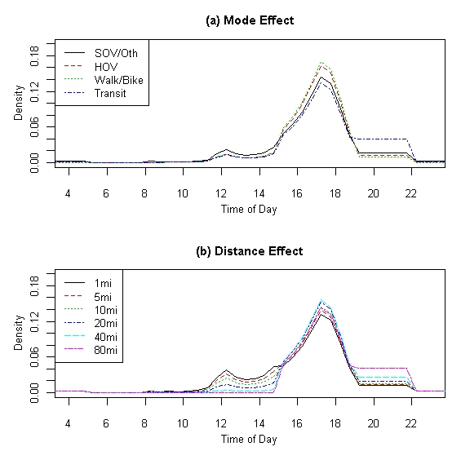

Table . Home-to-Other TOD Model Coefficient Estimates

|  |  |  |  |  |  |  |  |  |  |
| --- | --- | --- | --- | --- | --- | --- | --- | --- | --- |
|  | | **AM Peak** | | **Midday** | | **PM Peak** | | **Evening** | |
| **Variables** | | **Coeff.** | **t-stat** | **Coeff.** | **t-stat** | **Coeff.** | **t-stat** | **Coeff.** | **t-stat** |
|  | **ASC** | 1.181 | 1.82 | -0.412 | -0.62 | -1.768 | -2.46 | -1.888 | -2.71 |
| **Household Level Variables** | **HH Size** | 0.187 | 1 | -0.063 | -0.31 | 0.822 | 3.72 | 0.212 | 1.13 |
| **Vehicles** | -0.436 | -3.38 | -0.329 | -2.53 | -0.297 | -2.27 | -0.301 | -2.12 |
| **Presence Children** | 1.842 | 4.05 | 0.867 | 1.79 | -0.189 | -0.37 | 1.81 | 3.98 |
| **No. Children** | -0.088 | -0.5 | 0.092 | 0.51 | 0.153 | 0.86 | -0.414 | -2.13 |
| **Vehicle Sufficiency** | 1.771 | 5.54 | 1.448 | 4.46 | 1.259 | 3.84 | 1.405 | 3.79 |
| **Middle Income** | 0.598 | 2.06 | 0.626 | 2.15 | 0.851 | 2.89 | 0.686 | 2.18 |
| **High Income** | 0.129 | 0.52 | -0.035 | -0.14 | 0.318 | 1.26 | 0.12 | 0.44 |
| **Individual Variables** | **Male** | -0.376 | -2.01 | -0.66 | -3.5 | -0.495 | -2.61 | -0.343 | -1.67 |
| **Age** | -0.016 | -2.9 | 0.019 | 3.39 | 0.011 | 1.84 | 0.01 | 1.68 |
| **Trip Level Variables** | **Shared Ride Mode** | -0.131 | -0.45 | -0.501 | -1.59 | -0.453 | -1.38 | 0.104 | 0.35 |
| **Non-Motorized Mode** | -2.294 | -8.91 | -2.919 | -11.14 | -1.884 | -7.22 | -1.205 | -4.23 |
| **Transit Mode** | 9.23 | 0.15 | 7.877 | 0.13 | 8.08 | 0.13 | 8.28 | 0.13 |
| **Distance (miles)** | -0.002 | -0.25 | 0.004 | 0.39 | -0.011 | -1.08 | -0.06 | -4.14 |
| **Region-Specific Variables** | **Population 500K-1M** | 0.105 | 0.26 | 0.024 | 0.06 | -0.238 | -0.59 | -0.18 | -0.4 |
| **Population 1M+** | -0.562 | -2.68 | -0.459 | -2.18 | -0.651 | -3.07 | -0.231 | -1.01 |
| **Shifts** | **Shift Early 1** | 0.336 | 0.45 | -0.407 | -1.07 | 1.751 | 1.91 |  |  |
| **Shift Early 2** | -0.335 | -0.72 | 0.172 | 1.38 | -0.506 | -1.07 |  |  |
| **Shift Late 1** | -0.636 | -1.22 | -0.817 | -1.95 | 3.074 | 3.42 |  |  |
| **Shift Late 2** | 0.597 | 2.28 | 0.204 | 1.41 | -1.529 | -3.3 |  |  |
| **HH Size Shifts** | **Shift Early 1** | -0.56 | -1.82 | 0.473 | 2.79 | -1.366 | -3.53 |  |  |
| **Shift Early 2** | 0.081 | 0.4 | -0.138 | -2.5 | 0.547 | 2.72 |  |  |
| **Shift Late 1** | -0.011 | -0.05 | 0.53 | 2.89 | -1.33 | -3.55 |  |  |
| **Shift Late 2** | -0.03 | -0.3 | -0.134 | -2.14 | 0.588 | 3.03 |  |  |
| **Presence Children Shifts** | **Shift Early 1** | -0.606 | -0.9 | -1.639 | -4.53 | 2.492 | 3.15 |  |  |
| **Shift Early 2** | 0.245 | 0.56 | 0.614 | 5.25 | -1.008 | -2.44 |  |  |
| **Shift Late 1** | 0.307 | 0.71 | -1.088 | -2.81 | 1.799 | 2.38 |  |  |
| **Shift Late 2** | -0.416 | -1.93 | 0.435 | 3.32 | -0.726 | -1.85 |  |  |
| **Shared Ride Shifts** | **Shift Early 1** | 0.246 | 0.59 | 0.224 | 0.96 | 1.168 | 2.45 |  |  |
| **Shift Early 2** | -0.294 | -1.04 | -0.042 | -0.56 | -0.716 | -2.89 |  |  |
| **Shift Late 1** | 1.868 | 7.25 | 0.417 | 1.66 | 0.035 | 0.08 |  |  |
| **Shift Late 2** | -1.043 | -7.93 | -0.235 | -2.76 | 0.257 | 1.08 |  |  |

Table . Other-to-Home TOD Model Coefficient Estimates

|  |  |  |  |  |  |  |  |  |  |
| --- | --- | --- | --- | --- | --- | --- | --- | --- | --- |
|  | | **AM Peak** | | **Midday** | | **PM Peak** | | **Evening** | |
| **Variables** | | **Coeff.** | **t-stat** | **Coeff.** | **t-stat** | **Coeff.** | **t-stat** | **Coeff.** | **t-stat** |
|  | **ASC** | -2.404 | -3.28 | -0.622 | -1.2 | 0.533 | 1.05 | -0.949 | -1.94 |
| **Household Level Variables** | **HH Size** | -0.108 | -0.41 | 0.189 | 1.2 | -0.222 | -1.44 | 0.186 | 1.41 |
| **Vehicles** | -0.23 | -2.2 | -0.17 | -1.81 | -0.068 | -0.73 | -0.158 | -1.59 |
| **Presence Children** | 1.934 | 3.34 | -0.287 | -0.84 | 1.13 | 3.37 | 0.468 | 1.61 |
| **No. Children** | 0.165 | 1.39 | 0.003 | 0.03 | -0.075 | -0.7 | -0.258 | -2.21 |
| **Vehicle Sufficiency** | 1.078 | 3.35 | 0.829 | 3.29 | 1.036 | 4.15 | 0.607 | 2.29 |
| **Middle Income** | 0.263 | 1.21 | 0.25 | 1.3 | 0.496 | 2.59 | 0.614 | 3.01 |
| **High Income** | 0.05 | 0.26 | -0.06 | -0.35 | 0.325 | 1.88 | 0.287 | 1.54 |
| **Individual Variables** | **Male** | -0.721 | -4.66 | -0.168 | -1.23 | -0.236 | -1.74 | -0.209 | -1.44 |
| **Age** | 0.039 | 8.1 | 0.003 | 0.67 | -0.011 | -2.67 | 0 | -0.09 |
| **Trip Level Variables** | **Shared Ride Mode** | -3.085 | -6.22 | 0.17 | 0.8 | 0.281 | 1.39 | 0.336 | 1.93 |
| **Non-Motorized Mode** | -1.264 | -6.21 | -1.608 | -8.55 | -1.206 | -6.56 | -0.737 | -3.67 |
| **Transit Mode** | 2.986 | 0.43 | 5.941 | 0.86 | 4.994 | 0.72 | 3.971 | 0.57 |
| **Distance (miles)** | -0.071 | -7.72 | -0.012 | -2.82 | -0.009 | -2.19 | -0.01 | -2.22 |
| **Region-Specific Variables** | **Population 500K-1M** | -0.297 | -1.08 | -0.597 | -2.42 | -0.79 | -3.23 | -0.598 | -2.27 |
| **Population 1M+** | -0.536 | -3.14 | -0.502 | -3.26 | -0.458 | -3 | -0.463 | -2.86 |
| **Shifts** | **Shift Early 1** | -3.941 | -2.1 | 0.099 | 0.22 | 0.096 | 0.16 |  |  |
| **Shift Early 2** | 1.514 | 1.29 | 0.053 | 0.34 | -0.281 | -0.9 |  |  |
| **Shift Late 1** | -1.912 | -1.54 | 0.184 | 0.46 | 0.591 | 0.89 |  |  |
| **Shift Late 2** | 0.861 | 1.39 | -0.021 | -0.16 | -0.605 | -1.64 |  |  |
| **HH Size Shifts** | **Shift Early 1** | 1.743 | 2.09 | -0.081 | -0.42 | 0.019 | 0.08 |  |  |
| **Shift Early 2** | -1.015 | -1.88 | -0.029 | -0.42 | 0.119 | 0.95 |  |  |
| **Shift Late 1** | 0.749 | 1.39 | 0.106 | 0.64 | -0.107 | -0.38 |  |  |
| **Shift Late 2** | -0.217 | -0.82 | -0.042 | -0.77 | 0.122 | 0.79 |  |  |
| **Presence Children Shifts** | **Shift Early 1** | -4.219 | -2.33 | -0.108 | -0.27 | -0.412 | -0.79 |  |  |
| **Shift Early 2** | 2.336 | 1.97 | 0.196 | 1.34 | 0.251 | 0.95 |  |  |
| **Shift Late 1** | 0.839 | 0.71 | -0.389 | -1.14 | -0.223 | -0.38 |  |  |
| **Shift Late 2** | -0.913 | -1.59 | 0.338 | 3.02 | -0.196 | -0.61 |  |  |
| **Shared Ride Shifts** | **Shift Early 1** | 5.289 | 2.09 | -0.073 | -0.27 | -0.264 | -0.85 |  |  |
| **Shift Early 2** | -5.033 | -1.9 | -0.152 | -1.52 | 0.001 | 0.01 |  |  |
| **Shift Late 1** | 2.007 | 2.1 | -1.11 | -4.89 | -0.297 | -0.81 |  |  |
| **Shift Late 2** | -0.747 | -1.68 | 0.327 | 4.46 | 0.087 | 0.42 |  |  |

Figures 4.8 and 4.9 show the variables from the home-to-other model that had the most important effects on TOD distributions of these trips. Of the trip segments not shown in Figures 4.8 and 4.9, those from high vehicle households (3 or more vehicles) were found to be more likely to travel later in the day for these other trip types. From Figure 4.8a and 4.8b, it is obvious that children and those from households with children are more likely to travel during the morning hours, which is mainly because university and school trips are represented in this HBO trip type category. In the future it may be worth creating a variable specifically for children or those enrolled in school. Those traveling by transit and HOV modes are also much more likely to travel in the a.m. peak period (Figure 4.9a), while those traveling longer distances appear a bit more likely to travel during the middle of the day, with shorter distance trips more often occurring during p.m. peak hours (though a.m. peak travel is most likely, regardless of trip distance).

Figure . Presence of Children and Age Effects on Model-Predicted TOD Distributions for Home-to-Other Trips

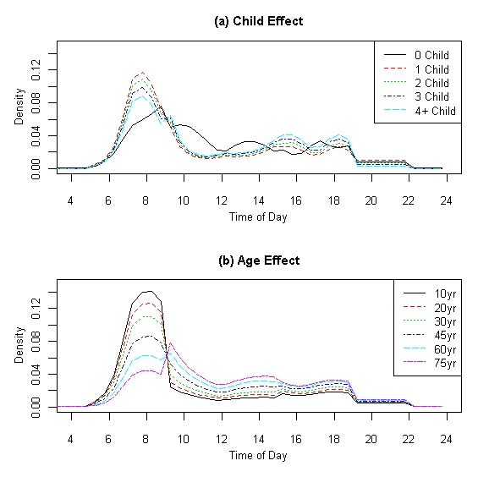

Figure . Mode and Distance Effects on Model-Predicted TOD Distributions for Home-to-Other Trips

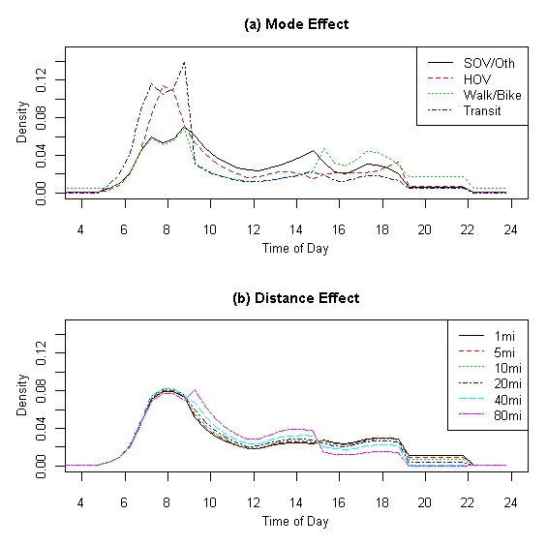

For other-to-home trips similar variables are found to have the most important implications for trip timing (Figures 4.10 and 4.11). Not surprisingly, given that many of the HBO trips are school related, those from households with any number of children and younger individuals tend to more often return home during the late afternoon. Like the home-to-other model, the age effect is probably a place where it would be best to introduce a variable specifically related to whether the child is enrolled in school. Late afternoon timing also appears to be more likely for individuals from larger households, while smaller household individuals are more likely to return during p.m. peak hours. Lastly, travel mode appears to have very important consequences to other-to-home trip timing, with transit mode trips peaking near the end of the midday period (about 3 p.m.).

Figure . Presence of Children and Household Size Effects on Model-Predicted TOD Distributions for Other-to-Home Trips

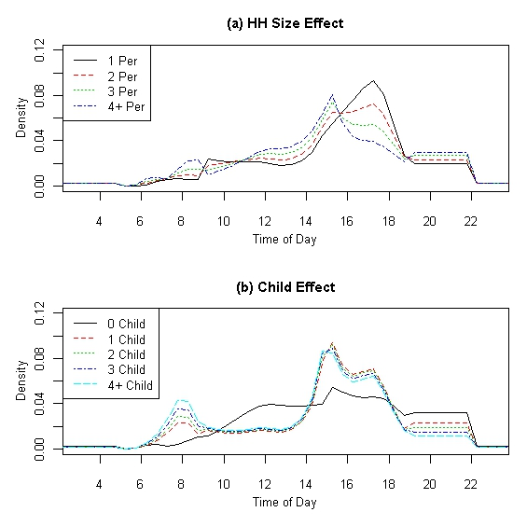

Figure . Mode and Age Effects on Model-Predicted TOD Distributions for Other-to-Home Trips

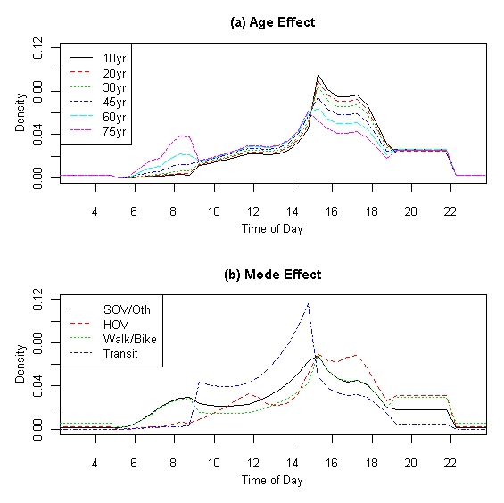

### NHB Trips

Since neither end of a NHB trip is a traveler’s home, all NHB trips are combined rather than separating them in any way. Like HBO trips, job type variables were excluded in the NHB models and shift variables were interacted with the household size variable, number of children variable, and HOV travel mode variable. Table 4.7 shows the model fit statistics for the NHB model and Table 4.8 shows estimated model coefficients.

Table . Model Fit Statistics for NHB Model

|  |  |
| --- | --- |
| **Measure** | **NHB Model** |
| Observations | 23,389 |
| Log Likelihood | -78,040 |
| Log Likelihood at Zero | -83,156 |
| Pseudo Rho-Squared | 0.062 |

Table . Non-Home Based TOD Model Coefficient Estimates

|  |  |  |  |  |  |  |  |  |  |
| --- | --- | --- | --- | --- | --- | --- | --- | --- | --- |
|  | | **AM Peak** | | **Midday** | | **PM Peak** | | **Evening** | |
| **Variables** | | **Coeff.** | **t-stat** | **Coeff.** | **t-stat** | **Coeff.** | **t-stat** | **Coeff.** | **t-stat** |
|  | **ASC** | -0.457 | -2.57 | 0.261 | 2.27 | 0.928 | 7.3 | -1.323 | -10.25 |
| **Household Level Variables** | **HH Size** | -0.175 | -8.87 | 0.046 | 4.72 | -0.255 | -21.64 | 0.163 | 16.91 |
| **Vehicles** | -0.32 | -61.03 | -0.239 | -50.81 | -0.177 | -37.09 | -0.084 | -15.43 |
| **Presence Children** | 0.522 | 6.11 | -0.199 | -4.75 | 0.378 | 7.49 | -0.104 | -2.49 |
| **No. Children** | 0.307 | 38.48 | 0.15 | 20.47 | 0.281 | 38.13 | -0.038 | -4.45 |
| **Vehicle Sufficiency** | 0.804 | 20.51 | 0.873 | 26.19 | 0.851 | 24.88 | 0.672 | 16.37 |
| **Middle Income** | 0.278 | 11.69 | 0.083 | 3.93 | 0.155 | 7.19 | 0.259 | 10.36 |
| **High Income** | 0.459 | 21.14 | 0.381 | 19.73 | 0.425 | 21.6 | 0.283 | 12.39 |
| **Individual Variables** | **Male** | 0.117 | 9.91 | 0.098 | 9.24 | -0.121 | -11.2 | 0.151 | 12.16 |
| **Age** | 0.015 | 11.59 | 0.027 | 24.07 | 0.012 | 10.24 | 0.003 | 27.22 |
| **Trip Level Variables** | **Shared Ride Mode** | -0.89 | -25.21 | -0.457 | -27.72 | -0.384 | -19.19 | 0.022 | 1.38 |
| **Non-Motorized Mode** | -1.844 | -49.99 | -1.182 | -40.25 | -1.222 | -40.32 | -0.523 | -14.65 |
| **Transit Mode** | 0.526 | 0.84 | 1.12 | 1.85 | 0.016 | 0.03 | 0.877 | 1.33 |
| **Distance (miles)** | -0.003 | -17.59 | -0.013 | -27.54 | -0.011 | -22.83 | -0.005 | -15.76 |
| **Region-Specific Variables** | **Population 500K-1M** | 0.216 | 3.01 | 0.134 | 1.98 | 0.278 | 4.08 | 0.319 | 4.23 |
| **Population 1M+** | -0.55 | -40.26 | -0.686 | -55.32 | -0.544 | -43.19 | -0.201 | -13.91 |
| **Shifts** | **Shift Early 1** | -0.947 | -1.09 | -0.032 | -1.08 | -0.824 | -6.22 |  |  |
| **Shift Early 2** | -0.879 | -2.27 | -0.067 | -17.01 | 0.394 | 11.25 |  |  |
| **Shift Late 1** | -0.427 | -1.33 | -0.165 | -6.28 | -1.162 | -7.43 |  |  |
| **Shift Late 2** | 0.529 | 6.96 | -0.028 | -8.43 | 0.31 | 6.84 |  |  |
| **HH Size Shifts** | **Shift Early 1** | 0.72 | 4.88 | -0.072 | -11.77 | 0.491 | 19.48 |  |  |
| **Shift Early 2** | -0.103 | -1.68 | 0.018 | 22.49 | -0.221 | -33.21 |  |  |
| **Shift Late 1** | 0.689 | 11.54 | 0.061 | 11.71 | 0.56 | 19.13 |  |  |
| **Shift Late 2** | -0.379 | -26.42 | -0.01 | -15.94 | -0.233 | -27.75 |  |  |
| **Presence Children Shifts** | **Shift Early 1** | -2.85 | -4.61 | -0.914 | -33.6 | -1.843 | -17.03 |  |  |
| **Shift Early 2** | 0.937 | 3.82 | 0.381 | 104.97 | 0.903 | 31.7 |  |  |
| **Shift Late 1** | -0.362 | -1.37 | -0.739 | -32.42 | -1.724 | -13.83 |  |  |
| **Shift Late 2** | 0.009 | 0.13 | 0.279 | 100.25 | 0.714 | 20.02 |  |  |
| **Shared Ride Shifts** | **Shift Early 1** | -2.079 | -6.29 | 0.141 | 11.97 | -0.365 | -8.13 |  |  |
| **Shift Early 2** | 1.322 | 10.11 | -0.163 | -100.02 | 0.176 | 14.89 |  |  |
| **Shift Late 1** | -0.673 | -5.77 | -0.237 | -24.72 | -0.428 | -8.28 |  |  |
| **Shift Late 2** | 0.302 | 10.72 | 0.103 | 87.96 | 0.367 | 24.74 |  |  |

As Figures 4.12 and 4.13 show for the most practically significant trip segments, NHB trips most often occur during the middle of the day, as opposed to peaking in the a.m. or p.m. peak periods. Figures 4.12a and 4.12b suggest that those from households without children are more likely to travel for NHB purpose during midday, while those from households with children have NHB TOD distributions that oscillate. In the future, perhaps it would be worthwhile to examine fewer interactions between the child variable and the shift variables, to attempt to eliminate such strange oscillating behavior in the TOD distributions. It makes sense then that young people travel for NHB purposes most often during p.m. peak (Figure 4.13a), as these are mostly children. Interestingly, those traveling by transit (Figure 4.13b) typically do so during the midday hours in comparison to those traveling by other modes.

Figure . Household Size and Presence Children Effects on Model-Predicted TOD Distributions for NHB Trips

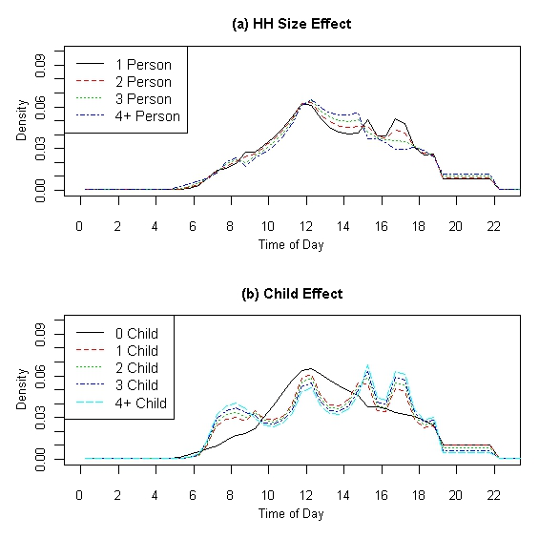

Figure . Age and Mode Effects on Model-Predicted TOD Distributions for NHB Trips

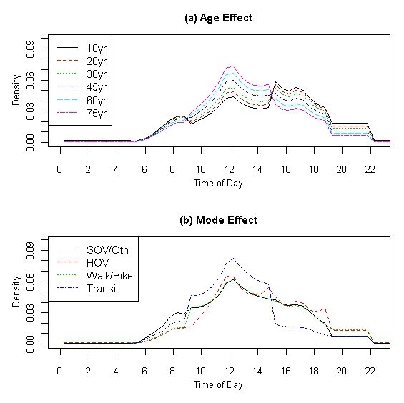

## Summary and Recommendations

Overall, the models appear to suggest reasonable behavior in terms of trip timing for HBW, HBO, and NHB trip types. For instance, home-to-work trips are predicted to occur most often during the a.m. peak and work-to-home trips during the p.m. peak. Home-to-other trips are also predicted to occur most often during the a.m. peak, with other-to-home trips exhibiting peaking during late afternoon hours. Of course, the timing of HBO trips is largely a byproduct of school and university trips being included among these types. NHB trips are found to be much flatter in TOD distribution than either of the other two types, with slight peaks occurring during the midday intervals, which makes sense.

Based on the estimated models, it seems the most practically important variables in the HBW models are the job type variables. There seems to be clear differences in the TOD distribution of HBW trips based on job type. The clerical and administrative support job category and the professional, managerial, and technical job category appear to be most similar, which is not surprising, since the former is often needed to support the latter. HBW trips related to industrial type jobs (like manufacturing, construction, and farming) typically occur a bit earlier in the day (by about 1 hour approximately) for the home-to-work and work-to-home trips, while HBW trips for sales and service jobs are typically more spread throughout the day (though some peaking remains in the a.m. and p.m. peaks).

Interestingly, very few other household composition and individual-specific variables were found to have much impact at all on the timing of HBW trips, other than possibly high income households and age. Both mode and distance were found to be important, however.

Similar results were noted for HBO trips, though the presence of children was one household composition variable that is particularly important for HBO trips as compared to HBW trips and age was found to be quite important as well. This is mostly due to the inclusion of school and university trips in the HBO category. NHB trip timing appears to be most affected by variables similar to those found important for the HBO trip type.

Overall, two variables were found to have almost no effect on trip timing in any of the models. These include the gender of the individual and regional population totals. Household income level (particularly the distinction between low and middle income households), household vehicle ownership, and distinction between households with fewer workers than vehicles and those with vehicles at least as many as workers were found to have only relatively small effects on trip timing in only some of the models.

# Empirical Methods to Relate Reported and Network Travel Times

Most travel demand models that are used by metropolitan planning organizations and other planning agencies are based on a daily traffic assignment or a two-period assignment distinguished by peak and off-peak conditions. Travel time data from those models are consequently restricted to a small number of time periods. Therefore, methods of synthesizing travel time data for a larger number of time periods, which could be used in the estimation of time of day choice models need to be considered. One method is to develop a model that relates reported travel time data from a survey to peak and off-peak skims obtained from the highway network, as well as other variables related to land use and geographic orientations, and estimated through regression analysis.

This chapter implements the method described above to obtain travel time data for multiple time periods using data collected in the 2009 NHTS. The survey data set and model files from the Southeast Regional Planning Model (SERPM) 6.5 model covering Broward, Miami-Dade, and Palm Beach counties. The SERPM has enough traffic congestion to provide a basis for modeling time of day choices using travel time variables. The SERPM is the only model that currently has time of day features and it defines peak as between 6:30 a.m. to 9:30 a.m. and 3:30 p.m. to 6:30 p.m. and off-peak as the other periods of the day.

The remainder of this chapter is organized as follows. Section 5.1 describes the datasets used in this analysis and the various data processing and screening procedures applied to the datasets, and provides some descriptive statistics of trip and network characteristics. Section 5.2 describes three main model specifications relating reported travel speeds from a survey to model skims and other variables and provides estimation results. Section 5.3 describes the STEWARD database and its potential as a source for travel time data.

## Data Validation and Statistics

The 2009 NHTS data for the SERPM region were used as the source for reported travel times. The level-of-service variables that were available from the travel demand model included a.m. peak (defined as 6:30-9:30 a.m.) and free flow network travel times (both in-vehicle and out-of-vehicle) and costs. The a.m. peak travel times were provided separately for drive-alone trips, shared-ride trips with two persons in the vehicle, and shared-ride trips with three or more persons in the vehicle. For the analysis documented in this memo, p.m. peak network travel times from a zone *i* to a zone *j* were set equal to a.m. peak network travel times from zone *j* to zone *i*. It is recognized that setting the p.m. times to equal the transpose of the a.m. times is a significant oversimplification and results in inaccuracies, but there were no other p.m. times available from the model.

The survey data set observations were screened so that observations that did not provide complete or valid data for the subsequent analysis could be dropped. Besides observations with missing data or data for trips that were outside the desired universe for the time of day choice model (e.g. weekend trips), observations for trips with data that were inconsistent with the modeled travel times were eliminated. The 2009 NHTS data report 29,916 (both production and attraction) trips in the SERPM region. The following steps were taken to prepare the dataset for analysis.

* Weekend trips were removed as the available travel time skims correspond to weekday travel.
* A consistency check was performed to validate the reported vehicle occupancies. This step consisted of removing trips that had a zero or unknown number of persons in a vehicle (this is needed for classifying a trip as a drive-alone or shared-ride trip) or one person in a carpool vehicle. Furthermore, trips where the vehicle occupancy is one and the only person in the vehicle is a passenger were also removed.
* Trips with an unknown origin or destination were removed.
* Only those trips with a positive and non-missing reported travel time were kept in the dataset. Note that speed is defined as the centroid-to-centroid distance divided by the sum of in-vehicle and out-of-vehicle travel times. Note also that the set of shared-ride person trips might contain records that refer to the same trip, since a shared-ride trip among members of the same family is reported by each of the family members participating in the survey. For the purpose of regression analyses reported later in this report, the duplicate shared-ride person trips were removed (i.e. only one record was kept of a trip that was reported more than once).
* Finally, reported travel times were checked for consistencies. Because respondents tend to round activity start and end times to the nearest 5, 10, 15, or even 30 minutes, there tends to be a large amount of random error introduced into estimates of the intervening travel time. While reported travel times might not be an accurate source of travel time data, they were the only available dataset from which we could estimate travel times that vary by time of day. Several screening methods, described below, have been investigated to obtain a more reliable set of reported travel times that could be subsequently used in travel time synthesis. Note that only trips by private vehicle (drive-alone and shared-ride) are analyzed in this report.
* The final dataset used for analysis after these screening procedures correspond to 15,570 weekday inter zonal auto (drive alone and shared ride) trips.

### Screening Method 1

In this screening method, the ratio of the reported speed to the network (modeled) speed is computed, where the network speed is equal to a.m. peak speed during the a.m. peak period (6:30 to 9:30 a.m.), p.m. peak speed during the p.m. peak period (3:30 to 6:30 p.m.), and free flow speed during all other periods. The times are based on departure time and in half hour increments from 5:00 a.m. to 10 p.m. Any observation where the ratio of reported to network speed is less than 0.5 or greater than 2 is removed. Figure 5.1 shows the mean ratio of reported speed to free flow speed versus time of day after screening method 1 is applied.

Figure . Mean ratio of reported to network speed versus time of day using screening method 1

As shown in Figure 5.1, this screening method is biased since it predefines the peak periods (see the sudden changes in the ratio of reported to free flow speed close to 7 a.m., 9 a.m., 3:30 p.m., and 6:30 p.m.) and characterizes all other time periods by conditions close to free flow conditions. In reality, conditions prevailing during midday periods for example might be closer to peak than to free flow conditions in the SERPM region. This led us to consider another screening method where we keep the denominator of the ratio of reported to modeled speed constant across all trips (rather than presetting the peak periods), and equal to free flow speed.

### Screening Method 2

In this screening method, upper and lower bounds on the ratio of reported to free flow speed are used to screen the observations. Theoretically, the free flow speed should be an upper bound on any observed speed. Allowing for a margin of error, any observation that has a reported speed greater than free flow speed by more than 10 % is removed. The lower bound is obtained as follows. For every remaining trip, the ratio of network peak speed to network free flow speed (using a.m. peak speed for a trip between 12:00 a.m. and 12:00 p.m., and p.m. peak speed for a trip between 12:00 p.m. and 12:00 a.m.) is computed. The 95th percentile of this ratio is 0.5602. In other words, 95 % of all trips have a ratio of peak to free flow speed greater than or equal to 0.5602.

The 95th percentile is used as follows. For every trip, the ratio of reported to free flow speed is computed. If this ratio is below the 95th percentile, the observation is dropped; otherwise, it is retained. Figure 5.2 shows the mean ratio of reported speed to free flow speed versus time of day after screening method 2 is applied.

Figure . Mean ratio of reported to free flow speed versus time of day using screening method 2

As shown in Figure 5.2, the distribution of the ratio of reported to free flow speed shows no obvious patterns. This led us yet to consider another screening method.

### Screening Method 3

In this screening method, peak and free flow periods are not preset but are rather determined by the output of the screening method. The model peak speeds should represent the most congested periods of the day, and the free flow speeds should theoretically represent the highest speeds. Therefore, any reported speed should ideally fall between the peak and free flow speeds with a certain margin of error. For every trip, two ratios are computed: (1) ratio1: the ratio of reported speed to network peak speed, and (2) ratio2: the ratio of reported speed to network free flow speed. If ratio1 is less than 0.5 or ratio2 is greater than 2, the observation is dropped; otherwise, it is retained. The model peak speed that is used to compute ratio1 is equal to a.m. peak speed for departures between 4:00 a.m. and 11:00 a.m., p.m. peak speed for departures between 2:00 p.m. and 10:00 p.m., and the minimum of a.m. peak speed and p.m. peak speed for departures in the remaining time periods (10:00 p.m. to 4:00 a.m. and 11:00 a.m. to 2:00 p.m.) as it is not obvious if conditions during the latter time periods are closer to a.m. peak or p.m. peak conditions. Figure 5.3 shows the mean ratio of reported speed to free flow speed versus time of day after screening method 3 is applied.

Figure . Mean ratio of reported to free flow speed versus time of day using screening method 3

Given the fluctuations in the mean by every half hour, the means were recomputed using one hour intervals (Figure 5.4). Doing this smoothes out the curve and defines the peak better and takes care of rounding of reported travel times. Compared to screening method 1, screening method 3 avoids the bias resulting from predefining the peak periods and results in a distribution of the mean ratio of reported to free flow speed that is smoother than when the peak periods are predefined (compare Figures 5.1 and 5.4). Compared to screening method 2, screening method 3 identifies more clearly those time periods that are characterized by peak conditions. In the remainder of this section, we use the dataset resulting from screening method 3 to perform the descriptive statistics and regression analyses for travel time synthesis.

Figure . Mean ratio of reported to free flow speed versus time of day using screening method 3 and 1-hr time periods

### Trip Distribution by Time of Day

Figure 5.5 shows the number of trips by departure time period before and after screening method 3 is applied. Note that the fraction of screened trips is highest in the midday and p.m. peak periods, which tend to have shorter trips.

Figure . Distribution of Trips by Time of Day before and after Screening

### Speed Distribution by Time of Day after Screening

Figure 5.6 shows the distribution of mean reported, network free flow, and network peak speed by time of day after screening method 3 is applied. As expected, the reported speeds generally fall between the network peak and free flow speeds.

Figure . Mean speed distribution by time of day after screening method 3 is applied

## Regression Analysis

In this section, we describe the linear regression analyses that were conducted to relate reported travel times from a survey to available network skims, land use variables, and geographic orientations. We present the results of the regression that worked best.

Rather than use travel times as variables in the regressions, speeds (or their ratios) were used instead since this allows for model estimation over a range of origin-destination pairs as the distance effect is accounted for in the computation of speed. As mentioned in Section 5.1, speed is computed as the ratio of centroid-to-centroid distance to the sum of in-vehicle and out-of-vehicle travel times.

Regression analyses are carried out on the sample remaining after screening method 3 was applied. Those regressions are departure-time-based; that is, they predict travel time conditional on departure during a certain time period. A total of 38 departure time periods are used in the regressions: 10:00 p.m. to Midnight, Midnight to 4:00 a.m., 4 a.m. to 5:30 a.m., and 34 half-hour periods starting at 5:00 a.m. and ending at 10:00 p.m.

The model is based on the following specification:



* Period-specific dummy variables. For example,  is equal to one if the departure is between 5:00 a.m. and 5:30 a.m., and is equal to zero otherwise.
* Four density-based area types for origin and destination zones: CBD or core, urban, suburban, and rural (used as a base). These area types are based on SERPM and are categorized as follows:
  + CBD = SERPM ATYPE 1 and 2
  + Urban = SERPM ATYPE 3
  + Suburban = SERPM ATYPE 4
  + Rural = SERPM ATYPE 5 (used as base)
* A log(distance) variable, which captures the effect of distance traveled on speed. We expect that speeds associated with longer trips should be larger than speeds associated with shorter trips.
* A carpool dummy variable, which is equal to 1 if a trip is a shared-ride trip and 0 if it is a drive-alone trip.

Estimation of this model resulted in a statistically insignificant coefficient for the delay variable specific to the period Midnight to 6:00 a.m. Therefore, this variable was dropped, and the model was re-estimated resulting in the following set of coefficients and t-statistics. The model results are shown in Table 5.1.

The adjusted R2 from this regression is 0.1649. The low R2 is not an issue since it is more important to have a correctly specified model and the model specified above behaves as expected. The log(distance) variable has a positive coefficient, indicating that speed increases with trip length, and is very significant. The relative magnitudes of the density-based area type variables are reasonable; as a trip originates from or ends in a zone with a higher density, the speed decreases. All the dummy variables are negative, which implies that compared to the period Midnight to 6:00 a.m. (base period), trips departing during all other periods experience lower speeds.

Table . Regression Results

|  |  |  |
| --- | --- | --- |
| **Variable** | **Parameter** | **t-stat** |
| Intercept | -0.48768 | -13.6 |
| log (Distance) | 0.15081 | 36.13 |
| Carpool Dummy | -0.01354 | -1.93 |
| CBD Origin | -0.08276 | -3.52 |
| Urban Origin | -0.09486 | -4.32 |
| Suburban Origin | -0.04859 | -2.26 |
| CBD Destination | -0.04087 | -1.83 |
| Urban Destination | -0.06992 | -3.36 |
| Suburban Destination | -0.03351 | -1.65 |
| Dummy(600 - 630) | -0.14677 | -4.97 |
| Dummy(630 - 700) | -0.11299 | -4.13 |
| Dummy(700 - 730) | -0.14295 | -5.78 |
| Dummy(730 - 800) | -0.19344 | -7.71 |
| Dummy(800 - 830) | -0.13228 | -5.09 |
| Dummy(830 - 900) | -0.13863 | -5.07 |
| Dummy(900 - 930) | -0.06244 | -2.17 |
| Dummy(930 - 1000) | -0.076 | -2.63 |
| Dummy(1000 - 1030) | -0.00307 | -0.11 |
| Dummy(1030 - 1100) | -0.08828 | -3.19 |
| Dummy(1100 - 1130) | -0.11053 | -4 |
| Dummy(1130 - 1200) | -0.13085 | -4.98 |
| Dummy(1200 - 1230) | -0.09544 | -3.57 |
| Dummy(1230 - 1300) | -0.09248 | -3.53 |
| Dummy(1300 - 1330) | -0.13136 | -4.84 |
| Dummy(1330 - 1400) | -0.09696 | -3.48 |
| Dummy(1400 - 1430) | -0.07645 | -2.81 |
| Dummy(1430 - 1500) | -0.15267 | -5.74 |
| Dummy(1500 - 1530) | -0.0341 | -1.36 |
| Dummy(1530 - 1600) | -0.11127 | -4.18 |
| Dummy(1600 - 1630) | -0.08918 | -3.43 |
| Dummy(1630 - 1700) | -0.20346 | -8.04 |
| Dummy(1700 - 1730) | -0.14135 | -5.58 |
| Dummy(1730 - 1800) | -0.05743 | -2.14 |
| Dummy(1800 - 1830) | -0.10562 | -3.69 |
| Dummy(1830 - 1900) | -0.12839 | -4.25 |
| Dummy(1900 - 1930) | -0.13661 | -4.56 |
| Dummy(1930 - 2000) | -0.01603 | -0.54 |
| Dummy(2000 - 2030) | -0.04436 | -1.29 |
| Dummy(2030 - 2100) | -0.24521 | -7.38 |
| Dummy(2100 - 2130) | -0.08975 | -2.63 |
| Dummy(2130 - 2200) | -0.08539 | -2.33 |
| Dummy(2200 - 2400) | -0.23787 | -7.38 |

## Statewide Transportation Engineering Warehouse for Archived Regional Data (STEWARD) Database

The Statewide Transportation Engineering Warehouse for Archived Regional Data (STEWARD) database offers a potential choice for determining travel speeds along the network. STEWARD is a collection of traffic data from SunGuide traffic management centers around the State of Florida. It contains daily traffic volumes, speeds, occupancies and travel times along major corridors in the State of Florida. The data are aggregated in 5, 15 and 60 minute intervals for each district. The user can choose the district and the type of data to download. The structure of STEWARD and the process of collection, retrieval, transfer and storage of the data are described in the Phase III final report available on the STEWARD website.

Currently, STEWARD is being moved to a new server which is located at <http://cce-trc-cdwserv.ce.ufl.edu/steward/default.asp?district_num=2>. The new server contains data for districts 2, 5, 6 and 7. STEWARD’s old server is located at <http://cdwserver.ce.ufl.edu/steward/index.html>. The old server includes data from district 4. The list of data currently available between the two servers is given in Table 5.2.

Table . STEWARD Data Availability

|  |  |  |  |  |  |
| --- | --- | --- | --- | --- | --- |
| **District** | **Urban Area** | **Facility** | **No. of Stations** | **Data Available** | **Facilities to be added** |
| 2 | Jacksonville | I-95, I-295 | 192 | Jun '07 - Feb '10 | I-10 |
| 4 | Ft. Lauderdale | I-95, I-595 | 334 | May '08 - Feb '10 | I-4, I-75, SR-869 |
| 5 | Orlando | I-4, I-95 | 452 | Apr '08 - Feb '10 | - |
| 6 | Miami | I-75, I-195, SR-826 | 233 | May '08 - Feb '10 | I-95, US-1 |
| 7 | Tampa | - | 233 | - | I-275, I-75, I-4 |

Three levels of data summary are available from the STEWARD website; facility level, section level and station level. Each level of data contains different reports for that level. The data reports available under the three levels are given below

* Facility Level:
  + All Data Fields – Includes lane by lane traffic count, speed, and occupancy for all stations on the selected facility.
  + Volume Map and I/O Balance – Includes entry/exit/through volumes at each station for the selected facility.
  + Traffic Counts – Includes lane-by-lane traffic count at each station on the facility.
* Section Level:
  + Performance Measure – Includes volumes, vehicle miles/hours, speed, delay, density, V/C ratio and LOS
  + Travel Time Reliability
* Station Level:
  + All Data Fields
  + Traffic Counts
  + Max Flow Rates
  + Effective Vehicle Length

The user has the option to choose the district, level of data summary required, date range, time interval, roadway facility/section or station for which the data are required. There are two output options: CSV file and on-screen.

### Viability of STEWARD as Data Source

While STEWARD offers great promise as a source for travel time data, there are various issues with it which prevents it adoption as a source for determining travel time. These include:

* STEWARD does not provide any travel time data. It does provide travel time reliability data reports at the section level.
* Currently STEWARD only includes 5 of the 7 districts in the State of Florida.
* Even though STEWARD provides detailed speed data, the data are only for major facility types such as freeways and does not provide any data for other facility type such as arterials.

It is recommended that phase 2 of this project investigate the viability of STEWARD more deeply and obtain access to the raw data feed.

###### Appendix A. Hourly Time of Day Factors

HOUSEHOLD INCOME – See Tables A.1 through A.3

URBAN AREA SIZE – See Tables A.4 through A.9

Table . Household Income Less than $25,000

|  |  |  |  |  |  |  |  |  |  |
| --- | --- | --- | --- | --- | --- | --- | --- | --- | --- |
|  | Income less than $25,000 | | | | | | | | |
| Time Period | HBW | | HBSHOP | | HBSOCREC | | HBO | | NHB |
|  | From Home | To Home | From Home | To Home | From Home | To Home | From Home | To Home |  |
| Midnight - 1 AM | 0.0% | 0.0% | 0.0% | 0.0% | 0.0% | 0.0% | 0.0% | 0.0% | 0.0% |
| 1 AM - 2 AM | 0.0% | 0.6% | 0.0% | 0.0% | 0.0% | 0.3% | 0.0% | 0.1% | 0.0% |
| 2 AM - 3 AM | 0.0% | 0.1% | 0.0% | 0.3% | 0.0% | 0.8% | 0.0% | 0.0% | 0.0% |
| 3 AM - 4 AM | 0.0% | 0.0% | 0.0% | 0.0% | 0.0% | 0.0% | 0.0% | 0.0% | 0.0% |
| 4 AM - 5 AM | 0.6% | 0.0% | 0.4% | 0.0% | 0.1% | 0.0% | 0.1% | 0.0% | 0.2% |
| 5 AM - 6 AM | 2.9% | 0.0% | 0.4% | 0.2% | 0.7% | 0.1% | 0.6% | 0.1% | 0.8% |
| 6 AM - 7 AM | 8.7% | 0.4% | 0.6% | 0.0% | 1.3% | 1.0% | 4.0% | 0.6% | 1.4% |
| 7 AM - 8 AM | 17.3% | 0.0% | 2.4% | 0.4% | 2.0% | 0.5% | 11.6% | 1.1% | 5.2% |
| 8 AM - 9 AM | 10.3% | 0.6% | 2.6% | 1.6% | 2.8% | 1.1% | 8.7% | 1.8% | 6.1% |
| 9 AM - 10 AM | 2.8% | 0.0% | 3.4% | 0.9% | 2.4% | 1.0% | 3.2% | 1.3% | 4.8% |
| 10 AM - 11 AM | 1.6% | 0.1% | 4.5% | 2.6% | 2.5% | 1.6% | 2.7% | 0.9% | 7.4% |
| 11 AM - 12 Noon | 0.8% | 0.6% | 3.6% | 3.8% | 1.1% | 0.9% | 3.0% | 2.2% | 7.4% |
| 12 Noon - 1 PM | 2.1% | 1.4% | 2.1% | 4.0% | 1.2% | 1.4% | 1.7% | 3.2% | 9.7% |
| 1 PM - 2 PM | 2.3% | 1.4% | 3.3% | 5.0% | 1.0% | 1.4% | 2.9% | 3.2% | 8.4% |
| 2 PM - 3 PM | 1.3% | 1.6% | 3.4% | 5.0% | 2.0% | 1.2% | 1.9% | 4.4% | 8.4% |
| 3 PM - 4 PM | 0.8% | 5.4% | 1.5% | 4.5% | 3.4% | 2.0% | 1.5% | 6.6% | 8.4% |
| 4 PM - 5 PM | 1.0% | 6.0% | 2.7% | 3.6% | 6.9% | 5.0% | 1.0% | 4.5% | 8.1% |
| 5 PM - 6 PM | 0.8% | 11.4% | 2.7% | 4.2% | 4.5% | 3.4% | 3.0% | 5.7% | 7.9% |
| 6 PM - 7 PM | 0.4% | 6.2% | 4.5% | 4.4% | 8.9% | 6.0% | 2.7% | 2.0% | 6.1% |
| 7 PM - 8 PM | 0.2% | 4.4% | 2.9% | 5.7% | 3.6% | 5.3% | 2.0% | 3.6% | 3.9% |
| 8 PM - 9 PM | 0.2% | 1.6% | 2.2% | 4.2% | 2.3% | 6.3% | 0.4% | 2.0% | 2.5% |
| 9 PM - 10 PM | 0.3% | 0.8% | 1.1% | 1.7% | 2.9% | 3.6% | 0.5% | 2.8% | 2.0% |
| 10 PM - 11 PM | 0.1% | 1.2% | 0.0% | 3.2% | 1.2% | 2.8% | 0.1% | 1.1% | 0.9% |
| 11 PM - Midnight | 0.0% | 1.5% | 0.0% | 0.3% | 0.6% | 2.6% | 0.6% | 0.6% | 0.3% |

Table . Household Income between $25,000 and $75,000

|  |  |  |  |  |  |  |  |  |  |
| --- | --- | --- | --- | --- | --- | --- | --- | --- | --- |
|  | Income between $25,000 and $75,000 | | | | | | | | |
| Time Period | HBW | | HBSHOP | | HBSOCREC | | HBO | | NHB |
|  | From Home | To Home | From Home | To Home | From Home | To Home | From Home | To Home |  |
| Midnight - 1 AM | 0.0% | 0.0% | 0.0% | 0.0% | 0.0% | 0.0% | 0.0% | 0.0% | 0.0% |
| 1 AM - 2 AM | 0.0% | 0.1% | 0.0% | 0.1% | 0.0% | 0.1% | 0.0% | 0.1% | 0.1% |
| 2 AM - 3 AM | 0.0% | 0.1% | 0.0% | 0.0% | 0.0% | 0.1% | 0.0% | 0.0% | 0.1% |
| 3 AM - 4 AM | 0.0% | 0.2% | 0.0% | 0.0% | 0.0% | 0.3% | 0.0% | 0.0% | 0.0% |
| 4 AM - 5 AM | 0.8% | 0.0% | 0.0% | 0.0% | 0.1% | 0.0% | 0.2% | 0.1% | 0.1% |
| 5 AM - 6 AM | 2.8% | 0.0% | 0.4% | 0.0% | 0.6% | 0.3% | 0.4% | 0.0% | 0.3% |
| 6 AM - 7 AM | 12.9% | 0.0% | 0.7% | 0.2% | 1.2% | 0.6% | 5.2% | 0.4% | 1.7% |
| 7 AM - 8 AM | 14.7% | 0.1% | 1.5% | 0.3% | 2.5% | 0.9% | 10.2% | 1.7% | 4.3% |
| 8 AM - 9 AM | 8.9% | 0.4% | 3.3% | 1.2% | 3.1% | 1.3% | 8.0% | 1.7% | 4.7% |
| 9 AM - 10 AM | 2.7% | 0.2% | 4.4% | 2.2% | 3.7% | 1.5% | 4.9% | 1.6% | 6.8% |
| 10 AM - 11 AM | 1.1% | 0.3% | 4.1% | 2.7% | 2.9% | 1.1% | 2.6% | 2.0% | 8.1% |
| 11 AM - 12 Noon | 0.6% | 1.3% | 3.5% | 4.4% | 2.0% | 1.8% | 1.8% | 2.0% | 9.4% |
| 12 Noon - 1 PM | 1.8% | 2.0% | 3.4% | 3.9% | 2.9% | 2.8% | 1.7% | 2.4% | 10.9% |
| 1 PM - 2 PM | 2.3% | 1.4% | 4.2% | 5.3% | 2.0% | 2.1% | 2.4% | 2.2% | 9.0% |
| 2 PM - 3 PM | 1.2% | 2.4% | 3.1% | 4.8% | 2.6% | 1.9% | 2.7% | 6.2% | 8.6% |
| 3 PM - 4 PM | 0.9% | 6.7% | 2.7% | 5.2% | 2.4% | 2.5% | 2.9% | 6.8% | 8.6% |
| 4 PM - 5 PM | 1.0% | 8.7% | 3.4% | 4.3% | 4.8% | 3.6% | 2.4% | 5.2% | 7.8% |
| 5 PM - 6 PM | 1.3% | 11.4% | 3.2% | 6.0% | 5.3% | 4.4% | 2.7% | 5.3% | 6.9% |
| 6 PM - 7 PM | 0.3% | 4.3% | 3.3% | 3.9% | 7.0% | 4.5% | 2.5% | 2.1% | 5.3% |
| 7 PM - 8 PM | 0.1% | 2.0% | 2.1% | 4.4% | 4.1% | 5.6% | 1.4% | 1.9% | 2.9% |
| 8 PM - 9 PM | 0.1% | 0.6% | 0.8% | 3.3% | 2.0% | 5.3% | 0.8% | 2.8% | 2.3% |
| 9 PM - 10 PM | 0.1% | 0.8% | 0.1% | 1.9% | 1.1% | 5.7% | 0.3% | 1.5% | 1.1% |
| 10 PM - 11 PM | 0.1% | 2.3% | 0.2% | 1.1% | 0.2% | 1.6% | 0.1% | 0.7% | 0.9% |
| 11 PM - Midnight | 0.1% | 1.3% | 0.0% | 0.2% | 0.3% | 1.2% | 0.2% | 0.2% | 0.2% |

Table . Household Income More than $75,000

|  |  |  |  |  |  |  |  |  |  |
| --- | --- | --- | --- | --- | --- | --- | --- | --- | --- |
|  | Income more than $75,000 | | | | | | | | |
| Time Period | HBW | | HBSHOP | | HBSOCREC | | HBO | | NHB |
|  | From Home | To Home | From Home | To Home | From Home | To Home | From Home | To Home |  |
| Midnight - 1 AM | 0.0% | 0.0% | 0.0% | 0.0% | 0.0% | 0.0% | 0.0% | 0.0% | 0.0% |
| 1 AM - 2 AM | 0.0% | 0.3% | 0.0% | 0.0% | 0.0% | 0.6% | 0.0% | 0.0% | 0.0% |
| 2 AM - 3 AM | 0.0% | 0.1% | 0.0% | 0.0% | 0.0% | 0.3% | 0.0% | 0.0% | 0.0% |
| 3 AM - 4 AM | 0.0% | 0.1% | 0.0% | 0.0% | 0.0% | 0.3% | 0.0% | 0.0% | 0.0% |
| 4 AM - 5 AM | 1.0% | 0.0% | 0.2% | 0.0% | 0.2% | 0.0% | 0.1% | 0.1% | 0.3% |
| 5 AM - 6 AM | 3.7% | 0.0% | 0.4% | 0.0% | 1.3% | 0.3% | 0.8% | 0.2% | 0.5% |
| 6 AM - 7 AM | 10.3% | 0.1% | 0.8% | 0.1% | 2.0% | 0.9% | 4.7% | 0.6% | 1.7% |
| 7 AM - 8 AM | 14.8% | 0.0% | 1.5% | 0.3% | 2.3% | 1.6% | 12.2% | 2.4% | 4.6% |
| 8 AM - 9 AM | 9.7% | 0.2% | 2.3% | 1.0% | 3.3% | 1.2% | 9.1% | 1.9% | 5.2% |
| 9 AM - 10 AM | 3.9% | 0.2% | 2.9% | 1.9% | 3.3% | 1.6% | 4.2% | 1.3% | 5.0% |
| 10 AM - 11 AM | 2.1% | 0.5% | 4.7% | 2.6% | 3.4% | 1.5% | 2.2% | 1.7% | 6.0% |
| 11 AM - 12 Noon | 0.9% | 0.8% | 3.8% | 3.3% | 2.3% | 2.2% | 1.8% | 1.6% | 9.3% |
| 12 Noon - 1 PM | 1.5% | 2.1% | 3.3% | 4.6% | 2.5% | 2.2% | 1.4% | 1.9% | 11.5% |
| 1 PM - 2 PM | 1.6% | 1.3% | 3.3% | 4.5% | 1.8% | 2.1% | 1.9% | 1.9% | 8.4% |
| 2 PM - 3 PM | 1.4% | 2.5% | 2.8% | 4.7% | 2.7% | 1.9% | 2.6% | 5.5% | 9.0% |
| 3 PM - 4 PM | 1.6% | 5.3% | 2.3% | 4.3% | 1.7% | 3.2% | 2.5% | 7.8% | 8.9% |
| 4 PM - 5 PM | 0.7% | 7.6% | 3.2% | 5.2% | 3.6% | 3.6% | 2.3% | 5.5% | 7.7% |
| 5 PM - 6 PM | 0.5% | 11.3% | 3.4% | 6.1% | 6.3% | 5.2% | 2.4% | 4.3% | 7.4% |
| 6 PM - 7 PM | 0.7% | 4.9% | 4.4% | 5.9% | 6.1% | 5.1% | 2.2% | 3.0% | 5.9% |
| 7 PM - 8 PM | 0.0% | 2.4% | 2.0% | 4.5% | 3.8% | 5.2% | 1.4% | 1.8% | 3.7% |
| 8 PM - 9 PM | 0.0% | 1.5% | 1.1% | 4.4% | 1.5% | 4.1% | 0.6% | 1.7% | 2.3% |
| 9 PM - 10 PM | 0.1% | 1.1% | 0.5% | 2.2% | 1.2% | 4.2% | 0.4% | 2.0% | 1.4% |
| 10 PM - 11 PM | 0.2% | 1.5% | 0.2% | 1.0% | 0.2% | 2.5% | 0.4% | 0.7% | 0.7% |
| 11 PM - Midnight | 0.0% | 1.2% | 0.0% | 0.1% | 0.1% | 1.0% | 0.2% | 0.5% | 0.4% |
|  |  |  |  |  |  |  |  |  |  |

Table . Urban Population between 50,000 and 199,999

|  |  |  |  |  |  |  |  |  |  |
| --- | --- | --- | --- | --- | --- | --- | --- | --- | --- |
| **Urban Population 50,000 to 199,999** | | | | | | | | | |
| **Time Period** | **HBW** | | **HBSHOP** | | **HBSOCREC** | | **HBO** | | **NHB** |
|  | **From Home** | **To Home** | **From Home** | **To Home** | **From Home** | **To Home** | **From Home** | **To Home** |  |
| Midnight - 1 AM | 0.0% | 0.0% | 0.0% | 0.0% | 0.0% | 0.0% | 0.0% | 0.0% | 0.0% |
| 1 AM - 2 AM | 0.0% | 0.2% | 0.0% | 0.0% | 0.0% | 0.1% | 0.0% | 0.0% | 0.0% |
| 2 AM - 3 AM | 0.0% | 0.0% | 0.0% | 0.0% | 0.0% | 0.0% | 0.0% | 0.3% | 0.0% |
| 3 AM - 4 AM | 0.0% | 0.0% | 0.0% | 0.0% | 0.0% | 0.0% | 0.0% | 0.0% | 0.0% |
| 4 AM - 5 AM | 0.8% | 0.0% | 0.0% | 0.0% | 0.1% | 0.1% | 0.3% | 0.1% | 0.0% |
| 5 AM - 6 AM | 3.7% | 0.0% | 0.9% | 0.1% | 1.0% | 0.5% | 0.6% | 0.0% | 0.0% |
| 6 AM - 7 AM | 11.9% | 0.0% | 0.7% | 0.2% | 2.1% | 0.5% | 5.0% | 0.2% | 0.0% |
| 7 AM - 8 AM | 13.8% | 0.1% | 1.2% | 0.3% | 4.1% | 1.9% | 13.8% | 2.0% | 0.0% |
| 8 AM - 9 AM | 7.1% | 0.1% | 3.4% | 1.4% | 2.4% | 1.6% | 7.6% | 1.6% | 0.0% |
| 9 AM - 10 AM | 2.8% | 0.3% | 4.3% | 2.3% | 3.3% | 1.9% | 2.7% | 1.7% | 0.0% |
| 10 AM - 11 AM | 1.2% | 0.1% | 6.0% | 2.8% | 3.3% | 1.2% | 2.3% | 1.2% | 0.0% |
| 11 AM - 12 Noon | 0.9% | 2.4% | 3.5% | 4.2% | 2.1% | 1.5% | 1.3% | 1.4% | 0.0% |
| 12 Noon - 1 PM | 3.3% | 1.9% | 3.2% | 3.5% | 3.1% | 2.3% | 1.3% | 1.8% | 0.0% |
| 1 PM - 2 PM | 2.6% | 1.0% | 3.7% | 5.7% | 1.4% | 1.7% | 1.8% | 2.0% | 0.0% |
| 2 PM - 3 PM | 1.8% | 1.8% | 2.1% | 5.5% | 2.1% | 2.6% | 2.1% | 7.9% | 0.1% |
| 3 PM - 4 PM | 1.3% | 6.4% | 2.1% | 5.4% | 1.5% | 2.0% | 4.0% | 7.3% | 0.1% |
| 4 PM - 5 PM | 1.0% | 8.9% | 2.9% | 3.3% | 4.9% | 4.1% | 2.4% | 4.1% | 0.0% |
| 5 PM - 6 PM | 0.5% | 11.9% | 5.4% | 7.0% | 7.8% | 4.0% | 3.0% | 5.8% | 0.1% |
| 6 PM - 7 PM | 0.3% | 4.2% | 1.4% | 4.0% | 6.0% | 5.2% | 3.0% | 2.1% | 0.0% |
| 7 PM - 8 PM | 0.1% | 2.6% | 1.6% | 2.8% | 3.4% | 4.9% | 0.7% | 1.8% | 0.0% |
| 8 PM - 9 PM | 0.0% | 0.5% | 0.4% | 4.8% | 1.7% | 5.8% | 1.4% | 2.0% | 0.0% |
| 9 PM - 10 PM | 0.2% | 1.1% | 0.3% | 1.9% | 1.3% | 3.7% | 0.6% | 2.1% | 0.0% |
| 10 PM - 11 PM | 0.1% | 1.4% | 0.1% | 1.2% | 0.1% | 2.2% | 0.1% | 0.7% | 0.0% |
| 11 PM - Midnight | 0.0% | 1.6% | 0.0% | 0.1% | 0.1% | 0.6% | 0.0% | 0.2% | 0.0% |

Table . Urban Population between 200,000 and 499,999

|  |  |  |  |  |  |  |  |  |  |
| --- | --- | --- | --- | --- | --- | --- | --- | --- | --- |
| **Urban Population 200,000 to 499,999** | | | | | | | | | |
| **Time Period** | **HBW** | | **HBSHOP** | | **HBSOCREC** | | **HBO** | | **NHB** |
|  | **From Home** | **To Home** | **From Home** | **To Home** | **From Home** | **To Home** | **From Home** | **To Home** |  |
| Midnight - 1 AM | 0.0% | 0.0% | 0.0% | 0.0% | 0.0% | 0.0% | 0.0% | 0.0% | 0.0% |
| 1 AM - 2 AM | 0.0% | 0.1% | 0.0% | 0.0% | 0.0% | 0.0% | 0.0% | 0.0% | 0.0% |
| 2 AM - 3 AM | 0.0% | 0.2% | 0.0% | 0.3% | 0.0% | 0.3% | 0.0% | 0.0% | 0.0% |
| 3 AM - 4 AM | 0.0% | 0.2% | 0.0% | 0.0% | 0.0% | 0.5% | 0.0% | 0.0% | 0.0% |
| 4 AM - 5 AM | 1.0% | 0.0% | 0.4% | 0.0% | 0.1% | 0.0% | 0.2% | 0.0% | 0.3% |
| 5 AM - 6 AM | 4.0% | 0.0% | 0.3% | 0.1% | 1.0% | 0.2% | 0.6% | 0.1% | 0.7% |
| 6 AM - 7 AM | 11.5% | 0.3% | 0.6% | 0.0% | 1.2% | 0.8% | 4.9% | 0.4% | 1.7% |
| 7 AM - 8 AM | 16.0% | 0.1% | 1.6% | 0.3% | 2.9% | 1.1% | 11.5% | 2.3% | 4.7% |
| 8 AM - 9 AM | 10.5% | 0.3% | 2.2% | 0.8% | 3.7% | 1.5% | 9.3% | 1.7% | 4.5% |
| 9 AM - 10 AM | 2.7% | 0.0% | 3.4% | 1.7% | 4.0% | 1.4% | 3.0% | 1.4% | 5.2% |
| 10 AM - 11 AM | 1.6% | 0.6% | 3.8% | 2.6% | 3.2% | 1.8% | 2.5% | 1.7% | 6.1% |
| 11 AM - 12 Noon | 0.5% | 0.3% | 4.0% | 3.7% | 1.8% | 1.8% | 2.2% | 1.3% | 9.3% |
| 12 Noon - 1 PM | 1.2% | 2.4% | 3.7% | 3.7% | 1.9% | 2.4% | 1.4% | 3.2% | 11.2% |
| 1 PM - 2 PM | 1.7% | 1.8% | 4.1% | 5.2% | 1.6% | 2.3% | 2.2% | 2.1% | 10.5% |
| 2 PM - 3 PM | 1.6% | 2.0% | 2.9% | 4.4% | 2.0% | 1.4% | 3.1% | 6.0% | 8.4% |
| 3 PM - 4 PM | 0.7% | 6.4% | 2.5% | 4.3% | 1.6% | 4.1% | 2.8% | 7.6% | 10.2% |
| 4 PM - 5 PM | 0.7% | 8.3% | 3.4% | 4.4% | 5.7% | 4.2% | 1.7% | 5.8% | 8.7% |
| 5 PM - 6 PM | 0.8% | 10.4% | 3.7% | 5.9% | 6.8% | 4.8% | 2.7% | 4.5% | 7.2% |
| 6 PM - 7 PM | 0.3% | 5.4% | 4.5% | 6.7% | 6.5% | 3.8% | 1.9% | 3.1% | 5.3% |
| 7 PM - 8 PM | 0.0% | 1.8% | 2.0% | 3.7% | 2.9% | 5.2% | 0.8% | 2.2% | 1.9% |
| 8 PM - 9 PM | 0.0% | 1.0% | 1.1% | 4.4% | 1.0% | 5.1% | 0.4% | 1.7% | 2.1% |
| 9 PM - 10 PM | 0.2% | 1.0% | 0.5% | 1.4% | 1.1% | 3.9% | 0.2% | 1.8% | 1.0% |
| 10 PM - 11 PM | 0.0% | 1.5% | 0.3% | 1.0% | 0.2% | 2.5% | 0.3% | 0.7% | 0.8% |
| 11 PM - Midnight | 0.0% | 0.8% | 0.0% | 0.1% | 0.3% | 1.2% | 0.3% | 0.2% | 0.2% |

Table . Urban Population between 500,000 and 999,999

|  |  |  |  |  |  |  |  |  |  |
| --- | --- | --- | --- | --- | --- | --- | --- | --- | --- |
| **Urban Population 500,000 to 999,999** | | | | | | | | | |
| **Time Period** | **HBW** | | **HBSHOP** | | **HBSOCREC** | | **HBO** | | **NHB** |
|  | **From Home** | **To Home** | **From Home** | **To Home** | **From Home** | **To Home** | **From Home** | **To Home** |  |
| Midnight - 1 AM | 0.0% | 0.0% | 0.0% | 0.0% | 0.0% | 0.0% | 0.0% | 0.0% | 0.0% |
| 1 AM - 2 AM | 0.0% | 0.0% | 0.0% | 0.0% | 0.0% | 0.2% | 0.0% | 0.1% | 0.1% |
| 2 AM - 3 AM | 0.0% | 0.0% | 0.0% | 0.0% | 0.0% | 0.5% | 0.0% | 0.0% | 0.0% |
| 3 AM - 4 AM | 0.0% | 0.1% | 0.0% | 0.0% | 0.0% | 0.0% | 0.0% | 0.0% | 0.1% |
| 4 AM - 5 AM | 1.7% | 0.0% | 0.1% | 0.0% | 0.2% | 0.0% | 0.1% | 0.1% | 0.1% |
| 5 AM - 6 AM | 4.2% | 0.0% | 0.8% | 0.1% | 1.5% | 0.1% | 1.7% | 0.2% | 0.4% |
| 6 AM - 7 AM | 12.4% | 0.0% | 0.8% | 0.1% | 1.2% | 0.4% | 5.9% | 0.5% | 2.6% |
| 7 AM - 8 AM | 15.8% | 0.0% | 1.1% | 0.2% | 2.7% | 1.0% | 8.2% | 1.6% | 4.1% |
| 8 AM - 9 AM | 7.2% | 0.3% | 1.9% | 1.1% | 2.7% | 0.9% | 10.3% | 3.0% | 4.6% |
| 9 AM - 10 AM | 3.5% | 0.3% | 2.4% | 1.6% | 3.0% | 1.2% | 4.2% | 1.4% | 4.2% |
| 10 AM - 11 AM | 0.5% | 0.7% | 4.0% | 2.7% | 2.9% | 1.3% | 2.9% | 1.4% | 6.7% |
| 11 AM - 12 Noon | 0.8% | 0.3% | 4.0% | 4.2% | 3.5% | 2.3% | 2.1% | 1.9% | 8.5% |
| 12 Noon - 1 PM | 1.9% | 1.6% | 4.4% | 3.8% | 4.7% | 3.0% | 1.4% | 2.0% | 10.5% |
| 1 PM - 2 PM | 0.7% | 0.3% | 3.3% | 4.4% | 1.1% | 2.3% | 2.6% | 1.6% | 11.0% |
| 2 PM - 3 PM | 0.8% | 2.0% | 3.9% | 7.0% | 3.8% | 1.6% | 3.3% | 6.0% | 9.3% |
| 3 PM - 4 PM | 2.0% | 6.7% | 2.3% | 4.4% | 1.8% | 2.7% | 2.3% | 8.2% | 11.3% |
| 4 PM - 5 PM | 0.5% | 11.1% | 2.4% | 4.4% | 4.6% | 6.8% | 2.1% | 6.5% | 5.9% |
| 5 PM - 6 PM | 0.2% | 10.4% | 3.3% | 3.4% | 4.8% | 4.4% | 1.6% | 3.2% | 7.2% |
| 6 PM - 7 PM | 1.4% | 3.9% | 4.9% | 5.3% | 7.4% | 5.9% | 2.2% | 1.7% | 6.5% |
| 7 PM - 8 PM | 0.0% | 2.3% | 3.3% | 3.9% | 3.2% | 4.9% | 0.9% | 2.2% | 2.6% |
| 8 PM - 9 PM | 0.0% | 0.9% | 0.6% | 4.2% | 1.5% | 3.7% | 0.5% | 1.4% | 2.4% |
| 9 PM - 10 PM | 0.1% | 1.6% | 0.3% | 3.8% | 0.3% | 2.2% | 0.7% | 2.5% | 1.0% |
| 10 PM - 11 PM | 0.3% | 2.7% | 0.7% | 1.1% | 0.0% | 2.5% | 0.3% | 0.6% | 0.9% |
| 11 PM - Midnight | 0.0% | 1.1% | 0.0% | 0.0% | 0.1% | 1.0% | 0.1% | 0.2% | 0.2% |

Table . Urban Population over 1,000,000 (excluding Southeast Florida)

|  |  |  |  |  |  |  |  |  |  |
| --- | --- | --- | --- | --- | --- | --- | --- | --- | --- |
| **Urban Population 1,000,000 or more without heavy rail** | | | | | | | | | |
| **Time Period** | **HBW** | | **HBSHOP** | | **HBSOCREC** | | **HBO** | | **NHB** |
|  | **From Home** | **To Home** | **From Home** | **To Home** | **From Home** | **To Home** | **From Home** | **To Home** |  |
| Midnight - 1 AM | 0.0% | 0.0% | 0.0% | 0.0% | 0.0% | 0.0% | 0.0% | 0.0% | 0.0% |
| 1 AM - 2 AM | 0.0% | 0.5% | 0.0% | 0.0% | 0.0% | 0.7% | 0.0% | 0.0% | 0.0% |
| 2 AM - 3 AM | 0.0% | 0.2% | 0.0% | 0.0% | 0.0% | 0.0% | 0.1% | 0.0% | 0.1% |
| 3 AM - 4 AM | 0.1% | 0.0% | 0.0% | 0.0% | 0.0% | 0.1% | 0.0% | 0.0% | 0.1% |
| 4 AM - 5 AM | 0.9% | 0.0% | 0.0% | 0.0% | 0.4% | 0.0% | 0.2% | 0.2% | 0.3% |
| 5 AM - 6 AM | 3.3% | 0.0% | 0.1% | 0.0% | 1.4% | 0.5% | 0.7% | 0.2% | 0.5% |
| 6 AM - 7 AM | 9.4% | 0.1% | 0.8% | 0.2% | 2.2% | 1.2% | 4.9% | 0.7% | 1.2% |
| 7 AM - 8 AM | 14.6% | 0.1% | 2.0% | 0.5% | 1.4% | 1.1% | 11.4% | 1.8% | 4.3% |
| 8 AM - 9 AM | 10.1% | 0.2% | 2.5% | 0.8% | 3.2% | 1.0% | 9.0% | 1.9% | 5.4% |
| 9 AM - 10 AM | 4.2% | 0.4% | 3.3% | 2.2% | 3.7% | 2.1% | 5.1% | 1.1% | 5.8% |
| 10 AM - 11 AM | 2.3% | 0.4% | 3.9% | 2.2% | 3.2% | 0.9% | 2.2% | 1.7% | 6.5% |
| 11 AM - 12 Noon | 0.7% | 0.9% | 3.3% | 3.3% | 1.6% | 2.7% | 1.4% | 1.4% | 8.8% |
| 12 Noon - 1 PM | 1.5% | 2.1% | 3.2% | 4.9% | 1.7% | 2.4% | 1.6% | 1.8% | 11.8% |
| 1 PM - 2 PM | 2.0% | 0.8% | 3.5% | 4.6% | 1.9% | 2.2% | 1.4% | 2.3% | 6.7% |
| 2 PM - 3 PM | 1.6% | 3.9% | 2.6% | 3.6% | 2.7% | 1.6% | 2.1% | 5.1% | 8.7% |
| 3 PM - 4 PM | 2.2% | 5.4% | 2.4% | 4.1% | 2.2% | 2.8% | 2.6% | 7.3% | 7.3% |
| 4 PM - 5 PM | 0.4% | 5.9% | 3.1% | 5.0% | 4.0% | 2.1% | 2.3% | 6.2% | 9.0% |
| 5 PM - 6 PM | 0.4% | 12.0% | 3.7% | 7.8% | 5.4% | 5.2% | 2.9% | 4.2% | 6.6% |
| 6 PM - 7 PM | 0.8% | 4.1% | 4.2% | 5.5% | 5.9% | 5.4% | 2.9% | 3.2% | 6.7% |
| 7 PM - 8 PM | 0.1% | 2.2% | 2.0% | 4.6% | 4.2% | 6.2% | 1.9% | 1.7% | 5.2% |
| 8 PM - 9 PM | 0.0% | 1.1% | 1.6% | 4.5% | 1.3% | 4.7% | 0.4% | 2.3% | 1.9% |
| 9 PM - 10 PM | 0.0% | 1.1% | 0.3% | 2.0% | 1.8% | 5.9% | 0.4% | 1.8% | 1.6% |
| 10 PM - 11 PM | 0.4% | 1.8% | 0.0% | 1.4% | 0.2% | 1.6% | 0.6% | 0.8% | 1.0% |
| 11 PM - Midnight | 0.0% | 1.8% | 0.1% | 0.0% | 0.0% | 1.0% | 0.0% | 0.3% | 0.6% |

Table . Urban Population over 1,000,000 (Southeast Florida)

|  |  |  |  |  |  |  |  |  |  |
| --- | --- | --- | --- | --- | --- | --- | --- | --- | --- |
| **Urban Population 1,000,000 or more with heavy rail (Southeast Florida)** | | | | | | | | | |
| **Time Period** | **HBW** | | **HBSHOP** | | **HBSOCREC** | | **HBO** | | **NHB** |
|  | **From Home** | **To Home** | **From Home** | **To Home** | **From Home** | **To Home** | **From Home** | **To Home** |  |
| Midnight - 1 AM | 0.0% | 0.0% | 0.0% | 0.0% | 0.0% | 0.0% | 0.0% | 0.0% | 0.0% |
| 1 AM - 2 AM | 0.0% | 0.4% | 0.0% | 0.1% | 0.0% | 0.8% | 0.0% | 0.0% | 0.1% |
| 2 AM - 3 AM | 0.0% | 0.1% | 0.0% | 0.0% | 0.0% | 0.5% | 0.0% | 0.0% | 0.0% |
| 3 AM - 4 AM | 0.0% | 0.1% | 0.0% | 0.0% | 0.0% | 0.4% | 0.0% | 0.0% | 0.0% |
| 4 AM - 5 AM | 0.6% | 0.0% | 0.3% | 0.0% | 0.0% | 0.0% | 0.1% | 0.0% | 0.3% |
| 5 AM - 6 AM | 2.2% | 0.0% | 0.4% | 0.1% | 0.8% | 0.1% | 0.6% | 0.2% | 0.6% |
| 6 AM - 7 AM | 9.0% | 0.2% | 0.6% | 0.1% | 1.8% | 0.8% | 3.7% | 0.7% | 1.3% |
| 7 AM - 8 AM | 16.3% | 0.0% | 2.0% | 0.3% | 1.9% | 1.4% | 12.5% | 1.8% | 5.1% |
| 8 AM - 9 AM | 11.1% | 0.5% | 2.9% | 1.5% | 2.9% | 1.0% | 8.6% | 1.7% | 6.2% |
| 9 AM - 10 AM | 3.5% | 0.1% | 3.3% | 1.5% | 2.1% | 1.0% | 3.6% | 1.4% | 4.8% |
| 10 AM - 11 AM | 2.0% | 0.2% | 5.1% | 2.8% | 2.7% | 1.7% | 2.2% | 1.1% | 7.2% |
| 11 AM - 12 Noon | 1.1% | 0.5% | 3.8% | 3.5% | 1.9% | 1.1% | 2.5% | 2.1% | 7.6% |
| 12 Noon - 1 PM | 1.7% | 1.7% | 1.9% | 4.5% | 1.7% | 1.6% | 1.7% | 2.5% | 10.2% |
| 1 PM - 2 PM | 2.0% | 1.8% | 3.1% | 4.5% | 1.6% | 1.4% | 2.7% | 2.8% | 7.5% |
| 2 PM - 3 PM | 1.3% | 1.5% | 2.8% | 4.8% | 2.2% | 1.8% | 2.2% | 4.7% | 9.6% |
| 3 PM - 4 PM | 0.8% | 5.2% | 1.6% | 4.9% | 2.9% | 2.2% | 1.5% | 7.1% | 8.0% |
| 4 PM - 5 PM | 1.2% | 6.7% | 3.3% | 4.5% | 4.6% | 4.4% | 1.7% | 4.3% | 8.1% |
| 5 PM - 6 PM | 0.8% | 11.5% | 2.3% | 4.7% | 4.7% | 4.5% | 2.7% | 5.3% | 7.9% |
| 6 PM - 7 PM | 0.5% | 6.4% | 4.7% | 4.1% | 7.2% | 5.8% | 2.4% | 2.4% | 5.8% |
| 7 PM - 8 PM | 0.1% | 3.9% | 2.7% | 5.6% | 4.8% | 5.4% | 1.8% | 2.8% | 4.2% |
| 8 PM - 9 PM | 0.1% | 1.9% | 1.9% | 3.9% | 2.6% | 5.0% | 0.6% | 2.1% | 2.6% |
| 9 PM - 10 PM | 0.2% | 0.7% | 0.9% | 2.1% | 2.2% | 3.6% | 0.6% | 2.4% | 1.7% |
| 10 PM - 11 PM | 0.0% | 1.1% | 0.1% | 2.5% | 1.0% | 2.9% | 0.1% | 1.0% | 0.8% |
| 11 PM - Midnight | 0.0% | 1.1% | 0.0% | 0.3% | 0.5% | 2.2% | 0.6% | 0.9% | 0.4% |

Table . Not in an Urban Area

|  |  |  |  |  |  |  |  |  |  |
| --- | --- | --- | --- | --- | --- | --- | --- | --- | --- |
| **Not in an Urban Area** | | | | | | | | | |
| **Time Period** | **HBW** | | **HBSHOP** | | **HBSOCREC** | | **HBO** | | **NHB** |
|  | **From Home** | **To Home** | **From Home** | **To Home** | **From Home** | **To Home** | **From Home** | **To Home** |  |
| Midnight - 1 AM | 0.0% | 0.0% | 0.0% | 0.0% | 0.0% | 0.0% | 0.0% | 0.0% | 0.0% |
| 1 AM - 2 AM | 0.0% | 0.0% | 0.0% | 0.1% | 0.0% | 0.2% | 0.0% | 0.0% | 0.0% |
| 2 AM - 3 AM | 0.0% | 0.0% | 0.0% | 0.1% | 0.0% | 0.0% | 0.0% | 0.0% | 0.0% |
| 3 AM - 4 AM | 0.0% | 0.0% | 0.0% | 0.0% | 0.0% | 0.0% | 0.0% | 0.0% | 0.0% |
| 4 AM - 5 AM | 0.8% | 0.0% | 0.0% | 0.0% | 0.0% | 0.0% | 0.0% | 0.0% | 0.0% |
| 5 AM - 6 AM | 5.9% | 0.0% | 0.0% | 0.0% | 0.3% | 0.0% | 0.0% | 0.0% | 0.9% |
| 6 AM - 7 AM | 16.2% | 0.0% | 1.9% | 0.0% | 0.8% | 0.6% | 4.0% | 0.0% | 1.8% |
| 7 AM - 8 AM | 16.2% | 0.0% | 0.6% | 0.3% | 1.3% | 0.4% | 12.8% | 2.2% | 3.5% |
| 8 AM - 9 AM | 4.7% | 1.1% | 2.7% | 1.5% | 3.7% | 1.1% | 11.3% | 1.4% | 6.1% |
| 9 AM - 10 AM | 0.7% | 0.0% | 3.4% | 1.8% | 1.6% | 0.3% | 8.8% | 1.4% | 6.3% |
| 10 AM - 11 AM | 0.5% | 0.3% | 4.6% | 2.9% | 4.3% | 0.7% | 1.9% | 8.1% | 5.6% |
| 11 AM - 12 Noon | 1.3% | 1.5% | 2.9% | 3.6% | 0.8% | 1.9% | 1.7% | 1.6% | 9.1% |
| 12 Noon - 1 PM | 2.4% | 2.5% | 4.7% | 6.1% | 3.2% | 2.6% | 1.3% | 2.0% | 11.5% |
| 1 PM - 2 PM | 1.3% | 0.8% | 4.1% | 4.8% | 2.3% | 1.5% | 4.6% | 1.4% | 9.0% |
| 2 PM - 3 PM | 1.9% | 0.6% | 4.0% | 7.9% | 0.4% | 1.7% | 1.6% | 2.5% | 9.3% |
| 3 PM - 4 PM | 0.5% | 4.4% | 2.2% | 4.1% | 2.3% | 1.4% | 1.6% | 7.1% | 11.3% |
| 4 PM - 5 PM | 2.1% | 6.8% | 2.7% | 5.3% | 3.8% | 2.8% | 2.0% | 5.1% | 7.6% |
| 5 PM - 6 PM | 0.0% | 13.0% | 2.2% | 5.9% | 5.0% | 2.4% | 1.9% | 7.4% | 5.8% |
| 6 PM - 7 PM | 0.2% | 2.6% | 4.1% | 4.5% | 15.4% | 3.7% | 1.2% | 1.7% | 3.5% |
| 7 PM - 8 PM | 0.0% | 0.8% | 1.2% | 4.4% | 5.2% | 4.0% | 0.5% | 0.2% | 4.3% |
| 8 PM - 9 PM | 0.2% | 0.4% | 0.5% | 2.0% | 1.4% | 5.2% | 0.1% | 1.3% | 3.3% |
| 9 PM - 10 PM | 0.5% | 2.0% | 0.3% | 2.0% | 0.3% | 11.9% | 0.0% | 0.5% | 0.8% |
| 10 PM - 11 PM | 0.5% | 3.8% | 0.0% | 0.5% | 0.0% | 4.3% | 0.1% | 0.4% | 0.3% |
| 11 PM - Midnight | 0.3% |  | 0.0% |  | 0.0% |  | 0.1% |  | 0.1% |

###### Appendix B. CONFAC Development

Table . CONFAC Development – Income Based

|  |  |  |  |
| --- | --- | --- | --- |
|  | **Income Segmentation** | | |
| **TRIP TIME PERIOD** | **Less than $25,000** | **$25,000 to $75,000** | **More than $75,000** |
| Midnight - 1 AM |  |  |  |
| 1 AM - 2 AM | 20,669.44 | 10,556.89 | 56,206.24 |
| 2 AM - 3 AM | 22,847.03 | 9,345.49 | 27,865.35 |
| 3 AM - 4 AM | 1,791.77 | 12,070.76 | 21,435.80 |
| 4 AM - 5 AM | 34,233.56 | 33,318.25 | 130,408.11 |
| 5 AM - 6 AM | 141,096.00 | 113,786.61 | 441,522.57 |
| 6 AM - 7 AM | 439,985.96 | 583,422.88 | 1,397,179.69 |
| 7 AM - 8 AM | 1,078,908.15 | 1,012,292.16 | 2,877,299.37 |
| 8 AM - 9 AM | 972,444.72 | 959,032.73 | 2,484,687.90 |
| 9 AM - 10 AM | 546,794.48 | 906,162.04 | 1,791,895.77 |
| 10 AM - 11 AM | 666,706.65 | 849,879.03 | 1,837,448.01 |
| 11 AM - 12 Noon | 686,580.10 | 925,841.89 | 2,067,053.15 |
| 12 Noon - 1 PM | 783,090.15 | 1,065,434.79 | 2,453,166.68 |
| 1 PM - 2 PM | 830,933.77 | 1,021,135.81 | 2,091,717.08 |
| 2 PM - 3 PM | 837,330.07 | 1,106,404.64 | 2,609,644.26 |
| 3 PM - 4 PM | 942,610.24 | 1,218,320.34 | 2,900,666.24 |
| 4 PM - 5 PM | 975,130.01 | 1,225,947.39 | 2,854,779.68 |
| 5 PM - 6 PM | 1,135,153.41 | 1,325,918.76 | 3,175,119.12 |
| 6 PM - 7 PM | 980,184.73 | 956,333.07 | 2,585,832.72 |
| 7 PM - 8 PM | 789,648.75 | 696,861.92 | 1,668,321.68 |
| 8 PM - 9 PM | 512,501.25 | 522,415.03 | 1,151,819.58 |
| 9 PM - 10 PM | 392,407.76 | 333,064.62 | 854,623.50 |
| 10 PM - 11 PM | 245,584.61 | 190,862.71 | 470,970.17 |
| 11 PM - Midnight | 147,147.78 | 85,215.21 | 207,960.23 |

Table . CONFAC Development – Urban Area Size Based

|  |  |  |  |  |  |  |
| --- | --- | --- | --- | --- | --- | --- |
| TRIP TIME PERIOD | 50,000 to 199,999 | 200,000 to 499,999 | 500,000 to 999,999 | 1,000,000 or more (excluding Southeast Florida) | 1,000,000 or more (Southeast Florida) | Not in an Urban Area |
| Midnight - 1 AM |  |  |  |  |  |  |
| 1 AM - 2 AM | 2,087.66 | 2,662.50 | 4,133.41 | 28,142.44 | 40,582.11 | 9,824.46 |
| 2 AM - 3 AM | 3,695.76 | 15,368.77 | 4,133.99 | 12,251.23 | 15,216.89 | 9,391.23 |
| 3 AM - 4 AM | 291.30 | 10,276.66 | 1,987.90 | 7,104.19 | 14,678.80 | 959.47 |
| 4 AM - 5 AM | 14,798.90 | 45,324.43 | 17,627.32 | 55,146.24 | 49,457.89 | 15,605.14 |
| 5 AM - 6 AM | 64,594.45 | 128,698.43 | 79,941.80 | 162,390.00 | 177,736.72 | 83,043.78 |
| 6 AM - 7 AM | 235,881.73 | 429,560.84 | 224,119.50 | 563,102.16 | 642,253.50 | 325,670.81 |
| 7 AM - 8 AM | 468,621.00 | 889,286.44 | 332,391.85 | 1,101,784.11 | 1,626,050.83 | 550,365.45 |
| 8 AM - 9 AM | 337,532.28 | 771,101.34 | 340,983.63 | 1,019,313.62 | 1,435,631.87 | 511,602.63 |
| 9 AM - 10 AM | 302,203.74 | 544,084.45 | 234,477.28 | 821,476.64 | 845,821.94 | 496,788.24 |
| 10 AM - 11 AM | 298,690.91 | 588,293.87 | 268,796.67 | 712,505.36 | 984,880.68 | 500,866.20 |
| 11 AM - 12 Noon | 397,104.56 | 673,053.61 | 322,633.38 | 763,106.39 | 1,006,986.00 | 516,591.21 |
| 12 Noon - 1 PM | 386,328.53 | 815,609.87 | 377,347.36 | 987,343.99 | 1,143,936.68 | 591,125.19 |
| 1 PM - 2 PM | 380,381.17 | 813,672.13 | 336,847.39 | 769,395.43 | 1,116,664.60 | 526,825.94 |
| 2 PM - 3 PM | 424,351.63 | 826,604.18 | 434,934.51 | 990,886.56 | 1,292,234.04 | 584,368.06 |
| 3 PM - 4 PM | 450,520.06 | 997,290.16 | 465,010.92 | 1,106,229.62 | 1,379,381.71 | 663,164.35 |
| 4 PM - 5 PM | 409,692.20 | 979,033.94 | 438,010.50 | 1,167,511.89 | 1,444,222.29 | 617,386.27 |
| 5 PM - 6 PM | 576,624.42 | 1,023,322.88 | 388,766.15 | 1,310,319.58 | 1,649,566.60 | 687,591.66 |
| 6 PM - 7 PM | 348,942.20 | 828,937.37 | 402,588.25 | 1,081,614.14 | 1,362,285.95 | 497,982.60 |
| 7 PM - 8 PM | 209,295.58 | 431,633.94 | 238,424.57 | 771,783.93 | 1,119,580.02 | 384,114.31 |
| 8 PM - 9 PM | 231,995.02 | 368,105.08 | 159,421.46 | 478,415.74 | 721,379.97 | 227,418.58 |
| 9 PM - 10 PM | 135,219.50 | 227,095.34 | 133,335.36 | 377,169.07 | 519,952.26 | 187,324.33 |
| 10 PM - 11 PM | 71,996.28 | 149,350.47 | 86,726.00 | 212,948.34 | 312,940.71 | 73,455.69 |
| 11 PM - Midnight | 24,145.31 | 56,974.03 | 22,725.81 | 95,477.66 | 208,032.10 | 32,968.31 |

1. Yin. Y, S. Srinivasan, A. Komma, and L. Zhang. *“Development of Time of Day Modeling Procedures using FSUTMS powered CUBE-VOYAGER”*, FDOT Contract BD-545, RPWO #65, TRC, University of Florida, August 2007.
2. Ibid.
3. http://www.fsutmsonline.net/images/uploads/newsletter/FLTransModNewsFeb08.pdf
4. Cambridge Systematics, Inc. *FSUTMS-Cube Framework Phase II: Model Calibration and Validation Standards*. Prepared for Florida Department of Transportation Systems Planning Office, October 2, 2008.