**Memorandum To: Advanced Traffic Assignment Subcommittee**

**From: Steve Ruegg, PB**

**Contributions from: Ashish Kulshrestha, PB; Sandeep Puppala, PB; Heinrich McBean, PB**

**Date: January 28, 2013, revised February 26, 2013**

# Subject: Phase I Managed Lane Assignment Model Testing –

# I-95 Corridor, Orlando and Tampa Regional Model

## Introduction

One methodology to modeling managed lanes in Florida, known as the Phase I Model, has been proposed for use by FDOT districts, Counties and MPOs to assess proposed managed lane projects at a planning or feasibility stage. The Phase I model, as its name implies, is part of a more comprehensive plan of approach to planning-level managed lane forecasting that features a mode-choice based estimation (Phase II) and Phase III, which takes advantage of Activity-Based and DTA concepts to estimate demand for managed lanes. The focus of this memo, however, is the Phase I methodology.

In December, 2012, the Phase I methodology was presented to the Advanced Traffic Assignment (ATA) committee during the Model Task Force conference, held Dec 5-7 in Orlando. At that presentation, the validity and usefulness of the model was discussed, and the ATA committee directed the FDOT Systems Planning staff to conduct further testing of the Phase I methodology to demonstrate the usefulness of the approach. This work was to be conducted in 60 days. The results of this testing will be presented to and reviewed by the ATA committee to allow for a better informed decision on whether to adopt this approach as a statewide standard.

This memorandum summarizes the results of this testing, using three separate models within the state.

These include:

1. I-95 subarea – this is a subarea model that includes the current I95 HOT lanes. It was obtained from Dr. Hadi at Florida International University (FIU) and contains a small network subarea around the current I-95 HOT lane corridor. Associated trip tables are also provided, including a trip table that was developed using a synthetic matrix estimation technique to attempt to match both toll and non-toll vehicle flows to counts. This network was used since it is a real HOT lane implementation, and contains observed counts and flows derived from observed counts.
2. Orlando regional model – the entire regional model was chosen to show how the Phase I methodology would perform in a large, congested network. Hypothetical managed lanes were included.
3. Tampa regional model – this represents the first application of the Phase I approach in an actual planning project. Our team at systems planning used this testbed to examine how the Phase I approach would perform in a large network with extensive managed lane system.

The model testing had the following goals:

1. Demonstrate the stability of the modeling process, in terms of:
   1. Ability to reach a stable equilibrium flow condition
   2. Ability to respond to changes in willingness to pay, toll cost policy, and competing facilities in a rational way.
2. Demonstrate the ability of the model to accommodate separate toll policies for different facilities within the same network.
3. Demonstrate the ability to reasonably match observed toll demand and toll levels.
4. Demonstrate the Phase I approach as valid for different networks and models.

## The Phase I Managed Lane Modeling Approach

Figure 1 shows the overall process flow for the Phase I modeling approach. This procedure is implemented within the “Highway” module of the CUBE/Voyager software platform, which is also used to support the Florida Standard Urban Transportation Modeling Structure (FSUTMS). The toll demand and other HOV demand is estimated within the assignment phase, in the context of a multi-class equilibrium assignment process.

Besides the standard assignment inputs of trip flows, and networks, parameters include the required equilibrium closure criteria and volume-delay functions. In addition, the user supplies two additional lookup tables or functions.

Figure 1: Phase I Managed Lane Model Flow-Chart

First, a willingness to pay curve shown in Figure 2 is provided, which describes the probability of the user to pay for a managed lane given the marginal cost/minute saved for a given Origin to Destination (OD) zone pair. Second, a toll policy curve shown in Figure 3 is specified, which describes how the toll is varies by congestion, as measured by the volume/capacity (vc) ratio. In our application, we have chosen to use the maximum vc ratio in a given user-defined toll segment, though other statistics, such as the mean vc ratio could also be used.

Figure 2: Sample Toll Willingness to Pay Function



Figure 3: Sample Toll Policy Curve (MnDOT MnPass Shown)



Each iteration of the equilibrium assignment is executed in the standard fashion. However between iterations, two adjustments are made. First, using the willingness to pay curve, and computed marginal cost/time savings, the class demand split between those trips willing to pay and those not is adjusted for the next iteration. Secondly, the toll value by managed lane segment is re-calculated based on the volume to capacity ratio from the previous assignment. Tolls and travel times are then skimmed anew to provide inputs to the next iteration toll demand calculation.

The process continues until the equilibrium criteria or the maximum iterations are reached, as in a standard equilibrium assignment.

## Case Study Results

The following sections describe the models and phase I model application and testing as applied to three separate networks in Florida

### I-95 Express Corridor Subarea

Figure 4: I-95 Subarea Network

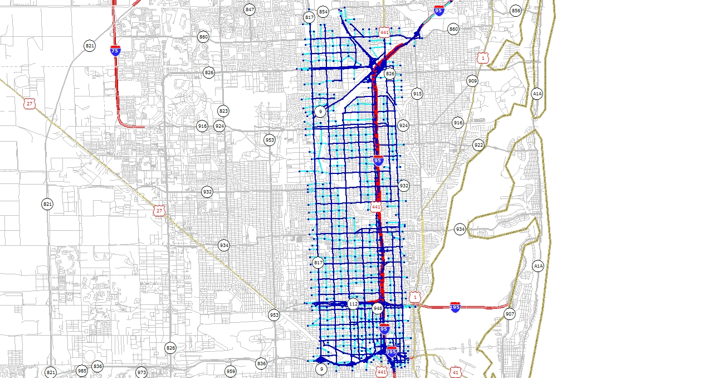The I-95 express corridor extends from SR-112 north to NW 151st Street on I-95 in the Miami/Ft. Lauderdale area. A model subarea which includes this corridor was developed by FIU from the regional model. The network for the subarea is shown in Figure 4, with the managed lane shown in red. The network contains 284 zones, and 3,064 links. Three subarea trip table sets were provided by FIU, the creator of this network. Two of these were used. The first set was stratified by vehicle type, including Drive-Alone, Shared ride 2, Shared Ride 3+ and Truck. This trip table was factored based on traffic counts. A second set of trip tables was stratified by mode and toll choice, and included SOV Non-Toll, SOV/HOV toll, Shared Ride 3+ and Truck. The latter trip table was adjusted to counts using a synthetic matrix estimation process. Totals for these trip tables are shown in Table 1. The factored table was used in these evaluations.

Table 1: I95 AM Peak Hour Trip Tables, 8:30-9:30am

|  |  |  |
| --- | --- | --- |
| Trip Tables | Factored | SME |
| SOV | 79,078 |  |
| SR2 | 16,418 |  |
| SR3+ | 7,812 | 7,984 |
| Truck | 9,410 | 7,984 |
|  |  |  |
| SOV Non-Toll |  | 93,447 |
| Toll |  | 2,623 |
| Total | 112,717 | 112,038 |

The trip tables were also stratified by 15-minute intervals from 6:30am to 9:30am. The peak hour within this timeframe was from 8:30am to 9:30am and this was the demand period assigned to the network. Changes were made to the assignment script and network to ensure compatibility to a 1-hour assignment.

#### Results – I-95 HOT Lane

Several types of tests were performed to evaluate the performance of the Phase I methodology for this model. First, the input willingness to pay and toll policy curves were systematically modified to gauge the reaction of the model to these changes. Figure 5 and Figure 6 show the variations of these input curves. In Figure 5, four WTP curves were tested, representing average values of time of $11.84, $19.02, $25.34 and $34.11. Of course, since these curves represent distributed values of time, it is possible to have different shaped curves represent the same average value of time. So, to some extent the shape of these curves is also important. The average values of time above represent 34%, 55%, 73% and 99% of the regional average annual household income, which is $71,969. A total of 10 combinations of the WTP and toll policy curves were tested.

Figure 5: Willingess to Pay Curves Tested for I95 Subarea

The toll policy curves shown in Figure 6 represent a range of low, medium and high toll policies, with similar minimum and maximum values. A fourth curve, labeled “Turnpike” is an approximation of the actual I-95 toll adjustment algorithm. The turnpike toll policy exhibits a very low and flat toll for volume to capacity ratios below 0.25, with a relatively steep increase in tolls above that level, when compared with the other toll policy curves. The “medium” toll policy curve is identical to that used by MnDOT in their original evaluations of the I35W HOT lane in the Minneapolis/St. Paul region.

Figure 6: Toll Policy Curves Tested for I-95

Three measures were used to evaluate the response to these sensitivity tests:

1. Southbound Demand on the HOT lane (Figure 7)
2. Maximum Estimated Toll (Figure 8)
3. Overall Revenue (Figure 9)

Figure 7 shows how the peak directional demand (i.e., southbound peak hour demand) varies as we change both the willingness to pay curve and the toll policy curve. As the figure illustrates, the toll lane demand, which includes toll payers as well as 3+ occupancy carpools, increases with higher values of time, and with lower tolls, as expected. This demonstrates the model’s rational response to toll and value of time.

The 2011 observed average am peak hour southbound flow was 1,389 vehicles per lane[[1]](#footnote-1), and the I95 facility is 2 lanes for most of the facility length. The SME trip table was assigned, and resulted in a total volume of 1,952 trips southbound, considerably less than the equivalent observed 2,778 vehicles. This suggests that the SME trip table, and the factored trip table (which are virtually the same magnitude) may be under-estimating the actual demand. When using the I95 toll policy curve and a WTP curve at $19.02, the model estimates 1,296 trips which is lower than the SME trip table. The peak hour toll value estimated by the model was $2.23 vs. $1.70 observed.[[2]](#footnote-2) The underestimation of demand, coupled with an overestimation of the toll suggests that both of the toll and demand could be brought closer to the “observed” values with a lower toll policy and/or a higher value of time. This in fact is the case for a high VOT and a medium toll policy, which results in a demand of 1,788 and an average toll of $1.64 for southbound travel – much closer to the targets of 1,952 SME demand and $1.70 fare.

Figure 7: I95 Toll Demand Sensitivity

Figure 8 shows the sensitivity of the modeled toll to changes in the WTP curve and toll policy curves. As expected, the estimated peak hour southbound toll increases with a greater VOT and with higher toll policy curves. Values range from a low of $0.72 for a low toll/low VOT assumption to a high of $2.23 which uses the I95 simulated toll policy and a medium-high VOT (73% of average hourly income).

Figure 8: I95 Toll Level Sensitivity

Figure 9 shows how the revenue (toll \*paying users) varies with the combination of WTP curves and toll policy curves. In our tests, the greater VOT assumed in the WTP curves always resulted in a greater revenue for a given toll policy, which is expected. However, for a given VOT, the revenue did not necessarily increase with higher toll policy curves. As tolls increase, demand, being somewhat elastic, is suppressed and results in lower revenues. In our tests, the peak revenue occurs at a high VOT and a medium toll policy, with decreased revenues for both low and high toll policy curves.

Figure 9: I95 Toll Revenue Sensitivity

#### Dual Toll Facility Test

Figure 10: I95 Dual HOT Lane Test Network

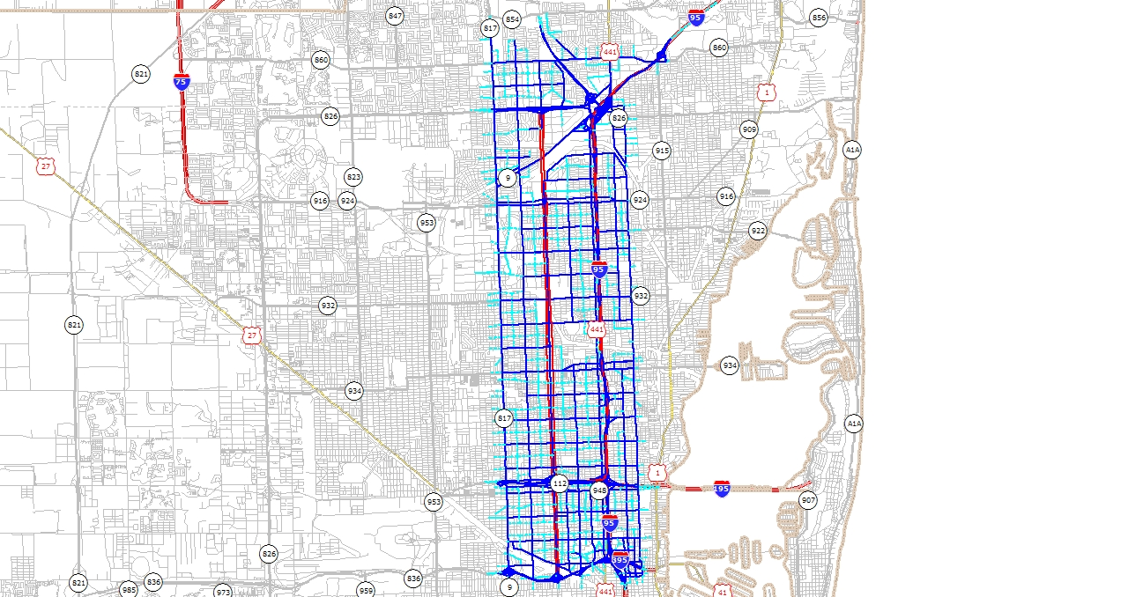A test was performed to determine how the model would respond to competing toll facilities. In the test, the I95 subarea network was modified to include a second north-south, two way HOT lanes along 17th Avenue, with one lane in each direction. The lane extends from the Palmetto Expressway to the EW expressway (SH836). The facility is divided into two toll segments, north and south of the Airport expressway. In addition to access points at the termini and the Airport Expressway, additional access/egress was provided at 87th Street and at 135th Street.

The test included two model runs, one using a medium-high VOT WTP curve ($25.34/hr average VOT) coupled with the simulated I95 toll policy curve. The second run was identical, except that for the 17th Avenue HOT lanes, a lower toll policy curve is applied, approximately $1.00 lower for volume to capacity ratios between 0.4 and 0.98. No change was made for the I95 toll policy curve.

Figure 11 shows the results of this test. The figure captures a screenline across the HOT lanes about 1.5 miles south of the Palmetto Expressway, and focuses on the AM peak hour (8:30am-9:30am) southbound HOT lane flows at that screenline. The far right bar on Figure 11 shows the demand at this point without the 17th Avenue HOT lane. The chart reveals the following:

1. The demand on the I95 HOT lane was not adversely affected by the addition of the 17th Avenue HOT lane. This is probably due to the higher capacity of the I95 HOT lane (2 lanes vs. 1 lane for 17th Avenue) and the different travel markets each serves. The small change in I95 shows a decrease in HOV2 paying trips with the addition of the 17th Avenue HOT lane.
2. In changing from a Low to a High toll policy curve, the demand on 17th Avenue by about 16% while the average toll increases by 21%. However, the overall revenue decreases by 12.7%. This equates to an elasticity of demand with respect to toll of -0.76.
3. The HOV2 lane flows changed the more than the SOV flows on the 17th Avenue HOT lane. As shown in Figure 12 and Figure 13 the demand flows provided show a much greater HOV2 toll demand using the 17th Avenue HOT lane while SOV toll flows use the I95 HOT lane more prominently. This appears to be a function of the OD pattern of HOV2 and SOV demand flows, which lend themselves to either the 17th Avenue or I95 HOT lanes.

Figure 11: Sensitivity to Toll Changes, Competing HOT Lanes

Figure 12: HOV2 Paying Vehicle Flows, Dual HOT Lane Testing

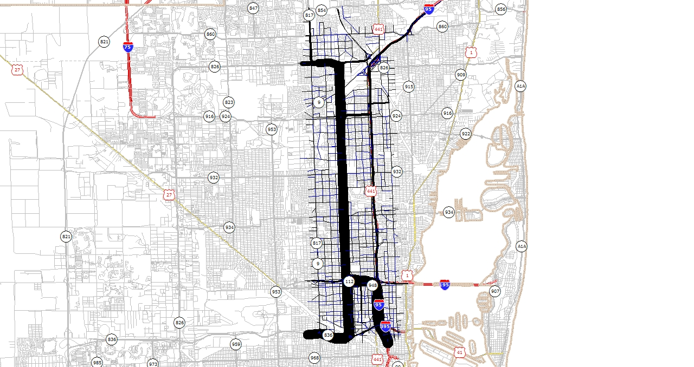

Figure 13: SOV Pay Vehicle Flows, Dual HOT Lane Testing

### SOVToll.jpg

The results of this test show that the Phase I model does respond in a reasonable way to competing HOT lanes, and to changes in toll levels under this type of scenario.

#### Equilibrium Assignment Iteration Stability

A final examination of the Phase I model in this subarea looked at how Managed Lane demand and toll levels change within the equilibrium iteration. It is important to show that the progression of demand and tolls reaches a stable solution. This test used data from the dual toll facility test assignments, with the high toll option on the 17th Avenue HOT lanes.

Figure 14 shows how the SOV and HOV2 paying volume varies by iteration. The assignment converged in 80 iterations, a gap criteria of 0.000001 was set and a RAAD criteria (relative average absolute difference in volumes between iterations) of 0. The RAAD criterion was met after 80 iterations. The gap at that point was 0.00013 and the relative gap was 0.00042. For comparison, the low toll option, with the same convergence criteria, converged after 72 iterations, and had a final gap value of 0.0000651 and a relative gap of 0.00036.

Figure 14: Toll Volume Estimation by Assignment Iteration

As Figure 14 shows, both the SOV and HOV2 toll demand stabilizes quite quickly after about 20 iterations and is certainly stable in the iterations that follow, well before the relative gap reaches a minimum. During the last 20 iterations, the volumes changed by an average of less than 0.01%, the equivalent of less than 10 trips.

In Figure 15 the toll variability by equilibrium iteration is show. The variability of the toll values (shown here by toll segment) is extremely stable after about 10 iterations, and remains so throughout the remaining iterations. Note that the purple line represents the toll on the 17th Avenue HOT lane, Southbound, northern segment, and the red line represents the toll on I95, Southbound.

Figure 15: Toll Estimation by Assignment Iteration

### Orlando HOT Lane Testing

A second sensitivity test used the CFRPM regional model as a testbed for the Phase I model application. This tested the applicability of the Phase I approach to a large regional model. Once again, the same set of WTP curves (Figure 5) and toll policy curves (Figure 6) were used, and the same combinations were tested to evaluate the toll demand, toll level and revenue response to each.

The HOT lane was coded on I-4 from Saxon Blvd in Deltona on the north end to SR434 near Longwood on the south – a length of about 17 miles. Five toll segments were identified within this length, with each direction receiving its own toll assessment. Figure 16 and Figure 17 show the area and location of the HOT lane coding.

Figure 16: Orlando I4 HOT Lane Test, Large Scale

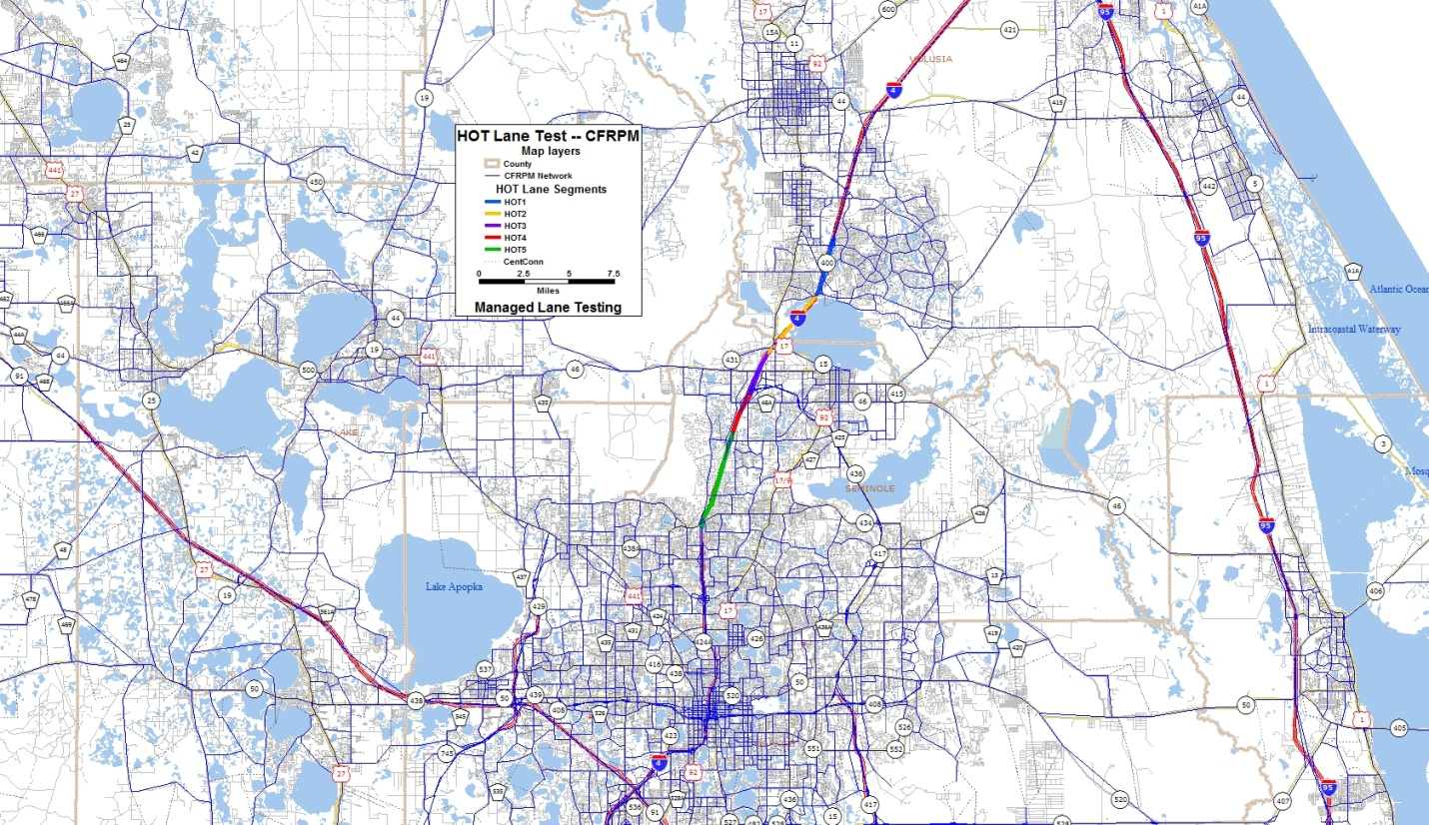

Figure 17: Orlando I4 HOT Lane Test, Detailed Scale

### OrlandoHOT_detail.jpg

Figure 18 shows the demand sensitivity, using the peak segment demand. The toll lane demand, which includes toll payers as well as 3+ occupancy carpools, increases with higher values of time, and with lower tolls, as expected. This demonstrates the model’s rational response to toll and value of time.

Figure 18: I4 Orlando Toll Demand Sensitivity

Figure 19 illustrates the model’s estimated peak segment tolls as a function of variations to the toll policy curve and the average VOT, as expressed in the WTP curve. Again, the chart shows a clear trend that tolls increase with increasing average VOT and with higher toll policy curves. This is also consistent with expectations.

Figure 19: I4 Orlando Toll Sensitivity

Figure 20 shows how overall revenue changes with increasing VOT and with changes to the toll policy curve. As the WTP curves change to represent increasing VOT, the revenue increases steadily. However, the toll level increases, the toll revenue stays relatively flat. In the case of a high VOT, the toll revenue actually decreases as the higher toll discourages demand, offsetting the increased toll. Both of these results are rational, and demonstrate the usefulness of the model to optimize anticipated revenue.

Figure 20: Orlando I4 Toll Revenue Sensitivity

#### Orlando Model Equilibrium Assignment Iteration Stability

Figure 21 shows the toll demand variation for the VOT/Toll variations tested. All show significant stability after about 25 assignment iterations and certainly well before the equilibrium closure criteria are met. In the final 20 iterations, all volumes show an average variation from the previous iteration of less than 0.025% or no more than 5 trips.

Figure 21: Orlando I4 Toll Demand Variation by Assignment Iteration

### Tampa HOT Lane Testing

A third sensitivity test uses the Tampa Bay regional model as a testbed for the Phase I model application. The reason to include this particular model for testing is because this is the first application of the Phase 1 approach in an actual planning project and phase I assignment methodology has already been implemented for managed lane scenario in the model. Another unique aspect is that it contains an extensive HOT lane system in the network as shown in .

However, it was found that the implementation is not exactly the same as Phase I approach, and required some modifications to demonstrate the performance of Phase 1 model for the HOT lane system. Although willingness to pay curve was incorporated in the model to estimate the variable toll/no-toll demand, variable toll values were not considered and rather a fixed per mile toll is assumed for the HOT lanes. The model script was revised to implement dynamic tolls along with some other modifications, in order to allow the testing of full features of the Phase I approach. The HOT lane system in the network was split into different segments as shown in Figure 23, so that the variable toll can be applied to the segments using a similar approach based on the toll policy curve.

Figure 22: HOT Lane System

**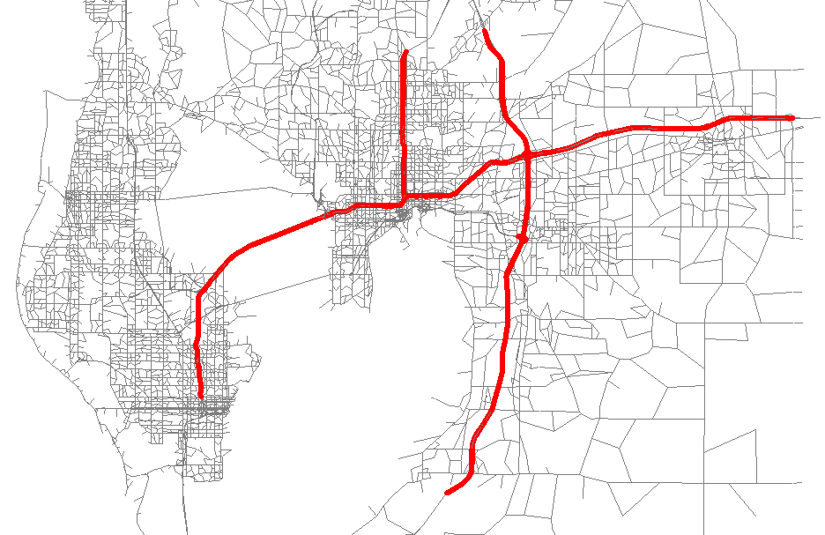**

Figure 23: HOT Lane System Divided into Segments

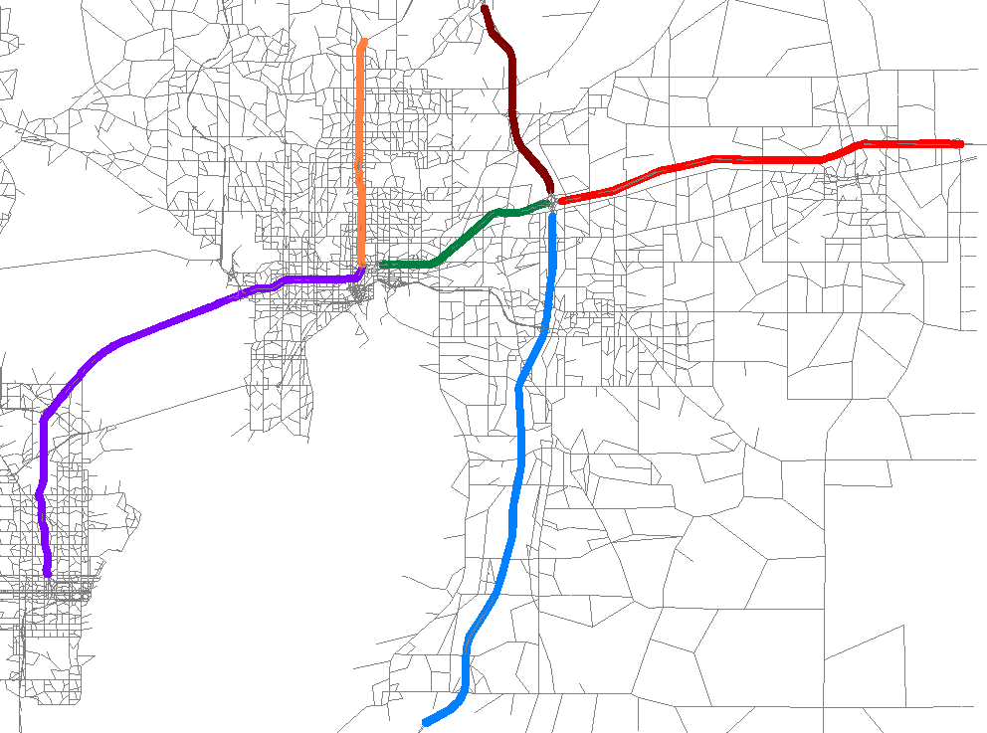

#### Results – HOT Lane System, Tampa Regional Model

Similar tests were performed to evaluate the performance of the Phase I methodology for this large regional model with an extensive HOT lane system. Once again the same set of WTP curves (Figure 5) and toll policy curves (Figure 6) were used, and the same combinations were tested to evaluate the toll demand, toll level and revenue response to each.

Figure 24 shows the HOT demand sensitivity for the peak hour as we change the willingness to pay curve and the toll policy curve. The figure illustrates that the total HOT demand increases with higher values of time, and with lower tolls, demonstrating the model’s rational response to toll and value of time, consistent with the other two model test results.

Figure 24: HOT Demand Sensitivity – Tampa Regional Model

Figure 25 presents the sensitivity of the segment tolls as the WTP curve and toll policy curve changes. The reported toll values in the figure are the maximum peak toll among all the HOT segments in the network. Once again, the figure illustrate that the peak hour toll increase with increase in VOT and with higher toll policy curves. This is again consistent with expectations and the trend from other two model tests.

Figure 25: HOT Toll Sensitivity – Tampa Regional Model

Figure 26 shows how the total HOT revenue changes with change in VOT and with changes to the toll policy curve. As expected, the greater VOT assumed in the WTP curves always resulted in a greater revenue for a given toll policy curve. However, for a given VOT, the total revenue did not necessarily increase with higher toll policy curves, illustrating the effects of elasticity of demand with respect to tolls.

Figure 26: HOT Revenue Sensitivity – Tampa Regional Model

#### Equilibrium Assignment Iteration Stability

Figure 27 and Figure 28 shows the variation of HOT demand and segment tolls respectively during the equilibrium assignment for the different combination of VOT and Toll policy. For demonstration, toll values reported in Figure 28 are for HOT segment 1. For all the tests, stability in demand and toll was achieved after about 18-20 and 10 assignment iterations respectively and thus once again demonstrating that the highway assignment application produces stable solutions.

Figure 27: HOT Demand Variation by Assignment Iteration – Tampa Regional Model

Figure 28: HOT Toll Variation by Assignment Iteration – Tampa Regional Model

#### Results with Existing WTP Curve

Additional tests were performed using a different willingness to pay curve which is provided in the managed lane application of the TBRPM model. The existing WTP curve is segmented by trip purpose and the model considered three slightly different input curves for HBW, HBO and NHB trips as shown in Figure 29, representing average values of time of $15.91, $14.17 and $15.18 respectively. As mentioned earlier, the Phase I implementation in TBRPM model does not consider variable toll, but a fixed per mile toll on the HOT lanes is assumed. We tested how the model would respond to the existing WTP curve segmented by trip purpose and the fixed toll policy considered in the model. Additionally, we also tested the model response with low, medium, and high toll policy curves considered in previous set of tests.

Figure 29: Existing Willingess to Pay Curve

For a given WTP curve, Figure 30 yet again demonstrates that the HOT demand decreases with the higher tolls. Similar trend is observed in Figure 31 for HOT demand with different trip purpose.

Figure 30: HOT Demand Sensitivity – Existing WTP

Figure 31: HOT Demand Sensitivity by Trip Purpose – Existing WTP

Figure 32 and Figure 33 shows the sensitivity of HOT toll and revenue respectively for different toll policies with existing willingness to pay curve. Figures illustrates that the peak hour toll increases with the higher toll policy curve and revenue does not necessarily increase with the higher toll policy curve, consistent with the findings from other tests. For the fixed toll policy it was observed that even though the toll level is high, HOT demand is also very high, indicating the sufficient capacity of the HOT lanes to allow high demand even under a high toll value.

Figure 32: HOT Toll Sensitivity – Existing WTP

Figure 33: HOT Revenue Sensitivity – Existing WTP

## Conclusions

The sensitivity tests presented in this memo show that the Phase I managed lane modeling approach has the following characteristics:

1. The toll demand, toll values and revenue respond in a reasonable way to changes to the willingness to pay curve (representing users’ VOT) and the toll policy curve (representing the tolling strategy).
2. The model is capable of approximating observed results, given reasonable flexibility in VOT and toll policy curves, and allowing for the approximate nature of OD flows in the model.
3. The model shows a reasonable response to the presence of a competing managed lane, and shows reasonable sensitivity to toll policy changes within a competitive managed lane configuration.
4. The demand and toll estimates reach a stable solution within 20 iterations, and also within the number of iterations required for a “tight” closure criterion.

1. “95 Express Annual Report”, prepared by FDOT District 6, February 17, 2012. Page 10. [↑](#footnote-ref-1)
2. “95 Express Annual Report”, prepared by FDOT District 6, February 17, 2012. Page 12. [↑](#footnote-ref-2)