Managed Lane Modeling Application for FSUTMS

Phase II

March, 2013

Draft version 2.2

Version Date: 3/27/2013





Table of Contents

1. Introduction 4

2. Development of Mode Choice Model with Toll Paying Alternatives 5

2.1. Mode Choice Model Structure 5

2.2. TOLL and HOV Choice Utility Equations 7

2.3. Mode-Specific Constants 9

2.4. XCHOICE Implementation 10

2.5. Prototype Network and Network Coding 11

2.6. Overall Model Flow 14

2.7. Testing Results 14

2.8. Guidance on Model Estimation and Calibration 17

3. Integration of Mode Choice Toll Model and Assignment-Based Dynamic Toll Model 18

3.1. Feedback Integration 18

3.2. Integration with Assignment-Based Dynamic Toll Model 19

3.3. Consistency in Value of Time 20

3.4. Testing of Integrated Model 22

3.5. Model Estimation and Calibration Guidance 26

4. Conclusions 27

Appendix 28

A-1. Cube Script for Mode Choice Model with Toll Paying Alternatives 28

A-2. Cube Script for Highway Assignment in Integrated Model 44

List of Tables

Table 1‑1: Managed Lane Modeling Development Plan 4

Table 2‑1: Calibration Results for TOLL Constant 10

Table 2‑2: Calibration Results for HOV Constant 10

List of Figures

Figure 2‑1: Existing Mode Choice Model in FSUTMS 6

Figure 2‑2: Auto Nest in Existing Mode Choice Model 6

Figure 2‑3: Revised Nesting Structure for Auto Nest 7

Figure 2‑4: Sample Utility Equation 9

Figure 2‑5: Sample XCHOICE Command 11

Figure 2‑6: HOT and HOV Segments 12

Figure 2‑7: Network Coding Diagram 13

Figure 2‑8: Location of Test Origin and Destination 15

Figure 2‑9: Sensitivity to Toll Values for Mode Choice Probability for Selected OD (475-5) 16

Figure 2‑10: Sensitivity to Tolls for Shares within Drive Alone Nest for Selected OD (475-5) 17

Figure 3‑1: Flow Chart for Feedback Integration 18

Figure 3‑2: Flow Chart for Integrated Model Implementation 20

Figure 3‑3: Willingness to Pay Curve 21

Figure 3‑4: Toll Policy Curve 21

Figure 3‑5: Toll Segments for HOT Facility 22

Figure 3‑6: Total Toll Trips 23

Figure 3‑7: Total HOV Trips 23

Figure 3‑8: Eastbound Toll Values 24

Figure 3‑9: Westbound Toll Values 24

Figure 3‑10: Eastbound Toll Values within a Feedback Iteration 25

Figure 3‑11: Westbound Toll Values within a Feedback Iteration 25

# Introduction

Managed lanes treatments are becoming a preferred strategy for major capacity additions for roadways in Florida. Managed lane strategies include a variety of measures that seek to actively control and incentivize travelers with the aim of offering a superior level of service and/or safety. Examples of managed lanes are toll facilities, toll lanes, HOT lanes (which allow high-occupancy vehicles free access along with paying single-occupancy vehicles), express lanes and reversible lanes. With this increased emphasis on managed lanes in Florida, there is a need to adopt a standard modeling practice for forecasting managed lane demand, one that is flexible enough to cover the varieties of managed lane treatments, consistent in assumptions and able to be implemented so that assumptions are transparent and easy to understand.

summarizes the development plan of managed lane modeling application for the Florida Standard Urban Transportation Model Structure (FSUTMS). This proposed three-phase program will generate a robust “toolbox” of managed lane modeling applications that can meet the planning needs of all agencies based on their modeling capabilities and the required level of detail and model sophistication. This report describes the development and testing of prototype application of the Phase II model for managed lane modeling.

Table 1‑1: Managed Lane Modeling Development Plan

|  |  |  |  |
| --- | --- | --- | --- |
|  | **Phase I** | **Phase II** | **Phase III** |
| **Type** | Assignment-Based | Mode Choice + Assignment | Discrete Choice |
| **Model Type** | Trip-Based, Static | Trip-Based, Static | AB and/or DTA |
| **Features** | Dynamic toll Estimation, Willingness to pay Curve, Toll Policy | Feedback of toll LOS skims to mode choice. Sensitive to multi-modal shifts | Incorporates detailed HHLD characteristics for toll choice |
| **Uses** | LRTP & Corridor Planning | Multi-modal corridor evaluation | Policy Sensitivity Testing, and TP Planning |
| **Data Requirements** | SP/RP survey for WTP curve or logit estimation | SP+RP survey to estimation and calibrate MC logit | HIS supportive of AB models |
| **Availability** | Summer, 2012 | 2013 | 2014-2015 |

Phase II of the managed lanes modeling develops a prototype toll choice element within the mode choice model, and then integrates this enhanced mode choice model with the assignment-based toll model developed in Phase I using a feedback structure. Together the mode choice and feedback structure will form a complete and flexible system that can be used to estimate both toll choice as a mode and toll facility choice as a path choice.

The report outline is as follows. Section 2 presents the development of proposed mode choice model with toll paying alternatives. Integration of model choice model with phase 1 assignment process along with testing and sensitivity of integrated model is presented in Section 3. Section 4 summarizes the conclusions and recommendations from the prototype development effort. Application script for the mode choice model and integrated model is listed in Appendix A-1 and A-2 respectively.

# Development of Mode Choice Model with Toll Paying Alternatives

Traditionally, a mode choice model distinguished between drive-alone and shared ride modes for auto alternatives based on time savings, leaving the highway assignment model to allocate vehicle-trips to toll and no-toll facilities based on generalized costs, including tolls. However, the choice to use a toll facility is not simply a route choice decision, but a combination of mode choice and route choice decisions. Adding a toll choice in the mode choice model allows the model to be sensitive to different traveler markets, and to capture shift in travel modes for various managed lane strategies. The use of logit model is considered to be behaviorally better in estimating managed lane demand by allowing a wide range of travel characteristics and explanatory variables to be evaluated in the mode choice, and providing a relatively simple set of options for the highway assignment model. This section presents the development work for the enhanced mode choice model with toll paying alternatives.

## Mode Choice Model Structure

The purpose of mode choice model is to estimate the shares of person trips using different modes. FSUTMS applies a nested logit model for mode split, in which the person trips are divided into auto, transit and non-motorized modes, which are further divided into various sub-mode choices. The current model choice model in FSUTMS after the proposed improvements and recommendations as a part of transit model update project meets state of the practice. shows a model structure of the existing mode choice model in FSUTMS. Depending on the importance of transit system in the modeled area, more or less detailed nesting structure can be used under the transit nest. Since the focus of this mode choice model update is to add toll choices under auto alternatives; transit and non-motorized components are expected to remain same as in existing model.

Figure 2‑1: Existing Mode Choice Model in FSUTMS

Proposed Mode Choice Model.emf

For the auto nest, it is divided into drive alone and shared ride trips. Shared ride trips are further divided into shared ride 2 (two person trips) and shared ride 3+ (3 or more person trips). shows the auto nest in the existing mode choice model.

Figure 2‑2: Auto Nest in Existing Mode Choice Model

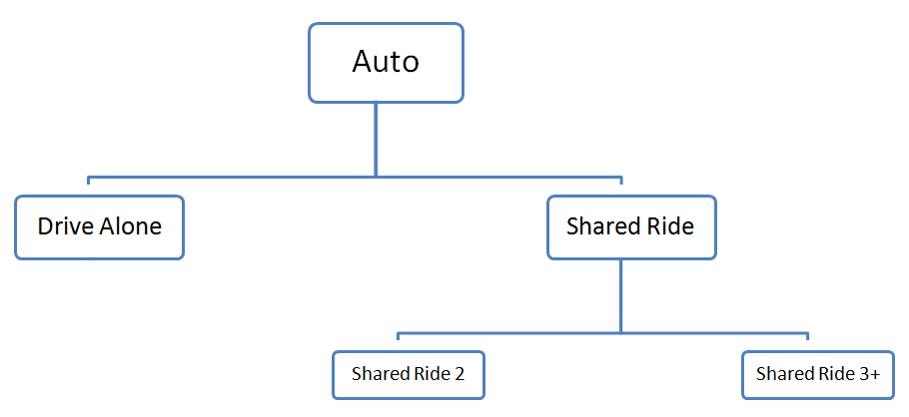

As mentioned, this phase II work aims at enhancing the current model choice model, to enable toll-paying and non-toll-paying choices for passenger car demand. A toll choice structure is added within the auto nest, currently representing drive-alone, shared ride 2, and shared ride 3+ alternatives. Consequently, each of the three auto alternatives is sub-divided into toll and no-toll choices. In addition, in order to have more general and complete choice set, the model design also allows for the choice dimensions to be further extended to include choice to use HOV facilities. More specifically, the nesting structure includes all the four possible path combinations of using toll and HOV facilities for shared ride 2 and shared 3+ alternatives. This enumeration of all the combinations allows the model to be more flexible and to provide more detailed information about each alternative. presents the revised nesting structure for the auto nest within the mode choice model.

Figure 2‑3: Revised Nesting Structure for Auto Nest

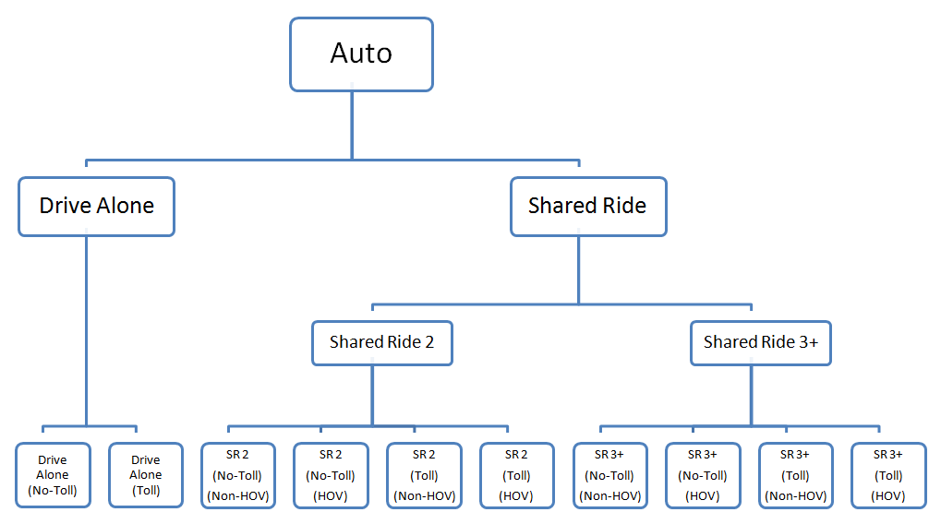

## TOLL and HOV Choice Utility Equations

In addition to the standard components for utility equations after the proposed improvements and recommendations in the mode choice model as a part of transit model update, few additional new terms were added for the utility equations for Toll and HOV choice alternatives. The coefficients mentioned here are subject to estimation based on observed values, and the constants should be used to calibrate this model, again based on observed data.

*Travel Time Savings.* To capture the difference in level of service for using Toll and HOV facilities, a travel time saving term was added to the utility equations. Time saving component for different Toll and HOV alternatives was calculated as the travel time on the best path that does not include Toll/HOV facility use minus the travel time for a path that uses a Toll/ HOV facility. The model also considers a user-specified minimum amount of time saved as an eligibility criterion in order for the alternatives with or without Toll/HOV to be considered different relative to each other. For instance, if the travel time saving for Drive Alone (Toll) alternative with respect to Drive Alone (No-Toll) is less than the specified minimum time saving, time savings will be made zero in the utility equation for Drive Alone (Toll) alternative and there is no perceived travel time benefit for a drive alone user to choose toll facility. Under these conditions, the drive-alone toll option would be removed from the choice set for this particular O-D pair.

*Time Savings Coefficient*. Studies have suggested that the time saved by using Toll/HOV facilities has a higher utility weight based on the features of traveling on these facilities, such as improved level-of-service or higher level of reliability. It has been indicated that a traveler’s value of time for using these facilities and Toll/HOV values of time are generally higher compared to the ordinary value of time, as expressed in the coefficients for auto operating costs, parking costs and/or transit fares. For the prototype model, the coefficient on time saving term in utility equations is used as the 1.5 times of the existing in-vehicle time (IVT) coefficient.

*Toll Values*. Traditionally, toll on the links are considered by converting them to a time equivalent via CTOLL parameter during the highway assignment. The logit model in the mode choice allows the toll values to be directly considered in the utility equations as a cost component.

*Mode-Specific Constants.* The mode specific constant captures the effect of un-included attributes. Some of these attributes are related to the trip-maker and trip purpose while others are related to the mode. Two new mode specific constants for Toll and HOV “modes” were added to the utility equations and appropriate values for these constants (refer Section 2.3) were used in the prototype mode choice model.

*Nesting Coefficients.* As indicated earlier, an additional level of Toll/HOV choice nest is added to the nesting structure. It is required that the nesting coefficient at a lower level should be less than or equal to the upper level nesting coefficient and the product of the nesting coefficient of all levels should not be lower than 0.25-0.30. Based on these guidelines, the nesting coefficients used for the prototype model are 0.7 (Auto), 0.65 (Auto occupancy) and 0.55 (Toll/HOV choice).

To demonstrate how utilities are defined in the script for different alternatives, shows an example of utility for drive alone toll alternative. The utility term has a toll constant term, a terminal time component, travel time (drive alone toll time in this case), travel time saving component (time saved by using Toll facility relative to general purpose facility for a drive alone vehicle), toll value, parking cost and auto operating cost.

Figure 2‑4: Sample Utility Equation

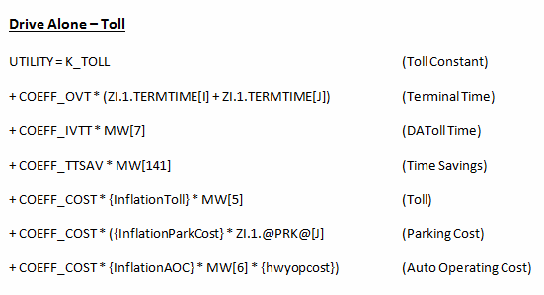

## Mode-Specific Constants

Constants for Toll and HOV “modes” are calibration parameters and appropriate values for these constants must be established via model calibration. For the prototype model to produce reasonable output, a calibration process was performed to get the appropriate values of these constants. For a given value of constant (K_TOLL/K_HOV), Toll and HOV trips from the mode choice model and from the highway assignment model are obtained. First, the Toll and HOV trips estimates from mode choice model should be reasonable numbers and should not be very different from the trips actually assigned to the HOT and HOV facilities in the network during the assignment step. Second, the mode choice model results estimating the TOLL and HOV demand should be to some extent restricted by the physical capacity of the network. Consequently, for the calibration process, the constants are adjusted up or down until most of the mode choice trips are actually assigned to the HOT and HOV facilities and the link loadings are comparable to the link capacity. Note that the constants shown here were “calibrated” in this general way in the context of the integrated mode choice and phase I assignment process, which is discussed in section 4.

and present the calibration results for TOLL and HOV constant respectively. In the tables, columns representing TOLL/HOV trips for “Mode Choice” are the estimated total Toll and HOV trips from enhanced mode choice model and for “Hwy Assignment” are the total trips actually using HOT/HOV facilities in the network. The column “maximum load” indicates the maximum volume on any particular link of the HOT/HOV facility in loaded network after the highway assignment. The “V/C” column is the volume (maximum load) to capacity ratio for the managed lane links. Based on the obtained results, the mode-specific constants used in the prototype network for Toll and HOV “modes” are chosen as -1.5 and 0.0 respectively.

Note that for the prototype model, the constants are not calibrated to the actual values; instead the constants are obtained by comparing link loadings to capacities for reasonableness. However, the same basic steps would be taken in an actual calibration, if the observed demand or count data is available.

Table 2‑1: Calibration Results for TOLL Constant

|  |  |  |  |  |  |
| --- | --- | --- | --- | --- | --- |
| **K_TOLL** | **TOLL Trips** | | **Maximum Load** | **Ratio (Max/Total)** | **V/C** |
| **Mode Choice** | **Hwy Assignment** |
| -0.50 | 7615 | 6962 | 4799 | 0.69 | 2.78 |
| -0.75 | 4506 | 4461 | 3365 | 0.75 | 1.95 |
| -1.00 | 3688 | 3663 | 2893 | 0.79 | 1.67 |
| -1.25 | 3591 | 3547 | 2878 | 0.81 | 1.67 |
| **-1.50** | **2021** | **2003** | **1688** | **0.84** | **0.98** |
| -1.75 | 588 | 573 | 495 | 0.86 | 0.29 |

Table 2‑2: Calibration Results for HOV Constant

|  |  |  |  |  |  |
| --- | --- | --- | --- | --- | --- |
| **K_HOV** | **HOV Trips** | | **Maximum Load** | **Ratio (Max/Total)** | **V/C** |
| **Mode Choice** | **Hwy Assignment** |
| 0.25 | 4762 | 3931 | 1861 | 0.47 | 1.08 |
| **0.00** | **3272** | **2688** | **1227** | **0.46** | **0.71** |
| -0.25 | 2309 | 2007 | 963 | 0.48 | 0.56 |
| -0.50 | 905 | 816 | 448 | 0.55 | 0.26 |
| -0.75 | 606 | 516 | 262 | 0.51 | 0.15 |
| -1.00 | 224 | 178 | 109 | 0.61 | 0.06 |

## XCHOICE Implementation

XCHOICE command statement is used to implement a logit model. Alternatively, model script can be written to compute the mode shares based on logit probabilities. However, the XCHOICE command makes the process easy and it is faster and more efficient to use. It is a single command with readable keywords, and all the matrix manipulation for the logit model is automated for the user. describes the sample XCHOICE command to implement a nested logit model for mode choice.

Figure 2‑5: Sample XCHOICE Command

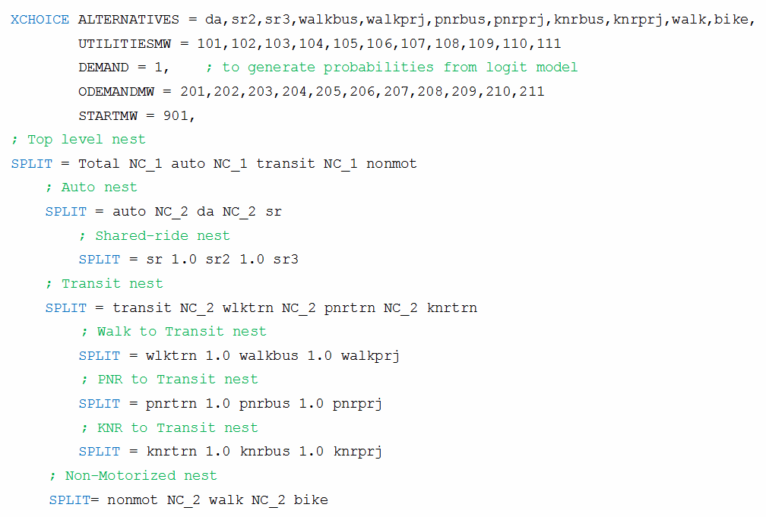

## Prototype Network and Network Coding

The enhanced mode choice model was developed as a prototype model and the application was implemented for the Olympus model. The prototype application was tested with a managed lane scenario with a set of HOT facility along I-4 and HOV facility along Polk Parkway. This managed lane scenario will allow us to obtain different combination of HOV/Toll skims, required as an input to the mode choice model. In , the three colored sections (orange, brown and red) along I-4 represent the different toll segments, and the green colored section along Polk Parkway represent the HOV facility in the network. Note that for the three toll sections, the toll cost in eastbound directions may be different than the toll cost in westbound direction, and thus there are in fact six separate toll segments for this prototype network.

Figure 2‑6: HOT and HOV Segments

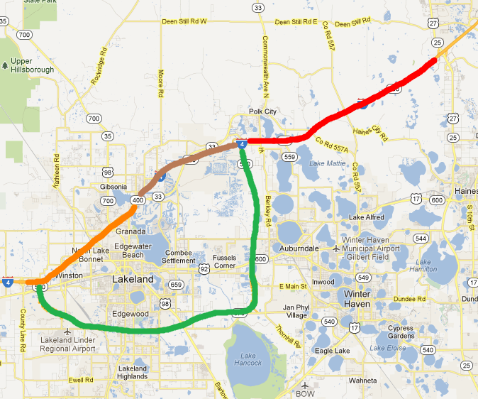

shows an example of the network coding used to represent the managed lanes scenario. What had previously been coded as general purpose lanes for I-4 and Polk Parkway was revised to include coding for both general purpose and managed lanes facilities. The figure shows that toll lanes were coded in parallel to existing general purpose lanes along I-4. Similarly, HOV lanes were coded in parallel to existing general purpose lanes along Polk Parkway. For each node in the general purpose lane links that provided a connection to the non-freeway network system, entry and exit links between the managed lanes and general purpose lanes were added.

The network editor feature of Cube was used to add HOT and HOV lanes and the entry/exit to the network. Attributes for the new links were coded the same as the adjacent existing general purpose links, with the exception of number of lanes and facility type. Appropriate facility types were defined for the links along HOT and HOV facilities and one lane for both HOT and HOV facility in addition to two and one adjacent general purpose lanes respectively.

Figure 2‑7: Network Coding Diagram

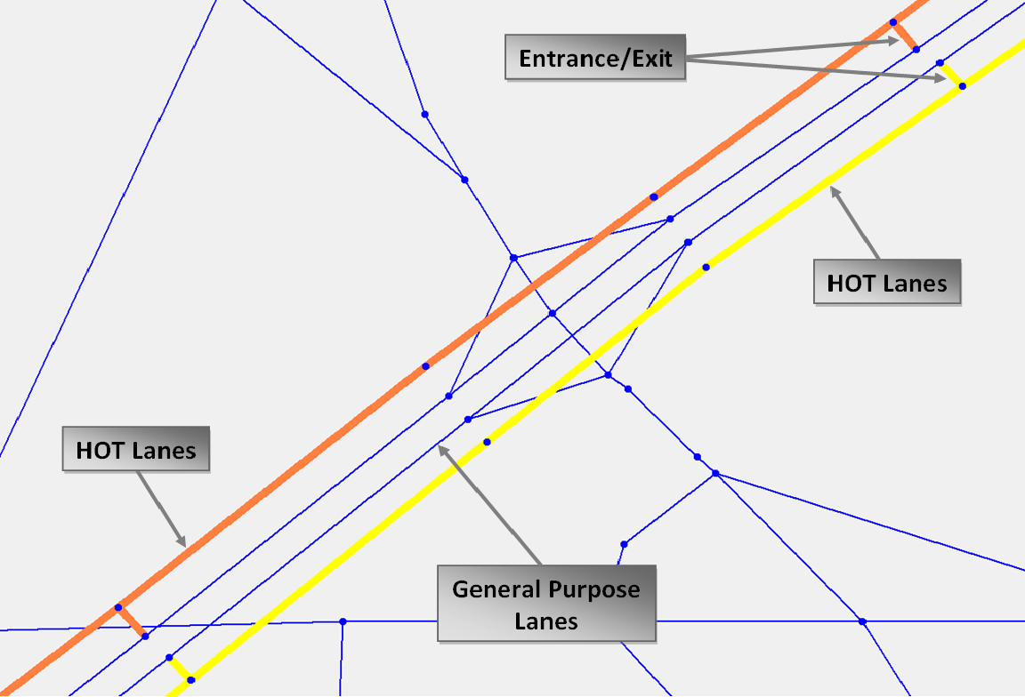

## Overall Model Flow

The cube script for enhanced mode choice model with toll paying alternatives is listed in an Appendix at the end of this report. The overall model flow for the mode choice model in FSUTMS is unchanged and is similar as after the proposed improvements and recommendations as a part of transit model update project.

The model earlier had separate skims for SOV and HOV facilities. In the updated model, the scripts were revised to generate the time and cost skims supporting all different HOV/Toll combinations for input to the mode choice model. The skims are obtained using the loaded highway network after the pre-assignment model step. The pre-assignment part uses a peak and off-peak dummy trip table to load on the network, and the structure of dummy trip table and highway assignment procedure in the “Network” step was revised to include different HOV/Toll combinations. Note that since the initial skims are obtained based on dummy trip tables, the dummy trip tables for different alternatives should be a close approximation of actual demand, to obtain reasonable travel time savings and other inputs to the mode choice model.

Further, the model script was revised for the time saving component inside the mode choice model to obtain the travel time savings for using HOV/Toll “modes”. Earlier, the scripts had the similar time saving calculation for using HOV relative to SOV. Finally, the script was revised (see Appendix A-1) for the mode choice model to calculate the probabilities of using different modes for different trip purposes and periods. In addition to the required changes in scripts in the model components, appropriate values of constants and parameters should be used in the model.

## Testing Results

The prototype mode choice model was tested for the updated network with the managed lane scenario. The model was tested for functionality and verified the output results from mode choice model for reasonableness. In addition to confirming that the prototype model functioned correctly as expected, some sensitivity analysis was done. The test procedure allowed us to compare the mode choice probabilities under varying toll values for HOT lanes. The origin-destination pair (475 – 5) used for testing the sensitivity of results is shown in .

The mode choice model generates probabilities of choosing different modes as output. For each trip purpose, the mode choice model is segmented by household markets (based on income and car sufficiency) and by peak and off-peak period. The household markets segments in the model are:

1. Zero Cars All Income – Market 1
2. Car Insufficient Low Income – Market 2
3. Car Insufficient Medium Income – Market 3
4. Car Insufficient High Income – Market 4
5. Car Sufficient Low Income – Market 5
6. Car Sufficient Medium Income – Market 6
7. Car Sufficient High Income – Market 7

Figure 2‑8: Location of Test Origin and Destination

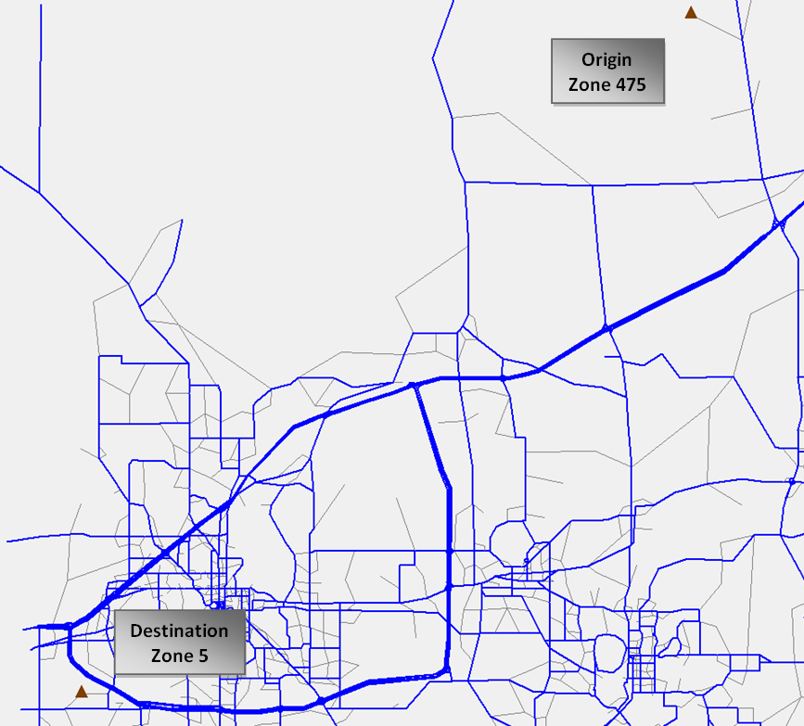

As a measure of toll choice sensitivity in the mode choice model, response of the model to change in toll values was evaluated and is presented below in and . The mode choice probabilities results shown in these figures are for “HBW” trips and “Peak” period. Also, note that the results provided below for the mode choice model testing are for a particular O-D pair and not system-wide. presents the probabilities of choosing “Drive Alone – Toll” mode for different defined markets in the model by varying toll values between the selected O-D pair. The figure show logical sensitivity towards toll and as expected. The probability of choosing “drive alone – toll” alternative decreases as the toll is increased. Although the magnitude of change in probability may not significant in many cases, the general trend from the model is decreasing. Note that the magnitude of decrease in probability by increasing toll is directly related to the coefficient on cost in the model.

shows toll sensitivities to mode shares for “Drive Alone – Toll” and “Drive Alone – NoToll” alternative within Drive Alone nest. For demonstration, the results for market 4 (Car Insufficient High Income) are only shown in the figure. It is observed that as the toll value for an O-D pair increases, probability of choosing “drive alone – toll” alternative decreases and “drive alone – no toll” alternative increases, as expected. Similar output results and trends were observed for all other trips purpose and periods for different markets. The testing demonstrates that the mode choice model is sensitive towards toll level. Further, mode choice toll model illustrates the capability to evaluate the Toll/HOV choice by capturing additional travel characteristics and explanatory variables by the use of logit model in mode choice.

Figure 2‑9: Sensitivity to Toll Values for Mode Choice Probability for Selected OD (475-5)

Figure 2‑10: Sensitivity to Tolls for Shares within Drive Alone Nest for Selected OD (475-5)

## Guidance on Model Estimation and Calibration

The mode choice model estimation for the proposed structure, which includes toll and HOV demand, should proceed in the same general manner as any model estimation. Specifically, there will be a need to collect data (either stated or revealed-preference) on user’s choice between toll and non-toll, HOV and non-HOV options, with associate travel times. A least-squares estimate can then be made for the time and cost coefficients specified in the model. The data may also be useful in revealing the minimum time savings required. Model calibration will require observed toll and HOV demand on a trip O-D basis, coupled with model-estimated travel time and using the previously-estimated utility coefficients. This data may be collected from a general home interview survey, or potentially from trip-intercept data or through a targeted sample of HOV/HOT lane users, similar to how transit users are selected for surveys.

# Integration of Mode Choice Toll Model and Assignment-Based Dynamic Toll Model

## Feedback Integration

The developed mode choice toll model is first integrated with the rest of the model structure in FSUTMS; including the feedback from the highway assignment model without the Phase I dynamic toll assignment procedure. The mode choice model generates logsums for all modes which are subsequently used as an input into the trip distribution model. Trip distribution model then establishes the total number of person trips for the model choice model. Using the previously-estimated mode shares, the actual number of mode-specific trips is then determined. Because of the addition of new alternatives (“modes”) in the mode choice model, model scripts and input/output structures of rest of the model components (in particular trip distribution and highway assignment) were revised to have a seamless integration with the enhanced mode choice model. The feedback of skims between mode choice model and highway assignment step was developed, so that demand matrices produced by the model choice model are used in the assignment model and skims generated in the assignment step are used in the mode choice model. Finally, the complete model was tested for functionality. shows the flowchart of the feedback integration between mode choice, trip distribution, highway assignment and skims.

Figure 3‑1: Flow Chart for Feedback Integration

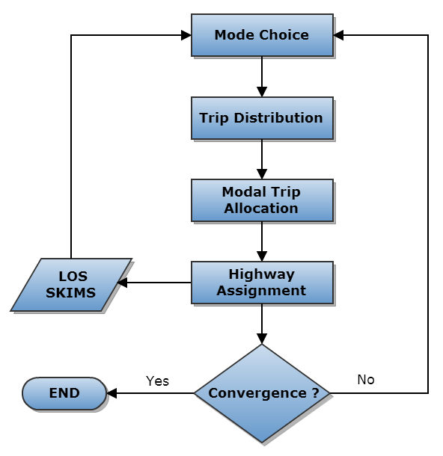

## Integration with Assignment-Based Dynamic Toll Model

The feedback integration described in the previous section uses skims from a standard multi-class highway assignment to inform the mode choice and distribution models for the next iteration. To this point, the mode choice model must use a fixed toll skim, with little variation except for that which would be a result of different path sets between iterations. However, it is desirable to incorporate the dynamic tolling highway assignment model developed in phase I in order to obtain the toll values which are optimal to the demand level, and to have integration and consistency between the dynamic toll assignment procedure and the mode choice toll model. This integration ensures better consistency between both travel times and costs that determine demand and the demand that influences travel time and costs.

Dynamic toll procedure of phase I was implemented in the highway assignment step and the feedback of toll values between mode choice model and highway assignment model was also developed. Similar to phase I project, two key input tables are used to implement this dynamic toll assignment procedure, i.e., willingness to pay curve which describes the probability of the user to pay given the marginal cost/minute saved, and a toll policy curve which describes how the toll varies by congestion as measured by the volume to capacity ratio.

First, mode choice toll model uses an initial set of toll values for the toll segments. Based on the mode choice probabilities and the trip distribution model, toll and no-toll demand for the mode choice model is established using initial toll values. The first iteration of the equilibrium assignment is executed in the standard fashion with toll values same as the input tolls for mode choice and the toll/no-toll demand as the output of mode choice model. However from second iteration, two adjustments are made between iterations. First, using the willingness to pay curve and computed marginal cost/time savings, the toll/no-toll demand, i.e., the demand split between those trips willing to pay and those not is adjusted for the next iteration. Secondly, the toll value for toll segment is re-calculated based on the volume to capacity ratio from the previous assignment iteration. The highway assignment process continues until the equilibrium criteria or the maximum iterations are reached, as in a standard equilibrium assignment. Tolls and travel times are then skimmed anew which are fed back as inputs to the model choice model for the next feedback loop, and the entire process repeats until the convergence criteria for the feedback loop is met. The flowchart for overall implementation of this integrated model is shown in .

As shown in figure, the travel time and cost feedback is an iterative process – the travel times and toll values estimated by the dynamic toll highway assignment procedure are fed back to the mode choice toll model; the mode choice and trip distribution models are executed again to obtain vehicle trips by mode (including toll and non-toll, HOV and non-HOV), and then a new set of travel times and tolls are obtained from the Phase I dynamic toll model which uses these modal estimates of demand as the initial conditions for the dynamic toll model. The process continues until there is no further change in toll demand or toll levels for either the mode choice or assignment routines.

Figure 3‑2: Flow Chart for Integrated Model Implementation

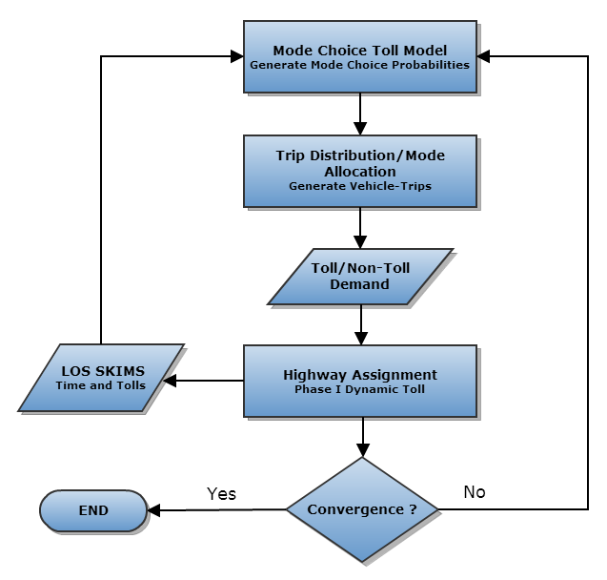

## Consistency in Value of Time

In the integrated model, it is vital to have the consistency of value of time (VOT) as an input to the mode choice model and the implied VOT from the willingness to pay curve in the highway assignment. The average VOT from mode choice model (based on time and cost coefficients) is estimated as $18.81. Consequently, the input willingness to pay curve (shown in ) for dynamic tolling highway assignment procedure was modified slightly to represent the same average VOT. Of course, since the willingness to pay curve represent distributed value of time, it is possible to have different shape curve representing the same average value of time. So, to some extent the shape of willingness to pay curve is important, and reflects the particular characteristics of the traveling market – this should be based on observed data whenever possible.

The toll policy curve (shown in ) used as an input for the integrated model is same as the one used in Phase I work, which is originally taken from a managed lane project in Minneapolis, MN. Note that for implementation purpose, these two curves should be revised by the user based on the local/regional conditions.

Figure 3‑3: Willingness to Pay Curve

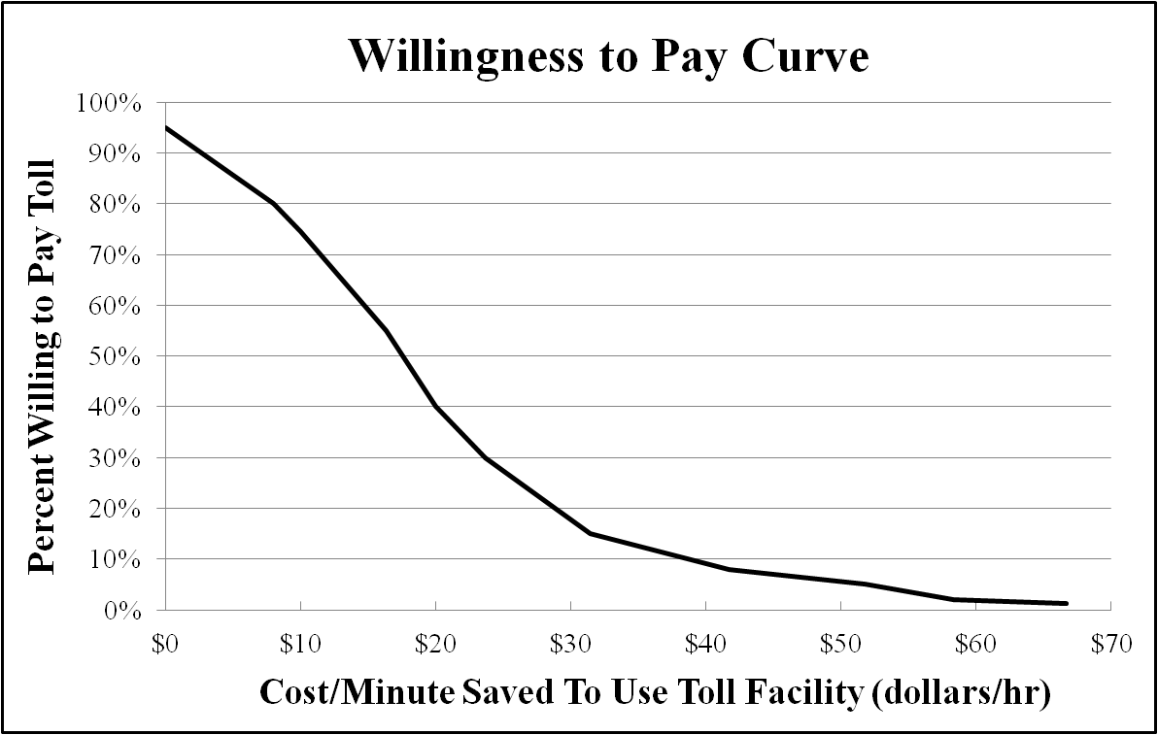

Figure 3‑4: Toll Policy Curve

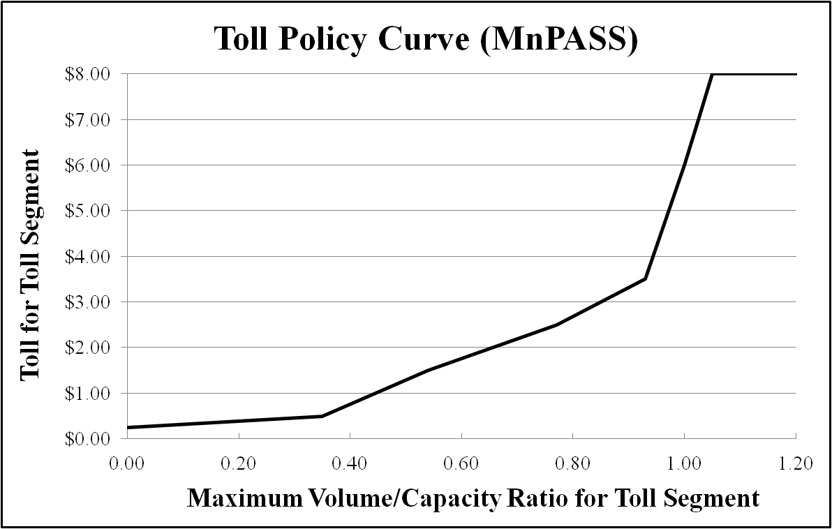

## Testing of Integrated Model

The same managed lanes scenario described in Sections 2.5 was used to test the complete integrated system for functionality. After running various model runs it was established that the integrated model functioned correctly and as expected. In addition, the response of the integrated model was evaluated , indicating how the model output measures, such as demand matrices, level of service matrices, network flows, etc. change for a given feedback iteration relative to the previous iteration. Testing results which are presented for the integrated model are obtained from running the complete model for 10 feedback iterations. Model results for the AM peak period for the total Toll/HOV trips, and toll values on the different toll segments were evaluated and summarized graphically below. shows the different toll segments for the HOT facility in the network and the numeric index on in the figure indicate eastbound segments 1, 3, and 5 and westbound segments 2, 4, and 6.

Figure 3‑5: Toll Segments for HOT Facility

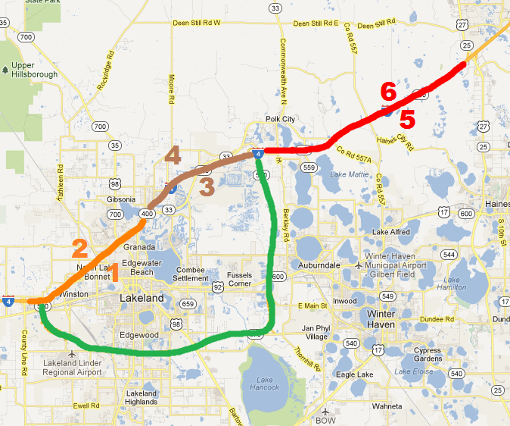

The figures below show the integrated model outputs for the total toll trips () and total HOV trips () obtained from mode choice model and highway assignment with the feedback iterations. It is observed that the toll/HOV trips tend to become stable with the feedback iterations.

Figure 3‑6: Total Toll Trips

Figure 3‑7: Total HOV Trips

and presents the toll values for the eastbound and westbound toll segments respectively. The segment toll values get fairly stable for all the toll segments and not much variation is observed in tolls after few feedback iterations.

Figure 3‑8: Eastbound Toll Values

Figure 3‑9: Westbound Toll Values

and shows the variation of segment toll values within dynamic toll highway assignment process for a particular feedback iteration (iteration # 10 in this case). Again, the highway assignment procedure produces stable tolls and after sufficient number of feedback iteration, no significant change in magnitude of segment toll values is observed because of the effect of highway assignment dynamic toll procedure during later feedback loop iterations, i.e., the starting and final toll within the assignment step is fairly similar.

Figure 3‑10: Eastbound Toll Values within a Feedback Iteration

Figure 3‑11: Westbound Toll Values within a Feedback Iteration

## Model Estimation and Calibration Guidance

The model estimation should focus on establishing proper cost and time coefficients in the mode choice model. The assignment model willingness to pay curve should be consistent with the implied average value of time in the mode choice model, and use stated-preference or revealed preference data on willingness to pay to refine the shape of this curve. Ideally, a common dataset can be used to estimate both mode choice and assignment toll parameters.

Implementation of feedback for the integrated model necessitate a key decision that how to measure convergence. In general, many different measures of convergence or gap can be been proposed. Convergence could be measured by relative change in skims (travel times and toll values) or by relative change in Toll/HOV trips in two successive feedback iterations. At system convergence, these measures would indicate insufficient change to warrant running additional iterations. These measures are generally satisfactory, provided that the threshold or maximum gap value chosen is small enough.

In addition, it is recommended that a minimum and maximum number of feedback iterations be established in the application. A typical value is between 5 and 10 iterations, which often guarantees or nearly guarantees convergence. The gap measure between iterations should be reported, so that the analyst is able to establish the convergence history, and decide whether additional iterations are required.

# Conclusions

The phase II managed lane model incorporates toll and HOV choice in the mode choice model, by adding these choices at a new nest level below the drive alone, 2-person and 3+ person auto nests of the recommend structure. By incorporating these choices into the mode choice model, it allows for sensitivity to

* Trip purpose,
* Time of day,
* Income, and
* Auto sufficiency

Through the feedback mechanism, updated travel times and costs, including fares, can inform subsequent iteration of the model. This can be repeated until a stable solution is found.

The second element of the Phase II model is the integration of the mode choice model with the Phase I dynamic toll assignment model. Through this integration, additional information on how the toll levels may change with respect to demand is used to update the mode choice model toll calculations. Assumptions on willingness to pay within the toll assignment model should be consistent with the implied value of time used in the mode choice step.

The combination of a mode-choice based toll choice model, which permits a wider range of market considerations, and the capability of updated dynamic toll estimation from the phase I assignment model allows the phase II model to represent both the long-term considerations of income, auto ownership, time of day and purpose with the short term factors involved in route choice when demand-sensitive variable tolls are being considered.

The prototype model demonstrates the feasibility of using both mode choice and assignment in estimating toll demand. The model can reach a stable condition, and may be estimated and calibrated jointly using observed O-D and link flow data.

# Appendix

## Cube Script for Mode Choice Model with Toll Paying Alternatives

; Script for program MATRIX (mode choice probabilities) for the mode choice toll model in file "E:\Ashish\Managed Lane Modeling\Phase II\Mode_Choice_Toll_Model\Applications\MCMAT00A.S"

; Do not change filenames or add or remove FILEI/FILEO statements using an editor. Use Cube/Application Manager.

RUN PGM=MATRIX PRNFILE="{CATALOG_DIR}\APPLICATIONS\MCMAT00A_@PURP@_@PERIOD@.PRN" MSG='Mode Choice Probabilities'

FILEI MATI[12] = "{SCENARIO_DIR}\OUTPUT\ST2ST_{alt}{year}.MAT"

FILEI MATI[11] = "{SCENARIO_DIR}\OUTPUT\TimeSavings_{alt}{year}_@LoopNum@.MAT"

; For Peak: Table 1 - Toll time savings, Table 2 - HOV time savings, Table 3 - Toll+HOV time savings

; For Off-Peak: Table 4 - Toll time savings, Table 5 - HOV time savings, Table 6 - Toll+HOV time savings

FILEI MATI[5] = "{SCENARIO_DIR}\OUTPUT\TSKIM@PERIOD@4.{Alt}{year}"

FILEI MATI[4] = "{SCENARIO_DIR}\OUTPUT\TSKIM@PERIOD@3.{Alt}{year}"

FILEI MATI[3] = "{SCENARIO_DIR}\OUTPUT\TSKIM@PERIOD@2.{Alt}{year}"

FILEI MATI[2] = "{SCENARIO_DIR}\OUTPUT\TSKIM@PERIOD@1.{Alt}{year}"

; Tables 1-6: 1-WalkTime, 2-AutoTime, 3-XferTime, 4-BusTime, 5-PRJBusTime, 6-CircTime

; Tables 7-10: 7-RailTime, 8-CommuterRailTime, 9-OtherModeTime, 10-ProjectModeTime

; Tables 11-15: 11-NumXfers, 12-InitialWaitTime, 13-XferWaitTime, 14-Fare, 15-Total time

FILEI MATI[1] = "{SCENARIO_DIR}\OUTPUT\@SKIMFILE@.MAT"

; Tables 1-4 for SOV_NoToll: 1-Toll, 2-Distance, 3-Time, 4-Time2

; Tables 5-8 for SOV_Toll: 5-Toll, 6-Distance, 7-Time, 8-Time2

; Tables 9-12 for HOV_NoToll: 9-Toll, 10-Distance, 11-Time, 12-Time2

; Tables 13-16 for HOV_Toll: 13-Toll, 14-Distance, 15-Time, 16-Time2

; Table 17 is terminal time

FILEI LOOKUPI[2] = "{SCENARIO_DIR}\OUTPUT\TRN_COEFFICIENTS.DBF"

FILEI LOOKUPI[1] = "{SCENARIO_DIR}\OUTPUT\MC_CONSTANTS.DBF"

FILEI ZDATI[2] = "{SCENARIO_DIR}\OUTPUT\STATDATA_{alt}{year}.DBF"

FILEI ZDATI[1] = "{SCENARIO_DIR}\OUTPUT\TAZDATA_{alt}{year}.DBF"

FILEO MATO[12] = "{SCENARIO_DIR}\OUTPUT\farexfer_tmp_@PERIOD@.mat",

MO=211-216,220-225,DEC=12*2,

NAME=farewb,farewp,farepb,farepp,farekb,farekp,xferwb,xferwp,xferpb,xferpp,xferkb,xferkp

FILEO MATO[11] = "{SCENARIO_DIR}\OUTPUT\expautoutil_tmp_@PERIOD@.mat",

MO=131-137,111-117,DEC=14*S,NAME=EXPA_M1,EXPA_M2,EXPA_M3,EXPA_M4,EXPA_M5,EXPA_M6,EXPA_M7,

SPLITCMP_M1,SPLITCMP_M2,SPLITCMP_M3,SPLITCMP_M4,SPLITCMP_M5,SPLITCMP_M6,SPLITCMP_M7

FILEO MATO[8] = "{SCENARIO_DIR}\OUTPUT\@PURP@@PERIOD@_MCPRB7.MAT",

MO=429-446,849-866,721-738,DEC=54*8,

NAME=DA_NOTOLL_CWM7,DA_TOLL_CWM7,SR2_NOTOLL_NONHOV_CWM7,SR2_NOTOLL_HOV_CWM7,

SR2_TOLL_NONHOV_CWM7,SR2_TOLL_HOV_CWM7,SR3_NOTOLL_NONHOV_CWM7,SR3_NOTOLL_HOV_CWM7,

SR3_TOLL_NONHOV_CWM7,SR3_TOLL_HOV_CWM7,WBUS_CWM7,WPRJ_CWM7,PBUS_CWM7,PPRJ_CWM7,KBUS_CWM7,

KPRJ_CWM7,WALK_CWM7,BIKE_CWM7,DA_NOTOLL_MDM7,DA_TOLL_MDM7,SR2_NOTOLL_NONHOV_MDM7,

SR2_NOTOLL_HOV_MDM7,SR2_TOLL_NONHOV_MDM7,SR2_TOLL_HOV_MDM7,SR3_NOTOLL_NONHOV_MDM7,

SR3_NOTOLL_HOV_MDM7,SR3_TOLL_NONHOV_MDM7,SR3_TOLL_HOV_MDM7,WBUS_MDM7,WPRJ_MDM7,PBUS_MDM7,

PPRJ_MDM7,KBUS_MDM7,KPRJ_MDM7,WALK_MDM7,BIKE_MDM7,DA_NOTOLL_NTM7,DA_TOLL_NTM7,

SR2_NOTOLL_NONHOV_NTM7,SR2_NOTOLL_HOV_NTM7,SR2_TOLL_NONHOV_NTM7,SR2_TOLL_HOV_NTM7,

SR3_NOTOLL_NONHOV_NTM7,SR3_NOTOLL_HOV_NTM7,SR3_TOLL_NONHOV_NTM7,SR3_TOLL_HOV_NTM7,

WBUS_NTM7,WPRJ_NTM7,PBUS_NTM7,PPRJ_NTM7,KBUS_NTM7,KPRJ_NTM7,WALK_NTM7,BIKE_NTM7

FILEO MATO[7] = "{SCENARIO_DIR}\OUTPUT\@PURP@@PERIOD@_MCPRB6.MAT",

MO=411-428,831-848,701-718,DEC=54*8,

NAME=DA_NOTOLL_CWM6,DA_TOLL_CWM6,SR2_NOTOLL_NONHOV_CWM6,SR2_NOTOLL_HOV_CWM6,

SR2_TOLL_NONHOV_CWM6,SR2_TOLL_HOV_CWM6,SR3_NOTOLL_NONHOV_CWM6,SR3_NOTOLL_HOV_CWM6,

SR3_TOLL_NONHOV_CWM6,SR3_TOLL_HOV_CWM6,WBUS_CWM6,WPRJ_CWM6,PBUS_CWM6,PPRJ_CWM6,KBUS_CWM6,

KPRJ_CWM6,WALK_CWM6,BIKE_CWM6,DA_NOTOLL_MDM6,DA_TOLL_MDM6,SR2_NOTOLL_NONHOV_MDM6,

SR2_NOTOLL_HOV_MDM6,SR2_TOLL_NONHOV_MDM6,SR2_TOLL_HOV_MDM6,SR3_NOTOLL_NONHOV_MDM6,

SR3_NOTOLL_HOV_MDM6,SR3_TOLL_NONHOV_MDM6,SR3_TOLL_HOV_MDM6,WBUS_MDM6,WPRJ_MDM6,PBUS_MDM6,

PPRJ_MDM6,KBUS_MDM6,KPRJ_MDM6,WALK_MDM6,BIKE_MDM6,DA_NOTOLL_NTM6,DA_TOLL_NTM6,

SR2_NOTOLL_NONHOV_NTM6,SR2_NOTOLL_HOV_NTM6,SR2_TOLL_NONHOV_NTM6,SR2_TOLL_HOV_NTM6,

SR3_NOTOLL_NONHOV_NTM6,SR3_NOTOLL_HOV_NTM6,SR3_TOLL_NONHOV_NTM6,SR3_TOLL_HOV_NTM6,

WBUS_NTM6,WPRJ_NTM6,PBUS_NTM6,PPRJ_NTM6,KBUS_NTM6,KPRJ_NTM6,WALK_NTM6,BIKE_NTM6

FILEO MATO[6] = "{SCENARIO_DIR}\OUTPUT\@PURP@@PERIOD@_MCPRB5.MAT",

MO=393-410,813-830,681-698,DEC=54*8,

NAME=DA_NOTOLL_CWM5,DA_TOLL_CWM5,SR2_NOTOLL_NONHOV_CWM5,SR2_NOTOLL_HOV_CWM5,

SR2_TOLL_NONHOV_CWM5,SR2_TOLL_HOV_CWM5,SR3_NOTOLL_NONHOV_CWM5,SR3_NOTOLL_HOV_CWM5,

SR3_TOLL_NONHOV_CWM5,SR3_TOLL_HOV_CWM5,WBUS_CWM5,WPRJ_CWM5,PBUS_CWM5,PPRJ_CWM5,KBUS_CWM5,

KPRJ_CWM5,WALK_CWM5,BIKE_CWM5,DA_NOTOLL_MDM5,DA_TOLL_MDM5,SR2_NOTOLL_NONHOV_MDM5,

SR2_NOTOLL_HOV_MDM5,SR2_TOLL_NONHOV_MDM5,SR2_TOLL_HOV_MDM5,SR3_NOTOLL_NONHOV_MDM5,

SR3_NOTOLL_HOV_MDM5,SR3_TOLL_NONHOV_MDM5,SR3_TOLL_HOV_MDM5,WBUS_MDM5,WPRJ_MDM5,PBUS_MDM5,

PPRJ_MDM5,KBUS_MDM5,KPRJ_MDM5,WALK_MDM5,BIKE_MDM5,DA_NOTOLL_NTM5,DA_TOLL_NTM5,

SR2_NOTOLL_NONHOV_NTM5,SR2_NOTOLL_HOV_NTM5,SR2_TOLL_NONHOV_NTM5,SR2_TOLL_HOV_NTM5,

SR3_NOTOLL_NONHOV_NTM5,SR3_NOTOLL_HOV_NTM5,SR3_TOLL_NONHOV_NTM5,SR3_TOLL_HOV_NTM5,

WBUS_NTM5,WPRJ_NTM5,PBUS_NTM5,PPRJ_NTM5,KBUS_NTM5,KPRJ_NTM5,WALK_NTM5,BIKE_NTM5

FILEO MATO[5] = "{SCENARIO_DIR}\OUTPUT\@PURP@@PERIOD@_MCPRB4.MAT",

MO=375-392,795-812,661-678,DEC=54*8,

NAME=DA_NOTOLL_CWM4,DA_TOLL_CWM4,SR2_NOTOLL_NONHOV_CWM4,SR2_NOTOLL_HOV_CWM4,

SR2_TOLL_NONHOV_CWM4,SR2_TOLL_HOV_CWM4,SR3_NOTOLL_NONHOV_CWM4,SR3_NOTOLL_HOV_CWM4,

SR3_TOLL_NONHOV_CWM4,SR3_TOLL_HOV_CWM4,WBUS_CWM4,WPRJ_CWM4,PBUS_CWM4,PPRJ_CWM4,KBUS_CWM4,

KPRJ_CWM4,WALK_CWM4,BIKE_CWM4,DA_NOTOLL_MDM4,DA_TOLL_MDM4,SR2_NOTOLL_NONHOV_MDM4,

SR2_NOTOLL_HOV_MDM4,SR2_TOLL_NONHOV_MDM4,SR2_TOLL_HOV_MDM4,SR3_NOTOLL_NONHOV_MDM4,

SR3_NOTOLL_HOV_MDM4,SR3_TOLL_NONHOV_MDM4,SR3_TOLL_HOV_MDM4,WBUS_MDM4,WPRJ_MDM4,PBUS_MDM4,

PPRJ_MDM4,KBUS_MDM4,KPRJ_MDM4,WALK_MDM4,BIKE_MDM4,DA_NOTOLL_NTM4,DA_TOLL_NTM4,

SR2_NOTOLL_NONHOV_NTM4,SR2_NOTOLL_HOV_NTM4,SR2_TOLL_NONHOV_NTM4,SR2_TOLL_HOV_NTM4,

SR3_NOTOLL_NONHOV_NTM4,SR3_NOTOLL_HOV_NTM4,SR3_TOLL_NONHOV_NTM4,SR3_TOLL_HOV_NTM4,

WBUS_NTM4,WPRJ_NTM4,PBUS_NTM4,PPRJ_NTM4,KBUS_NTM4,KPRJ_NTM4,WALK_NTM4,BIKE_NTM4

FILEO MATO[4] = "{SCENARIO_DIR}\OUTPUT\@PURP@@PERIOD@_MCPRB3.MAT",

MO=357-374,777-794,641-658,DEC=54*8,

NAME=DA_NOTOLL_CWM3,DA_TOLL_CWM3,SR2_NOTOLL_NONHOV_CWM3,SR2_NOTOLL_HOV_CWM3,

SR2_TOLL_NONHOV_CWM3,SR2_TOLL_HOV_CWM3,SR3_NOTOLL_NONHOV_CWM3,SR3_NOTOLL_HOV_CWM3,

SR3_TOLL_NONHOV_CWM3,SR3_TOLL_HOV_CWM3,WBUS_CWM3,WPRJ_CWM3,PBUS_CWM3,PPRJ_CWM3,KBUS_CWM3,

KPRJ_CWM3,WALK_CWM3,BIKE_CWM3,DA_NOTOLL_MDM3,DA_TOLL_MDM3,SR2_NOTOLL_NONHOV_MDM3,

SR2_NOTOLL_HOV_MDM3,SR2_TOLL_NONHOV_MDM3,SR2_TOLL_HOV_MDM3,SR3_NOTOLL_NONHOV_MDM3,

SR3_NOTOLL_HOV_MDM3,SR3_TOLL_NONHOV_MDM3,SR3_TOLL_HOV_MDM3,WBUS_MDM3,WPRJ_MDM3,PBUS_MDM3,

PPRJ_MDM3,KBUS_MDM3,KPRJ_MDM3,WALK_MDM3,BIKE_MDM3,DA_NOTOLL_NTM3,DA_TOLL_NTM3,

SR2_NOTOLL_NONHOV_NTM3,SR2_NOTOLL_HOV_NTM3,SR2_TOLL_NONHOV_NTM3,SR2_TOLL_HOV_NTM3,

SR3_NOTOLL_NONHOV_NTM3,SR3_NOTOLL_HOV_NTM3,SR3_TOLL_NONHOV_NTM3,SR3_TOLL_HOV_NTM3,

WBUS_NTM3,WPRJ_NTM3,PBUS_NTM3,PPRJ_NTM3,KBUS_NTM3,KPRJ_NTM3,WALK_NTM3,BIKE_NTM3

FILEO MATO[3] = "{SCENARIO_DIR}\OUTPUT\@PURP@@PERIOD@_MCPRB2.MAT",

MO=339-356,759-776,621-638,DEC=54*8,

NAME=DA_NOTOLL_CWM2,DA_TOLL_CWM2,SR2_NOTOLL_NONHOV_CWM2,SR2_NOTOLL_HOV_CWM2,

SR2_TOLL_NONHOV_CWM2,SR2_TOLL_HOV_CWM2,SR3_NOTOLL_NONHOV_CWM2,SR3_NOTOLL_HOV_CWM2,

SR3_TOLL_NONHOV_CWM2,SR3_TOLL_HOV_CWM2,WBUS_CWM2,WPRJ_CWM2,PBUS_CWM2,PPRJ_CWM2,KBUS_CWM2,

KPRJ_CWM2,WALK_CWM2,BIKE_CWM2,DA_NOTOLL_MDM2,DA_TOLL_MDM2,SR2_NOTOLL_NONHOV_MDM2,

SR2_NOTOLL_HOV_MDM2,SR2_TOLL_NONHOV_MDM2,SR2_TOLL_HOV_MDM2,SR3_NOTOLL_NONHOV_MDM2,

SR3_NOTOLL_HOV_MDM2,SR3_TOLL_NONHOV_MDM2,SR3_TOLL_HOV_MDM2,WBUS_MDM2,WPRJ_MDM2,PBUS_MDM2,

PPRJ_MDM2,KBUS_MDM2,KPRJ_MDM2,WALK_MDM2,BIKE_MDM2,DA_NOTOLL_NTM2,DA_TOLL_NTM2,

SR2_NOTOLL_NONHOV_NTM2,SR2_NOTOLL_HOV_NTM2,SR2_TOLL_NONHOV_NTM2,SR2_TOLL_HOV_NTM2,

SR3_NOTOLL_NONHOV_NTM2,SR3_NOTOLL_HOV_NTM2,SR3_TOLL_NONHOV_NTM2,SR3_TOLL_HOV_NTM2,

WBUS_NTM2,WPRJ_NTM2,PBUS_NTM2,PPRJ_NTM2,KBUS_NTM2,KPRJ_NTM2,WALK_NTM2,BIKE_NTM2

FILEO MATO[2] = "{SCENARIO_DIR}\OUTPUT\@PURP@@PERIOD@_MCPRB1.MAT",

MO=321-338,741-758,601-618,DEC=54*8,

NAME=DA_NOTOLL_CWM1,DA_TOLL_CWM1,SR2_NOTOLL_NONHOV_CWM1,SR2_NOTOLL_HOV_CWM1,

SR2_TOLL_NONHOV_CWM1,SR2_TOLL_HOV_CWM1,SR3_NOTOLL_NONHOV_CWM1,SR3_NOTOLL_HOV_CWM1,

SR3_TOLL_NONHOV_CWM1,SR3_TOLL_HOV_CWM1,WBUS_CWM1,WPRJ_CWM1,PBUS_CWM1,PPRJ_CWM1,KBUS_CWM1,

KPRJ_CWM1,WALK_CWM1,BIKE_CWM1,DA_NOTOLL_MDM1,DA_TOLL_MDM1,SR2_NOTOLL_NONHOV_MDM1,

SR2_NOTOLL_HOV_MDM1,SR2_TOLL_NONHOV_MDM1,SR2_TOLL_HOV_MDM1,SR3_NOTOLL_NONHOV_MDM1,

SR3_NOTOLL_HOV_MDM1,SR3_TOLL_NONHOV_MDM1,SR3_TOLL_HOV_MDM1,WBUS_MDM1,WPRJ_MDM1,PBUS_MDM1,

PPRJ_MDM1,KBUS_MDM1,KPRJ_MDM1,WALK_MDM1,BIKE_MDM1,DA_NOTOLL_NTM1,DA_TOLL_NTM1,

SR2_NOTOLL_NONHOV_NTM1,SR2_NOTOLL_HOV_NTM1,SR2_TOLL_NONHOV_NTM1,SR2_TOLL_HOV_NTM1,

SR3_NOTOLL_NONHOV_NTM1,SR3_NOTOLL_HOV_NTM1,SR3_TOLL_NONHOV_NTM1,SR3_TOLL_HOV_NTM1,

WBUS_NTM1,WPRJ_NTM1,PBUS_NTM1,PPRJ_NTM1,KBUS_NTM1,KPRJ_NTM1,WALK_NTM1,BIKE_NTM1

FILEO MATO[1] = "{SCENARIO_DIR}\OUTPUT\@PURP@@PERIOD@_MCLS_{ALT}{Year}.MAT",

MO=291-297,DEC=7*4,

NAME=LSUM_M1,LSUM_M2,LSUM_M3,LSUM_M4,LSUM_M5,LSUM_M6,LSUM_M7

ARRAY TYPE=F K_AUT=7, K_SR=7, K_SR3=7, K_HOV=7, K_TOLL=7, K_TRN=7, K_TDRV=7, K_TKNR=7, K_NMOT=7, K_BIKE=7

ARRAY TYPE=C30 MARKET_NAME=7

; Coefficients

LOOKUP, NAME=COEFF, LOOKUP[1]=1, RESULT=@PURPNO@, INTERPOLATE=N, LIST=Y, LOOKUPI=2

; Constants

LOOKUP, NAME=CONSTANTS, LOOKUP[1]=1, RESULT=@PURPNO@, INTERPOLATE=N, , LIST=Y, LOOKUPI=1

; Market stratification for all trip purposes except student trips is based on Car Sufficiency.

; Market stratification for student trips (HBCU & HBSC) is based on Household Size.

IF (i=FirstZone)

; Index _m identifies the market segment, as follows:

; All HB purposes except school HBCU and HBSC

; ---------------------------------------------------------------

; _m = 1 zero-car households 1 person hhld

; _m = 2 low income, car insufficient hhlds 2 person hhld

; _m = 3 medium income, car insufficient hhlds 3 person hhld

; _m = 4 high income, car insufficient hhlds 4+ person hhld

; _m = 5 low income, car sufficient hhlds

; _m = 6 medium income, car sufficient hhlds

; _m = 7 high income, car sufficient hhlds

LOOP _m=1,7

; Household market stratified constants

K_AUT[_m] = CONSTANTS(1,(_m-1)*10+1) ; auto

K_SR[_m] = CONSTANTS(1,(_m-1)*10+2) ; shared-ride 2 & 3+

K_SR3[_m] = CONSTANTS(1,(_m-1)*10+3) ; shared ride 3+

K_TRN[_m] = CONSTANTS(1,(_m-1)*10+4) ; transit

K_TDRV[_m] = CONSTANTS(1,(_m-1)*10+5) ; drive to transit

K_TKNR[_m] = CONSTANTS(1,(_m-1)*10+6) ; knr to transit

K_NMOT[_m] = CONSTANTS(1,(_m-1)*10+7) ; non-motorized (walk & bike)

K_BIKE[_m] = CONSTANTS(1,(_m-1)*10+8) ; bike

K_TOLL[_m] = CONSTANTS(1,(_m-1)*10+9) ; toll/no toll choice

K_HOV[_m] = CONSTANTS(1,(_m-1)*10+10) ; HOV choice by shared-ride 2 & 3+

ENDLOOP

; MARKETS=@MARKETS@

MARKET_NAME[1] = '@Mkt1_Name@'

MARKET_NAME[2] = '@Mkt2_Name@'

MARKET_NAME[3] = '@Mkt3_Name@'

MARKET_NAME[4] = '@Mkt4_Name@'

MARKET_NAME[5] = '@Mkt5_Name@'

MARKET_NAME[6] = '@Mkt6_Name@'

MARKET_NAME[7] = '@Mkt7_Name@'

; Mode-specific constants -- same for all hhld markets

K_EXP = CONSTANTS(1,71) ; premium bus

K_BRT = CONSTANTS(1,72) ; brt

K_UR = CONSTANTS(1,73) ; urban rail

K_CR = CONSTANTS(1,74) ; commuter rail

; Nesting coefficients

NC_1 = COEFF(1,10) ; Level 1 - auto, trn, non-mot

NC_2 = COEFF(1,11) ; Level 2 - transit access, auto occupancy

NC_3 = COEFF(1,12) ; Level 3 - toll choice

NCP_1 = NC_1 * NC_2

NCP_2 = NC_1 * NC_2 * NC_3

NCP_3= NC_2 * NC_3

; Level of Service Coefficients

COEFF_IVTT = COEFF(1,1)

COEFF_OVT = COEFF(1,3)

COEFF_TTSAV = COEFF(1,4)

COEFF_AAT = COEFF(1,5)

COEFF_XFER = COEFF(1,6)

COEFF_DCBD = COEFF(1,7)

COEFF_DEXUP = COEFF(1,8)

COEFF_DEXUA = COEFF(1,9)

COEFF_DCBD_WALK = COEFF(1,15)

COEFF_DCBD_PNR = COEFF(1,16)

COEFF_DCBD_KNR = COEFF(1,17)

; Cost Coefficients

ARRAY TYPE=F COEFF_COST=7

COEFF_COST[1] = COEFF(1,21)

COEFF_COST[2] = COEFF(1,22)

COEFF_COST[3] = COEFF(1,23)

COEFF_COST[4] = COEFF(1,24)

COEFF_COST[5] = COEFF(1,25)

COEFF_COST[6] = COEFF(1,26)

COEFF_COST[7] = COEFF(1,27)

ENDIF

FILLMW MW[1]=MI.1.1,2,3,4,5,6,7,8,9,10,11,12,13,14,15,16 ; highway skims

; Time savings

FILLMW MW[141]=MI.11.TOLL_TimeSave@PERIOD@ ; For Drive Alone(Toll) and Shared Ride(Toll,NonHOV): PK/OP

FILLMW MW[142]=MI.11.HOV_TimeSave@PERIOD@ ; For Shared Ride(NoToll,HOV): PK/OP

FILLMW MW[143]=MI.11.TOLLHOV_TimeSave@PERIOD@ ; For Shared Ride(Toll,HOV): PK/OP

FILLMW MW[201]=MI.12.@STATION_TABLE@ ; 8 tables - Peak/Off-Peak: StationTAZ_pnrb,

ParkCost_pnrb,TermTimepnnrb,TermTimeknrb,StationTAZ_pnrp,ParkCost_pnrp,TermTimepnrp,TermTimeknrp

FILLMW MW[21]=MI.2.1,2,3,4,5,6,7,8,9,10,11,12,13,14,15 ; tskim1 -- walk to local bus

FILLMW MW[41]=MI.3.1,2,3,4,5,6,7,8,9,10,11,12,13,14,15 ; tskim2 -- walk to project bus

FILLMW MW[61]=MI.4.1,2,3,4,5,6,7,8,9,10,11,12,13,14,15 ; tskim3 -- drive to local bus

FILLMW MW[81]=MI.5.1,2,3,4,5,6,7,8,9,10,11,12,13,14,15 ; tskim4 -- drive to project bus

; Distance for the walk and bike modes

; distance portion that is 1 mile or less

MW[231] = MIN(MW[2],1)

; distance portion that is longer than 1 mile

JLOOP

IF (MW[2][J] > 1)

MW[232] = MW[2][J] - 1

ELSE

MW[232] = 0

ENDIF

ENDJLOOP

LOOP ACC=1,3

IF (ACC==1) then

ACC_NAME='CAN WALK TO TRANSIT'

ELSEIF (ACC==2)

ACC_NAME='MUST DRIVE TO TRANSIT'

ELSEIF (ACC==3)

ACC_NAME='NO TRANSIT'

ENDIF

; ===============================================================

; COMMON UTILITY CALCULATIONS

; Computes utility common across all household market segments

; ===============================================================

; DRIVE ALONE (NOTOLL) ELEMENTS OF UTILITY ARE:

MW[301] = (COEFF_OVT * (ZI.1.TERMTIME[I] + ZI.1.TERMTIME[J]) + ; Terminal time

COEFF_IVTT * MW[3] + ; IVTT (SOV_NT Time)

@isNHB@ COEFF_DCBD * (ZI.1.CBD_DUMMY[I] + ZI.1.CBD_DUMMY[J]) + ; CBD dummy (NHB)

@noNHB@ COEFF_DCBD * ZI.1.CBD_DUMMY[J] + ; CBD dummy

COEFF_DEXUP * ZI.1.EXU_DUMMY[I] + ; Exurban production dummy

COEFF_DEXUA * ZI.1.EXU_DUMMY[J]) / NCP_2 ; Exurban attraction dummy

; DRIVE ALONE (TOLL) ELEMENTS OF UTILITY ARE:

MW[302] = (COEFF_OVT * (ZI.1.TERMTIME[I] + ZI.1.TERMTIME[J]) + ; Terminal time

COEFF_IVTT * MW[7] - ; IVTT (SOV_T Time)

COEFF_TTSAV * (MAX (MW[141], 0)) + ; Time savings

@isNHB@ COEFF_DCBD * (ZI.1.CBD_DUMMY[I] + ZI.1.CBD_DUMMY[J]) + ; CBD dummy (NHB)

@noNHB@ COEFF_DCBD * ZI.1.CBD_DUMMY[J] + ; CBD dummy

COEFF_DEXUP * ZI.1.EXU_DUMMY[I] + ; Exurban production dummy

COEFF_DEXUA * ZI.1.EXU_DUMMY[J]) / NCP_2 ; Exurban attraction dummy

; SHARED RIDE 2 (NOTOLL, NONHOV) PERSONS/SHARE RIDE - ONE PASSENGER ELEMENTS OF UTILITY ARE:

MW[303] = (COEFF_OVT * (ZI.1.TERMTIME[I] + ZI.1.TERMTIME[J]) + ; Terminal time

COEFF_IVTT * MW[3] + ; IVTT (SOV_NT Time)

@isNHB@ COEFF_DCBD * (ZI.1.CBD_DUMMY[I] + ZI.1.CBD_DUMMY[J]) + ; CBD dummy (NHB)

@noNHB@ COEFF_DCBD * ZI.1.CBD_DUMMY[J] + ; CBD dummy

COEFF_DEXUP * ZI.1.EXU_DUMMY[I] + ; Exurban production dummy

COEFF_DEXUA * ZI.1.EXU_DUMMY[J]) / NCP_2 ; Exurban attraction dummy

; SHARED RIDE 2 (NOTOLL, HOV) PERSONS/SHARE RIDE - ONE PASSENGER ELEMENTS OF UTILITY ARE:

MW[304] = (COEFF_OVT * (ZI.1.TERMTIME[I] + ZI.1.TERMTIME[J]) + ; Terminal time

COEFF_IVTT * MW[11] - ; IVTT (HOV_NT Time)

COEFF_TTSAV * (MAX (MW[142], 0)) + ; Time savings

@isNHB@ COEFF_DCBD * (ZI.1.CBD_DUMMY[I] + ZI.1.CBD_DUMMY[J]) + ; CBD dummy (NHB)

@noNHB@ COEFF_DCBD * ZI.1.CBD_DUMMY[J] + ; CBD dummy

COEFF_DEXUP * ZI.1.EXU_DUMMY[I] + ; Exurban production dummy

COEFF_DEXUA * ZI.1.EXU_DUMMY[J]) / NCP_2 ; Exurban attraction dummy

; SHARED RIDE 2 (TOLL, NONHOV) PERSONS/SHARE RIDE - ONE PASSENGER ELEMENTS OF UTILITY ARE:

MW[305] = (COEFF_OVT * (ZI.1.TERMTIME[I] + ZI.1.TERMTIME[J]) + ; Terminal time

COEFF_IVTT * MW[7] - ; IVTT (SOV_T Time)

COEFF_TTSAV * (MAX (MW[141], 0)) + ; Time savings

@isNHB@ COEFF_DCBD * (ZI.1.CBD_DUMMY[I] + ZI.1.CBD_DUMMY[J]) + ; CBD dummy (NHB)

@noNHB@ COEFF_DCBD * ZI.1.CBD_DUMMY[J] + ; CBD dummy

COEFF_DEXUP * ZI.1.EXU_DUMMY[I] + ; Exurban production dummy

COEFF_DEXUA * ZI.1.EXU_DUMMY[J]) / NCP_2 ; Exurban attraction dummy

; SHARED RIDE 2 (TOLL, HOV) PERSONS/SHARE RIDE - ONE PASSENGER ELEMENTS OF UTILITY ARE:

MW[306] = (COEFF_OVT * (ZI.1.TERMTIME[I] + ZI.1.TERMTIME[J]) + ; Terminal time

COEFF_IVTT * MW[15] - ; IVTT (HOV_T Time)

COEFF_TTSAV * (MAX (MW[143], 0)) + ; Time savings

@isNHB@ COEFF_DCBD * (ZI.1.CBD_DUMMY[I] + ZI.1.CBD_DUMMY[J]) + ; CBD dummy (NHB)

@noNHB@ COEFF_DCBD * ZI.1.CBD_DUMMY[J] + ; CBD dummy

COEFF_DEXUP * ZI.1.EXU_DUMMY[I] + ; Exurban production dummy

COEFF_DEXUA * ZI.1.EXU_DUMMY[J]) / NCP_2 ; Exurban attraction dummy

; SHARED RIDE 3+ (NOTOLL, NONHOV) PASSENGER ELEMENTS OF UTILITY ARE:

MW[307] = (COEFF_OVT * (ZI.1.TERMTIME[I] + ZI.1.TERMTIME[J]) + ; Terminal time

COEFF_IVTT * MW[3] + ; IVTT (HOV_NT Time)

@isNHB@ COEFF_DCBD * (ZI.1.CBD_DUMMY[I] + ZI.1.CBD_DUMMY[J]) + ; CBD dummy (NHB)

@noNHB@ COEFF_DCBD * ZI.1.CBD_DUMMY[J] + ; CBD dummy

COEFF_DEXUP * ZI.1.EXU_DUMMY[I] + ; Exurban production dummy

COEFF_DEXUA * ZI.1.EXU_DUMMY[J]) / NCP_2 ; Exurban attraction dummy

; SHARED RIDE 3+ (NOTOLL, HOV) PASSENGER ELEMENTS OF UTILITY ARE

MW[308] = (COEFF_OVT * (ZI.1.TERMTIME[I] + ZI.1.TERMTIME[J]) + ; Terminal time

COEFF_IVTT * MW[11] - ; IVTT (HOV_NT Time)

COEFF_TTSAV * (MAX (MW[142], 0)) + ; Time savings

@isNHB@ COEFF_DCBD * (ZI.1.CBD_DUMMY[I] + ZI.1.CBD_DUMMY[J]) + ; CBD dummy (NHB)

@noNHB@ COEFF_DCBD * ZI.1.CBD_DUMMY[J] + ; CBD dummy

COEFF_DEXUP * ZI.1.EXU_DUMMY[I] + ; Exurban production dummy

COEFF_DEXUA * ZI.1.EXU_DUMMY[J]) / NCP_2 ; Exurban attraction dummy

; SHARED RIDE 3+ (TOLL, NONHOV) PASSENGER ELEMENTS OF UTILITY ARE:

MW[309] = (COEFF_OVT * (ZI.1.TERMTIME[I] + ZI.1.TERMTIME[J]) + ; Terminal time

COEFF_IVTT * MW[7] - ; IVTT (SOV_T Time)

COEFF_TTSAV * (MAX (MW[141], 0)) + ; Time savings

@isNHB@ COEFF_DCBD * (ZI.1.CBD_DUMMY[I] + ZI.1.CBD_DUMMY[J]) + ; CBD dummy (NHB)

@noNHB@ COEFF_DCBD * ZI.1.CBD_DUMMY[J] + ; CBD dummy

COEFF_DEXUP * ZI.1.EXU_DUMMY[I] + ; Exurban production dummy

COEFF_DEXUA * ZI.1.EXU_DUMMY[J]) / NCP_2 ; Exurban attraction dummy

; SHARED RIDE 3+ (TOLL, HOV) PASSENGER ELEMENTS OF UTILITY ARE

MW[310] = (COEFF_OVT * (ZI.1.TERMTIME[I] + ZI.1.TERMTIME[J]) + ; Terminal time

COEFF_IVTT * MW[15] - ; IVTT (HOV_T Time)

COEFF_TTSAV * (MAX (MW[143], 0)) + ; Time savings

@isNHB@ COEFF_DCBD * (ZI.1.CBD_DUMMY[I] + ZI.1.CBD_DUMMY[J]) + ; CBD dummy (NHB)

@noNHB@ COEFF_DCBD * ZI.1.CBD_DUMMY[J] + ; CBD dummy

COEFF_DEXUP * ZI.1.EXU_DUMMY[I] + ; Exurban production dummy

COEFF_DEXUA * ZI.1.EXU_DUMMY[J]) / NCP_2 ; Exurban attraction dummy

; WALK ACCESS - BUS ELEMENTS OF UTILITY ARE:

MW[311] = (COEFF_OVT * (MW[21] + MW[23]) + ; Walk & transfer time

COEFF_OVT * (MW[32] + MW[33]) + ; Initial & transfer wait

COEFF_IVTT * (MW[24] + MW[25] + MW[26] + MW[27] + MW[28] + MW[29] + MW[30]) + ; IVTT

COEFF_XFER * (MW[31]) + ; Number of transfers

@isNHB@ COEFF_DCBD_WALK * (ZI.1.CBD_DUMMY[I] + ZI.1.CBD_DUMMY[J]) + ; CBD dummy (NHB)

@noNHB@ COEFF_DCBD_WALK * ZI.1.CBD_DUMMY[J] + ; CBD dummy

COEFF_DEXUP * ZI.1.EXU_DUMMY[I] + ; Exurban production dummy

COEFF_DEXUA * ZI.1.EXU_DUMMY[J]) / NCP_1 ; Exurban attraction dummy

; WALK ACCESS - PROJECT ELEMENTS OF UTILITY ARE:

MW[312] = (COEFF_OVT * (MW[41] + MW[43]) + ; Walk & transfer time

COEFF_OVT * (MW[52] + MW[53]) + ; Initial & transfer wait

COEFF_IVTT * (MW[44] + MW[45] + MW[46] + MW[47] + MW[48] + MW[49] + MW[50]) + ; IVTT

COEFF_XFER * (MW[51]) + ; Number of transfers

@isNHB@ COEFF_DCBD_WALK * (ZI.1.CBD_DUMMY[I] + ZI.1.CBD_DUMMY[J]) + ; CBD dummy (NHB)

@noNHB@ COEFF_DCBD_WALK * ZI.1.CBD_DUMMY[J] + ; CBD dummy

COEFF_DEXUP * ZI.1.EXU_DUMMY[I] + ; Exurban production dummy

COEFF_DEXUA * ZI.1.EXU_DUMMY[J]) / NCP_1 ; Exurban attraction dummy

; PNR ACCESS - BUS ELEMENTS OF UTILITY ARE:

MW[313] = (COEFF_OVT * (MW[61] + MW[63]) + ; Walk & transfer time

COEFF_OVT * (MW[72] + MW[73]) + ; Initial & transfer wait

COEFF_IVTT * (MW[62]) + ; Auto access time

COEFF_IVTT * (MW[64] + MW[65] + MW[66] + MW[67] + MW[68] + MW[69] + MW[70]) + ; IVTT

COEFF_XFER * (MW[71]) + ; Number of transfers

@isNHB@ COEFF_DCBD_PNR * (ZI.1.CBD_DUMMY[I] + ZI.1.CBD_DUMMY[J]) + ; CBD dummy (NHB)

@noNHB@ COEFF_DCBD_PNR * ZI.1.CBD_DUMMY[J] + ; CBD dummy

COEFF_DEXUP * ZI.1.EXU_DUMMY[I] + ; Exurban production dummy

COEFF_DEXUA * ZI.1.EXU_DUMMY[J] ) / NCP_1 ; Exurban attraction dummy

; PNR ACCESS - PROJECT ELEMENTS OF UTILITY ARE:

MW[314] = (COEFF_OVT * (MW[81] + MW[83]) + ; Walk & transfer time

COEFF_OVT * (MW[92] + MW[93]) + ; Initial & transfer wait

COEFF_IVTT * (MW[82]) + ; Auto access time

COEFF_IVTT * (MW[84] + MW[85] + MW[86] + MW[87] + MW[88] + MW[89] + MW[90]) + ; IVTT

COEFF_XFER * (MW[91]) + ; Number of transfers

@isNHB@ COEFF_DCBD_PNR * (ZI.1.CBD_DUMMY[I] + ZI.1.CBD_DUMMY[J]) + ; CBD dummy (NHB)

@noNHB@ COEFF_DCBD_PNR * ZI.1.CBD_DUMMY[J] + ; CBD dummy

COEFF_DEXUP * ZI.1.EXU_DUMMY[I] + ; Exurban production dummy

COEFF_DEXUA * ZI.1.EXU_DUMMY[J]) / NCP_1 ; Exurban attraction dummy

; KNR ACCESS - BUS ELEMENTS OF UTILITY ARE:

MW[315] = (COEFF_OVT * (MW[61] + MW[63]) + ; Walk & transfer time

COEFF_OVT * (MW[72] + MW[73]) + ; Initial & transfer wait

COEFF_IVTT * (MW[62]-({InflationFare}*(COEFF(1,23)/COEFF(1,1))*MW[201])+(COEFF(1,3)/COEFF(1,1))*(-mw[202]+mw[203])) + ; Auto access time

COEFF_IVTT * (MW[64] + MW[65] + MW[66] + MW[67] + MW[68] + MW[69] + MW[70]) + ; IVTT

COEFF_XFER * (MW[71]) + ; Number of transfers

@isNHB@ COEFF_DCBD_KNR * (ZI.1.CBD_DUMMY[I] + ZI.1.CBD_DUMMY[J]) + ; CBD dummy (NHB)

@noNHB@ COEFF_DCBD_KNR * ZI.1.CBD_DUMMY[J] + ; CBD dummy

COEFF_DEXUP * ZI.1.EXU_DUMMY[I] + ; Exurban production dummy

COEFF_DEXUA * ZI.1.EXU_DUMMY[J]) / NCP_1 ; Exurban attraction dummy

; KNR ACCESS - PROJECT ELEMENTS OF UTILITY ARE:

MW[316] = (COEFF_OVT * (MW[81] + MW[83]) + ; Walk & transfer time

COEFF_OVT * (MW[92] + MW[93]) + ; Initial & transfer wait

COEFF_IVTT * (MW[82]-({InflationFare}*(COEFF(1,23)/COEFF(1,1))*MW[205])+(COEFF(1,3)/COEFF(1,1))*(-mw[206]+mw[207])) + ; Auto access time

COEFF_IVTT * (MW[84] + MW[85] + MW[86] + MW[87] + MW[88] + MW[89] + MW[90]) + ; IVTT

COEFF_XFER * (MW[91]) + ; Number of transfers

@isNHB@ COEFF_DCBD_KNR * (ZI.1.CBD_DUMMY[I] + ZI.1.CBD_DUMMY[J]) + ; CBD dummy (NHB)

@noNHB@ COEFF_DCBD_KNR * ZI.1.CBD_DUMMY[J] + ; CBD dummy

COEFF_DEXUP * ZI.1.EXU_DUMMY[I] + ; Exurban production dummy

COEFF_DEXUA * ZI.1.EXU_DUMMY[J]) / NCP_1 ; Exurban attraction dummy

; WALK MODE ELEMENTS OF UTILITY ARE:

MW[317] = (COEFF_IVTT * 2 * (60/3) * MW[231] + ; walking time if less than 1 mile

COEFF_IVTT * 3 * (60/3) * MW[232]) / NCP_1 ; walking time if more than 1 mile

; BIKE MODE ELEMENTS OF UTILITY ARE

MW[318] = (COEFF_IVTT * 2 * (60/10) * MW[231] + ; biking time if less than 1 mile

COEFF_IVTT * 3 * (60/10) * MW[232]) / NCP_1 ; biking time if more than 1 mile

; =============== END COMMON UTILITY CALCULATIONS ===============

; ===============================================================

; ADD HOUSEHOLD MARKET SPECIFIC TERMS

; Cost Utility and constants

; ===============================================================

LOOP _m=1,@MARKETS@

; Drive alone (NoToll)

MW[451+20*(_m-1)] = MW[301] + (0 + ; Constant(s)

@noNHB@ COEFF_COST[_m] * ((({InflationParkCost} * ZI.1.@PRK@[J]) / 1.0) / 2.0) + ; Auto parking cost

@isNHB@ COEFF_COST[_m] * ((({InflationParkCost} * ZI.1.@PRK@[J]) / 1.0) / 1.0) + ; Auto parking cost

COEFF_COST[_m] * (({InflationAOC} * MW[2] * {hwyopcost}) / 1.0) ) / NCP_2 ; Auto operating cost

; Drive alone (Toll)

MW[452+20*(_m-1)] = MW[302] + (K_TOLL[_m] + ; Constant(s)

COEFF_COST[_m] * {InflationToll} * MW[5] + ; Toll

@noNHB@ COEFF_COST[_m] * ((({InflationParkCost} * ZI.1.@PRK@[J]) / 1.0) / 2.0) + ; Auto parking cost

@isNHB@ COEFF_COST[_m] * ((({InflationParkCost} * ZI.1.@PRK@[J]) / 1.0) / 1.0) + ; Auto parking cost

COEFF_COST[_m] * (({InflationAOC} * MW[6] * {hwyopcost}) / 1.0) ) / NCP_2 ; Auto operating cost

; Shared Ride 2-person (NOTOLL, NONHOV)

MW[453+20*(_m-1)] = MW[303] + (K_SR[_m] + ; Constant(s)

@noNHB@ COEFF_COST[_m] * ((({InflationParkCost} * ZI.1.@PRK@[J]) / 2.0) / 2.0) + ; Auto parking cost

@isNHB@ COEFF_COST[_m] * ((({InflationParkCost} * ZI.1.@PRK@[J]) / 2.0) / 1.0) + ; Auto parking cost

COEFF_COST[_m] * (({InflationAOC} * MW[2] * {hwyopcost}) / 1.0) ) / NCP_2 ; Auto operating cost (not shared among occupants)

; Shared Ride 2-person (NOTOLL, HOV)

MW[454+20*(_m-1)] = MW[304] + (K_SR[_m] + K_HOV[_m] + ; Constant(s)

@noNHB@ COEFF_COST[_m] * ((({InflationParkCost} * ZI.1.@PRK@[J]) / 2.0) / 2.0) + ; Auto parking cost

@isNHB@ COEFF_COST[_m] * ((({InflationParkCost} * ZI.1.@PRK@[J]) / 2.0) / 1.0) + ; Auto parking cost (NHB)

COEFF_COST[_m] * (({InflationAOC} * MW[10] * {hwyopcost}) / 1.0) ) / NCP_2 ; Auto operating cost (not shared among occupants)

; Shared Ride 2-person (TOLL, NONHOV)

MW[455+20*(_m-1)] = MW[305] + (K_SR[_m] + K_TOLL[_m] + ; Constant(s)

COEFF_COST[_m] * ({InflationToll} * MW[5] / 2.0) + ; Toll

@noNHB@ COEFF_COST[_m] * ((({InflationParkCost} * ZI.1.@PRK@[J]) / 2.0) / 2.0) + ; Auto parking cost

@isNHB@ COEFF_COST[_m] * ((({InflationParkCost} * ZI.1.@PRK@[J]) / 2.0) / 1.0) + ; Auto parking cost

COEFF_COST[_m] * (({InflationAOC} * MW[6] * {hwyopcost}) / 1.0) ) / NCP_2 ; Auto operating cost (not shared among occupants)

; Shared Ride 2-person (TOLL, HOV)

MW[456+20*(_m-1)] = MW[306] + (K_SR[_m] + K_TOLL[_m] + K_HOV[_m] + ; Constant(s)

COEFF_COST[_m] * ({InflationToll} * MW[13] / 2.0) + ; Toll

@noNHB@ COEFF_COST[_m] * ((({InflationParkCost} * ZI.1.@PRK@[J]) / 2.0) / 2.0) + ; Auto parking cost

@isNHB@ COEFF_COST[_m] * ((({InflationParkCost} * ZI.1.@PRK@[J]) / 2.0) / 1.0) + ; Auto parking cost

COEFF_COST[_m] * (({InflationAOC} * MW[14] * {hwyopcost}) / 1.0) ) / NCP_2 ; Auto operating cost (not shared among occupants)

; Shared Ride 3+ person (NOTOLL, NONHOV)

MW[457+20*(_m-1)] = MW[307] + (K_SR[_m] + K_SR3[_m] + ; Constant(s)

@noNHB@ COEFF_COST[_m] * ((({InflationParkCost} * ZI.1.@PRK@[J]) / @OCC3@) / 2.0) + ; Auto parking cost

@isNHB@ COEFF_COST[_m] * ((({InflationParkCost} * ZI.1.@PRK@[J]) / @OCC3@) / 1.0) + ; Auto parking cost

COEFF_COST[_m] * (({InflationAOC} * MW[2] * {hwyopcost}) / 1.0) ) / NCP_2 ; Auto operating cost (not shared among occupants)

; Shared Ride 3+ person (NOTOLL, HOV)

MW[458+20*(_m-1)] = MW[308] + (K_SR[_m] + K_SR3[_m] + K_HOV[_m] + ; Constant(s)

@noNHB@ COEFF_COST[_m] * ((({InflationParkCost} * ZI.1.@PRK@[J]) / @OCC3@) / 2.0) + ; Auto parking cost

@isNHB@ COEFF_COST[_m] * ((({InflationParkCost} * ZI.1.@PRK@[J]) / @OCC3@) / 1.0) + ; Auto parking cost

COEFF_COST[_m] * (({InflationAOC} * MW[10] * {hwyopcost}) / 1.0) ) / NCP_2 ; Auto operating cost (not shared among occupants)

; Shared Ride 3+ person (TOLL, NONHOV)

MW[459+20*(_m-1)] = MW[309] + (K_SR[_m] + K_SR3[_m] + K_TOLL[_m] + ; Constant(s)

COEFF_COST[_m] * ({InflationToll} * MW[5] / @OCC3@) + ; Toll

@noNHB@ COEFF_COST[_m] * ((({InflationParkCost} * ZI.1.@PRK@[J]) / @OCC3@) / 2.0) + ; Auto parking cost

@isNHB@ COEFF_COST[_m] * ((({InflationParkCost} * ZI.1.@PRK@[J]) / @OCC3@) / 1.0) + ; Auto parking cost

COEFF_COST[_m] * (({InflationAOC} * MW[6] * {hwyopcost}) / 1.0) ) / NCP_2 ; Auto operating cost (not shared among occupants)

; Shared Ride 3+ person (TOLL, HOV)

MW[460+20*(_m-1)] = MW[310] + (K_SR[_m] + K_SR3[_m] + K_TOLL[_m] + K_HOV[_m] + ; Constant(s)

COEFF_COST[_m] * ({InflationToll} * MW[13] / @OCC3@) + ; Toll

@noNHB@ COEFF_COST[_m] * ((({InflationParkCost} * ZI.1.@PRK@[J]) / @OCC3@) / 2.0) + ; Auto parking cost

@isNHB@ COEFF_COST[_m] * ((({InflationParkCost} * ZI.1.@PRK@[J]) / @OCC3@) / 1.0) + ; Auto parking cost

COEFF_COST[_m] * (({InflationAOC} * MW[14] * {hwyopcost}) / 1.0) ) / NCP_2 ; Auto operating cost (not shared among occupants)

; Walk to Local Bus

MW[461+20*(_m-1)] = MW[311] + (K_TRN[_m] + ; Constant(s)

COEFF_COST[_m] * {InflationFare} * (MW[34]) ) / NCP_1 ; Transit fare

; Walk to Project

MW[462+20*(_m-1)] = MW[312] + (K_TRN[_m] + K_EXP + ; Constant(s)

COEFF_COST[_m] * {InflationFare} * (MW[54]) ) / NCP_1 ; Transit fare

; PNR to Local Bus

MW[463+20*(_m-1)] = MW[313] + (K_TRN[_m] + K_TDRV[_m] + ; Constant(s)

@isNHB@ COEFF_COST[_m] * ((({InflationFare}*MW[291])/{OCCPNRAccess})/2.0) + ; add in other half of NHB PNR parking cost

COEFF_COST[_m] * {InflationFare} * (MW[74]) ) / NCP_1 ; Transit fare

; PNR to Project

MW[464+20*(_m-1)] = MW[314] + (K_TRN[_m] + K_TDRV[_m] + K_EXP + ; Constant(s)

@isNHB@ COEFF_COST[_m] * ((({InflationFARE}*MW[295])/{OCCPNRAccess})/2.0) + ; add in other half of NHB PNR parking cost

COEFF_COST[_m] * {InflationFare} * (MW[94]) ) / NCP_1 ; Transit fare

; KNR to Local Bus

MW[465+20*(_m-1)] = MW[315] + (K_TRN[_m] + K_TDRV[_m] + K_TKNR[_m] + ; Constant(s)

COEFF_COST[_m] * {InflationFare} * (MW[74]) ) / NCP_1 ; Transit fare

; KNR to Project Bus

MW[466+20*(_m-1)] = MW[316] + (K_TRN[_m] + K_TDRV[_m] + K_TKNR[_m] + K_EXP + ; Constant(s)

COEFF_COST[_m] * {InflationFare} * (MW[94]) ) / NCP_1 ; Transit fare

; Walk

MW[467+20*(_m-1)] = MW[317] + (K_NMOT[_m])/NCP_1 ; Constant(s)

; Bike

MW[468+20*(_m-1)] = MW[318] + (K_NMOT[_m] + K_BIKE[_m])/NCP_1 ; Constant(s)

ENDLOOP

; =================== END UTILITY CALCULATIONS ==================

; ===============================================================

; MODE AVAILABILITY CHECKS

; ===============================================================

; Drive alone and PNR to transit not available to zero car households

MW[451] = -9999.99

MW[452] = -9999.99

MW[463] = -9999.99

MW[464] = -9999.99

LOOP _m=1,@MARKETS@

JLOOP

; No TOLL or HOV alternatives if time savings are zero

; time savings less than minimum savings are already made zero in input matrix

IF (MW[141] == 0) ; No TOLL Savings

MW[452+20*(_m-1)] = -9999.99 ; Drive Alone (TOLL)

MW[455+20*(_m-1)] = -9999.99 ; Shared Ride 2 (TOLL,NONHOV)

MW[459+20*(_m-1)] = -9999.99 ; Shared Ride 3+ (TOLL,NONHOV)

ENDIF

IF (MW[142] == 0) ; No HOV Savings

MW[454+20*(_m-1)] = -9999.99 ; Shared Ride 2 (NOTOLL,HOV)

MW[458+20*(_m-1)] = -9999.99 ; Shared Ride 3+ (NOTOLL,HOV)

ENDIF

IF (MW[143] == 0) ; No TOLL+HOV Savings

MW[456+20*(_m-1)] = -9999.99 ; Shared Ride 2 (TOLL,HOV)

MW[460+20*(_m-1)] = -9999.99 ; Shared Ride 3+ (TOLL,HOV)

ENDIF

; Transit not available if no line-haul in-vehicle time on the transit path

; Walk to local bus

IF ((MW[24] + MW[26]) == 0) MW[461+20*(_m-1)]=-9999.99

; Walk to project

IF ((MW[45] + MW[47] + MW[48] + MW[49] + MW[50]) == 0) MW[462+20*(_m-1)]=-9999.99

; PNR to local bus

IF ((MW[64] + MW[66]) == 0) MW[463+20*(_m-1)]=-9999.99

; PNR to project

IF ((MW[85] + MW[87] + MW[88] + MW[89] + MW[90]) == 0) MW[464+20*(_m-1)]=-9999.99

; KNR to local bus

IF ((MW[64] + MW[66]) == 0) MW[465+20*(_m-1)]=-9999.99

; KNR to project

IF ((MW[85] + MW[87] + MW[88] + MW[89] + MW[90]) == 0) MW[466+20*(_m-1)]=-9999.99

; If walk access distance less than minimum, no walk access to transit

IF (MW[2] < {MinDistWalkAcc})

MW[461+20*(_m-1)]=-9999.99

MW[462+20*(_m-1)]=-9999.99

ENDIF

; If drive access distance less than minimum, no drive access to transit

IF (MW[2] < {MinDistAutoAcc})

MW[463+20*(_m-1)]=-9999.99

MW[464+20*(_m-1)]=-9999.99

MW[465+20*(_m-1)]=-9999.99

MW[466+20*(_m-1)]=-9999.99

ENDIF

; Walk to transit not available for the MD or NT access markets;

IF(ACC==2 || ACC==3)

MW[461+20*(_m-1)]=-9999.99

MW[462+20*(_m-1)]=-9999.99

ENDIF

; Transit not available for NT access markets;

IF(ACC==3)

MW[463+20*(_m-1)]=-9999.99

MW[464+20*(_m-1)]=-9999.99

MW[465+20*(_m-1)]=-9999.99

MW[466+20*(_m-1)]=-9999.99

ENDIF

ENDJLOOP

ENDLOOP ; end market segment loop to check mode availability

; ===============================================================

; XCHOICE SETUP

; ===============================================================

; Use DEMAND = 1 to generate probabilities!

; 0-Car Households

_DMD=1

XCHOICE ALTERNATIVES=danotoll,datoll,sr2notollnonhov,sr2notollhov,sr2tollnonhov,sr2tollhov,sr3notollnonhov,sr3notollhov,sr3tollnonhov,sr3tollhov,walkbus,walkprj,pnrbus,pnrprj,knrbus,knrprj,walk,bike,

UTILITIESMW=451,452,453,454,455,456,457,458,459,460,461,462,463,464,465,466,467,468,

DEMAND=_DMD,

ODEMANDMW=601,602,603,604,605,606,607,608,609,610,611,612,613,614,615,616,617,618,

STARTMW=901,

; Model Structure

; Top level nest

SPLIT = Total NC_1 auto NC_1 transit NC_1 nonmot,

SPLITCOMP=101,

; Auto nest

SPLIT = auto NCP_3 da NC_2 sr,

SPLITCOMP=111,

; Drive alone nest

SPLIT = da 1.0 danotoll 1.0 datoll,

; Shared-ride nest

SPLIT = sr NC_3 sr2 NC_3 sr3,

; Shared-ride 2 nest

SPLIT = sr2 1.0 sr2notollnonhov 1.0 sr2notollhov 1.0 sr2tollnonhov 1.0 sr2tollhov,

; Shared-ride 3+ nest

SPLIT = sr3 1.0 sr3notollnonhov 1.0 sr3notollhov 1.0 sr3tollnonhov 1.0 sr3tollhov,

; Transit nest

SPLIT = transit NC_2 wlktrn NC_2 pnrtrn NC_2 knrtrn,

; Walk to Transit nest

SPLIT = wlktrn 1.0 walkbus 1.0 walkprj,

; PNR to Transit nest

SPLIT = pnrtrn 1.0 pnrbus 1.0 pnrprj,

; KNR to Transit nest

SPLIT = knrtrn 1.0 knrbus 1.0 knrprj,

; Non-Motorized nest

SPLIT= nonmot NC_2 walk NC_2 bike

IF(@MARKETS@==1) GOTO next

; Car-insufficient, Low Income Households

_DMD=1

XCHOICE ALTERNATIVES=danotoll,datoll,sr2notollnonhov,sr2notollhov,sr2tollnonhov,sr2tollhov,sr3notollnonhov,sr3notollhov,sr3tollnonhov,sr3tollhov,walkbus,walkprj,pnrbus,pnrprj,knrbus,knrprj,walk,bike,

UTILITIESMW=471,472,473,474,475,476,477,478,479,480,481,482,483,484,485,486,487,488,

DEMAND=_DMD,

ODEMANDMW=621,622,623,624,625,626,627,628,629,630,631,632,633,634,635,636,637,638,

STARTMW=901,

; Model Structure

; Top level nest

SPLIT = Total NC_1 auto NC_1 transit NC_1 nonmot,

SPLITCOMP=102,

; Auto nest

SPLIT = auto NCP_3 da NC_2 sr,

SPLITCOMP=112,

; Drive alone nest

SPLIT = da 1.0 danotoll 1.0 datoll,

; Shared-ride nest

SPLIT = sr NC_3 sr2 NC_3 sr3,

; Shared-ride 2 nest

SPLIT = sr2 1.0 sr2notollnonhov 1.0 sr2notollhov 1.0 sr2tollnonhov 1.0 sr2tollhov,

; Shared-ride 3+ nest

SPLIT = sr3 1.0 sr3notollnonhov 1.0 sr3notollhov 1.0 sr3tollnonhov 1.0 sr3tollhov,

; Transit nest

SPLIT = transit NC_2 wlktrn NC_2 pnrtrn NC_2 knrtrn,

; Walk to Transit nest

SPLIT = wlktrn 1.0 walkbus 1.0 walkprj,

; PNR to Transit nest

SPLIT = pnrtrn 1.0 pnrbus 1.0 pnrprj,

; KNR to Transit nest

SPLIT = knrtrn 1.0 knrbus 1.0 knrprj,

; Non-Motorized nest

SPLIT= nonmot NC_2 walk NC_2 bike

; Car-insufficient, Medium Income Households

_DMD=1

XCHOICE ALTERNATIVES=danotoll,datoll,sr2notollnonhov,sr2notollhov,sr2tollnonhov,sr2tollhov,sr3notollnonhov,sr3notollhov,sr3tollnonhov,sr3tollhov,walkbus,walkprj,pnrbus,pnrprj,knrbus,knrprj,walk,bike,

UTILITIESMW=491,492,493,494,495,496,497,498,499,500,501,502,503,504,505,506,507,508,

DEMAND=_DMD,

ODEMANDMW=641,642,643,644,645,646,647,648,649,650,651,652,653,654,655,656,657,658,

STARTMW=901,

; Model Structure

; Top level nest

SPLIT = Total NC_1 auto NC_1 transit NC_1 nonmot,

SPLITCOMP=103,

; Auto nest

SPLIT = auto NCP_3 da NC_2 sr,

SPLITCOMP=113,

; Drive alone nest

SPLIT = da 1.0 danotoll 1.0 datoll,

; Shared-ride nest

SPLIT = sr NC_3 sr2 NC_3 sr3,

; Shared-ride 2 nest

SPLIT = sr2 1.0 sr2notollnonhov 1.0 sr2notollhov 1.0 sr2tollnonhov 1.0 sr2tollhov,

; Shared-ride 3+ nest

SPLIT = sr3 1.0 sr3notollnonhov 1.0 sr3notollhov 1.0 sr3tollnonhov 1.0 sr3tollhov,

; Transit nest

SPLIT = transit NC_2 wlktrn NC_2 pnrtrn NC_2 knrtrn,

; Walk to Transit nest

SPLIT = wlktrn 1.0 walkbus 1.0 walkprj,

; PNR to Transit nest

SPLIT = pnrtrn 1.0 pnrbus 1.0 pnrprj,

; KNR to Transit nest

SPLIT = knrtrn 1.0 knrbus 1.0 knrprj,

; Non-Motorized nest

SPLIT= nonmot NC_2 walk NC_2 bike

; Car-insufficient, High Income Households

_DMD=1

XCHOICE ALTERNATIVES=danotoll,datoll,sr2notollnonhov,sr2notollhov,sr2tollnonhov,sr2tollhov,sr3notollnonhov,sr3notollhov,sr3tollnonhov,sr3tollhov,walkbus,walkprj,pnrbus,pnrprj,knrbus,knrprj,walk,bike,

UTILITIESMW=511,512,513,514,515,516,517,518,519,520,521,522,523,524,525,526,527,528,

DEMAND=_DMD,

ODEMANDMW=661,662,663,664,665,666,667,668,669,670,671,672,673,674,675,676,677,678,

STARTMW=901,

; Model Structure

; Top level nest

SPLIT = Total NC_1 auto NC_1 transit NC_1 nonmot,

SPLITCOMP=104,

; Auto nest

SPLIT = auto NCP_3 da NC_2 sr,

SPLITCOMP=114,

; Drive alone nest

SPLIT = da 1.0 danotoll 1.0 datoll,

; Shared-ride nest

SPLIT = sr NC_3 sr2 NC_3 sr3,

; Shared-ride 2 nest

SPLIT = sr2 1.0 sr2notollnonhov 1.0 sr2notollhov 1.0 sr2tollnonhov 1.0 sr2tollhov,

; Shared-ride 3+ nest

SPLIT = sr3 1.0 sr3notollnonhov 1.0 sr3notollhov 1.0 sr3tollnonhov 1.0 sr3tollhov,

; Transit nest

SPLIT = transit NC_2 wlktrn NC_2 pnrtrn NC_2 knrtrn,

; Walk to Transit nest

SPLIT = wlktrn 1.0 walkbus 1.0 walkprj,

; PNR to Transit nest

SPLIT = pnrtrn 1.0 pnrbus 1.0 pnrprj,

; KNR to Transit nest

SPLIT = knrtrn 1.0 knrbus 1.0 knrprj,

; Non-Motorized nest

SPLIT= nonmot NC_2 walk NC_2 bike

IF(@MARKETS@==4) GOTO next

; Car-sufficient, Low Income Households

_DMD=1

XCHOICE ALTERNATIVES=danotoll,datoll,sr2notollnonhov,sr2notollhov,sr2tollnonhov,sr2tollhov,sr3notollnonhov,sr3notollhov,sr3tollnonhov,sr3tollhov,walkbus,walkprj,pnrbus,pnrprj,knrbus,knrprj,walk,bike,

UTILITIESMW=531,532,533,534,535,536,537,538,539,540,541,542,543,544,545,546,547,548,

DEMAND=_DMD,

ODEMANDMW=681,682,683,684,685,686,687,688,689,690,691,692,693,694,695,696,697,698,

STARTMW=901,

; Model Structure

; Top level nest

SPLIT = Total NC_1 auto NC_1 transit NC_1 nonmot,

SPLITCOMP=105,

; Auto nest

SPLIT = auto NCP_3 da NC_2 sr,

SPLITCOMP=115,

; Drive alone nest

SPLIT = da 1.0 danotoll 1.0 datoll,

; Shared-ride nest

SPLIT = sr NC_3 sr2 NC_3 sr3,

; Shared-ride 2 nest

SPLIT = sr2 1.0 sr2notollnonhov 1.0 sr2notollhov 1.0 sr2tollnonhov 1.0 sr2tollhov,

; Shared-ride 3+ nest

SPLIT = sr3 1.0 sr3notollnonhov 1.0 sr3notollhov 1.0 sr3tollnonhov 1.0 sr3tollhov,

; Transit nest

SPLIT = transit NC_2 wlktrn NC_2 pnrtrn NC_2 knrtrn,

; Walk to Transit nest

SPLIT = wlktrn 1.0 walkbus 1.0 walkprj,

; PNR to Transit nest

SPLIT = pnrtrn 1.0 pnrbus 1.0 pnrprj,

; KNR to Transit nest

SPLIT = knrtrn 1.0 knrbus 1.0 knrprj,

; Non-Motorized nest

SPLIT= nonmot NC_2 walk NC_2 bike

; Car-sufficient, Medium Income Households

_DMD=1

XCHOICE ALTERNATIVES=danotoll,datoll,sr2notollnonhov,sr2notollhov,sr2tollnonhov,sr2tollhov,sr3notollnonhov,sr3notollhov,sr3tollnonhov,sr3tollhov,walkbus,walkprj,pnrbus,pnrprj,knrbus,knrprj,walk,bike,

UTILITIESMW=551,552,553,554,555,556,557,558,559,560,561,562,563,564,565,566,567,568,

DEMAND=_DMD,

ODEMANDMW=701,702,703,704,705,706,707,708,709,710,711,712,713,714,715,716,717,718,

STARTMW=901,

; Model Structure

; Top level nest

SPLIT = Total NC_1 auto NC_1 transit NC_1 nonmot,

SPLITCOMP=106,

; Auto nest

SPLIT = auto NCP_3 da NC_2 sr,

SPLITCOMP=116,

; Drive alone nest

SPLIT = da 1.0 danotoll 1.0 datoll,

; Shared-ride nest

SPLIT = sr NC_3 sr2 NC_3 sr3,

; Shared-ride 2 nest

SPLIT = sr2 1.0 sr2notollnonhov 1.0 sr2notollhov 1.0 sr2tollnonhov 1.0 sr2tollhov,

; Shared-ride 3+ nest

SPLIT = sr3 1.0 sr3notollnonhov 1.0 sr3notollhov 1.0 sr3tollnonhov 1.0 sr3tollhov,

; Transit nest

SPLIT = transit NC_2 wlktrn NC_2 pnrtrn NC_2 knrtrn,

; Walk to Transit nest

SPLIT = wlktrn 1.0 walkbus 1.0 walkprj,

; PNR to Transit nest

SPLIT = pnrtrn 1.0 pnrbus 1.0 pnrprj,

; KNR to Transit nest

SPLIT = knrtrn 1.0 knrbus 1.0 knrprj,

; Non-Motorized nest

SPLIT= nonmot NC_2 walk NC_2 bike

; Car-sufficient, High Income Households

_DMD=1

XCHOICE ALTERNATIVES=danotoll,datoll,sr2notollnonhov,sr2notollhov,sr2tollnonhov,sr2tollhov,sr3notollnonhov,sr3notollhov,sr3tollnonhov,sr3tollhov,walkbus,walkprj,pnrbus,pnrprj,knrbus,knrprj,walk,bike,

UTILITIESMW=571,572,573,574,575,576,577,578,579,580,581,582,583,584,585,586,587,588,

DEMAND=_DMD,

ODEMANDMW=721,722,723,724,725,726,727,728,729,730,731,732,733,734,735,736,737,738,

STARTMW=901,

; Model Structure

; Top level nest

SPLIT = Total NC_1 auto NC_1 transit NC_1 nonmot,

SPLITCOMP=107,

; Auto nest

SPLIT = auto NCP_3 da NC_2 sr,

SPLITCOMP=117,

; Drive alone nest

SPLIT = da 1.0 danotoll 1.0 datoll,

; Shared-ride nest

SPLIT = sr NC_3 sr2 NC_3 sr3,

; Shared-ride 2 nest

SPLIT = sr2 1.0 sr2notollnonhov 1.0 sr2notollhov 1.0 sr2tollnonhov 1.0 sr2tollhov,

; Shared-ride 3+ nest

SPLIT = sr3 1.0 sr3notollnonhov 1.0 sr3notollhov 1.0 sr3tollnonhov 1.0 sr3tollhov,

; Transit nest

SPLIT = transit NC_2 wlktrn NC_2 pnrtrn NC_2 knrtrn,

; Walk to Transit nest

SPLIT = wlktrn 1.0 walkbus 1.0 walkprj,

; PNR to Transit nest

SPLIT = pnrtrn 1.0 pnrbus 1.0 pnrprj,

; KNR to Transit nest

SPLIT = knrtrn 1.0 knrbus 1.0 knrprj,

; Non-Motorized nest

SPLIT= nonmot NC_2 walk NC_2 bike

:next

; Exponentiated composite utilities

LOOP _m=1,@MARKETS@

MW[130+_m]=exp(NC_1 * MW[110+_m]) ; exponentiated auto utility

MW[120+_m]=exp(MW[100+_m]) ; exponentiated total utility

ENDLOOP

; Store probabilities for each access category

IF (ACC == 1)

LOOP _m=1,@MARKETS@

LOOP _c=1,18

_n=320+_c+(_m-1)*18

_d=600+_c + (_m-1)*20

MW[_n]=MW[_d] ; MW[_n] --> MW(321 to 446)

ENDLOOP

ENDLOOP

ELSEIF (ACC == 2)

LOOP _m=1,@MARKETS@

LOOP _c=1,18

_n=740+_c+(_m-1)*18

_d=600+_c + (_m-1)*20

MW[_n]=MW[_d] ; MW[_n] --> MW(741 to 866)

ENDLOOP

ENDLOOP

ENDIF

; Calculate access market shares

ARRAY TYPE=F ACCShare=ZONES,ZONES,3

JLOOP

IF (ACC==1)

ACCShare[I][J][ACC] = (ZI.1.PCWPRD@PERIOD@[I] * 0.01) * (ZI.1.PCWATT@PERIOD@[J] * 0.01) ; Can Walk

ELSEIF (ACC==2)

ACCShare[I][J][ACC] = (1 - (ZI.1.PCWPRD@PERIOD@[I] * 0.01)) * (ZI.1.PCWATT@PERIOD@[J] * 0.01) ; Must Drive

ELSEIF (ACC==3)

ACCShare[I][J][ACC] = 1 - ACCShare[I][J][1] - ACCShare[I][J][2] ; No Transit

ENDIF

ENDJLOOP

; Calculate logit avg of the mode choice logsums (composite utilities) across access markets

LOOP _m=1,@MARKETS@

JLOOP

MW[290+_m] = MW[290+_m] + EXP(MW[100+_m]) * ACCShare[I][J][ACC]

IF(ACC==3) MW[290+_m] = LN(MW[290+_m])

ENDJLOOP

ENDLOOP

; =================== END XCHOICE ==================

ENDLOOP ; end access loop

ENDRUN

## Cube Script for Highway Assignment in Integrated Model

; Script for HIGHWAY program for highway assignment in file "E:\Ashish\Managed Lane Modeling\Phase II\Integrated_Model\Applications\AMHWY00A.S"

; Do not change filenames or add or remove FILEI/FILEO statements using an editor. Use Cube/Application Manager.

RUN PGM=HIGHWAY PRNFILE="{CATALOG_DIR}\APPLICATIONS\AMHWY00A_@LoopNum@.PRN" MSG='AM Highway Assignment'

FILEO PRINTO[2] = "{SCENARIO_DIR}\OUTPUT\SEGMENT_TOLL_temp.TXT"

FILEI LOOKUPI[3] = "{SCENARIO_DIR}\OUTPUT\SEGMENT_TOLL_AM_@PrevLoop@.DBF"

FILEI LOOKUPI[2] = "{SCENARIO_DIR}\INPUT\WTPCurve_2.DBF"

FILEI LOOKUPI[1] = "{SCENARIO_DIR}\INPUT\TollPolicyCurve.DBF"

FILEI MATI[1] = "{SCENARIO_DIR}\OUTPUT\HWYTTAB_{ALT}{Year}_AM_@LoopNum@.MAT"

FILEI TURNPENI = "{SCENARIO_DIR}\INPUT\TURN_{Year}{ALT}.PEN"

FILEI NETI = "{SCENARIO_DIR}\OUTPUT\HNet_AM_tmp.NET"

FILEO PRINTO[1] = "{SCENARIO_DIR}\OUTPUT\SEGTOLL_ASSITER_AM_@LoopNum@.TXT"

FILEO NETO = "{SCENARIO_DIR}\OUTPUT\HWYLOAD_{ALT}{Year}_AMTMP.NET"

FILEO TURNVOLO[1] = "{SCENARIO_DIR}\OUTPUT\TURNS_{ALT}{Year}_AM.TRN"

FILEO MATO[3] = "{SCENARIO_DIR}\OUTPUT\HWY_TOLLMATRICES_AM_@LoopNum@.MAT",

MO=210,310, NAME=SOVT_TOLL, HOVT_TOLL

FILEO MATO[2] = "{SCENARIO_DIR}\OUTPUT\HWY_TOLL_NOTOLL_DEMAND_AM_@LoopNum@.MAT",

MO=602,601,604,608,603,607,606,610,605,609, NAME=DA_NoToll,DA_Toll,SR2_NoTollNonHOV,SR2_NoTollHOV,

SR2_TollNonHOV,SR2_TollHOV,SR3_NoTollNonHOV,SR3_NoTollHOV,SR3_TollNonHOV,SR3_TollHOV

FILEO MATO[1] = "{SCENARIO_DIR}\OUTPUT\SELGRP_AM_@LoopNum@.MAT",

MO=808-809, NAME=TOLL_DEMAND, HOV_DEMAND

PAR ZONEMSG=100 MAXITERS={AssignIters} COMBINE=EQUI, GAP=0.00001, RELATIVEGAP=0, AAD=0, RAAD=0, RMSE=0

TURNS N=1-999999

Zones={ZONESA}

LOOKUP LOOKUPI=1, NAME=TOLL, ; LOS-Toll table

LOOKUP[1]=VC, RESULT=TOLL,

INTERPOLATE=Y,

FAIL=0.25,8.00

LOOKUP LOOKUPI=2, NAME=DIVERT, ; VOT distribution

LOOKUP[1]=COST, RESULT=PCTWTP,

INTERPOLATE=Y,

FAIL = 5,100

LOOKUP LOOKUPI=3, NAME=SEGTOLL, ; Segment tolls

LOOKUP[1]=SEGMENT, RESULT=TOLL

PROCESS PHASE=LINKREAD

T0=LI.TIME

DISTANCE=LW.DISTANCE

C=LI.CAPACITY*LI.LANES*LI.UROADFACTOR*{CapFac_AM}

IF (LI.TOLLSEG=1) ADDTOGROUP=1 ; Toll segment 1

IF (LI.TOLLSEG=2) ADDTOGROUP=2 ; Toll segment 2

IF (LI.TOLLSEG=3) ADDTOGROUP=3 ; Toll segment 3

IF (LI.TOLLSEG=4) ADDTOGROUP=4 ; Toll segment 4

IF (LI.TOLLSEG=5) ADDTOGROUP=5 ; Toll segment 5

IF (LI.TOLLSEG=6) ADDTOGROUP=6 ; Toll segment 6

IF (LI.FTYPE=80-89) ADDTOGROUP=8 ; HOV facilities

IF (LI.FTYPE=49) ADDTOGROUP=7 ; Transit only facilities

_toll1 = SEGTOLL(1,1)

_toll2 = SEGTOLL(1,2)

_toll3 = SEGTOLL(1,3)

_toll4 = SEGTOLL(1,4)

_toll5 = SEGTOLL(1,5)

_toll6 = SEGTOLL(1,6)

ENDPROCESS

PROCESS PHASE=ILOOP

_maxVC1 = 0

_maxVC2 = 0

_maxVC3 = 0

_maxVC4 = 0

_maxVC5 = 0

_maxVC6 = 0

IF(ITERATION>1)

LINKLOOP

IF(LI.TOLLSEG=1 & LW.LinkVC > _maxVC1) _maxVC1 = LW.LinkVC

IF(LI.TOLLSEG=2 & LW.LinkVC > _maxVC2) _maxVC2 = LW.LinkVC

IF(LI.TOLLSEG=3 & LW.LinkVC > _maxVC3) _maxVC3 = LW.LinkVC

IF(LI.TOLLSEG=4 & LW.LinkVC > _maxVC4) _maxVC4 = LW.LinkVC

IF(LI.TOLLSEG=5 & LW.LinkVC > _maxVC5) _maxVC5 = LW.LinkVC

IF(LI.TOLLSEG=6 & LW.LinkVC > _maxVC6) _maxVC6 = LW.LinkVC

ENDLINKLOOP

LINKLOOP

IF(LI.TOLLSEG=1) _toll1 = TOLL(1,_maxVC1)

IF(LI.TOLLSEG=2) _toll2 = TOLL(1,_maxVC2)

IF(LI.TOLLSEG=3) _toll3 = TOLL(1,_maxVC3)

IF(LI.TOLLSEG=4) _toll4 = TOLL(1,_maxVC4)

IF(LI.TOLLSEG=5) _toll5 = TOLL(1,_maxVC5)

IF(LI.TOLLSEG=6) _toll6 = TOLL(1,_maxVC6)

ENDLINKLOOP

ENDIF

IF(I=LASTZONE)

print list=' Iteration: ',ITERATION,printo=1

print list=' Toll 1 ',_toll1,printo=1

print list=' Toll 2 ',_toll2,printo=1

print list=' Toll 3 ',_toll3,printo=1

print list=' Toll 4 ',_toll4,printo=1

print list=' Toll 5 ',_toll5,printo=1

print list=' Toll 6 ',_toll6,printo=1

print list=' ------------------------',printo=1

ENDIF

_temp1 = _toll1

_temp2 = _toll2

_temp3 = _toll3

_temp4 = _toll4

_temp5 = _toll5

_temp6 = _toll6

LOG VAR = _temp1

LOG VAR = _temp2

LOG VAR = _temp3

LOG VAR = _temp4

LOG VAR = _temp5

LOG VAR = _temp6

; Build SOV No-Toll path based on time

PATHLOAD PATH=TIME, PENI={PENSET}, EXCLUDEGROUP=1-6,7,8, MW[101]=PATHCOST

; Build SOV Toll path

PATHLOAD PATH=TIME, PENI={PENSET}, EXCLUDEGROUP=7,8, MW[102]=PATHCOST,

MW[201]=_toll1, SELECTGROUP=1, ; toll for segment 1

MW[202]=_toll2, SELECTGROUP=2, ; toll for segment 2

MW[203]=_toll3, SELECTGROUP=3, ; toll for segment 3

MW[204]=_toll4, SELECTGROUP=4, ; toll for segment 4

MW[205]=_toll5, SELECTGROUP=5, ; toll for segment 5

MW[206]=_toll6, SELECTGROUP=6 ; toll for segment 6

MW[210]=MW[201]+MW[202]+MW[203]+MW[204]+MW[205]+MW[206] ; Toll (sum of segment tolls)

MW[220]=MW[101]-MW[102] ; time saving (No-Toll time minus Toll time)

; Build HOV No-Toll path

PATHLOAD PATH=TIME, PENI={PENSET}, EXCLUDEGROUP=1-6,7, MW[103]=PATHCOST

; Build HOV Toll path

PATHLOAD PATH=TIME, PENI={PENSET}, EXCLUDEGROUP=7, MW[104]=PATHCOST,

MW[301]=_toll1, SELECTGROUP=1, ; toll for segment 1

MW[302]=_toll2, SELECTGROUP=2, ; toll for segment 2

MW[303]=_toll3, SELECTGROUP=3, ; toll for segment 3

MW[304]=_toll4, SELECTGROUP=4, ; toll for segment 4

MW[305]=_toll5, SELECTGROUP=5, ; toll for segment 5

MW[306]=_toll6, SELECTGROUP=6 ; toll for segment 6

MW[310]=MW[301]+MW[302]+MW[303]+MW[304]+MW[305]+MW[306] ; Toll (sum of segment tolls)

MW[320]=MW[103]-MW[104] ; time saving (No-Toll time minus Toll time)

JLOOP

IF(ITERATION=1)

MW[601] = MI.1.2 ; Drive Alone (Toll) trips from MC

MW[602] = MI.1.1 ; Drive Alone (No-Toll) trips from MC

MW[603] = MI.1.5 ; SR2 (Non-HOV, Toll) trips from MC

MW[604] = MI.1.3 ; SR2 (Non-HOV, No-Toll) trips from MC

MW[605] = MI.1.9 ; SR3 (Non-HOV, Toll) trips from MC

MW[606] = MI.1.7 ; SR3 (Non-HOV, No-Toll) trips from MC

MW[607] = MI.1.6 ; SR2 (HOV, Toll) trips from MC

MW[608] = MI.1.4 ; SR2 (HOV, No-Toll) trips from MC

MW[609] = MI.1.10 ; SR3 (HOV, Toll) trips from MC

MW[610] = MI.1.8 ; SR3 (HOV, No-Toll) trips from MC

ELSE

IF (I==J)

MW[502] = 0

MW[503] = 0

MW[504] = 0

MW[506] = 0

MW[507] = 0

ELSE

IF (MW[220]>0)

MW[501] = MW[210]/MW[220] ; toll cost per minute saved

MW[502] = 100 - DIVERT(1,MW[501]) ; percent willing to pay at this level -- Drive Alone

MW[503] = 100 - DIVERT(1,MW[501]) ; percent willing to pay -- SR2 (Non-HOV)

MW[504] = 100 - DIVERT(1,MW[501]) ; percent willing to pay -- SR3 (Non-HOV)

MW[601] = (MI.1.1 + MI.1.2)*MW[502]/100 ; paying trips -- Drive Alone (Toll)

MW[602] = (MI.1.1 + MI.1.2) - MW[601] ; non-paying trips -- Drive Alone (No-Toll)

MW[603] = (MI.1.3 + MI.1.5)*MW[503]/100 ; paying trips -- SR2 (Non-HOV, Toll)

MW[604] = (MI.1.3 + MI.1.5) - MW[603] ; non-paying trips -- SR2 (Non-HOV, No-Toll)

MW[605] = (MI.1.9 + MI.1.7)*MW[504]/100 ; paying trips -- SR3 (Non-HOV, Toll)

MW[606] = (MI.1.9 + MI.1.7) - MW[605] ; non-paying trips -- SR3 (Non-HOV, No-Toll)

ELSE

MW[501] = -1 ; flag for 0 minute saved

MW[502] = 0 ; no-one will pay if there is no savings -- Drive Alone

MW[503] = 0 ; no-one will pay if there is no savings -- SR2 (Non-HOV)

MW[504] = 0 ; no-one will pay if there is no savings -- SR3 (Non-HOV)

MW[601] = 0 ; paying trips are 0 -- Drive Alone (Toll)

MW[602] = (MI.1.1 + MI.1.2) ; all trips are non-paying -- Drive Alone (No-Toll)

MW[603] = 0 ; paying trips are 0-- SR2 (Non-HOV, Toll)

MW[604] = (MI.1.3 + MI.1.5) ; all trips are non-paying -- SR2 (Non-HOV, No-Toll)

MW[605] = 0 ; paying trips are 0 -- SR3 (Non-HOV, Toll)

MW[606] = (MI.1.9 + MI.1.7) ; all trips are non-paying -- SR3 (Non-HOV, No-Toll)

ENDIF

IF (MW[320]>0)

MW[505] = MW[310]/MW[320] ; toll cost per minute saved

MW[506] = 100 - DIVERT(1,MW[505]) ; percent willing to pay at this level -- SR2 (HOV)

MW[507] = 100 - DIVERT(1,MW[505]) ; percent willing to pay at this level -- SR3 (HOV)

MW[607] = (MI.1.6 + MI.1.4)*MW[506]/100 ; paying trips -- SR2 (HOV, Toll)

MW[608] = (MI.1.6 + MI.1.4) - MW[607] ; non-paying trips -- SR2 (HOV, No-Toll)

MW[609] = (MI.1.8 + MI.1.10)*MW[507]/100 ; paying trips -- SR3 (HOV, Toll)

MW[610] = (MI.1.8 + MI.1.10) - MW[609] ; non-paying trips -- SR3 (HOV, No-Toll)

ELSE

MW[505] = -1 ; flag for 0 minute saved

MW[506] = 0 ; no-one will pay if there is no savings -- SR2 (HOV)

MW[507] = 0 ; no-one will pay if there is no savings -- SR3 (HOV)

MW[607] = 0 ; paying trips are 0 -- SR2 (HOV, Toll)

MW[608] = (MI.1.6 + MI.1.4) ; all trips are non-paying -- SR2 (HOV, No-Toll)

MW[609] = 0 ; paying trips are 0 -- SR3 (HOV, Toll)

MW[610] = (MI.1.8 + MI.1.10) ; all trips are non-paying -- SR3 (HOV, No-Toll)

ENDIF

ENDIF

ENDIF

ENDJLOOP

; Assignment for General Purpose Trips

; DA(NOTOLL) + SR2(NOTOLL,NONHOV) + SR3(NOTOLL,NONHOV)

PATHLOAD PATH=TIME, PENI={PENSET}, MW[801]=MW[602]+MW[604]+MW[606], EXCLUDEGROUP=1-6,7,8, VOL[1]=MW[801]

; Assignment for Toll Eligible Trips

; DA(TOLL) + SR2(TOLL,NONHOV) + SR3(TOLL,NONHOV)

PATHLOAD PATH=TIME, PENI={PENSET}, MW[802]=MW[601]+MW[603]+MW[605], EXCLUDEGROUP=7,8, VOL[2]=MW[802]

; Assignment for HOV Eligible Trips

; SR2(NOTOLL,HOV) + SR3(NOTOLL,HOV)

PATHLOAD PATH=TIME, PENI={PENSET}, MW[803]=MW[608]+MW[610], EXCLUDEGROUP=1-6,7, VOL[3]=MW[803]

; Assignment for (TOLL+HOV) Eligible Trips

; SR2(TOLL,HOV) + SR3(TOLL,HOV)

PATHLOAD PATH=TIME, PENI={PENSET}, MW[804]=MW[607]+MW[609], EXCLUDEGROUP=7, VOL[4]=MW[804]

; Assignment for TRK/TAXI Trips

PATHLOAD PATH=TIME, PENI={PENSET}, MW[805]=MI.1.11, EXCLUDEGROUP=1-6,7,8, VOL[5]=MW[805]

; Assignment for (IE_DA + IE_SR2 + IE_SR3) Trips

PATHLOAD PATH=TIME, PENI={PENSET}, MW[806]=MI.1.12 + MI.1.13 + MI.1.14, EXCLUDEGROUP=1-6,7,8, VOL[6]=MW[806]

; Assignment for EE Trips

PATHLOAD PATH=TIME, PENI={PENSET}, MW[807]=MI.1.15, EXCLUDEGROUP=1-6,7,8, VOL[7]=MW[807]

; Select group for TOLL Demand

PATHLOAD PATH=TIME, PENI={PENSET}, MW[808]=MW[802]+MW[804], SELECTGROUP=1-6, VOL[8]=MW[808]

; Select group for HOV Demand

PATHLOAD PATH=TIME, PENI={PENSET}, MW[809]=MW[803]+MW[804], SELECTGROUP=8, VOL[9]=MW[809]

ENDPROCESS

PROCESS PHASE=ADJUST

FUNCTION V=VOL[1]+VOL[2]+VOL[3]+VOL[4]+VOL[5]+VOL[6]+VOL[7]

FUNCTION TC=LI.TIME*(1+LI.BPRCOEFFICIENT*MIN((V/C),{VCMAX})^LI.BPREXPONENT)

IF (C>0) LW.LinkVC = (V/C)

ENDPROCESS

ENDRUN