Managed Lane Modeling Application for FSUTMS

Phase 1

July, 2012

Table of Contents
1. Introduction 1
2. Current Florida Practice – Managed Lane Modeling 2
2.1. Statewide Modeling 2
2.2. Urban and Regional Modeling 3
2.3. Review and Assessment of Current Practice 3
3. Proposed FSUTMS Phase 1 Managed Lane Modeling Approach 4
3.1. Overview of the Phase 1 Modeling Approach 4
3.1.1. Scenario Description 6
3.1.2. General Approach 6
3.2. Managed Lanes Scenario Network Coding 6
3.3. Dynamic Tolling Relationship 8
3.4. Willingness to Pay 9
4. Testing the Methodology 11
4.1. Dynamic Toll Calculations 14
5. Running the Dynamic Toll Traffic Assignment Procedure 15
6. Results from Full Statewide Phase 1 Model Application 16
7. Conclusions and Potential Future Directions for the Phase 1 Model 16
Appendix 18
A.1. Cube Script for Implementing Dynamic Toll Traffic Assignment Procedure 18

List of Tables and Figures
Table 1-1: Managed Lane Modeling Development Plan 3

Table 3-1: Not-Willing to Pay Proportions for cost per time saved, by Demand Category 11

Table 4-1: Testing Dynamic Toll Calculations 16

Figure 3-1: Managed Lanes Tolling Segments 7

Figure 3-2: Network Coding Diagram 9

Figure 3-3: Congestion versus Toll Cost 10

Figure 4-1: Location of Test Origin and Destination 14

Figure 4-2: Flow assigned to both managed and general purpose lanes 15

Figure 6-1: Sensitivity to Toll Values for Southbound Managed Lanes 19

Figure 6-2: Sensitivity to Toll Values for Southbound Managed Lanes 20

Figure 6-3: Sensitivity to Toll Values for Northbound Managed Lanes 20

Figure 6-4: Sensitivity to Willingness to Pay Tolls for Southbound Managed Lanes 21

Figure 6-5: Sensitivity to Willingness to Pay Tolls for Northbound Managed Lanes 21

Introduction
Managed lanes treatments are becoming a preferred strategy for major capacity additions for roadways in Florida. Managed lane strategies include a variety of measures that seek to actively control and incentivize travelers with the aim of offering a superior level of service and/or safety. Examples of managed lanes are toll facilities, toll lanes, HOT lanes (which allow high-occupancy vehicles free access along with paying single-occupancy vehicles), express lanes and reversible lanes. With this increased emphasis, there is a need to adopt a standard modeling practice for forecasting managed lane demand, one that is flexible enough to cover the varieties of managed lane treatments, consistent in assumptions and able to be implemented so that assumptions are transparent and easy to understand.
This report describes the development and prototype application of a new managed lane forecasting application for the Florida Standard Urban Transportation Model Structure (FSUTMS). The managed lane model discussed in this report represents Phase 1 of a three-phase program which will generate a robust “toolbox” of managed lane modeling applications that can meet the planning needs of all agencies based on their modeling capabilities and the required level of detail and model sophistication. This development plan is summarized in Table 1-1 below.
Table 1-1: Managed Lane Modeling Development Plan
 | Phase I | Phase II | Phase III
Type | Assignment-Based | Mode Choice + Assignment | Discrete Choice
Model Type | Trip-Based, Static | Trip-Based, Static | AB and/or DTA
Features | Dynamic toll Estimation,  Willingness to pay Curve, Toll Policy | Feedback of toll LOS skims to mode choice. Sensitive to multi-modal shifts | Incorporates detailed HHLD characteristics for toll choice
Uses | LRTP & Corridor Planning | Multi-modal corridor evaluation | Policy Sensitivity Testing, and TP Planning
Data Requirements | SP/RP survey for WTP curve or logit estimation | SP+RP survey to estimation and calibrate MC logit | HIS supportive of AB models
Availability | Summer, 2012 | 2013 | 2014-2015

The report outline is as follows. The following section will review current managed lane modeling practices in Florida, including those used for the statewide and regional models, and the turnpike modeling approach. Section 3 will outline the conceptual framework for the proposed managed lane modeling system. Section 4 will present the testing and sensitivity of the managed lane modeling methodology. Section 5 will describe details of the application script, listed in entirety in Appendix 1, to aide in running the procedure. Section 6 will describe model results using a test case from the statewide model. Section 7 summarizes conclusions from the prototype development effort and recommendations for future modeling improvements.
This report summarizes work done under contract with Florida Department of Transportation (FDOT), Systems Planning Group, under Task Work Order 11, subtask 2a.

Current Florida Practice – Managed Lane Modeling
In Florida, model applications for testing various kinds of managed lanes have been implemented at the statewide, district and MPO level. The nature of applications vary depending upon the particular planning needs and level of detail, accuracy and precision required at each level and for each particular type of managed lane. This section will outline these current applications with the goal of understanding both the planning needs and technical approaches that are used.

Statewide Modeling
Toll roads are the most common managed lanes at the statewide level. The Florida Turnpike Enterprise has ultimate responsibility for the Florida Turnpike system, and this includes planning activities related to proposed, new and modified facilities. As such, the Turnpike Enterprise uses a statewide model that is primarily focused on the major intercity roadways that include interstate, turnpike and state highways. Ramp to ramp toll values are specified and applied to potential demand in the context of a traditional 4-step model. The model platform is TRANPLAN. This model can support the development of investment-grade forecasts for specific toll road projects. The investment-grade forecasts are developed with additional data and procedures that focus on the anticipated revenue and demand for a particular corridor. The final estimates draw not only from the base forecasts but experience in similar projects and corridor-specific data that informs the final forecasts and revenue estimates. The Turnpike Enterprise also assists with and reviews planning for urban toll facilities as well in cooperation with district and MPO planning agencies.
On a more general planning level, the Florida Statewide Model (FLSWM) also has a toll road component. This model, implemented in CUBE, represents tolls as equivalent time added on special toll links (facility type 90-98). A separate toll file is used to allow the user to specify value of time, toll and whether the toll facility uses a traditional toll booth or electronic (SunPass) means to collect tolls. In addition, toll approach and departure links are provided which reflect the delay due to acceleration and deceleration and dwell time at traditional toll booths. These are not used if the toll facilities file indicates open-road tolling. The statewide model uses nine (9) vehicle classes for the daily assignment. Several of these classes, since they utilize only free-flow travel time, are insensitive to tolls. These classes are generally long-distance commercial and long-distance business travel.

Urban and Regional Modeling
Urban and regional models within the State follow the FSUTMS standard and as such use the link-based, time equivalent toll methodology described above. In some larger metropolitan urban areas, such as with the SERPM model, efforts have been made to implement a more dynamic, demand-responsive toll methodology, but this effort has had limited success and resulted in longer model runtimes. The approach involved iteratively looping through assignment while updating toll values based on demand. In large urban areas, the mode choice model has also been enhanced to recognize toll and HOV nests for autos, enabling a multi-class assignment to make use of model-estimated demand that may use HOV and/or toll facilities.

Review and Assessment of Current Practice
Current modeling practices used for toll facilities have traditionally served the purpose of providing planning-level estimates for toll facilities and, in the case of those applications used by the Turnpike, have supported more advanced investment-grade forecasts for new and modified toll facilities. However, state investment policies with regard to major new roadway capacity expansions will place higher planning requirements on state and local agencies, and in particular will demand greater model sensitivity to new types of managed lane applications. Limitations of the current modeling approaches will greatly reduce the effectiveness of current toll model applications in light of the expanded set of managed lanes concepts now being considered. These issues include:
- Dynamic pricing: Currently the models in use do not have a link between pricing and demand. Most new tolled facilities in urban areas will include some form of dynamic pricing and the current models will not reflect this sensitivity, or at best require a priori assumptions of toll levels and many model iterations. Associated with this issue is the need to use time-specific assignment routines to allow the model to reflect variation in congestion, travel times, and toll levels throughout the day.
- Distributed Value of time: While the more advanced turnpike procedures recognize that drivers have a distribution of their value of time, the FSUTMS procedures inherently assume a single value of time for all drivers, regardless of type of trip, time of day or purpose. This assumption leads to aggregation bias, since the choice of toll or non-toll facility is essentially left to the highway path-builder, which is at base an all-or-nothing choice. The approach also has a lack of sensitivity to changes in user characteristics.
- Insensitive to network reliability. Recent research has demonstrated that reliability is as influential as travel time savings for certain classes of travelers. Network reliability is not reflected or accounted for in current Florida models.
- Rigid application requirements: The current model applications require the analyst to assume a specific toll and value of time for each toll facility. Sensitivity testing therefore requires several model runs to represent a range of potential outcomes.
- Lack of observed toll behavioral data: The turnpike has conducted several surveys in recent years to assess willingness to pay for users in specific corridors. Further understanding and dissemination of this data would be very useful. In addition, a more comprehensive data collection effort that targeted specific markets, such as trucks and visitors, would be very useful in understanding their response to pricing or other preferential service treatments such as express or high-occupancy vehicle lanes.
- Flexibility and Consistency: The current toll modeling application is not sufficiently flexible to model variations and toll policy changes. For example, it cannot easily reflect the demand split between cash and SunPass users, which leads to aggregation error and a biased reflection of revenues. In addition, the model structure does not accommodate testing policies which allow certain classes of travelers to use priced lanes without cost, such as free use of HOT lanes by 2 or 3+ occupancy vehicles.
There is a clear need to update the current FSUTMS modeling system to address these issues and to be able to respond to the new generation of managed lane proposals now underway.

Proposed FSUTMS Phase 1 Managed Lane Modeling Approach
The proposed Phase 1 managed lane modeling approach will address the issues described above by changing from a prescriptive, rigid and very basic behavioral model to one that minimizes user input, allows flexibility and consistency in treating managed lane demand, and is based on a more detailed understanding of the travel markets. It will also require additional behavioral information on users’ response to pricing.
In concept the new managed lane modeling approach should meet the following requirements:
- Flexibility – able to accommodate most or all “flavors” of managed lanes within a unified approach
- Behaviorally Sensitive – Includes variables that are important to selection and use of a managed lane
- Policy Sensitive – Has the ability to test different Managed Lane Policies (e.g., tolls, hours of operation, eligibility)
- Easy to use – Model implementation compatible with FSUTMS and a reasonable runtime
- Understandable – No “black boxes”

Overview of the Phase 1 Modeling Approach
The Phase 1 modeling approach was implemented as a prototype application that demonstrates the model responsiveness to the requirements listed above – flexibility, behavioral and policy sensitivity, ease of use and transparency. The application was developed for a managed lanes tolling facility scenario using I-75 with the extents being from just south of Lake City to approximately Wesley Chapel. The colored sections on Figure 3-1 show the extent of the scenario. This scenario definition is consistent with the use of FLSWM in that it is relevant to long distance travel and suitable for daily travel demand modeled by the FLSWM.

Figure 3-1: Managed Lanes Tolling Segments
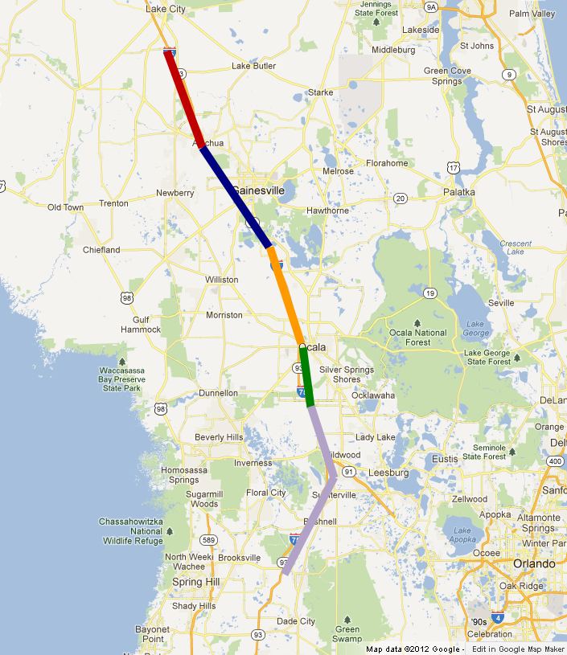

Scenario Description
The 5 colors in Figure 3-1 depict the areas in the scenario that share the same toll cost. The methodology allows for the toll cost to vary for these segments in response to demand for their use. Any vehicle using any part of a managed lane in one of these segments is subject to the cost determined for that segment. Note that for the 5 sections, the toll cost in the southbound direction may be different than the cost in the northbound section; in effect, there are therefore ten separate toll sections for this I-75 scenario.

General Approach
The Cube-based FLSWM was extended to implement this prototype. Demand matrices from a typical FLSWM were used as input, and the base unloaded highway network was revised to identify a toll segment code, 1-10, for each segment in the scenario (5 northbound and 5 southbound for the 5 areas shown in Figure 3-1.)
The Cube static traffic assignment model was run using a custom script developed to implement the dynamic tolling procedure. Details of that script will be provided in a later section of this report, and the appendix contains the actual script used. The traffic assignment results were evaluated using the Cube network visualizer and aggregate summaries to observe the effect of tolling to the distribution of traffic between general purpose lanes and managed lanes coded for the scenario.
A more detailed analysis of the response of traffic to tolls and willingness to pay was also evaluated for the prototype model by considering demand for only a single origin zone and destination zone, at opposite ends of the corridor, and evaluating the responses in the model to varying traffic loads, varying toll costs, and varying willingness to pay relationships. The purpose of the analysis was to demonstrate sensitivities of the prototype model and to highlight relationships that should be further analyzed and further developed should there be interest in fully developing the prototype model. As it stands, the prototype is suitable for use as a basis of comparison to other techniques for modeling managed lanes that FDOT may wish to consider in the future.

Managed Lanes Scenario Network Coding
Figure 3-2 shows an example of the network coding used to represent the managed lanes scenario. What had previously been coded as general purpose lanes for I-75 was revised to include coding for both general purpose and managed lanes facilities. The figure shows that managed lanes were coded through the entire corridor in parallel to existing general purpose lanes. For each node in the general purpose lane links that provided a connection to the non-freeway network system, entry and exit links between the managed lanes and general purpose lanes were added.
This network topology provides for routes in the network to be built through the managed lanes for demand willing to pay for tolls. These routes may enter the managed lanes at any point in the standard FLSWM network where entrance or exit links connect to the general purpose lanes. The routes do not have to enter at the beginning of the toll segments, but may enter at links along the facility where such locations allow for better travel paths. This coding represents the ability of traffic to shift between managed lanes and general purpose lanes for this prototype model. For a more detailed project study, one might consider adding additional links between managed and general purpose links to allow more opportunities for traffic to switch.

Figure 3-2: Network Coding Diagram
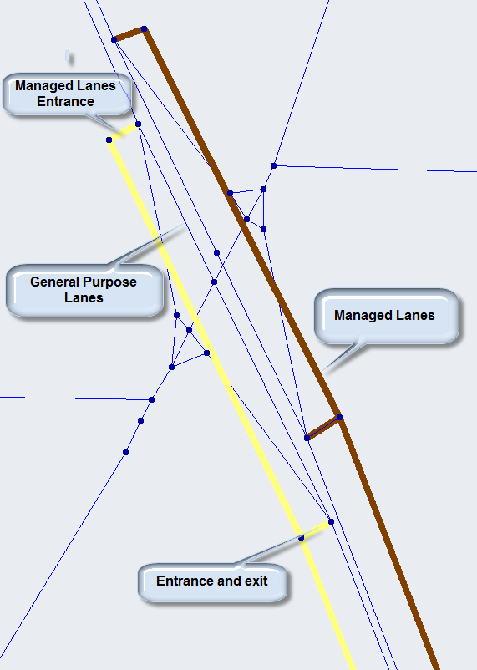

The network editor feature of Cube was used to add managed lane links and the entry/exit to the FLSWM network. Attributes for the new links were coded the same as the adjacent, existing general purpose links, with the exception of number of lanes, which were revised to 2 lanes for both the new managed lane links and the existing general purpose links. Besides coding the number of each type of lanes for this scenario lanes, link type, area type, speed, capacity, description fields and capacity restraint function fields were copied from the adjacent parallel general purpose links to the managed links.

Dynamic Tolling Relationship
Figure 3-3 shows a relationship between congestion, represented by volume to capacity ratio and travel time in minutes and toll cost in dollars, for a typical managed lane link. The curves in Figure 3-3 are for any typical managed lane link, assuming free flow time of 1.0 minute and using the volume/delay coefficient and exponent coded in the network for such links. The red curve shows how travel time changes with volume/capacity for this typical link and as a result, the blue curve shows how toll cost might change. These curves are a graphical representation of the values coded in the Cube script. In the dynamic tolling procedure, the toll cost for any toll segment is determined by a lookup function given the volume to capacity ratio for the toll segment. Since a toll segment consists of one or more managed lanes links, toll cost for each entire toll segment is determined based on the link in the segment with the highest volume to capacity ratio. The toll cost values in this figure, shown by the blue line, were taken from a dynamic tolling Cube script used for a managed lanes study in Minneapolis. These values would likely be revised by a user according to their desire to balance managed lanes congestion and toll revenue generated.

Figure 3-3: Congestion versus Toll Cost
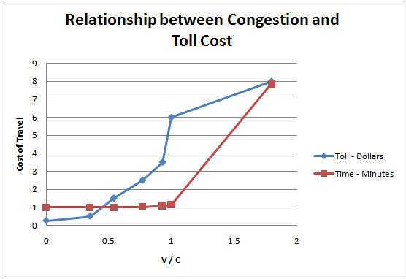
The dynamic tolling methodology implemented in this prototype determines a share of demand that is willing to pay a toll relative a measure of time savings on the managed lanes versus the cost. The costs for each toll segment are determined based on the relationships shown here.
As time savings on the managed lanes induces demand to shift to the toll paying category, an increase in toll cost can be set such that higher costs induce some of the toll paying vehicles to switch back to the general purpose lanes. The adjustment phase in Cube’s traffic assignment procedure handles the calculation of the toll costs per toll segment, and iterations of the traffic assignment cause demand to shift in such a way as to balance the effect of toll cost with congestion.
Policies that focus on revenue generation can be evaluated with the dynamic pricing methodology, as well as policies that focus on the mitigation of congestion in a corridor. The Cube script used to apply the procedure provides an open and easily modified set of values for adjusting the cost vs. congestion relationships used in the model.

Willingness to Pay
Besides dynamic tolling for managed lanes, the other important capability of the Phase 1 model is the ability to simply shift demand to allow network flows for both managed lanes and general purpose lanes to be determined. The mechanism for determining demand willing to pay tolls is a lookup procedure for willingness to pay proportions relative to a measure of cost per time saved on managed lanes. The higher the cost per minute saved, the lower the proportion willing to pay.

Table 3-1: Not-Willing to Pay Proportions for cost per time saved, by Demand Category
Toll Cents per Minute Saved | Demand Category
 | 1 | 2 | 3 | 4 | 5 | 6 | 7 | 8
0 | 5 | 5 | 5 | 5 | 5 | 5 | 5 | 5
8 | 50 | 50 | 50 | 50 | 50 | 50 | 50 | 50
10 | 60 | 60 | 60 | 60 | 60 | 60 | 60 | 60
16.3 | 75 | 75 | 75 | 75 | 75 | 75 | 75 | 75
20 | 81.7 | 81.7 | 81.7 | 81.7 | 81.7 | 81.7 | 81.7 | 81.7
23.7 | 85 | 85 | 85 | 85 | 85 | 85 | 85 | 85
31.4 | 90.5 | 90.5 | 90.5 | 90.5 | 90.5 | 90.5 | 90.5 | 90.5
41.7 | 95 | 95 | 95 | 95 | 95 | 95 | 95 | 95
51.8 | 96 | 96 | 96 | 96 | 96 | 96 | 96 | 96
58.3 | 98 | 98 | 98 | 98 | 98 | 98 | 98 | 98
66.7 | 98.8 | 98.8 | 98.8 | 98.8 | 98.8 | 98.8 | 98.8 | 98.8
Demand Categories:

1 - urban & rural short
2 - Long-Distance Business
3 - Long-Distance Tourist
4 - Short, Cross-border EI
5 - Long-Distance US, Canada
6 - Medium Trucks
7 - Unused
8 - Light Trucks

Table 3-1 shows 8 columns of proportions for values of cost per time saved index values (rows in the table). The proportions are the proportion “not willing to pay” for any index value. The values in Table 3-1 were taken from a Cube script for the same managed lane toll assignment project completed in Minneapolis, MN referred to above in describing the congestion and toll cost relationships.
The procedure works by looking at the cost of traveling between any given O/D pair. If any paths for that O/D pass through a managed lane link, the toll cost for the segment to which that managed lane belongs is accumulated. If the path passes through more than one toll segment, the cost of all the segments traversed is accumulated. The total toll cost is divided by the time saved by the managed lanes. In other words, the time for vehicles without access to managed lanes minus the time for vehicles with access to managed lanes is determined, and is the time savings. The ratio of cost in cents to time saved in minutes determines the index value for the lookup table shown above. The proportion values for ratio values falling between the index values shown are interpolated so that every ratio results in a proportion of the demand for the O/D that will not use managed lanes. The remaining portion of demand for the O/D are willing to pay a toll and are eligible to use the managed lanes if the traffic assignment procedure so routes them.
The procedure for determining toll paying demand satisfies several requirements outlined above. The procedure is simple to modify and transparent as it is coded in the Cube script. The procedure has the ability to set different willingness to pay proportions by demand type. The calculations for the ratio index are done in the Cube script and therefore can be easily modified to test other relationships. For example, instead of basing the proportions on totals cost divided by time saved, one might prefer to use a measure such as cost per mile traveled divided by time saved relative to the total trip time. This lookup index measure might reflect willingness to pay relative to the length of trip, and might be more appropriate for some policy analyses. The procedure is flexible in this regard, and appropriate proportions can easily be defined in the script.

Testing the Methodology
The script developed to calculate dynamic tolls, toll paying demand, and resulting network flows was tested using Cube, the enhanced network with managed lanes scenario, and a demand matrix with demand specified for a single O/D pair. The O/D pair is shown in Figure 4-1, and the demand specified for testing purposes was 50,000 auto trips.
This simple demand matrix allowed for examining the effect on link flows of changing the dynamic tolling relationships, the number of trips required to obtain congested conditions, and the resulting shifts in demand and toll costs as the procedure iterated. Figure 4-1 shows the paths to which demand was assigned for three iterations of user-optimal equilibrium with Cube. The green paths are paths over managed lanes links, while yellow shows links on general purpose lanes. This assignment procedure found two major paths between these end points, with a little more path dispersion around the centroid connectors. While it is difficult to discern in these graphs, one may be able to see the yellow hints around the green paths indicating that both general purpose and managed lane links are receiving flow. Figure 4-2 shows the distribution better, at a northern section of the scenario.
Figure 4-1: Location of Test Origin and Destination
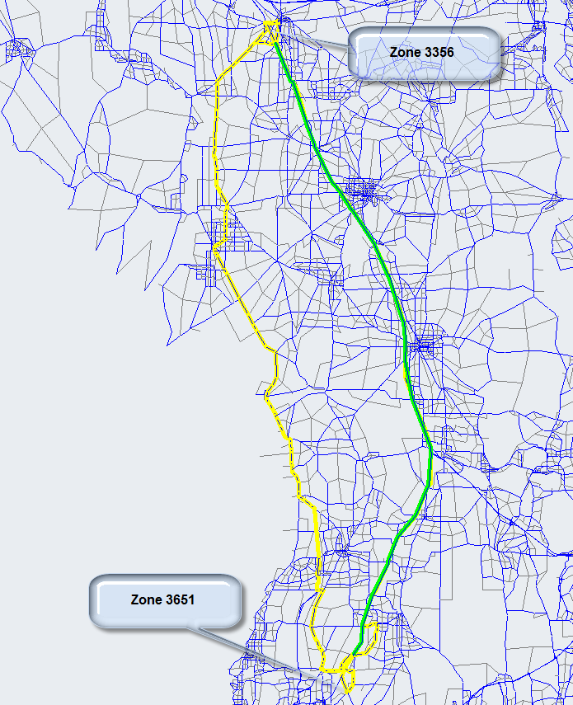

Figure 4-2: Flow assigned to both managed and general purpose lanes
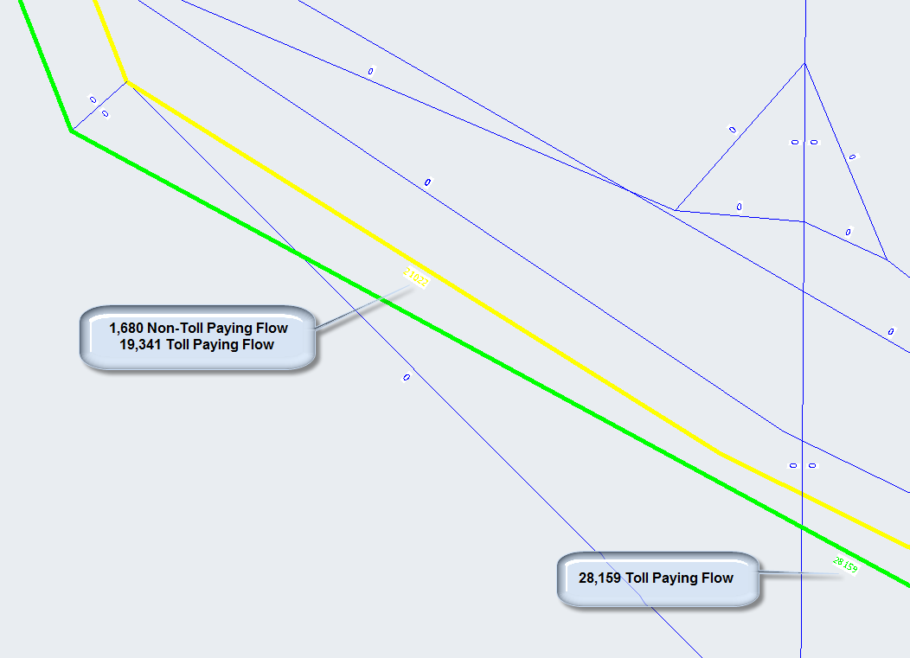

Figure 4-2 shows flow on managed lanes represents only flow from demand willing to pay tolls. Flow on general purpose lanes shows flow from both categories of demand, those willing to pay and those not willing to pay tolls. In other words, demand allocated as willing to pay a toll is able to, but does not necessarily have to choose managed lanes. In this test, due to the limited number of equilibrium iterations, a large number of managed lane eligible trips found better path travel time on the general purpose lanes, and were so assigned.
The figure also shows zero flow on links other than I-75, due to the fact flow from only one O/D pair was assigned for the test. Finally, one can note that the total flow determined by adding the three flows in Figure 4-2 is 49,181. The other approximately 820 vehicles follow the second major path shown in Figure 4-1.
The test procedure allowed us to compare the proportions of flow on managed lanes under varying congestion levels, with varying willingness to pay settings, and with varying toll costs associated with congestion levels. We were able to evaluate the various sensitivities of the procedure under relatively controlled conditions.

Table 4-1: Testing Dynamic Toll Calculations
iteration | start | end | segment | pay | toll | OD toll | OD minutes | OD Percent | V/C
 | node | node |  |  |  | Cost | Saved | Will pay
1 | 93354 | 93358 | 1 | 0 | 25 | 125 | 58.7 | 83% | 0
1 | 93358 | 93359 | 1 | 0 | 25 | 125 | 58.7 | 83% | 0
1 | 93359 | 93362 | 1 | 0 | 25 | 125 | 58.7 | 83% | 0
1 | 93362 | 93363 | 1 | 0 | 25 | 125 | 58.7 | 83% | 0
1 | 93363 | 93366 | 1 | 0 | 25 | 125 | 58.7 | 83% | 0
1 | 93366 | 93367 | 1 | 0 | 25 | 125 | 58.6 | 83% | 0
2 | 93354 | 93358 | 1 | 8500 | 50 | 250 | 15.1 | 25% | 0.35
2 | 93358 | 93359 | 1 | 8500 | 50 | 250 | 15.1 | 25% | 0.35
2 | 93359 | 93362 | 1 | 8500 | 50 | 250 | 15.1 | 25% | 0.35
2 | 93362 | 93363 | 1 | 8500 | 50 | 250 | 15.1 | 25% | 0.35
2 | 93363 | 93366 | 1 | 8500 | 50 | 250 | 15.1 | 25% | 0.35
2 | 93366 | 93367 | 1 | 8500 | 50 | 250 | 15.1 | 25% | 0.35
3 | 93354 | 93358 | 1 | 11000 | 80 | 400 | 14.5 | 10% | 0.42
3 | 93358 | 93359 | 1 | 11000 | 80 | 400 | 14.5 | 10% | 0.42
3 | 93359 | 93362 | 1 | 11000 | 80 | 400 | 14.5 | 10% | 0.42
3 | 93362 | 93363 | 1 | 11000 | 80 | 400 | 14.5 | 10% | 0.42
3 | 93363 | 93366 | 1 | 11000 | 80 | 400 | 14.5 | 10% | 0.42
3 | 93366 | 93367 | 1 | 11000 | 80 | 400 | 14.5 | 10% | 0.42

4.1. Dynamic Toll Calculations
Table 4-1 shows some results written out during testing of the dynamic toll calculation. Rather than include the entire table, which has many rows, the rows relevant to the first tolling segment (Southbound at northern end of scenario) are shown. This partial table is shown here to demonstrate specifically the calculation of the toll segment cost to be used for the following iteration. The first column indicates the assignment iteration. The next three columns show the start node and end node for managed lane links in toll segment 1. The next column, labeled as “pay”, shows the flow on the managed lane at the end of the iteration. The “toll” column shows the toll calculated. The V/C column is the volume to capacity ratio for the managed lane links. This table was used to perform manual checks to ensure the methodology for setting toll segment costs based on volume to capacity ratio values was correct.
In the first iteration, no toll paying demand exists, and 0 toll paying flow is the result. Using the lookup table defined in the procedure script in the Appendix, or looking at the graph shown in Figure 3-3, one can see that the dynamic toll cost associated with a minimum V/C value of 0 results in a toll cost of $0.25, and the value shown in the table calculated by the Cube script confirms this value. As a result of the new toll cost, an O/D toll cost and difference in path travel time results in a portion of the 50,000 trips being assigned as toll paying demand, and the resulting toll-paying flow is shown in the table for iteration 2. The resulting V/C value of 0.35 results in the new toll cost for the segment of about $2.50 (again, see the lookup table in the script or the graph to confirm). The new costs and time savings again cause shift to the toll paying demand, and in the 3rd iteration, even more flow is found on the managed lane links. This flow results in a V/C greater than 1.0. The associated toll cost is changed to $4, corresponding to the V/C ratio of 0.42.
This table was designed to allow one to check the values of the toll segments, based on the individual link V/C ratios, from the lookup table values used in the Cube script. The table further indicates how toll paying demand is determined from OD toll cost and minutes saved values, also shown in Table 4-1, and how the managed lanes flow is affected by varying toll paying demand. It should be pointed out that the table cannot show the direct relationship between “percent of demand willing to pay tolls” and managed lanes traffic flow since the network assignment procedure may allocate some toll paying demand to non-managed flow lanes and also allocates some demand to routes that don’t use I-75. The table does however allow one to compute the ratio of “OD toll cost” to “OD minutes saved on managed lanes”. This ratio is used in the willingness to pay proportion lookup procedure in the Cube script. Table 4-1 shows the percents calculated from this lookup table for this example.

5. Running the Dynamic Toll Traffic Assignment Procedure
The dynamic toll traffic assignment Cube script is listed in an Appendix at the end of this report. The script has references to Cube application framework variables and is intended to be included in a Cube application. The project folders containing the revised FLSWM with toll segment coding and the dynamic toll traffic assignment procedures accompany this report as a separate zip file.
The revised FLSWM application is run first to generate demand matrices suitable for being assigned by the tolling traffic assignment application. The demand matrices written to the FLSWM application “base\output” folder are copied to the toll assignment application “base\input” folder:
- "{SCENARIO_DIR}\output\FREIGHT.B05"
- "{SCENARIO_DIR}\input\TRUCKS-OD.B05"
- "{SCENARIO_DIR}\input\XTT_OD_05B.MAT"
Likewise, the unloaded highway network folder from the revised FLSWM folder is copied to the toll assignment folder:
- "{SCENARIO_DIR}\input\UNLOADED_B05.NET"

With these files copied, and the application folders in place, the toll assignment application is run to produce loaded network flows and travel times associated with the defined dynamic tolling managed lane scenario. Cube can be used to evaluate the typical model outputs:
- Model output PRN files
- Toll and non-toll demand matrices
- Managed lane and general purpose lane link flows and travel times

Results from Full Statewide Phase 1 Model Application
The same managed lanes scenario described in Sections 3 and 4 was applied for the entire statewide model. In addition to confirming that the prototype mode functioned correctly for the entire state model, some sensitivity analysis was done. Response of the model to changes in toll values and to willingness to pay toll proportions were evaluated and are summarized graphically below. In these figures, volume to capacity ratio values are shown for each test case: base, less toll, more toll for toll values and base, less willingness, more willingness, are shown for each of the five separate managed lane segments. The numeric index on the figures below indicate southbound segments 1, 3, 5, 7, and 9 and northbound segments 2, 4, 6, 8, and 10, as shown in figure 6-1.

Figure 6-1: Sensitivity to Toll Values for Southbound Managed Lanes
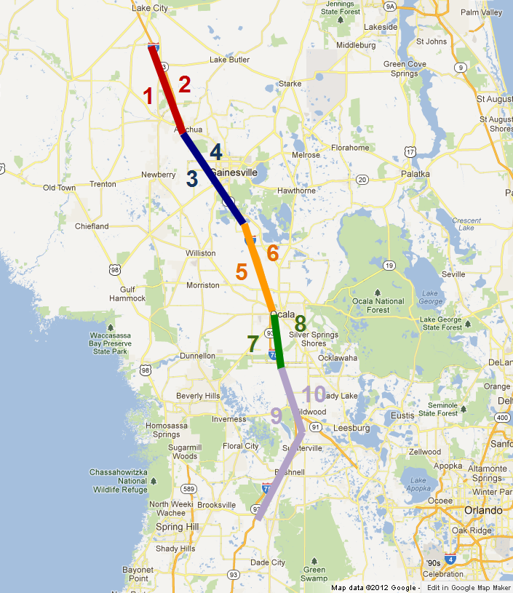

The figures below show the model sensitivity in terms of average congestion, represented by volume to capacity ratio measure, on the managed lane scenario relative to tolls.

Figure 6-2: Sensitivity to Toll Values for Southbound Managed Lanes

Figure 6-3: Sensitivity to Toll Values for Northbound Managed Lanes

The “less toll” case involves toll values that were half of the toll values used in the base case. The “more toll” case involves tolls twice the value of the base case. The volume to capacity ratio values are representative values for each of the five toll segments.
The next figures the sensitivities of congested flows to changes in willingness to pay values.

Figure 6-4: Sensitivity to Willingness to Pay Tolls for Southbound Managed Lanes

Figure 6-5: Sensitivity to Willingness to Pay Tolls for Northbound Managed Lanes

Willingness to pay proportions were increased for the “more willing” case and decreased for the “less willing” case relative to the base case.
Both sets of figures show logical sensitivities. The model generally shows more volume on the managed lanes (by measure of volume to capacity ratio) where tolls are decreased or willingness to pay is increased. Likewise, similar decreases in flows are shown as tolls increase or willingness to pay decreases. Also, the magnitudes of the value changes are relatively consistent by segment location and segment direction. This is understandable, given that the scenario is evaluating daily flows and the segments have low, relatively uncongested volume to capacity ratios.

7. Conclusions and Potential Future Directions for the Phase 1 Model
The sensitivity of the procedure to toll costs varying based on congestion measured by volume to capacity ratio and the sensitivity of toll paying demand determined by the lookup proportions defined as a function of some cost per time saved measure is illustrated in the above example. The Phase 1 model is flexible and capable of being adjusted to evaluate a range of policy sensitivities related to managed lanes, congestion indexed pricing, and shifts to toll paying demand. Adjustments may be made by users to the willing to pay proportions in the Cube lookup table in order to refine those values for any specific application area or to toll cost values by volume to capacity ratio in order to implement ones’ own level-of-service vs. revenue strategies.
Testing of the Phase 1 approach indicates the procedure has the necessary sensitivity and flexibility as outlined as requirements at the beginning of this report. The approach works for the full statewide model, but the outcomes raise questions that may require additional evaluation. In particular, the lack of specific time periods in the statewide model make evaluation of congestion responsive toll costs difficult. The statewide model doesn’t necessarily present enough congested conditions to evaluate such tradeoffs (thus the need for the test application used to artificially obtain targeted, congested conditions.)
Regardless, the Phase 1 prototype illustrates the capabilities desired for evaluating managed lanes scenarios using a dynamic tolling approach. Besides the need to represent traffic congestions at different times of the day and under different demand conditions, areas where additional work would be warranted are:
- Exploring dynamic toll cost relationships for specific areas of interest in Florida
- Comparing dynamic toll model results to traditionally tolled corridors for reasonableness
- Exploring willingness to pay by demand category
- Additional willingness to pay segments to reflect more “value of time” demand categories in the model
- Suitability of the procedure for models in metropolitan areas or smaller subareas
- Alternative methods for computing demand shift indices or congestion indices
- Adapting procedure to enable evaluation of non-tolling, HOV only applications

Recommendations for additional further study include:
- Evaluating model application on a specific, smaller area scenario with a congested corridor
- Enhancing the statewide model to include demand varying by different time periods so that specific peak condition travel can be evaluated separate from off-peak travel periods
- Developing demand matrices for managed lane travelers that reflect even more behaviorally sensitive relationships between travel time, cost, time of day, willingness to pay, and value of time from a fully implemented mode choice model
- Exploring advantages of dynamic traffic assignment model in representing managed lanes operations and effectiveness

Appendix

A.1. Cube Script for Implementing Dynamic Toll Traffic Assignment Procedure

; Script for program HIGHWAY in file "C:\jim\projects\FDOT\working\FLSWM_hwyassign - Toll\HAHWY01H.S"
; Do not change filenames or add or remove FILEI/FILEO statements using an editor. Use Cube/Application Manager.
RUN PGM=HIGHWAY PRNFILE="{SCENARIO_DIR}\reports\HAHWY01F.PRN" MSG='Assign Autos & Trucks, Toll Model'
FILEO MATO[1] = "{SCENARIO_DIR}\output\TollMatrices",
mo=75,175,81,281,381,481,581,681,881, dec=2*0,7*2,
name=toll1,toll2,trev1,trev2,trev3,trev4,trev5,trev6,trev8
FILEO MATO[2] = "{SCENARIO_DIR}\output\toll_ntoll_demand.trp",
mo=79-80,279-280,379-380,479-480,579-580,679-680,879-880, dec=14*4,
name=t1,nt1,t2,nt2,t3,nt3,t4,nt4,t5,nt5,t6,nt6,t8,nt8

DISTRIBUTEINTRASTEP PROCESSID='FLSWMPBID', PROCESSLIST=2-12,MinGroupSize=200,SavePrn=F
FILEI NETI = "{SCENARIO_DIR}\input\UNLOADED_B05.NET"
FILEI MATI[3] = "{SCENARIO_DIR}\input\FREIGHT.B05"
FILEI MATI[2] = "{SCENARIO_DIR}\input\TRUCKS-OD.B05"
FILEI MATI[1] = "{SCENARIO_DIR}\input\XTT_OD_05B.MAT"
;FILEI MATI[3] = "{SCENARIO_DIR}\input\temp_frt_demand.trp"
;FILEI MATI[2] = "{SCENARIO_DIR}\input\temp_trks_demand.trp"
;FILEI MATI[1] = "{SCENARIO_DIR}\input\temp_xxt_demand.trp"
FILEI TURNPENI = "{SCENARIO_DIR}\\input\TURN_05B.PEN"
FILEO NETO = "{SCENARIO_DIR}\output\HAHWY01D.NET"
FILEO PRINTO[1] = "{SCENARIO_DIR}\output\TOLL_SEG_INFO.DAT"

PAR ZONEMSG=10 COMBINE=EQUI MAXITERS=200 RELATIVEGAP=0.005 GAP=0.00000 RAAD=0.00000 AAD=0.00000 RMSE=0.00000
; look up deceleration rate based on approach speed
LOOKUP,
INTERPOLATE=Y, LIST=Y, NAME=DECEL,
LOOKUP[1]=1,RESULT=2,
R = '30 4',
'70 6.2'
;
; look-up for toll policy -- TOLL
;
LOOKUP NAME=TOLL,
LOOKUP[1]=1, RESULT=2,
INTERPOLATE=Y,
FAIL=25,800,
R = '0.00 25', ; LOS-Toll table reported by MnDOT
'0.35 50',
'0.54 150',
'0.77 250',
'0.93 350',
'1.00 600'
;
; look-up for willingness to pay curve -- DIVERT
;
LOOKUP NAME=DIVERT, ; VOT distribution as reported by NuStats
LOOKUP[1]=1, RESULT=2, ; 1 - urban & rural short result=2
lookup[2]=1, result=3, ; 2 - Long-Distance Business result=3
lookup[3]=1, result=4, ; 3 - Long-Distance Tourist result=4
lookup[4]=1, result=5, ; 4 - Short, Cross-border EI result=5
lookup[5]=1, result=6, ; 5 - Long-Distance US, Canada result=6
lookup[6]=1, result=7, ; 6 - Medium Trucks result=7
lookup[7]=1, result=8, ; 7 - Unused result=8
lookup[8]=1, result=9, ; 8 - Light Trucks result=9
INTERPOLATE=Y,
FAIL = 1,100,
R = ' 0.0 8.0 8.0 8.0 8.0 8.0 8.0 8.0 8.0',
' 8.0 60.0 60.0 60.0 60.0 60.0 60.0 60.0 60.0',
'10.0 70.0 70.0 70.0 70.0 70.0 70.0 70.0 70.0',
'16.3 85.0 85.0 85.0 85.0 85.0 85.0 85.0 85.0',
'20.0 91.7 91.7 91.7 91.7 91.7 91.7 91.7 91.7',
'23.7 95.0 95.0 95.0 95.0 95.0 95.0 95.0 95.0',
'31.4 97.5 97.5 97.5 97.5 97.5 97.5 97.5 97.5',
'41.7 98.0 98.0 98.0 98.0 98.0 98.0 98.0 98.0',
'51.8 98.5 98.5 98.5 98.5 98.5 98.5 98.5 98.5',
'58.3 99.0 99.0 99.0 99.0 99.0 99.0 99.0 99.0',
'66.7 99.5 99.5 99.5 99.5 99.5 99.5 99.5 99.5'

; LOOKUP NAME=DIVERT, ; VOT distribution as reported by NuStats
; LOOKUP[1]=1, RESULT=2, ; 1 - urban & rural short result=2
; lookup[2]=1, result=3, ; 2 - Long-Distance Business result=3
; lookup[3]=1, result=4, ; 3 - Long-Distance Tourist result=4
; lookup[4]=1, result=5, ; 4 - Short, Cross-border EI result=5
; lookup[5]=1, result=6, ; 5 - Long-Distance US, Canada result=6
; lookup[6]=1, result=7, ; 6 - Medium Trucks result=7
; lookup[7]=1, result=8, ; 7 - Unused result=8
; lookup[8]=1, result=9, ; 8 - Light Trucks result=9
; INTERPOLATE=Y,
; FAIL = 5,100,
; R = ' 0.0 5.0 5.0 5.0 5.0 5.0 5.0 5.0 5.0',
; ' 8.0 50.0 50.0 50.0 50.0 50.0 50.0 50.0 50.0',
; '10.0 60.0 60.0 60.0 60.0 60.0 60.0 60.0 60.0',
; '16.3 75.0 75.0 75.0 75.0 75.0 75.0 75.0 75.0',
; '20.0 81.7 81.7 81.7 81.7 81.7 81.7 81.7 81.7',
; '23.7 85.0 85.0 85.0 85.0 85.0 85.0 85.0 85.0',
; '31.4 90.5 90.5 90.5 90.5 90.5 90.5 90.5 90.5',
; '41.7 95.0 95.0 95.0 95.0 95.0 95.0 95.0 95.0',
; '51.8 96.0 96.0 96.0 96.0 96.0 96.0 96.0 96.0',
; '58.3 98.0 98.0 98.0 98.0 98.0 98.0 98.0 98.0',
; '66.7 98.8 98.8 98.8 98.8 98.8 98.8 98.8 98.8'

SELI = 3356
SELJ = 3651

PHASE=LINKREAD
LW.BPRCOEFFICIENT=LI.BPRCOEFFICIENT
LW.BPREXPONENT=LI.BPREXPONENT

;if (LI.FTYPE_{year}=10-19,70-79) ADDTOGROUP=7
;USER SUPPLIED ALPHA AND BETA FOR THE BPR CURVE
LW.DAILYCAP=((LI.LANE_{YEAR}*LI.CAPACITY)/LI.CONFAC)* LI.UROADFACTOR
LW.FFTIME=LI.TIME
T0=LI.TIME

C=LW.DAILYCAP
;IF (LI.FTYPE_{year}=80-89)C=LW.DAILYCAP*0.75; HOV Agginment Reduction by adjusting Capacity at 75%
LINKCLASS=1 ; no toll

T0=LW.FFTIME
if (LI.TOLL>0 & LI.TOLL_ACC=0 & LI.TOLL_DEC=0&LI.TOLLTYPE=1-3)
LINKCLASS=2 ; with toll
T0=(li.ctoll*LI.CARTOLL)*60 + LI.SVCMINUTES + LI.SVCSECONDS/60

if (iteration=0)
;If ((LI.SVCMINUTES+LI.SVCSECONDS)=0)SVCSECONDS=LI.SVCSECONDS+1
LW.ARRIVR=V*LI.CONFAC/LI.PLZALNSMAX ; hourly volume per toll lane ie. arrival rate in vehicles per hour
LW.SERVT=LI.SVCMINUTES+(Li.SVCSECONDS/60) ; Plaza lane service time in minutes per vehicle
LW.SERVR=(1/LW.SERVT)*60
If (LW.SERVT<0.001)
LW.SERVR=100
;LW.ARRIVR=1
ENDIF
;PRINT LIST='ARRIVR= ',LW.ARRIVR
;PRINT LIST='SERVT= ',LW.SERVT
;PRINT LIST='SERVR= ',LW.SERVR
if (LW.ARRIVR>=LW.SERVR) LW.ARRIVR=0.95*LW.SERVR ; prevent infinite or negative queue
endif

endif

if (li.TOLL_ACC>0)
LINKCLASS=3 ; Toll Plaza Acceleration link
T0= T0 + (LI.SPEED_{year}/{ACCELRATE})/60
endif

if (li.TOLL_DEC>0)
LINKCLASS=4 ; Toll Plaza Deceleration link
T0 = T0 + (LI.SPEED_{year}/DECEL(1,LI.SPEED_{year}))/60
endif
if (LI.TOLL>0 & LI.TOLL_ACC=0 & LI.TOLL_DEC=0 & LI.TOLLTYPE=4-6)
LINKCLASS=5 ; Open Road Toll
T0 = (li.ctoll*li.cartoll)*60
endif

IF (LI.OUTSTATE=1) ADDTOGROUP=1
IF (LI.EXCLUDE<>0) ADDTOGROUP=2

if (li.tollseg=1) addtogroup=4
if (li.tollseg=2) addtogroup=5
if (li.tollseg=3) addtogroup=6
if (li.tollseg=4) addtogroup=7
if (li.tollseg=5) addtogroup=8
if (li.tollseg=6) addtogroup=9
if (li.tollseg=7) addtogroup=10
if (li.tollseg=8) addtogroup=11
if (li.tollseg=9) addtogroup=12
if (li.tollseg=10) addtogroup=13

ENDPROCESS

PROCESS PHASE=ILOOP

_maxVC4 = 0
_maxVC5 = 0
_maxVC6 = 0
_maxVC7 = 0
_maxVC8 = 0
_maxVC9 = 0
_maxVC10 = 0
_maxVC11 = 0
_maxVC12 = 0
_maxVC13 = 0

LINKLOOP
IF (li.tollseg=1 & lw.linkvc > _maxVC4) _maxVC4 = lw.linkvc
IF (li.tollseg=2 & lw.linkvc > _maxVC5) _maxVC5 = lw.linkvc
IF (li.tollseg=3 & lw.linkvc > _maxVC6) _maxVC6 = lw.linkvc
IF (li.tollseg=4 & lw.linkvc > _maxVC7) _maxVC7 = lw.linkvc
IF (li.tollseg=5 & lw.linkvc > _maxVC8) _maxVC8 = lw.linkvc
IF (li.tollseg=6 & lw.linkvc > _maxVC9) _maxVC9 = lw.linkvc
IF (li.tollseg=7 & lw.linkvc > _maxVC10) _maxVC10 = lw.linkvc
IF (li.tollseg=8 & lw.linkvc > _maxVC11) _maxVC11 = lw.linkvc
IF (li.tollseg=9 & lw.linkvc > _maxVC12) _maxVC12 = lw.linkvc
IF (li.tollseg=10 & lw.linkvc > _maxVC13) _maxVC13 = lw.linkvc
ENDLINKLOOP

LINKLOOP
IF (li.tollseg=1) _toll4 = TOLL(1,_maxVC4)
IF (li.tollseg=2) _toll5 = TOLL(1,_maxVC5)
IF (li.tollseg=3) _toll6 = TOLL(1,_maxVC6)
IF (li.tollseg=4) _toll7 = TOLL(1,_maxVC7)
IF (li.tollseg=5) _toll8 = TOLL(1,_maxVC8)
IF (li.tollseg=6) _toll9 = TOLL(1,_maxVC9)
IF (li.tollseg=7) _toll10 = TOLL(1,_maxVC10)
IF (li.tollseg=8) _toll11 = TOLL(1,_maxVC11)
IF (li.tollseg=9) _toll12 = TOLL(1,_maxVC12)
IF (li.tollseg=10) _toll13 = TOLL(1,_maxVC13)
ENDLINKLOOP

LINKLOOP
IF (li.tollseg=1 & i=SELI) PRINT LIST=A, B, li.TOLLSEG, lw.linkvol, lw.linkcap, lw.linkvc, ', _toll4=', _toll4, ', _maxVC4=', _maxVC4, printo=1
IF (li.tollseg=2 & i=SELI) PRINT LIST=A, B, li.TOLLSEG, lw.linkvol, lw.linkcap, lw.linkvc, ', _toll5=', _toll5, ', _maxVC5=', _maxVC5, printo=1
IF (li.tollseg=3 & i=SELI) PRINT LIST=A, B, li.TOLLSEG, lw.linkvol, lw.linkcap, lw.linkvc, ', _toll6=', _toll6, ', _maxVC6=', _maxVC6, printo=1
IF (li.tollseg=4 & i=SELI) PRINT LIST=A, B, li.TOLLSEG, lw.linkvol, lw.linkcap, lw.linkvc, ', _toll7=', _toll7, ', _maxVC7=', _maxVC7, printo=1
IF (li.tollseg=5 & i=SELI) PRINT LIST=A, B, li.TOLLSEG, lw.linkvol, lw.linkcap, lw.linkvc, ', _toll8=', _toll8, ', _maxVC8=', _maxVC8, printo=1
IF (li.tollseg=6 & i=SELI) PRINT LIST=A, B, li.TOLLSEG, lw.linkvol, lw.linkcap, lw.linkvc, ', _toll9=', _toll9, ', _maxVC9=', _maxVC9, printo=1
IF (li.tollseg=7 & i=SELI) PRINT LIST=A, B, li.TOLLSEG, lw.linkvol, lw.linkcap, lw.linkvc, ', _toll10=', _toll10, ', _maxVC10=', _maxVC10, printo=1
IF (li.tollseg=8 & i=SELI) PRINT LIST=A, B, li.TOLLSEG, lw.linkvol, lw.linkcap, lw.linkvc, ', _toll11=', _toll11, ', _maxVC11=', _maxVC11, printo=1
IF (li.tollseg=9 & i=SELI) PRINT LIST=A, B, li.TOLLSEG, lw.linkvol, lw.linkcap, lw.linkvc, ', _toll12=', _toll12, ', _maxVC12=', _maxVC12, printo=1
IF (li.tollseg=10 & i=SELI) PRINT LIST=A, B, li.TOLLSEG, lw.linkvol, lw.linkcap, lw.linkvc, ', _toll13=', _toll13, ', _maxVC13=', _maxVC13, printo=1
ENDLINKLOOP

PATHLOAD PATH=TIME, EXCLUDEGROUP=1,4-13, ; short urban and rural, short cross-border and light trucks
mw[2]=PATHCOST ; create non-toll skims

PATHLOAD PATH=TIME, excludegroup=1, ; short urban and rural, short cross-border and light trucks
mw[3] = PATHCOST,
mw[4] = _toll4, selectgroup=4,
mw[5] = _toll5, selectgroup=5,
mw[6] = _toll6, selectgroup=6,
mw[7] = _toll7, selectgroup=7,
mw[8] = _toll8, selectgroup=8,
mw[9] = _toll9, selectgroup=9,
mw[10] = _toll10, selectgroup=10,
mw[11] = _toll11, selectgroup=11,
mw[12] = _toll12, selectgroup=12,
mw[13] = _toll13, selectgroup=13

mw[75] = mw[4]+mw[5]+mw[6]+mw[7]+mw[8]+mw[9]+mw[10]+mw[11]+mw[12]+mw[13] ; sum of segment tolls
mw[76] = mw[2]-mw[3] ; non-pay time minus pay time;;

PATHLOAD PATH=TIME, EXCLUDEGROUP=1-2,4-13, ; long-distance, US and Canada
mw[102]=PATHCOST ; create non-toll skims

PATHLOAD PATH=TIME, excludegroup=1-2, ; long-distance, US and Canada
mw[103] = PATHCOST,
mw[104] = _toll4, selectgroup=4,
mw[105] = _toll5, selectgroup=5,
mw[106] = _toll6, selectgroup=6,
mw[107] = _toll7, selectgroup=7,
mw[108] = _toll8, selectgroup=8,
mw[109] = _toll9, selectgroup=9,
mw[110] = _toll10, selectgroup=10,
mw[111] = _toll11, selectgroup=11,
mw[112] = _toll12, selectgroup=12,
mw[113] = _toll13, selectgroup=13

mw[175] = mw[104]+mw[105]+mw[106]+mw[107]+mw[108]+mw[109]+mw[110]+mw[111]+mw[112]+mw[113] ; sum of segment tolls
mw[176] = mw[102]-mw[103] ; non-pay time minus pay time;

JLOOP

IF (I==J)
mw[78] = 0
mw[178] = 0
ELSE
IF (mw[76]>0)
mw[77] = mw[75]/mw[76] ; toll cost per minute saved

mw[78] = 100 - DIVERT(1,mw[77]) ; percent willing to pay at this level -- short urban & rural
mw[79] = MI.1.1 * mw[78] / 100 ; paying trips - short urban and rural
mw[80] = MI.1.1 - mw[79] ; non-paying trips -- short urban and rural
mw[81] = mw[79] * mw[75] ; revenue for average toll calculations - short urban and rural

mw[478] = 100 - DIVERT(4,mw[77]) ; percent willing to pay at this level -- short cross-border EI
mw[479] = MI.1.4 * mw[478] / 100 ; paying trips - short cross-border EI
mw[480] = MI.1.4 - mw[479] ; non-paying trips -- short cross-border EI
mw[481] = mw[479] * mw[75] ; revenue for average toll calculations - short cross-border EI

mw[878] = 100 - DIVERT(8,mw[77]) ; percent willing to pay at this level -- light trucks
mw[879] = MI.2.Light * mw[878] / 100 ; paying trips - light trucks
mw[880] = MI.2.Light - mw[879] ; non-paying trips -- light trucks
mw[881] = mw[879] * mw[75] ; revenue for average toll calculations - light trucks

IF (i=SELI && j=SELJ)
PRINT LIST= 'i=', I , ', j=', J, ', Iteration=', ITERATION,
', _toll4=', _toll4, ', _toll6=', _toll6, ', _toll8=', _toll8, ', _toll10=', _toll10, ', _toll12=', _toll12, printo=1
PRINT LIST= 'i=', I , ', j=', J, ', Iteration=', ITERATION,
', mw[4]=', mw[4], ', mw[6]=', mw[6], ', mw[8]=', mw[8], ', mw[10]=', mw[10], ', mw[12]=', mw[12], printo=1
PRINT LIST= 'i=', I , ', j=', J, ', Iteration=', ITERATION,
', mw[75]=', mw[75], ', mw[76]=', mw[76], ', mw[77]=', mw[77], ', mw[78]=', mw[78], printo=1
ENDIF

ELSE
mw[77] = -1 ; flag for 0 min saved
mw[78] = 0 ; no-one will pay if there is no savings -- short urban and rural
mw[79] = 0 ; so paying trips are 0 -- short urban and rural
mw[80] = MI.1.1 ; all trips are non-paying -- short urban and rural
mw[81] = 0 ; zero revenue -- short urban and rural

mw[478] = 0 ; no-one will pay if there is no savings -- short cross-border EI
mw[479] = 0 ; so paying trips are 0 -- short cross-border EI
mw[480] = MI.1.4 ; all trips are non-paying -- short cross-border EI
mw[481] = 0 ; zero revenue -- short cross-border EI

mw[878] = 0 ; no-one will pay if there is no savings -- light trucks
mw[879] = 0 ; so paying trips are 0 -- light trucks
mw[880] = MI.2.Light ; all trips are non-paying -- light trucks
mw[881] = 0 ; zero revenue -- light trucks

ENDIF
IF (mw[176]>0)
mw[177] = mw[175]/mw[176] ; toll cost per minute saved

mw[278] = 100 - DIVERT(2,mw[177]) ; percent willing to pay at this level -- long distance business
mw[279] = MI.1.2 * mw[278] / 100 ; paying trips - long distance business
mw[280] = MI.1.2 - mw[279] ; non-paying trips -- long distance business
mw[281] = mw[279] * mw[175] ; revenue for average toll calculations - long distance business

mw[378] = 100 - DIVERT(3,mw[177]) ; percent willing to pay at this level -- in-state tourist
mw[379] = MI.1.3 * mw[378] / 100 ; paying trips - in-state tourist
mw[380] = MI.1.3 - mw[379] ; non-paying trips -- in-state tourist
mw[381] = mw[379] * mw[175] ; revenue for average toll calculations - in-state tourist

mw[578] = 100 - DIVERT(5,mw[177]) ; percent willing to pay at this level -- US & Canada
mw[579] = MI.1.5 * mw[578] / 100 ; paying trips - US & Canada
mw[580] = MI.1.5 - mw[579] ; non-paying trips -- US & Canada
mw[581] = mw[579] * mw[175] ; revenue for average toll calculations - US & Canada

mw[678] = 100 - DIVERT(6,mw[177]) ; percent willing to pay at this level -- medium trucks
mw[679] = MI.2.Medium * mw[678] / 100 ; paying trips - medium trucks
mw[680] = MI.2.Medium - mw[679] ; non-paying trips -- medium trucks
mw[681] = mw[679] * mw[175] ; revenue for average toll calculations - medium trucks

ELSE
mw[177] = -1 ; flag for 0 min saved
mw[278] = 0 ; no-one will pay if there is no savings -- long distance business
mw[279] = 0 ; so paying trips are 0 -- long distance business
mw[280] = MI.1.2 ; all trips are non-paying -- long distance business
mw[281] = 0 ; zero revenue -- long distance business

mw[378] = 0 ; no-one will pay if there is no savings -- in-state tourist
mw[379] = 0 ; so paying trips are 0 -- in-state tourist
mw[380] = MI.1.3 ; all trips are non-paying -- in-state tourist
mw[381] = 0 ; zero revenue -- short in-state tourist

mw[578] = 0 ; no-one will pay if there is no savings -- US & Canada
mw[579] = 0 ; so paying trips are 0 -- US & Canada
mw[580] = MI.1.5 ; all trips are non-paying -- US & Canada
mw[581] = 0 ; zero revenue -- US & Canada

mw[678] = 0 ; no-one will pay if there is no savings -- medium trucks
mw[679] = 0 ; so paying trips are 0 -- medium trucks
mw[680] = MI.2.Medium ; all trips are non-paying -- medium trucks
mw[681] = 0 ; zero revenue -- medium trucks

ENDIF
ENDIF

ENDJLOOP

;
; non-toll assignments
;
PATHLOAD PATH=TIME, EXCLUDEGROUP=1,4-13,
VOL[1]=mw[80], ; URBAN AND RURAL SHORT TRIPS
VOL[4]=mw[480], ; Short-Cross-border EI
VOL[8]=mw[880]*{PCE_LT} ;light trucks

PATHLOAD PATH=TIME, EXCLUDEGROUP=1-2,4-13,
VOL[2]=mw[280], ; LONG DISTANCE BUSINESS
VOL[3]=mw[380] ; Long Distance In-state Tourists

PATHLOAD PATH=LW.FFTIME, EXCLUDEGROUP=1-2,4-13,
VOL[5]=mw[580], ; FL-US, US-FL. Canada-FL
VOL[6]=mw[680]*{PCE_MT} ; Medium Trucks

PATHLOAD PATH=LW.FFTIME, EXCLUDEGROUP=2,4-13,
VOL[7]=MI.2.Heavy*{PCE_HT},; Heavy Trucks
VOL[9]=MI.3.1*{PCE_HT} ; Freight Trucks based on the Freight Model

;
; toll assignment
;
PATHLOAD PATH=TIME, EXCLUDEGROUP=1,
VOL[10]=mw[79], ; URBAN AND RURAL SHORT TRIPS
VOL[13]=mw[479], ; Short-Cross-border EI
VOL[16]=mw[879]*{PCE_LT} ;light trucks

PATHLOAD PATH=TIME, EXCLUDEGROUP=1-2,
VOL[11]=mw[279], ; LONG DISTANCE BUSINESS
VOL[12]=mw[379] ; Long Distance In-state Tourists;;

PATHLOAD PATH=LW.FFTIME, EXCLUDEGROUP=1-2,
VOL[14]=mw[579], ; FL-US, US-FL. Canada-FL
VOL[15]=mw[679]*{PCE_MT} ; Medium Trucks

ENDPROCESS

PROCESS PHASE=ADJUST
FUNCTION V=VOL[1]+VOL[2]+VOL[3]+VOL[4]+VOL[5]+VOL[6]+VOL[7]+VOL[8]+VOL[9]+
VOL[10]+VOL[11]+VOL[12]+VOL[13]+VOL[14]+VOL[15]+VOL[16]

if (TIME>0) LW.CGSTSPEED=(LI.DISTANCE/TIME)*60
if (LI.TOLL>0 & LI.TOLL_ACC=0 & LI.TOLL_DEC=0&LI.TOLLTYPE=1-3)
LW.ARRIVR=V*LI.CONFAC/LI.PLZALNSMAX ; hourly volume per toll lane ie. arrival rate in vehicles per hour
LW.SERVT=LI.SVCMINUTES+(Li.SVCSECONDS/60) ; Plaza lane service time in minutes per vehicle
LW.SERVR=(1/LW.SERVT)*60
If (LW.SERVT<0.001)
LW.SERVR=100
LW.ARRIVR=1
ENDIF
if (LW.ARRIVR>=LW.SERVR) LW.ARRIVR=0.95*LW.SERVR ; prevent infinite or negative queue
;print list="****",LI.PLAZADESC,"****"
;PRINT LIST='ARRIVR= ',LW.ARRIVR
;PRINT LIST='SERVT= ',LW.SERVT
;PRINT LIST='SERVR= ',LW.SERVR
;PRINT LIST='TOLLTIME= ',TIME
endif
if (lw.servr-lw.arrivr=0.0) lw.servr=lw.servr+0.01

FUNCTION TC[1]=T0*(1+LW.BPRCOEFFICIENT*(V/C)^LW.BPREXPONENT) ; CONGESTED TIME, NO TOLL MODEL
; Freeflow for tourists
; Freeflow for medium trucks
; Freeflow for heavy trucks
FUNCTION TC[2]=MIN(5,(1/(2.0*(LW.SERVR-LW.ARRIVR)))*60) + li.ctoll*LI.CARTOLL*60
FUNCTION TC[3]=T0*(1+LW.BPRCOEFFICIENT*(MIN(V/C,10))^LW.BPREXPONENT) + (LW.CGSTSPEED/{ACCELRATE})/60; congested time toll acceleration links FUNCTION TC[3]=T0*(1+LW.BPRCOEFFICIENT*(V/C)^LW.BPREXPONENT) + (LW.CGSTSPEED/DECEL(1,LW.CGSTSPEED))/60 = ; congested time toll deceleration links
FUNCTION TC[4]=T0*(1+LW.BPRCOEFFICIENT*(MIN(V/C,10))^LW.BPREXPONENT) +((LW.CGSTSPEED/DECEL(1,LW.CGSTSPEED))/60); congested time toll deceleration links
FUNCTION TC[5]=(li.ctoll*LI.CARTOLL*60)

lw.linkvol = V
lw.linkcap = C
if (c > 0) lw.linkvc = (V/C)

ENDPROCESS

ENDRUN

