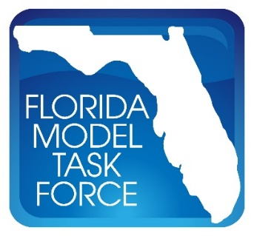
FMTF Data/GIS Committee Meeting Minutes
Date: Tuesday, October 17, 2017
Time: 3:00 – 4:00 P.M. EST
Where: FMTF, Orlando

Employment Data Purchase
- Frank Tabatabaee gave an update of the 2015 employment data
- Forecast employment data not available from CO and purview of districts
- Elaine - Work with MPOs and Districts to ensure resource availability

Website Update
- Move Model Download password submission button after submitting information
- Did District admins lose privleges - No change in control structure
- Awaiting new FIU Task Order to update the website
- Model metadata for model - Base, Horizon, Interim Years along with a ChangeLog
  - Metadata standards as part of model deliverable
  - Model compability and version number
  - Indicate data quality for interim years
  - FSUTMS App

Performance Measures
- May 20, 2018 - Target setting date
- Need to determine MPO cutoff
- Don't intend to include FHWA MAP21 PM standards in the Sourcebook

