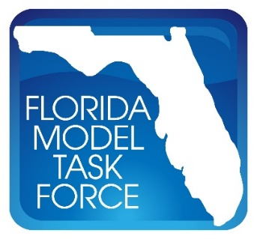
FMTF Data/GIS Committee Meeting Minutes
Date: Tuesday, September 1, 2020
Time: 2:00 P.M. – 3:00 P.M. EST
Where: Web Conference

Attendee | Agency
Alvimarie Corales | Sarasota/Manatee MPO
Chris Wiglesworth | FDOT Central Office
Christopher Simpron | FDOT District 1
Dan Beaty | HNTB
Dan Macmurphy | Traf-O-Data
Daniel Miller | RK&K
Danyu Shi | BCC Engineering
David Farmer | Metro Forecasting Models
Donnie Arbeau | Central Florida RPC
Elaine Martino | Martino Planning
Frank Tabatabaee | FDOT Central Office
Gary Kramer | Emerald Coast Regional Council
Granger Huntress | Dun & Bradstreet
Heather Lupton | Cambridge Systematics
Jasmine Blais | MetroPlan Orlando
Jeanette Berk | Gannett Fleming
Jerry Graham | Traf-O-Data
Jongson Won | PTV Group
Justin Woodard | Dun & Bradstreet
Krishnan Viswanathan | Cambridge Systematics
Makarand Gawade | HDR
Nancy Simpson | Sarasota/Manatee MPO
Paul Flavien | Broward MPO
Richard Pascoe | Stantec
Richard Ranck | Hillsborough County
Rob Schiffer | FuturePlan
Roberto Miquel | WRA
Sheldon Harrison | Cambridge Systematics
Soliman Salem | City of Jacksonville
Srin Varanasi | Corradino Group
Steve Infanti | Tindale Oliver
SungRyong Han | BCC Engineering
Tanner Martin | HDR
Terry Corkery | FDOT Central Office
Thomas Hill | FDOT Central Office
Zhong-Ren Peng | University of Florida

Meeting started - 2:00pm

2020 Employment data method and licensing – Dun & Bradstreet
- Data Cloud
  - Consistently ensure access to customers through trade partnerships.
  - Updated over five million times a day, providing real-time business data.
- D-U-N-S Number
  - Unique identification number for business identification at the site level.
    - Employment.
    - Revenue.
    - Industry classification.
- Provided a snapshot of 1.5 million records for the State of Florida for January, June, and preparing to provide a snapshot for September for analysis of impacts from the COVID-19 pandemic.
  - EconoVue software service merges data visualization, interactive mapping, extensive filtering, and location-based management tools to review the 2020 Dun & Bradstreet datasets.
- Questions
  - How is the data adjusted for self-employment?
    - Depends on whether they have activity from that business.
    - A lot of actual data and model data that is based on each industry.
  - Granger Huntress to pass information along to Frank to disperse to the Committee.

Action Item:
- Granger Huntress to provide information along to Frank Tabatabaee to be dispersed to the Committee.

Origin-Destination Study – Daniel Miller, RK&K
- Subcommittee developed to determine potential O-D data sources, how they are collected, and what services they provide.
- For more detailed information, refer to the presentation.
- Commercial:
  - StreetLight;
  - AirSage;
  - License plate surveys;
  - Helicopter/Drone (SkyComp);
  - American Transportation Research Institute (ATRI);
  - IHS Tourism Data;
  - Uber Movement;
  - Moonshadow/WeJo;
  - Bluetooth;
  - Strava;
  - InfoGroup; and
  - Credit Card Data.
- Government:
  - Travel diary;
  - National Household Travel Survey (NHTS);
  - Longitudinal Employer-Household Dynamics (LEHD);
  - Freight Analysis Framework (FAF);
  - Department of Motor Vehicles (DMV);
  - Weigh in Motion (WIM);
  - Video Cameras; and
  - Sunpass/E-Pass.
- Social Media:
  - Four Square;
  - Twitter;
  - Instagram/Facebook; and
  - LinkedIn.
- Questions/Comments
  - LOCUS data product available from Cambridge Systematics.
    - Origin-destination flow data from app data.
    - Location-based app data aggregated by a third party.
  - Florida Department of Transportation (FDOT) recently purchased HERE data for bicycle-pedestrian movement.

Census Timeline – Krishnan Viswanathan, Cambridge Systematics
- For more detailed information, refer to the presentation.
- Changes between 2010 and 2020 Census
  - Use of the internet as a tool for data collection.
  - Aerial imagery to confirm address reduces the number of field workers verifying addresses.
  - Fewer Census takers.
- Census Timeline:

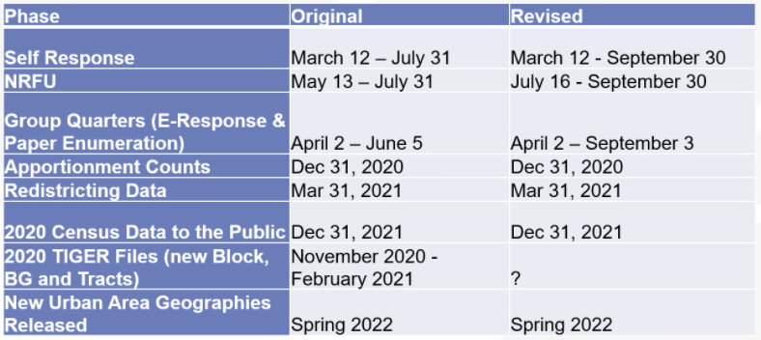

- Given that end of counts has been moved up by one month, from October to September, lawsuits have been filed protesting the change, arguing that this will seriously impact counts.
  - Serious concerns regarding the quality of the 2020 data due to the Census Bureau cutting corners in quality checks.
- Northwest Florida is currently the furthest behind target for Census responses in Florida.

Transportation Model Platform Update – Thomas Hill, FDOT
- Microsimulation: VISSIM
  - Annual Statewide VISSIM subscription.
  - 200 licenses available for FDOT, the Turnpike, and MPOs.
  - Current licenses.
    - Existing licenses will become inactive.
    - All licenses governed under this agreement.
  - Use of other microsimulation software packages.
    - Does not preclude the use of other packages.
  - Benefits.
    - Central Office training and support focus on VISSIM.
    - Cost savings.
  - Support from.
    - Executive team.
    - District Secretaries.
  - The following package was purchased.

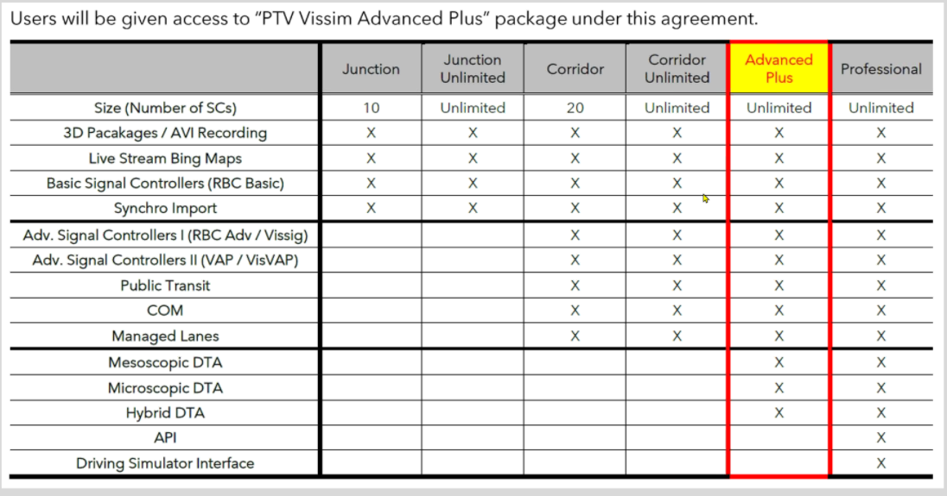

- Plan Forward.
  - VISSIM will be marketed and messaged to other offices/departments, serving to bridge the gap between modeling and other entities, such as PD&E, traffic operations, etc.
- Macrosimulation:
  - VISUM,
    - Had encumbered money for both VISUM and VISSIM, but things were complicated by the COVID-19 pandemic.
      - Currently working through Central Office and the Federal Highway ..Administration (FHWA) to acquire the funds and software.
  - TransCAD.
    - Plan to offer this software as a flexible alternative to the PTV primary.
    - Will also include Transmodeler SE.
  - Administrative services.
    - District-level/MPO-level interviews.
      - What do they want or prefer during this process?
    - Conversion schedule review
      - Sequence, priority, timeline, duration, delivery date, coordination, buffer time.
    - Website/user forum for idea exchanged to be hosted by the Model Task Force (MTF).
    - Standardized procedures for all Districts to approve and release the converted model
    - Training to be offered.
    - Will be holding Cube as a buffer for the next two years.

Comments – Members
- How is the rollout for VISSIM/VISUM going to be done across the state?
  - Currently developing a rollout plan with a subcommittee of the Model Advancement Committee.
    - Looking at a two-year window for the conversion and rollout process.
    - Will take at least a year to get all models converted and validated.

Meeting adjourned - 3:06pm

