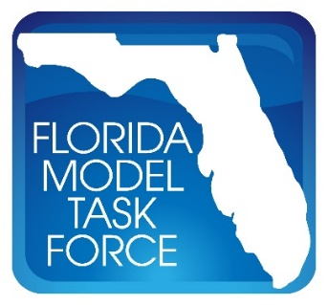
FMTF Data/GIS Committee Meeting Minutes
Date: Tuesday, January 18, 2022
Time: 10:00 A.M. – 11:00 A.M. EST
Where: Web Conference

Attendee | Agency
Andrew Tyrell | FDOT District 7
Chetan Joshi | PTV
Dan Beaty | HNTB
Daniel Miller | RK&K
Danyu Shi | BCC Engineering
David Farmer | Metro Forecasting Models
David Hutchinson | Sarasota/Manatee MPO
Dawn Carlson
Donald Scott | Southwest Florida RPC
Donnie Arbeau | Central Florida RPC
Elaine Martino | Martino Planning
Frank Tabatabaee | FDOT Central Office
Gabe Matthews | FDOT Central Office
Gary Kramer | Emerald Coast Regional Council
Heath Lupton | Cambridge Systematics
Hoyt Davis | Gannett Fleming
Jason Learned | FDOT District 5
Jerry Graham | Traf-O-Data
Krishnan Viswanathan | Cambridge Systematics
Li Jin | Nelson\Nygaard
Makarand Gawade | HDR
Patricia Tice | CREWS, LLC
Richard Ranck | Hillsborough County
Rob Schiffer | FuturePlan
Roberto Miquel | WRA
Sheldon Harrison | Cambridge Systematics
Soliman Salem | City of Jacksonville
Stephen Lawe | RSG
Steve Infanti | Benesch
SungRyong Han | BCC Engineering
Terry Corkery | FDOT Central Office
Thomas Hill | FDOT Central Office
Yongqiang Wu | Kittelson & Associates

Meeting started – 10:00am EST

- Frank Tabatabaee provided an overview of the Data/GIS Committee meeting agenda for the upcoming Model Task Force (MTF) to be held February 22-24, 2022 in Orlando, FL.
  - Dan Miller suggested the committee also discuss data needs and availability within the committee priorities discussion.
- Gary Kramer shared the committee priority list from previous years.
  - Four out of five priorities have been completed since the origination of the list.
    - Common file naming will be essential now that two transportation models are under consideration.
  - A survey will be sent out prior to the MTF to gauge the committee on their desired priorities moving forward.
- Thomas Hill provided a broad overview of the general body agenda for the MTF.

Meeting adjourned – 11:00am EST

