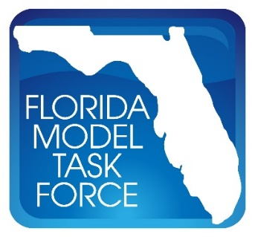
FMTF Freight Committee Meeting Minutes
Date: Tuesday, January 18, 2022
Time: 2:00 P.M. – 3:00 P.M. EST
Where: Web Conference

Attendee | Agency
Andrew Tyrell | FDOT District 7
Andrew Young | HNTB
Chetan Joshi | PTV
Christopher Simpron | Hardee County
Dan Beagan | Cambridge Systematics
Dan Macmurphy | Traf-O-Data
Frank Tabatabaee | FDOT Central Office
Heath Lupton | Cambridge Systematics
Hoyt Davis | Gannett Fleming
Jennifer Fortunas | FDOT Central Office
Jerry Graham | Traf-O-Data
Jiangchuan Hu
Krishnan Viswanathan | Cambridge Systematics
Moe Lavasani | Caltran
Rickey Fitzgerald | FDOT Central Office
Rob Schiffer | FuturePlan
Rodrigo Mesa-Arango | Florida Institute of Technology
Sheldon Harrison | Cambridge Systematics
SungRyong Han | BCC Engineering
Terry Corkery | FDOT Central Office
Yongqiang Wu | Kittelson & Associates

- Frank Tabatabaee introduced Christopher Simpron of Hardee County as the new chair of the Freight Committee.
- Frank then provided an overview of the Freight Committee meeting agenda for the upcoming Model Task Force (MTF) to be held February 22-24, 2022 in Orlando, FL.
- A survey will be sent out prior to the MTF to gauge the committee on their desired priorities moving forward.
  - Frank provided a brief preview of the survey questions.
- Frank provided a broad overview of the general body agenda for the MTF.

