Analysis of the Benefits of Arterial Dynamic Message Signs

A Report Prepared for

The ITS Program of the
Florida Department of Transportation (FDOT) District 4
2300 W. Commercial Blvd.
Fort Lauderdale, Florida 33309

By

Lehman Center for Transportation Engineers
Florida International University
10555 W. Flagler Street
Miami, FL 33174

October 31, 2011

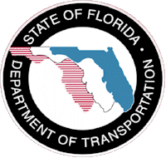

TABLE OF CONTENTS

1. INTRODUCTION 3
2. UTILIZED DATA 4
3. METHODOLOGY 5
3. RESULTS 7

1. INTRODUCTION
The Florida Department of Transportation (FDOT) District 4 has installed Arterial Dynamic Message Signs (ADMS) at all I-95 interchanges and at two I-75 interchanges in Broward County. Figure 1 show the location of the interchanges with arterial DMS (marked in red).
Previous assessments have been made of the benefits and costs of ITS components including the Road Ranger service patrol program, Closed Circuit Television (CCTV) camera subsystem, Severe Incident Response Vehicle (SIRV) program, and the Dynamic Message Signs (DMS) subsystem. The assessments of the benefits and costs of FDOT District 4 ITS program components have allowed the justification of the investments made in the expansion of the individual components of the program. FDOT District 4 has initiated this study to assess the benefits of the ADMS implementation.

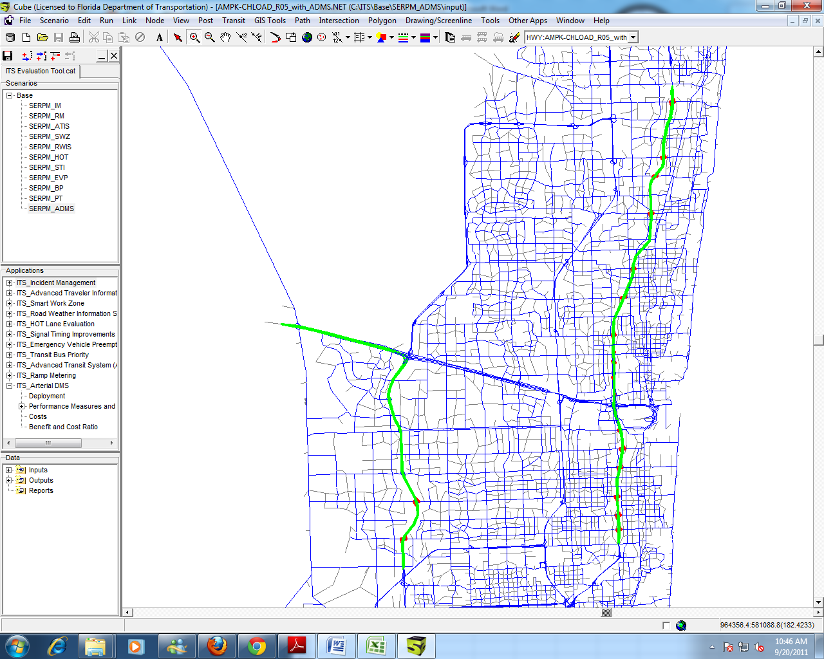

Figure 1 Locations of Affected Freeway Links and Ramps

2. UTILIZED DATA
The assessment of the benefits of the ADMS requires detailed and accurate incident data. The main source of data used in this study is the incident database maintained by FDOT District 4. All information gathered from the freeway incident management program of FDOT District 4 in Fort Lauderdale, FL, is stored in a comprehensive incident database. The database was developed based on a comprehensive requirement analysis to include a large set of data attributes allowing detailed incident analysis. These attributes include timestamps of the activities for all agencies involved, the tracking of lane and shoulder closures and clearances, incident location information, incident environmental conditions, incident type and severity, number and types of involved vehicles, and so on. Performance measures are assessed based on the database. Some of the assessed measures are published automatically at the SMART SunGuide website (www.smartsunguide.com). Quality control and quality assurance tasks are also performed to ensure the integrity of the SMART SunGuide database and the calculated performance measures.

3. METHODOLOGY

This study uses the DMS Evaluation module of the Florida’s Intelligent Transportation Systems Evaluation tool (FITSEVAL) to estimate the benefits of information sharing. FITSEVAL was developed as part of a FDOT research project performed in 2007-2008 to allow the evaluation of the costs and benefits of ITS alternatives within the FSUTMS/Cube software environment. The project used the Cube script language to implement the evaluation tool procedures. Depending on the types of the evaluated ITS deployments, the tool can produce various performance measures including vehicle miles of travel (VMT); vehicle hours of travel (VHT), average speed, number of accidents, and emission. The types of ITS deployments that can be evaluated using the current version of the developed tool include ramp metering, incident management systems, highway advisory radio (HAR) and dynamic message signs (DMS), advanced travel information systems, managed lanes, signal control, transit vehicle signal priority, emergency vehicle signal priority, advanced public transit systems, smart work zones, and road weather information systems. Figure 2 presents an example of the user interface of FITSEVAL.
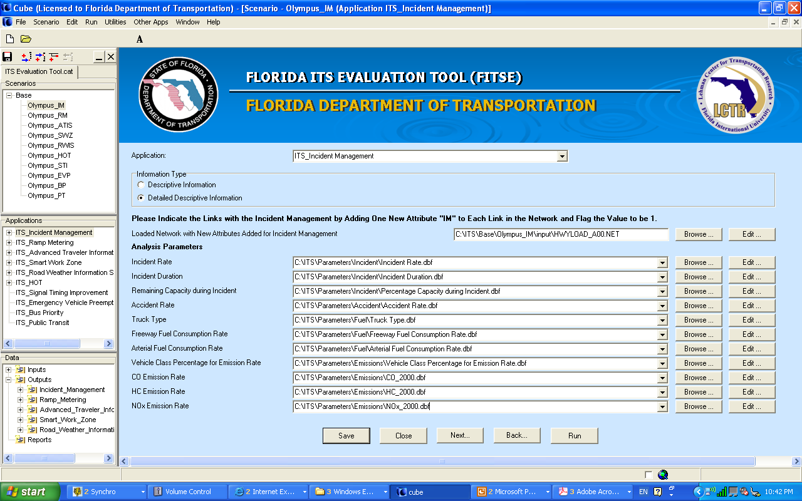

Figure 2 User Interface of FITSEVAL

A modified version of the Dynamic Message Sign evaluation methodology in FITSEVAL is used in this study to assess the benefits of ADMS. Below is a description of this methodology used in FITSEVAL to assess DMS.
- The default value for the number of DMS activations per year is assumed to equal to the number of lane blockage incidents per year. This default value can be changed by the user. The rational behind the use of this default value is that FDOT generally displays incident information on the DMS only when there are lane blockage incidents.

- FITSEVAL assumes that the net diversion rate is a function of the potential saving in delay due to the incidents, as shown in Figure 3. If the calculated saving in delay is less than a certain minimum delay threshold (5 minutes or 20% is used as a default value), then the diversion rate is assumed to be zero. This maximum diversion rate can be changed by the user. Between the minimum delay and the maximum diversion rate thresholds, a linear relationship is assumed, as shown in Figure 3.

- The total time savings resulting from dynamic message sign are calculated based on queuing equations using reduced volumes due to diversions by travelers passing the DMS locations. The calculation of the benefits in this study accounts for the fact that the diverted vehicles will most likely experience additional travel time due to diverting to the alternative routes compared to the travel time on their original route without incident. This additional travel time was estimated and subtracted from the travel time benefits due to the reduction in queue length during incidents, which result from traffic diversion.

The official version of FITSEVAL allows the assessment of freeway DMS but not ADMS. Thus, a modification was made in this study to the methodology to allow the assessment of ADMS. The main modification is that the affected travelers by the DMS are not all freeway users but only the fractions of on-ramp volumes that pass the incident locations. The estimation of these fractions required running the assignment routine in the FSUTMS SERPM model (the demand forecasting model for Southeast Florida) to determine the percentages of travelers from each ramp that are expected to pass through the incident locations.

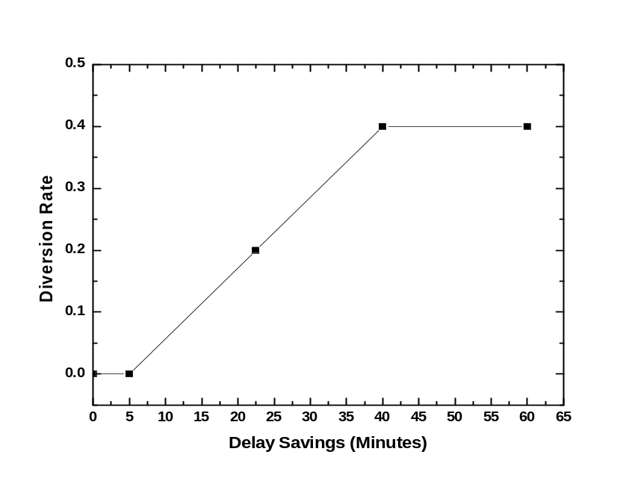
Figure 3 Relationship between diversion rate and expected delay savings

4. RESULTS

Figure 4 shows the percentages of ramp volumes using freeway links as function of the distance from each freeway location based on the results from the FSUTMS SERPM assignment routine. Figure 5 shows the same percentages after a smooth curve was used to fit the data based on regression analysis. Table 1 shows the results from the benefit-cost analysis. The results show that the benefit/cost ratio of the ADMS deployment is 6.12.

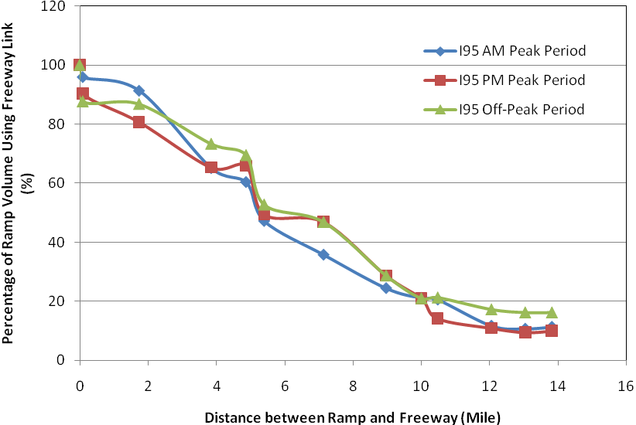
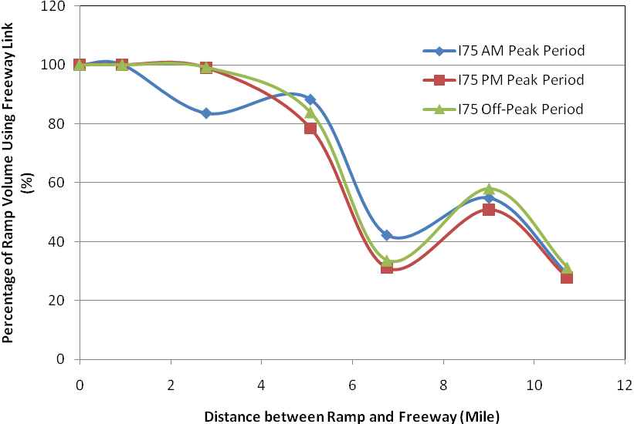

Figure 4 Percentage of Ramp Volumes using Downstream Freeway Links

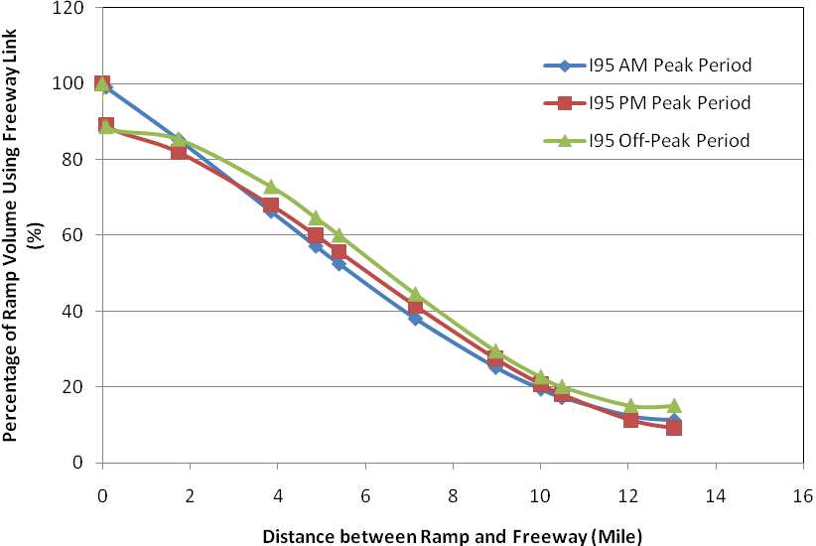

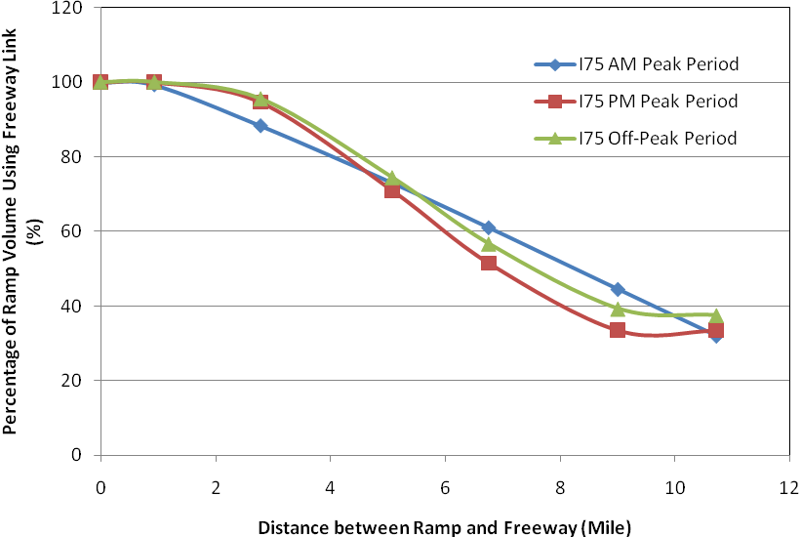

Figure 5 Percentage of Ramp Volumes using Downstream Freeway Links Utilizing Smooth Curves

Table 1 Benefit/Cost Analysis Results

Item | Life Time | Capital Costs | O & M Costs
DMS | 10 Years | $105,000 | $10,000
DMS Structure | 20 Years | $105,000 | $10,000

Benefits | Values
Delay Reduction (Veh-Hr) | AM Period | 156,926.24
Delay Reduction (Veh-Hr) | PM Period | 189,877.58
Delay Reduction (Veh-Hr) | Off-peak Period | 121,753.57
Delay Reduction (Veh-Hr) | Total | 468,557.4
Delay Reduction ($) | AM Period | 3,118,939.10
Delay Reduction ($) | PM Period | 3,771,121.00
Delay Reduction ($) | Off-peak Period | 2,451,713.02
Delay Reduction ($) | Total | 9,341,773.12
Annual Costs ($) | 1,525,270.43
Benefit/Cost Ratio | 6.12

