To: Vladimir Majanos
From: Hongbo Chi
Date: 03/06/2013
Subject: FLSWM Model OD Matrix Estimation & Future year traffic projection

Introduction
Florida State-Wide Model (FLSWM) provides travel forecasting over the entire state reflecting long range demographic and socioeconomic growth. Since the model is designed to forecast travel for the large scale, it requires additional procedure to validate according to the observed traffic count data.
This Memo describes the development of an OD matrix estimation and growth factor method application based upon FLSWM. The two applications are added to the current FLSWM, indicated in Figure 1. The following sections describe the OD matrix estimation model in detail. Section 1 outlines the procedure to calibrate the base year OD matrix by using Cube Analyst 2. This section also includes the performance of Cube Analyst2 in this application. Section 2 explains the method of growth factor to project the future year (2040) traffic volume. The last section introduces some guidance for user on how to run the updated FLSWM.

Figure 1. The two application groups added to the main application interface of FLSWM 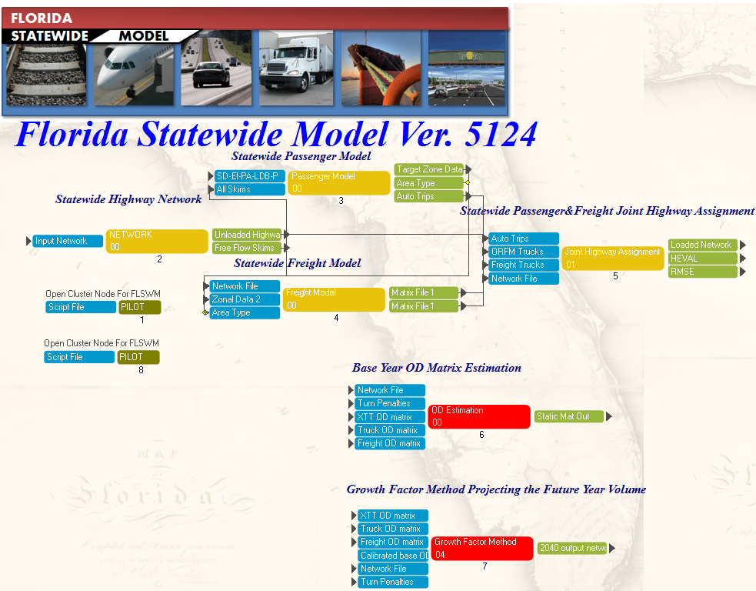

Static OD Matrix Calibration for Base Year
CUBE Analyst2 is utilized to perform the OD matrix estimation for FLSWM, which is a new version of the current CUBE Analyst. CUBE Analyst 2 adopts more efficient algorithm to handle the OD estimation problem for a large-scale network.
In this application of CUBE Analyst 2, a bi-level scheme iterates between optimizing a set of OD flows using a fixed trip proportion matrix, and between using HIGHWAY for simulating route choice assignments. A flow chart depicting this scheme is given in the following figure.

Figure 2. Flow Chart Describing the ANALYST 2 Estimation Procedure
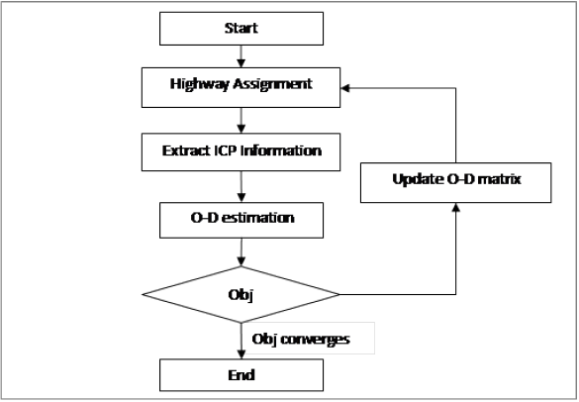
CUBE Analyst 2 models the OD estimation problem as a generalized minimization problem given by
$J\left(X\right)={F\left(AX-b\right)}^{2}+{G(X-X_{0})}^{2}$ [Eq. 1]
Subject to $X≥ 0$
Where A is the route choice probability matrix, X is the OD matrix to be estimated, and X₀ is the initial OD matrix. F and G are weighting factors.
CUBE Analyst 2 uses reduced gradient method to solve the OD estimation method. Sparse matrix technique is adopted to increase the efficiency of the solution algorithm.

Finally, the CUBE application for OD estimation is developed as the following Figure 3 shows. It should be noted that the FLSWM highway assignment procedure is used to generate ICP files for CUBE Analyst 2. The assignment program is a multi-modal multi-class assignment, which includes the following 9 classes of trips. Accordingly, the program also generates 9 ICP files for those user classes.
- Urban and rural short trips
- Long distance business trips
- Long distance in-state tourist trips
- Short cross-border EI trips
- FL-US, US-FL and Canada-FL tips
- Light truck
- Medium trucks
- Heavy trucks
- Freight trucks
The passenger car equivalent (PCE) units in path load statements for low, medium and heavy trucks are set to 1.0 to get actual vehicle trips, and the maximum number of iterations for highway assignment is set to 50, to be consistent with the FLSWM highway assignment script.
Figure 3. Application Flow Chart for OD Estimation for FLSWM
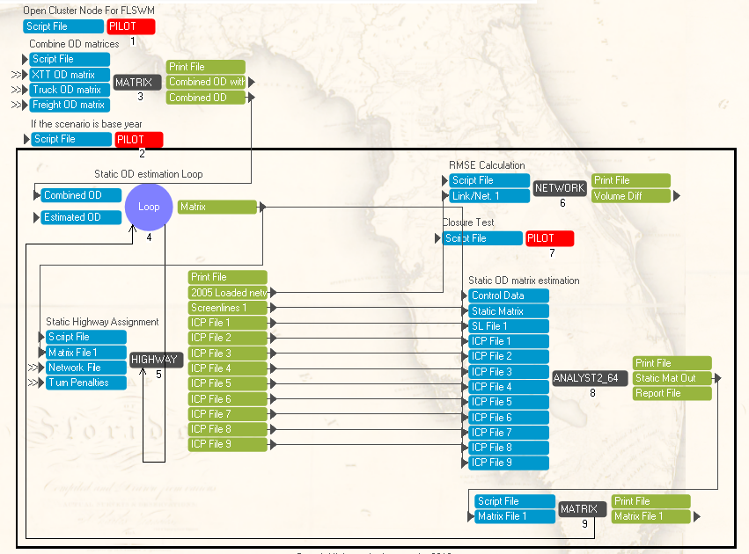
After developing the application, we ran it and got the estimation performance as Table 1 shows. According to the table, after 6 iterations, the overall RMSE% for volume drops from 35.10% to 18.80%. In the meantime, all the different volume groups also have significant reduction on the RMSE% after the estimation. The further RMSE% reduction can be expected if the iteration number is increased.

Table 1. FLSWM OD Estimation Result
Iteration | RMSE% for Different Volume Ranges
 | Over all | [20000,Inf] | [10000,20000] | [5000,10000] | [0,5000]
1 | 35.10% | 25.00% | 35.20% | 36.00% | 77.70%
2 | 27.20% | 19.50% | 26.30% | 29.40% | 67.90%
3 | 24.50% | 17.50% | 23.50% | 27.40% | 61.20%
4 | 22.10% | 15.80% | 21.00% | 25.60% | 54.70%
5 | 20.20% | 14.60% | 19.20% | 23.90% | 48.20%
6 | 18.80% | 13.40% | 17.90% | 22.90% | 43.40%

The Root Mean Square Error (RMSE) and Percent RMSE (RMSE%) are calculated by count group and for all count groups combined to identify how close the volumes are to the counts statistically. The calculation is based on the formula below.
RMSE = $\sqrt{\frac{\sum_{i=1}^{n}{{\left(V_{i}-C_{i}\right)}^{2}}}{n-1}}$ [Eq. 2]
RMSE% = $\frac{RMSE}{\frac{ \left(\sum_{i=1}^{n}{C_{i}}\right) }{n}}$ x 100 [Eq. 3]
Where:
n = number of counts
V_{i} = 2005 Highway assigned volumes on link i, i=1, 2, …, n
C_{i} = 2005 counts on link i, i=1, 2, …, n

Growth Factor Method for Future Year Volume Projection
Growth factor method is adopted to apply model based growth from 2005 to 2040. In this procedure, the based year 2005 trip table was subtracted from the 2040 trip table to obtain model generated growth. This incremental growth trip table is then added to the calibrated 2005 trip table obtained from the CUBE Analyst2 procedure i.e. the base year trip table calibrated based on the observed traffic counts. The resulting trip table is then assigned to 2040 road network to generate the projected traffic volume for 2040.

Figure 3. Application Flow Chart for Growth Factor Method
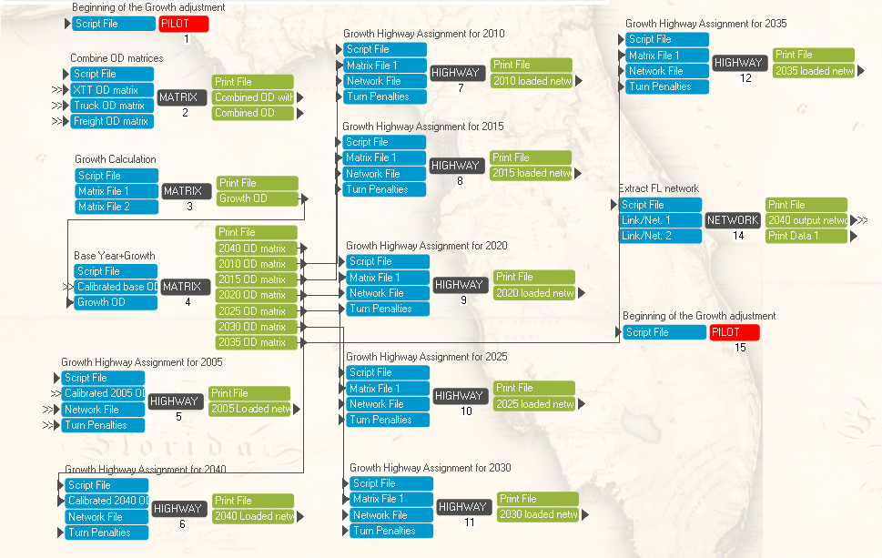

The user guidance on how to run the model
For the purpose of convenience, the OD estimation model and growth factor model are added as the checkboxes in the scenario manager for base year and the future year. The default setting is that in the base year, the OD estimation is checked, and Growth factor method unchecked. In the futher year, the checking status is just the reverse, which can be shown in Figure 4 and Figure 5. User also has the flexibility to deselect the OD estimation and growth factor projection for his own application purpose.
After the user finishes the settting, he/she need to double click the corresponding scenario, and click run to run the whole model.
Figure 4. The model selection in the scenario manager for base year
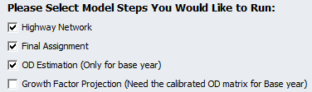
Figure 5. The model selection in the scenario manager for the year 2040
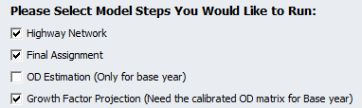

Computer requirement to run the model
The recommended configuration for computer should be
CPU:
Memory:
With the recommended configuration, the model running time is roughly about
Base year:
Year 2040:

